1. Output format needed? PDF or Html or any other. We will decide on the tool based on the output format required?

We can try for online help sort of output and will check about the subscription cost and all.

1. Is this application like a portal for all users or within the office premises (only officials will handle it)?

Only internal purpose, but few options where the public can download on their own will be given to external.

1. What is the actual workflow that Citizens are following now and where does this application alter the process flow?

Citizen comes to office and discusses with staff and he will give if he wants otherwise he refers to higher officers. To avoid people coming to the office, this tool is used.

1. Who are the different user roles and what actions are performed by them?

|  |  |
| --- | --- |
| **Users** | **Action** |
|  |  |
|  |  |
|  |  |
|  |  |

1. First access request where we raise the requests > is that the request for accessing the file which we create and store?

Yes.

1. All documents or records maintained in physical or digital?

Paper and Electronic.

1. Actual workflow on the site?

Access Request raised and checked by officer and will provide the record accordingly.

Under File, new records locations will be updated. Related data under File are available under Administration.

1. Access Disposition Period is same for all records or any difference?

It is the same for all.

1. Is only one Record Series available for one Subject?

Yes, it is unique.

In the Overview document, we will concentrate on

* what is this tool?
* how it is helpful for the users?
* Advantages over the conventional practice of record management?

Suggestions:

1. Highlight the tab that we have selected.
2. We can add the hyperlink or Html pages under the Help tab.
3. 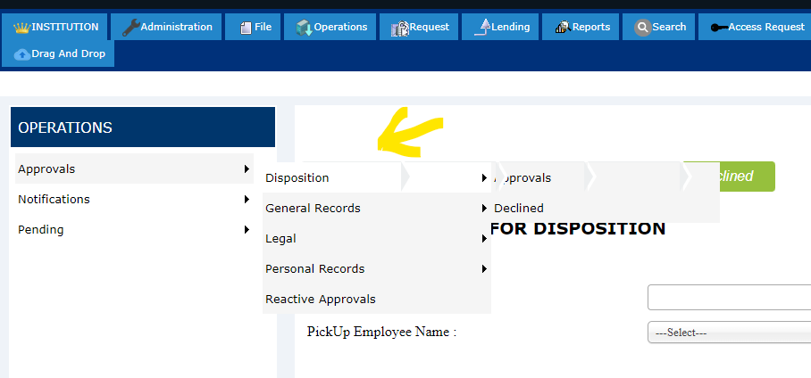
4. Ss