**Recommender-System-for-Groceries-Contractor**

Groceries are critical part for any Restaurants, Bakery, Breakfast Spot, Brewery, Cafe (with fresh and high quality groceries) etc. Their quality and timely delivery plays a critical role in the serviceability of a vendor. The supply chain's most important element in its supply is distributor or supplier. The location, transportation method, cost and quality plays a significant role. Moreover, the warehouse location plays a critical role in development and progress of a contractor / distributor. The project discusses a method to data mapping, visualization and applying machine learning techniques in order to identify optimum location in a neighborhood in Scarborough of Toronto for a groceries contractor.

**Problem description**

**Recommender System for Groceries Contractor**

* To provide a groceries contractor (in one of the boroughs of Toronto - Scarborough) recommendations for optimized warehouse location
* Supplier to various Restaurants, Bakery, Breakfast Spot, Brewery, Cafe (with fresh and high quality groceries)
* The contractor wants to build a warehouse for the groceries it buys from villagers and farmers inside the borough, so that they will support more customers and also bring better "Quality of Service" to the old customers.
* The contractor should build this warehouse where it is closest to its customers in order to minimize the cost of transportation in addition to the example above.
* Finding the right neighborhood is our mission and our recommender system will provide this contractor with a sorted list of neighborhoods in which the first element of the list will be the best suggested neighborhood.

Data

* Geo-locational information (latitude and longitude )about that specific borough and the neighborhoods in that borough.
* Data about different venues in different neighborhoods of that specific borough.
* "Foursquare" locational information to be used. ( basic and advanced information about that venue)

**Identification of postal codes**

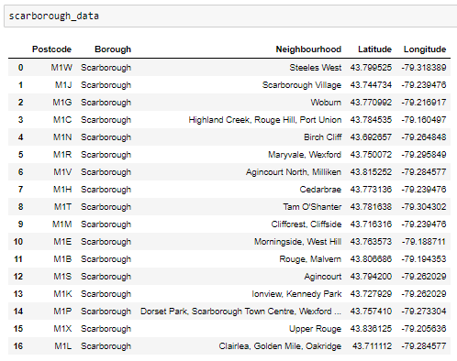

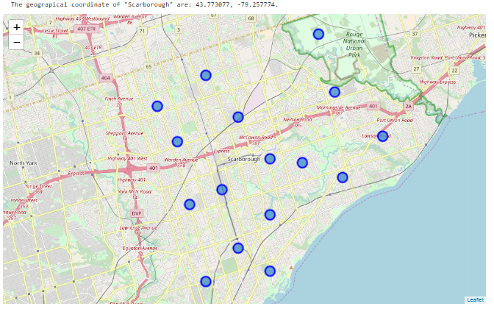

**Conclusion**

The project has discussed the method to data mapping, visualization and applied machine learning techniques in order to identify optimum location in a neighborhood in Scarborough of Toronto for a groceries contractor.