|  |  |  |  |  |  |  |
| --- | --- | --- | --- | --- | --- | --- |
| **Adjacency List, Source -> Destination** | **Search Algorithm** | | | | | |
| **Average Normalized**  **Results** | **DFS Iterative** | **DFS Recursive** | **BFS Iterative** | **BFS Recursive** | **Dijkstra** | **A\*** |
| **Nodes in Path** | 0.625761 | 0.69079 | 0.253777 | 0.253777 | 0.317241 | 0.317241 |
| **Nodes Explored** | 0.485186 | 0.530662 | 0.553792 | 0.553792 | 0.935265 | 0.432392 |
| **Execution Time** | 0.58474 | 0.690784 | 0.182797 | 0.182797 | 0.268094 | 0.268094 |
| **Distance** | 0.578065 | 0.648436 | 0.145918 | 0.145918 | 0.224213 | 0.224213 |
| **Cost** | 0.409419 | 0.182785 | 0.373434 | 0.341742 | 0.746399 | 0.597489 |

|  |  |  |  |  |  |  |
| --- | --- | --- | --- | --- | --- | --- |
| **Adjacency List, Destination -> Source** | **Search Algorithm** | | | | | |
| **Average Normalized**  **Results** | **DFS Iterative** | **DFS Recursive** | **BFS Iterative** | **BFS Recursive** | **Dijkstra** | **A\*** |
| **Nodes in Path** | 0.628021 | 0.660367 | 0.254326 | 0.254326 | 0.254326 | 0.254326 |
| **Nodes Explored** | 0.516139 | 0.508041 | 0.548237 | 0.548237 | 0.935265 | 0.338241 |
| **Execution Time** | 0.592499 | 0.612263 | 0.182797 | 0.182797 | 0.182797 | 0.182797 |
| **Distance** | 0.590081 | 0.618092 | 0.146386 | 0.146386 | 0.146386 | 0.146386 |
| **Cost** | 0.3825 | 0.202988 | 0.410183 | 0.353743 | 0.8417 | 0.51173 |

|  |  |  |  |  |  |  |
| --- | --- | --- | --- | --- | --- | --- |
| **Adjacency List, Destination -> Source** | **Search Algorithm** | | | | | |
| **Average Normalized**  **Results** | **DFS Iterative** | **DFS Recursive** | **BFS Iterative** | **BFS Recursive** | **Dijkstra** | **A\*** |
| **Nodes in Path** | 0.625761 | 0.69079 | 0.253777 | 0.253777 | 0.317241 | 0.317241 |
| **Nodes Explored** | 0.485186 | 0.530662 | 0.553792 | 0.553792 | 0.935265 | 0.432392 |
| **Execution Time** | 0.58474 | 0.690784 | 0.182797 | 0.182797 | 0.268094 | 0.268094 |
| **Distance** | 0.578065 | 0.648436 | 0.145918 | 0.145918 | 0.224213 | 0.224213 |
| **Cost** | 0.281721 | 0.123511 | 0.288185 | 0.278675 | 0.648145 | 0.515462 |

|  |  |  |  |  |  |  |
| --- | --- | --- | --- | --- | --- | --- |
| **Adjacency List, Source -> Destination** | **Search Algorithm** | | | | | |
| **Average Normalized**  **Results** | **DFS Iterative** | **DFS Recursive** | **BFS Iterative** | **BFS Recursive** | **Dijkstra** | **A\*** |
| **Nodes in Path** | 0.638021 | 0.662675 | 0.253777 | 0.253777 | 0.253777 | 0.253777 |
| **Nodes Explored** | 0.515514 | 0.507416 | 0.544487 | 0.544487 | 0.935265 | 0.334491 |
| **Execution Time** | 0.592499 | 0.612263 | 0.182797 | 0.182797 | 0.182797 | 0.182797 |
| **Distance** | 0.590081 | 0.617624 | 0.145918 | 0.145918 | 0.145918 | 0.145918 |
| **Cost** | 0.437199 | 0.237707 | 0.440588 | 0.426089 | 0.957406 | 0.57694 |

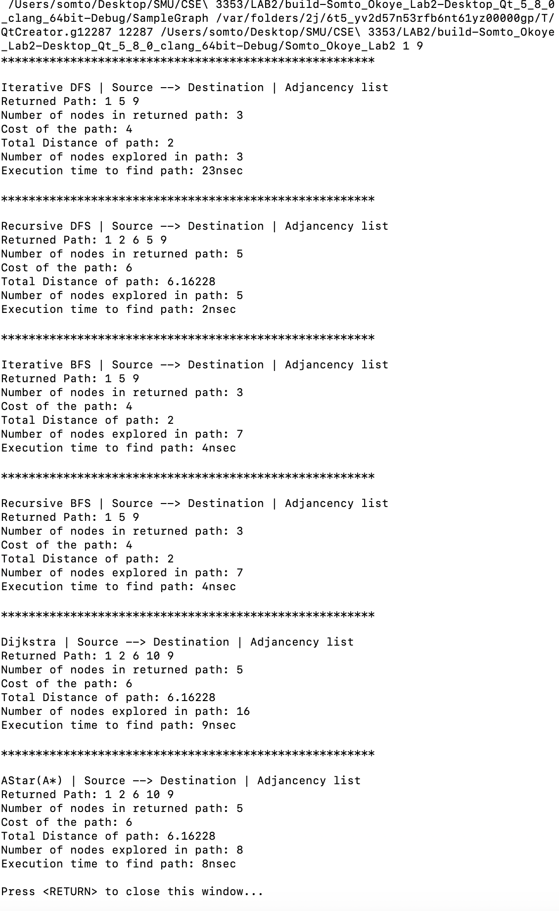

Based on the graphs and table above, the returned nodes, the DFS has the most nodes returned as well as the highest distance between the nodes. However, the execution time for the DFS is slightly significant compared to the other search algorithms.