WEEK 2 TASK
Sensor Integration and Data Acquisition Strategy
IoT Sensor Network Design, Simulation, Communication, and Security

1. Objective and Project Scope
This project designs and simulates an end-to-end IoT sensor integration system. The proposed system collects temperature, humidity, and motion data at an edge node, validates and processes the readings, publishes telemetry through MQTT, and forwards the data to a central processing/storage layer for visualization and alert generation. The simulation is implemented in Python so that the acquisition process can be reproduced without physical hardware.

2. Sensor Selection
Sensor | Measured variable | Interface | Typical configuration | Reason for selection
DS18B20 | Temperature | 1-Wire | 9–12-bit resolution; 3.0–5.5 V | Digital, inexpensive, good accuracy, unique address supports multiple sensors on one bus.
DHT22 | Relative humidity + temperature | Single-wire digital | 3.3–6 V; sample interval ≥2 s recommended | Low-cost humidity measurement with a simple digital interface.
HC-SR501 PIR | Motion/presence | Digital GPIO | 5 V module; adjustable delay/sensitivity | Very low processing overhead and suitable for occupancy/security events.
The three sensors complement one another: temperature and humidity provide environmental telemetry, while the PIR supplies event-driven occupancy information. In a physical prototype, the DHT22 and DS18B20 can share an ESP32-class edge controller while the PIR is connected to a GPIO input.

3. Sensor Configuration and Acquisition Strategy
Parameter | Temperature | Humidity | Motion
Sampling strategy | Periodic | Periodic | Event/digital state
Simulation rate | 1 sample/s | 1 sample/s | 1 sample/s polling of state
Validation | -40 to 85 °C | 0 to 100 %RH | Binary 0/1
Processing | Range check + threshold | Range check + threshold | Debounce/event detection
Alert example | >25.5 °C | <55 %RH | Motion = 1
For real hardware, the controller should avoid reading the DHT22 faster than its recommended sampling interval. Sensor timestamps should be generated at acquisition time, and each record should include a device identifier, sequence number, timestamp, measured values, and quality/status fields.

4. Sensor Network Architecture
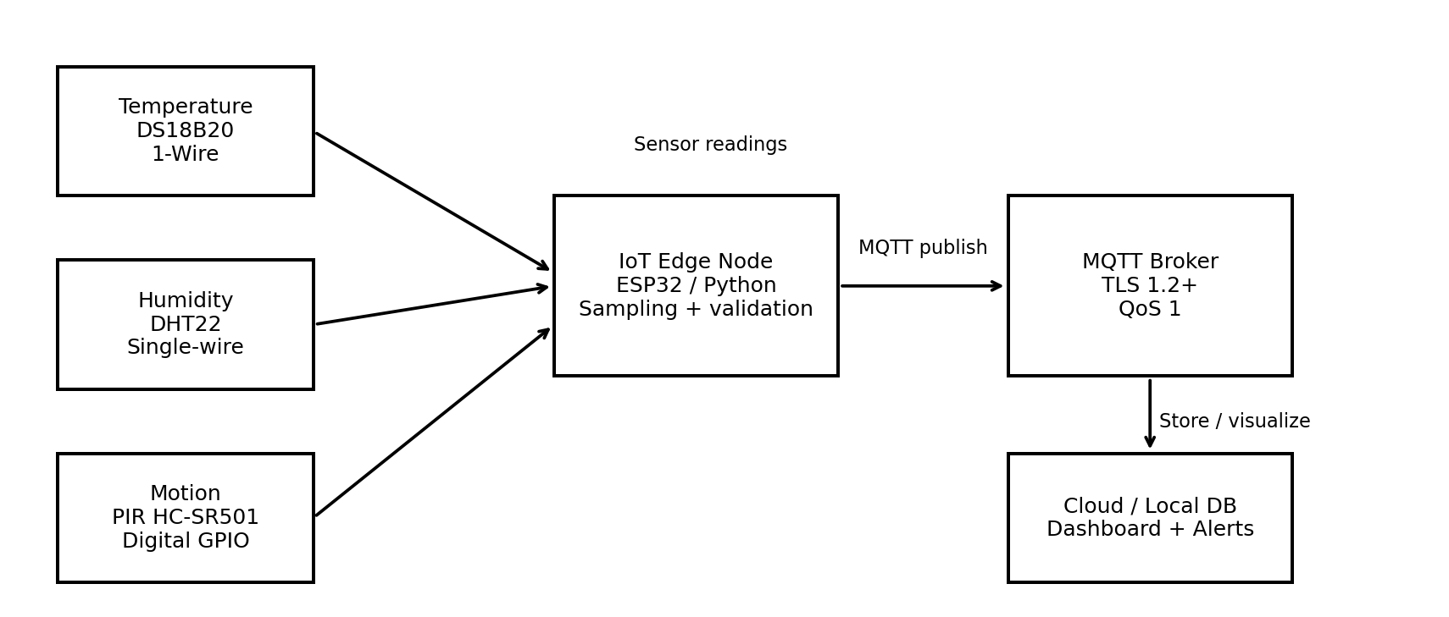
Figure 1. Proposed sensor-to-cloud/local-processing data pathway.

5. Data Acquisition and Processing Flow
- Sense: each sensor produces a physical measurement or digital event.
- Acquire: the edge controller reads the sensor interface and attaches a timestamp and device ID.
- Validate: impossible/out-of-range values are rejected; a quality flag can identify missing or stale samples.
- Normalize: values are represented in consistent units (°C, %RH, binary motion).
- Process: threshold rules generate local alerts without requiring a cloud round trip.
- Serialize: readings are encoded as compact JSON.
- Transmit: the edge node publishes telemetry to an MQTT topic using QoS 1.
- Store/visualize: a subscriber stores the records in a database and feeds a dashboard.
- Monitor: connection status, publish failures, timestamps, and alert counts are logged.

6. Communication Protocol: MQTT
MQTT is selected as the primary application-layer protocol because it uses a lightweight publish/subscribe model that separates sensor producers from data consumers. This is useful when multiple dashboards, databases, and analytics services need the same telemetry.
Setting | Proposed value | Effect
Topic | lab/iot-node-01/telemetry | Provides a clear namespace per device and data stream.
Payload | JSON | Human-readable and easy to integrate; can be replaced with CBOR for lower bandwidth.
QoS | 1 | At-least-once delivery; messages may be duplicated, so consumers should be idempotent.
Retain | Optional for latest-state topics | Useful for current state, but not required for high-rate telemetry.
Keep-alive | 30–60 s | Detects broken connections while avoiding excessive traffic.
Security | TLS 1.2+; username/password or certificates | Encrypts traffic and authenticates clients.
MQTT QoS 0 offers lower overhead but no delivery guarantee. QoS 1 provides a practical balance for this project. QoS 2 provides stronger delivery semantics but adds protocol overhead and is generally unnecessary for ordinary environmental telemetry.

7. Alternative: CoAP
CoAP is a lightweight REST-like protocol designed for constrained devices and commonly runs over UDP. It can be attractive where very small messages, multicast, or constrained network operation are priorities. For this project, MQTT is preferred because the central broker simplifies fan-out to multiple consumers and supports persistent sessions and QoS semantics. A CoAP deployment would need a suitable gateway or server architecture when integrating with conventional web/cloud services.

8. Message Format
Example JSON telemetry message:
{
"device_id": "iot-node-01",
"timestamp": "2026-10-05T12:34:00Z",
"temperature_c": 24.09,
"humidity_pct": 61.52,
"motion": 0,
"alerts": []
}
A production system should also consider a sequence number, firmware version, battery level where relevant, sensor calibration status, and an explicit schema/version field.

9. Simulation Implementation
The supplied Python program generates realistic sensor-like values using deterministic sinusoidal trends and noise, injects PIR motion events, validates the readings, applies threshold rules, and prints each acquisition record. The program also writes JSONL output. The commented MQTT publish point shows where a real broker connection can be inserted.
Recommended environment: Python 3.x with NumPy and Matplotlib.
Execution:
python -m pip install numpy matplotlib
python sensor_simulation.py
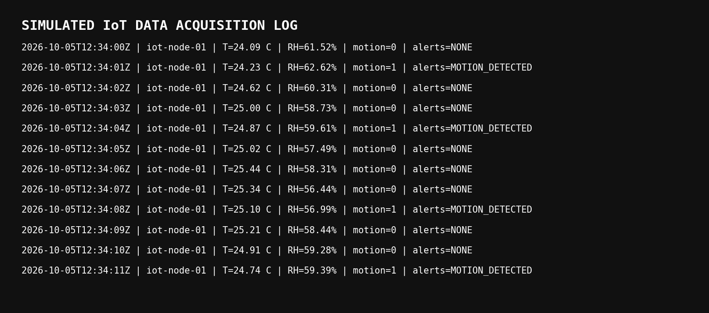
Figure 2. Example simulated real-time acquisition log.

10. Simulation Results
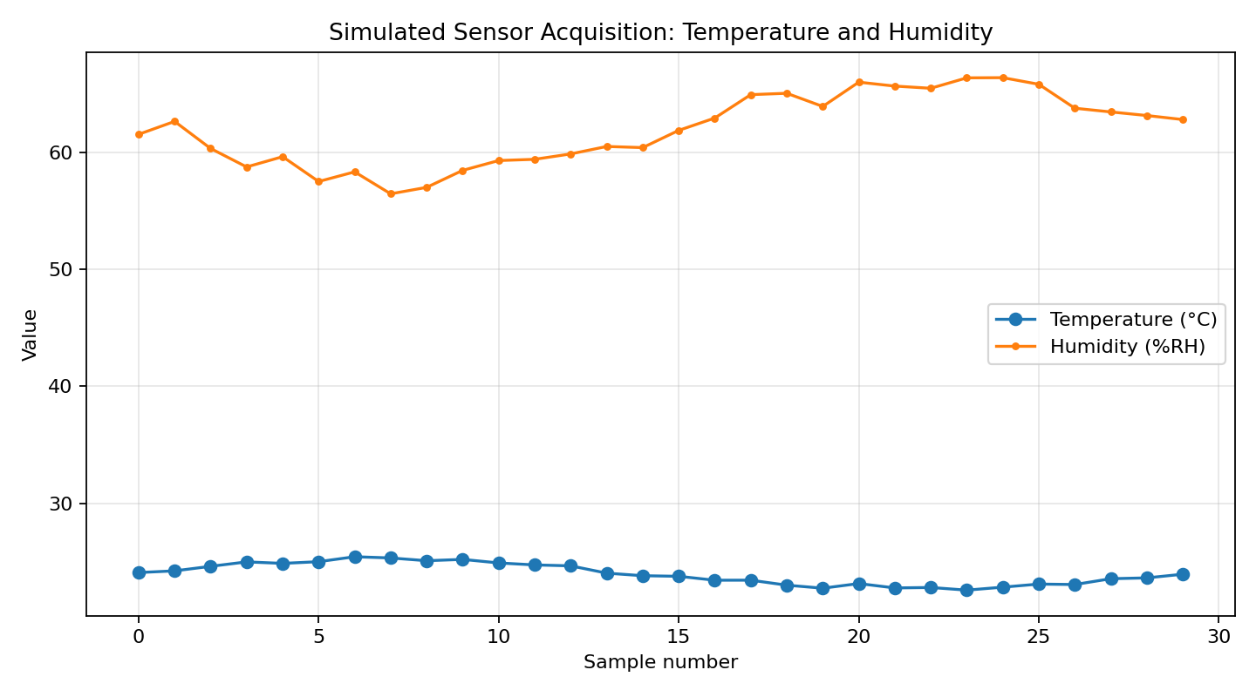
Figure 3. Simulated temperature and humidity trends.
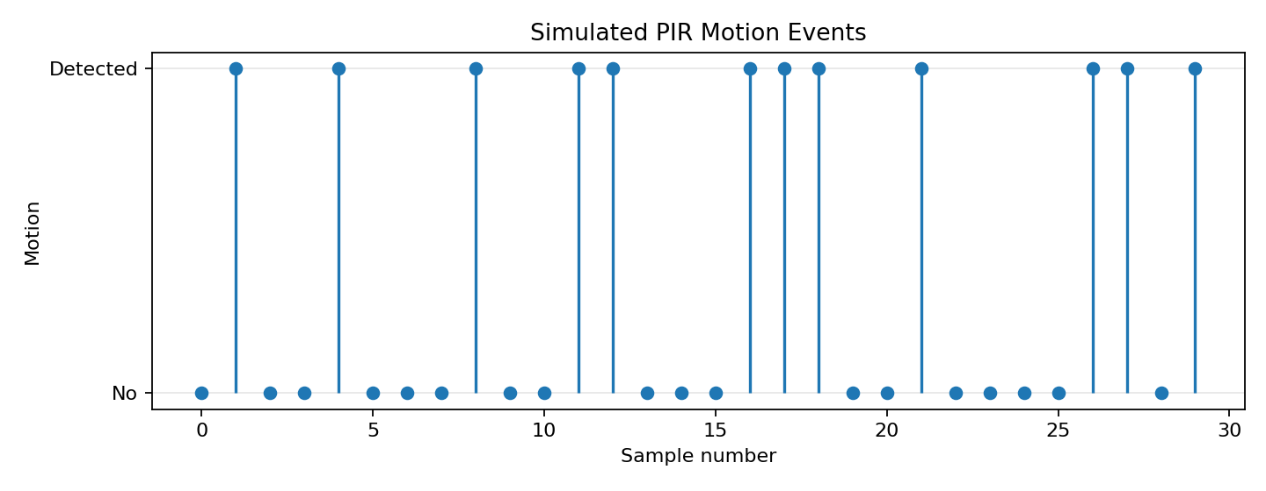
Figure 4. Simulated PIR motion events.
The 30-sample run produced 12 motion-positive samples. The simulated maximum temperature was 25.44 °C and the minimum humidity was 56.44 %RH. These results demonstrate periodic environmental acquisition combined with event detection.

11. Reliability and Fault Handling
- Use input validation and reject physically impossible values.
- Timestamp data at the edge so short network outages do not destroy acquisition timing.
- Buffer unsent messages locally and retry after MQTT reconnect.
- Use QoS 1 for important telemetry and make the consumer idempotent using a device ID + sequence number.
- Use MQTT Last Will and Testament to indicate unexpected device disconnects.
- Record sensor read errors separately from valid measurements.
- Use watchdog timers on embedded controllers and restart a failed acquisition task.
- Monitor latency, packet loss/retry count, broker connection state, and stale-device time.

12. Security Strategy
- Encrypt MQTT traffic with TLS 1.2 or newer.
- Give each device a unique identity and credentials; never share one credential across all devices.
- Use least-privilege topic permissions so a device can publish only to its own telemetry namespace.
- Disable anonymous broker access.
- Rotate credentials/certificates and keep device firmware and libraries updated.
- Avoid transmitting unnecessary personal information. PIR data should be treated as occupancy/event metadata rather than a camera-like identity source.
- Validate incoming messages at the broker/application layer before storage or automation.

13. Performance Considerations
Factor | Design choice | Benefit | Trade-off
Bandwidth | 1 message per second per node | Low network load | Less temporal detail than high-rate sampling
QoS | QoS 1 | Improved delivery reliability | Extra acknowledgements and possible duplicates
Payload | JSON | Easy debugging/integration | Larger than binary formats
Edge processing | Threshold alerts locally | Fast response and lower cloud traffic | More logic to maintain on the device
Buffering | Local retry queue | Resilience to temporary outages | Requires bounded memory/storage

14. Implementation Steps for Physical Deployment
- Connect DS18B20 to a GPIO/1-Wire bus with the required pull-up resistor and verify its unique address.
- Connect DHT22 to a GPIO pin and follow its power, timing, and pull-up requirements.
- Connect PIR output to a protected digital GPIO input and configure a suitable event/debounce interval.
- Implement the acquisition loop on an ESP32-class controller or Raspberry Pi.
- Add MQTT client configuration, TLS certificates/credentials, topic permissions, and reconnect handling.
- Deploy a broker such as Mosquitto on a local server or approved cloud IoT platform.
- Create a subscriber that validates JSON, stores telemetry, and renders a dashboard.
- Test normal operation, sensor disconnection, invalid values, network interruption, broker restart, and credential failure.
- Measure end-to-end latency and message delivery/retry behavior before final deployment.

15. Conclusion
The proposed architecture provides a technically viable path from physical sensing to centralized IoT processing. DS18B20, DHT22, and PIR sensors cover environmental and occupancy use cases while remaining simple to interface with a low-cost edge controller. MQTT with QoS 1, TLS, unique device credentials, validation, local buffering, and monitoring provides a balanced approach to performance, reliability, and security. The accompanying Python simulation demonstrates the core acquisition, processing, and data-forwarding workflow and can be extended to a real MQTT broker and physical hardware.

16. Deliverables Included
- Week2_Sensor_Integration_Report.docx
- sensor_simulation.py
- sensor_data.csv
- sensor_messages.jsonl
- sensor_network_architecture.png
- sensor_trends.png
- motion_events.png
- simulation_output_log.png
- README.md

