

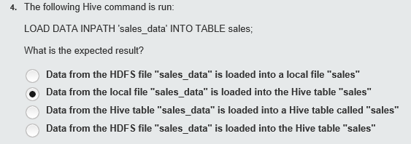



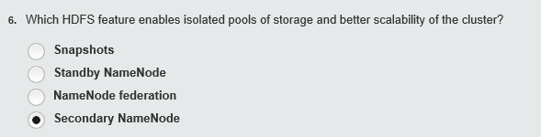















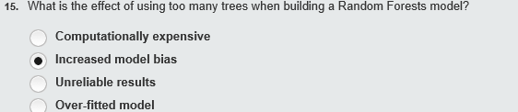

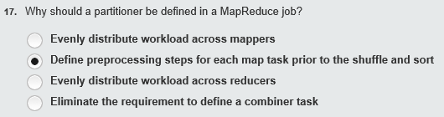

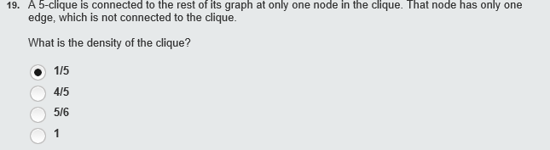

21



|  |  |  |  |  |
| --- | --- | --- | --- | --- |
| **26.**Which Hadoop File System shell command copies data from an HDFS directory to another HDFS directory?   |  | | --- | | **cp** | | **get** | | **put** | | **rm** | |

