Shri B.V.V. Sangha’s

BASAVESHWAR ENGINEERING COLLEGE, BAGALKOTE

[AICTE Approved, Government Aided Institution Affiliated To VTU, Belagavi]

DEPARTMENT OF COMPUTER SCIENCE & ENGINEERING
Mini-Project Report On
“Nutri Track”
Submitted in partial fulfillment of requirement for the award of the degree BACHELOR OF ENGINEERING In COMPUTER SCIENCE AND ENGINEERING 2024-2025

Project Guide Coordinator HOD Prof.J.S.Mulimani Prof.Basavaraj.Mallapur Dr.V.B.Pagi

Submitted by:

Yaseen Satakhed 2BA23CS124
Yateesh Mattur 2BA23CS125
Somashekhar Kadrolli 2BA23CS101
Praveen Nashi 2BA23CS071
Shri B.V.V. Sangha’s


BASAVESHWAR ENGINEERING COLLEGE, BAGALKOTE
[AICTE Approved, Government Aided Institution Affiliated To VTU, Belagavi]

Department of Computer Science and Engineering

CERTIFICATE
This is to certify that Yaseen S (2BA23CS124), Yateesh M (2B23CS125), Somashekhar K (2BA23CS101), Praveen N (2BA23CS071) has satisfactorily completed the mini project on “Nutri Track”, for partial fulfillment of their course in B.E. Computer Science and Engineering prescribed by Basaveshwar Engineering College, Bagalkote during the academic year 2024-2025.

Project Guide Coordinator HOD

Prof.J.S.Mulimani Prof.Basavaraj.M Dr.V.B.Pagi

Name of Examiners Signature of Examiner
1……………………. 1……………………….
2……………………. 2……………………….
3……………………. 3……………………….

DECLARATION

We are Yaseen.S (2BA23CS124),Yateesh.M (2BA23CS125),Somashekhar.K (2BA23CS101),Praveen .N (2BA23CS071), students of 5th semester BE in Computer science and Engineering of Basaveshwar Engineering College Bagalkot, hereby declare that the project work entitled "Nutri Track" submitted to the Visvesvaraya Technological University during the academic year 2025-26 is a record of an original work done by us under the guidance of Prof. J.S.Mulimani of Department of Computer Science and Engineering . This project work is submitted in partial fulfilment of the requirements for the award of the degree of Bachelor of Engineering in Computer science and Engineering. The results embodied in this thesis has not been submitted to any other University or Institute for the award of any degree.

Date: Yaseen.S

Place: Bagalkot Yateesh.M

Somashekhar.K
Praveen.N

ACKNOWLEDGEMENT
First and foremost, praises and thanks to the God, the Almighty, for his showers of blessings throughout our project work to complete the project successfully. We would like to express my deep and sincere gratitude to my project guide Prof. J.S.Mulimani and project coordinator Prof.Basawaraj.M for allowing us to do project work and providing valuable guidance throughout this project. Their dynamism, vision, sincerity, and motivation have deeply inspired us. They taught us the methodology to carry out the project and to present the project works as clearly as possible.
We are extremely grateful to our parents for their love, prayers, caring and sacrifices for educating and preparing us for our future.
We express our special thanks to Dr. B. R. Hiremath Principal, Basaveshwar Engineering College, Bagalkot and Dr. V. B. Pagi, Professor and Head of Department of Computer Science and Engineering for their genuine support throughout this project work. Finally, our thanks to all the people who have supported us directly and indirectly to carry out this project.

ABSTRACT
Nutri Track leverages a lightweight, user-friendly nutrition management system designed to help individuals track their daily dietary intake.. The primary aim of the application is to promote healthy eating habits by providing users with clear and organized information about the food they consume. Nutri Track allows users to add food items along with their calorie values, classify meals, and automatically compute the total calorie consumption for the day. The application stores data in the browser using local storage, enabling users to access their logs without needing a backend server.
The project incorporates essential web technologies such as HTML for structure, CSS for styling, and JavaScript for dynamic functionality. Through this system, users can update or delete incorrect entries, making the application flexible and easy to maintain. Nutri Track demonstrates fundamental concepts of front-end development, data handling, and user-interface design. Overall, the project provides a practical and efficient tool for health monitoring while showcasing the core principles of interactive web application development.

TABLE OF CONTENTS
Chapters Page No

1.Introduction 01

2. Problem Statement 02

2.1 Objectives

2.2 Limitations of Project

3. Literature Survey 03

4.Software Requirement 05

4.1 Front-End Requirements

4.2 Back-End Requirements

4.3 Software Libraries and Modules

5.Block Diagram 06

5.1 Start

5.2 Enter User Details

5.3 Validate Inputs

5.4 Calculate BMI

5.5 Calculate BMR

5.6 Calculate Total Daily Calorie Requirement

5.7 Adjust Calories Based on Goal

5.8 Fetch Nutrient Data from JSON Database

5.9 Generate Diet Plan

5.10 Generate Health Recommendations

5.11 Display Final Output

5.12 End

6. Implementation 10

6.1 Introduction

6.2 Frontend Implementation (HTML, CSS, JavaScript)

6.3 Backend Implementation (Python)

6.4 Food Database Implementation (JSON)

6.5 Diet Plan Generator

6.6 Health Recommendation

6.7 Output Generation

6.8 Storage Module

7. Results 15

7.1 Dashboard Page

7.2 Login Page

7.3 Dashboard

7.4 Nutrition Diet Plan Page

7.5 Health Information Page

7.6 Diet Plans

7.7 Plan Loss or Gain Page

7.8 Food Informaton Page

8. Conclusion 23

1.INTRODUCTION

- The Nutri Track is introduced because In recent years, maintaining a balanced diet and monitoring daily nutrition has become increasingly important due to rising lifestyle-related health issues. Many individuals struggle to keep track of what they eat, leading to problems such as overeating, nutrient deficiency, and unhealthy food habits. To address this challenge, digital tools and diet-tracking applications have become popular, offering simple ways to monitor calorie intake and improve overall health management.
- Nutri Track is a mini project developed with the aim of providing users a convenient, user-friendly platform to record and analyze their daily food consumption. The application enables users to enter food items, view their calorie values, and calculate their total calorie intake for the day. By continuously tracking this information, users can develop awareness of their eating patterns and make informed decisions about their diet.
- This Technically Nutri Track is built using fundamental front-end technologies such as HTML for webpage structure, CSS for styling and layout, and JavaScript for dynamic operations and data handling. The project does not rely on a complex backend or database; instead, it uses the browser’s local storage to save and retrieve user data. This makes the system lightweight, fast, and accessible, while still demonstrating practical implementation of essential web development concepts.
- The project showcases key aspects of user interface design, input validation, data management, and real-time calculation. Through Nutri Track, users can add new food items, edit or remove existing entries, and view an updated calorie count instantly. The simple design ensures that even beginners can use the system effortlessly. As a mini project, Nutri Track highlights the importance of integrating technology with personal health management and serves as a practical example of how web applications can be used to solve real-world problems.

2.Problem Statement

Nutri Track leverages a lightweight, user-friendly nutrition management system designed to help individuals to track their daily dietary intake.

2.1 Objectives:
    - To develop a simple and user-friendly nutrition tracking system that allows users to record their daily food intake easily.
    - To calculate and display the total calorie consumption based on the food items entered by the user.
    - To implement a lightweight web application using basic technologies like HTML, CSS, and JavaScript.

2.2 Limitations of Project:

- The Nutri Track project has several limitations. Since it uses only browser local storage, it does not provide strong data security or long-term reliability, and the stored information may be lost if the browser data is cleared or the user switches devices.
- The system can track only calorie values and does not include other important nutritional details such as proteins, fats, vitamins, or minerals.

The system uses browser local storage, which is neither secure nor reliable for long-term usage. Data may be lost if the browser cache is cleared or when switching devices, reducing overall data safety.

The application does not provide login or authentication features, restricting it to a single user. It cannot support multiple user profiles or cross-device access.

The system does not offer advanced analytics such as charts, recommendations, progress tracking, or detailed reports. It also works only in a web browser and does not support cloud backup or device synchronization, limiting accessibility and usability.

3.LITERATURE SURVEY
- Dietary self-monitoring (recording foods eaten and calories consumed) is a widely studied behavioral strategy for weight management. Multiple systematic reviews show that self-monitoring—whether low- or high-intensity—can support weight loss and improved diet awareness, though outcomes depend strongly on user adherence and how monitoring is implemented. These reviews conclude that better adherence to self-monitoring typically correlates with greater weight loss, but variability in study methods makes direct comparisons difficult.
- Commercial nutrition apps (for example, MyFitnessPal) demonstrate common practical features: large food databases, barcode scanning, meal logs, calorie and macronutrient summaries, goal setting, and integration with activity trackers. Such apps lower the effort of logging by providing searchable entries and automated tools, and they show how rich datasets and usability features can increase engagement. However, many popular apps are cloud-based, use freemium models, and require internet connectivity and account creation.
- Academic and usability studies emphasize two recurring themes: (1) user burden — manual entry is time-consuming and leads to incomplete or inaccurate logging, and (2) accuracy/usability tradeoffs — simpler logging methods (e.g., quick codes or image-based capture) reduce burden but can reduce precision or require more complex technology. Research exploring photo-based or AI-assisted logging finds promise for lowering entry burden, but also highlights challenges such as food segmentation, portion estimation, and participant privacy.
- Evaluations of smartphone food-diary apps and food-frequency tools show that different dietary assessment methods have different strengths: food diaries and 24-hour recalls can capture detailed intake but impose higher burden; questionnaires lower burden but miss contextual and temporal detail. Researchers therefore recommend balancing accuracy with usability, and exploring hybrid solutions (e.g., quick manual entries plus optional image or barcode support).
- Technical and ethical limitations noted in recent literature include: reliance on cloud storage and third-party databases (raising privacy and data portability issues), variable food database coverage (local/regional foods often missing), and dependency on internet connectivity or paid features for advanced functionality. Studies and reviews suggest that lightweight, offline-capable tools with clear privacy handling and simple UI can still be valuable—especially for educational orll-scale projects—while more advanced features (AI food recognition, multi-device sync) require extra development and testing.
- Gap & relevance for Nutri Track. The reviewed literature shows both the efficacy of dietary self-monitoring and the real usability problems that prevent sustained use (manual burden, lack of local food items, privacy concerns). Nutri Track’s focus on a simple, local (browser-storage) web app directly addresses educational use and low-resource contexts where cloud features, sign-up friction, or complex UIs are undesirable. At the same time, the literature suggests meaningful extensions you could consider later—such as adding barcode lookups, optional image capture, regional food entries, or secure cloud sync—to improve adherence and utility

4.Software Requirements

4.1 Front-End Requirements
- HTML – Used for structuring the web pages and user interface components.
- CSS– Used for styling the application, designing layouts, colors, fonts, and user interface enhancements.
- JavaScript – Used for client-side validation, dynamic page updates, DOM manipulation, and connecting the front-end with backend services.

4.2 Back-End Requirements
- Python 3.x
- Used as the backend server-side language.
- Handles processing of user data, routing, business logic, and interaction with stored JSON files.
- Facilitates reading, writing, and updating data through Python libraries.
- JSON (JavaScript Object Notation)
- Used as the data storage format for saving user information such as food items, calorie details, and logs.
- Lightweight, human-readable, and easily handled through Python’s built-in json module.
- Acts as a simple backend database alternative for this mini project.

4.3 Software Libraries and Modules
- Python json module – For encoding and decoding data into JSON format.
- Python HTTP modules (Flask/Django/Custom Server) – If you used Flask or Django, mention it:
Example: Flask framework used to build REST API endpoints.
- LocalStorage (Browser Storage) – For temporary caching of data on the client side (optional if used
5.BLOCK DIAGRAM
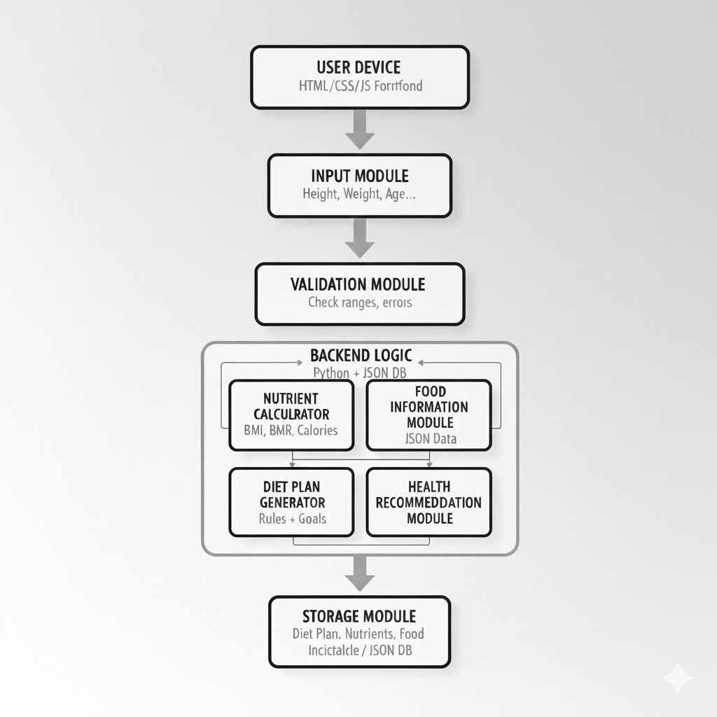

The flowchart represents the step-by-step working of the NutriTrack application, starting from userinput and ending with the personalized diet plan and health recommendations.

5.1 Start

The system begins when the user opens the NutriTrack application.

5.2 Enter User Details

The user provides the required personal information:

Height

Weight

Age

Gender

Activity level

Health goal (Weight loss, Gain, or Maintain)

This information is needed to compute calories and generate the diet plan.

5.3 Validate Inputs

The system checks all inputs:

Are fields empty?

Are values within the valid range?

Height (50–250 cm)

Weight (20–300 kg)

Age (5–100)

If any input is invalid → system displays an error and asks for correction.

5.4 Calculate BMI

The system converts height into meters and calculates BMI using:

BMI = Weight / (Height²)

This helps understand the user's weight categor

5.5 Calculate BMR

Using gender, age, height, and weight, the Basal Metabolic Rate is calculated:

Male: 10w + 6.25h – 5a + 5

Female: 10w + 6.25h – 5a – 161

This determines how many calories the body burns at rest.

5.6 Calculate Total Daily Calorie Requirement

The system multiplies the BMR by the user’s activity level to compute TDEE (Total Daily

Energy Expenditure).

5.7 Adjust Calories Based on Goal

Depending on the user's selected health goal:

Weight Loss: Reduce calories (−300 to −500 kcal)

Weight Gain: Increase calories (+200 to +300 kcal)

Maintenance: Keep calories equal to TDEE

This provides personalized calorie targets.

5.8 Fetch Nutrient Data from JSON Database

The system loads the food database stored as a JSON file.

Each food has:

Calories

Protein

Carbs

Fat

This data helps the diet generator create balanced meals.

5.9 Generate Diet Plan

The system constructs a full-day diet plan:

Breakfast

Lunch

Dinner

Snacks

5.10 Generate Health Recommendations

Based on BMI and calorie levels, the system provides:

Weight category (Underweight, Normal, Overweight, Obese)

Hydration tips

Exercise recommendations

Balanced diet suggestions

5.11 Display Final Output

The system displays:

BMI

BMR

Daily calorie requirement

Full diet plan

Food nutrients

Health tips

The output is shown on the user interface clearly and interactively.

5.12 End

The process ends once the results are shown, and the user can choose to re-enter values or exit the application.

6.Implementation
The implementation of the Nutri Track system involves developing a simple and interactive web-based application that allows users to track their daily food intake and monitor basic nutritional information. The project is implemented using HTML, CSS, and JavaScript, with each technology playing an important role in building the user interface and application logic.

6.1 Introduction
This chapter explains the actual implementation of the NutriTrack system. The implementation integrates the frontend interface, backend logic, JSON food database, nutrition calculation engine, and output generation modules. Each component plays a key role in taking user input and producing a personalized diet plan, nutrient information, and health insights.

6.2 Frontend Implementation (HTML, CSS, JavaScript)
The frontend was developed using HTML for structure, CSS for styling, and JavaScript for interaction.
The main tasks of the frontend are:
- Functions Implemented
- User input forms for height, weight, age, gender, activity level, and goals.
- Validation messages for incorrect or missing values.
- A dynamic display section for:
- BMI
- Daily calorie requirement
- Suggested diet plan

6.3 Backend Implementation (Python)
Python handles the core nutritional calculations and diet generation logic.
- Key backend tasks
- Receive data from frontend.
- Validate numeric ranges.

Compute:
- BMI
- BMR
- Daily Calorie Requirement (TDEE)
- Match calorie needs with food items from the JSON database.
- Generate personalized diet plan.

6.4 Food Database Implementation (JSON)
A JSON file is used to store nutritional values of food items.
Example: JSON structure
{
"banana": {
"calories": 89,
"protein": 1.1,
"fat": 0.3,
"carbs": 23
},
"rice": {
"calories": 130,
"protein": 2.4,
"carbs": 28
}}
How it works:
- Python loads the JSON file.
- Foods are selected based on calorie requirement.
- Balanced meals are auto-generated using rules.

6.5 Diet Plan Generator
This module creates breakfast, lunch, dinner, and snack plans depending on user goals:
Logic Implemented
- If goal = weight loss → reduce 15–20% calories
- If goal = weight gain → increase 15–20% calories
- If goal = maintain → equal to TDEE

6.6 Health Recommendation
This module checks BMI and creates health tips.
Examples of implemented rules
- BMI > 25 (Overweight) → Suggest low-carb diet, walking 30 min/day.
- BMI < 18.5 (Underweight) → Suggest high-protein foods.
- Low protein intake → Add protein-rich ingredients.
- Low hydration → Recommend water intake.

6.7 Output Generation
The output is displayed on the UI with:
Shows:
- BMI
- BMR
- Daily calorie requirement
- Full diet plan
- Food nutrient breakdown:
- Breakfast: Oats + Milk + Banana
- Lunch: Rice + Dal + Vegetables
- Dinner: Chapati + Salad + Paneer
- Snacks: Fruits / Nuts
- Water Intake: 3 liters/day

6.8 Storage Module
User data is stored using: LocalStorage (Frontend)
- Saves user profile
- Saves previous diet plans
- Stores food and nutrient data
- Easy to update and expand
Advantages of Nutri Track

- Layered Design: Clear separation of concerns between UI, logic, and storage.

- Real-Time Interaction: Updates display and calculations instantly.

- Data Persistence: Data remains intact across sessions using local Storage.

- Scalability: Can be extended with charts, diet suggestions, or backend integration.

- User-Friendly: Interactive interface ensures ease of use for all age group

7.Results
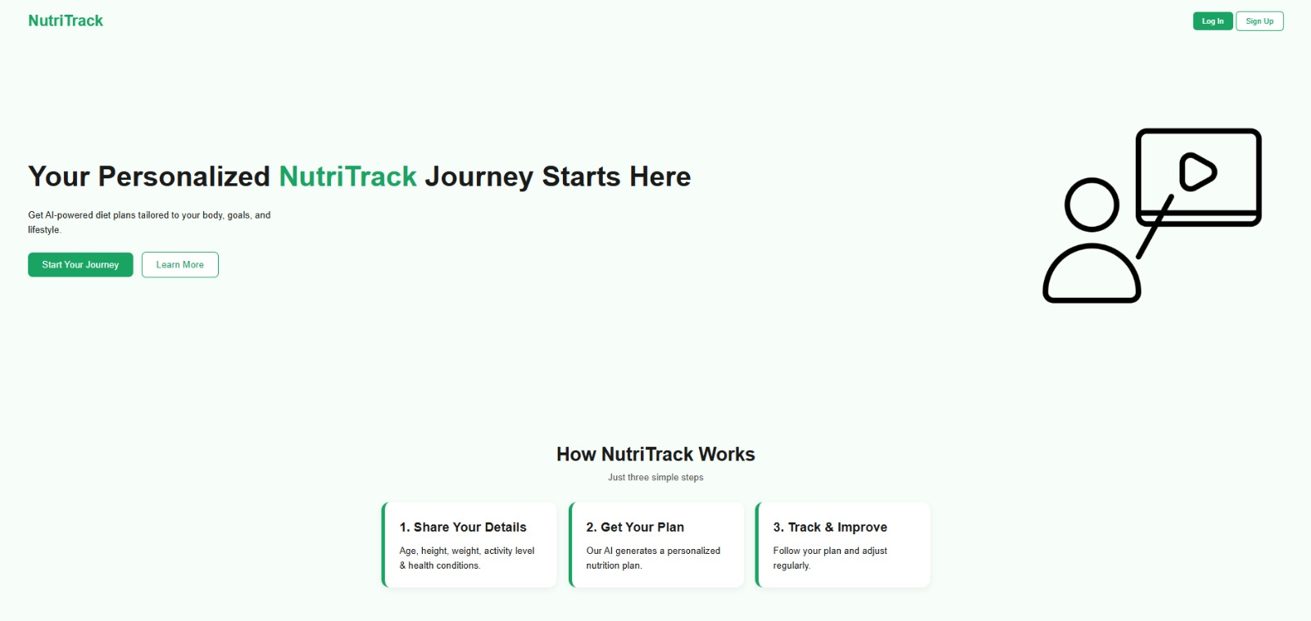
7.1 DASHBOARD PAGE

7.2 LOGIN PAGE

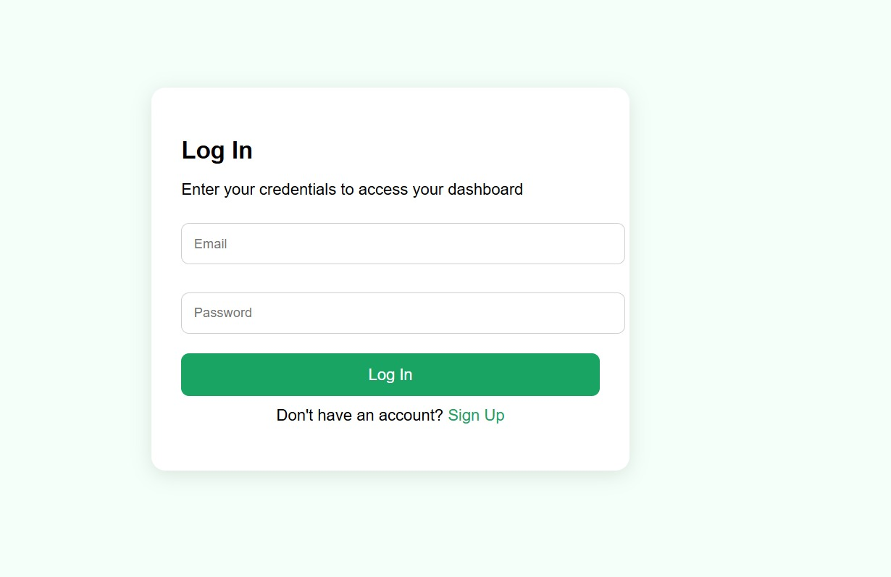
7.3 DASHBOARD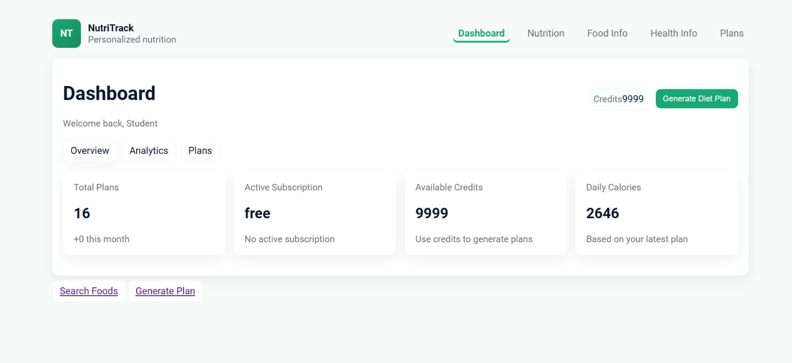

7.4 NUTRITION DIET PLAN PAGE
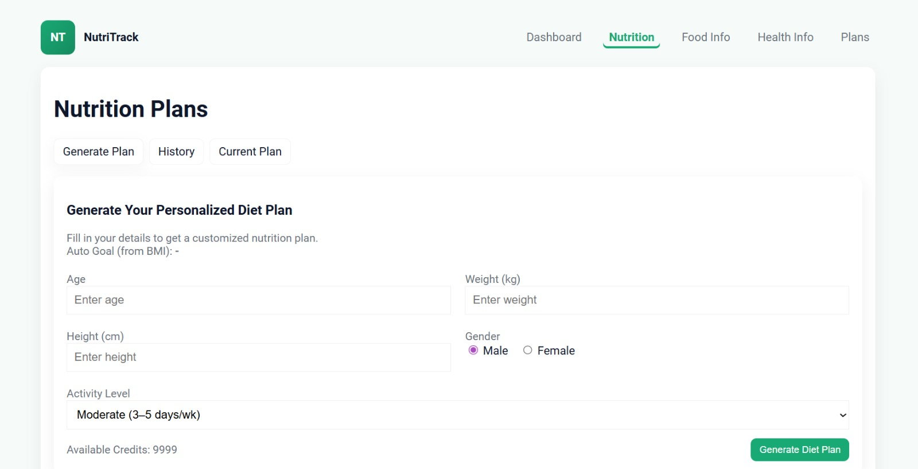

7.5 HEALTH INFORMATION PAGE
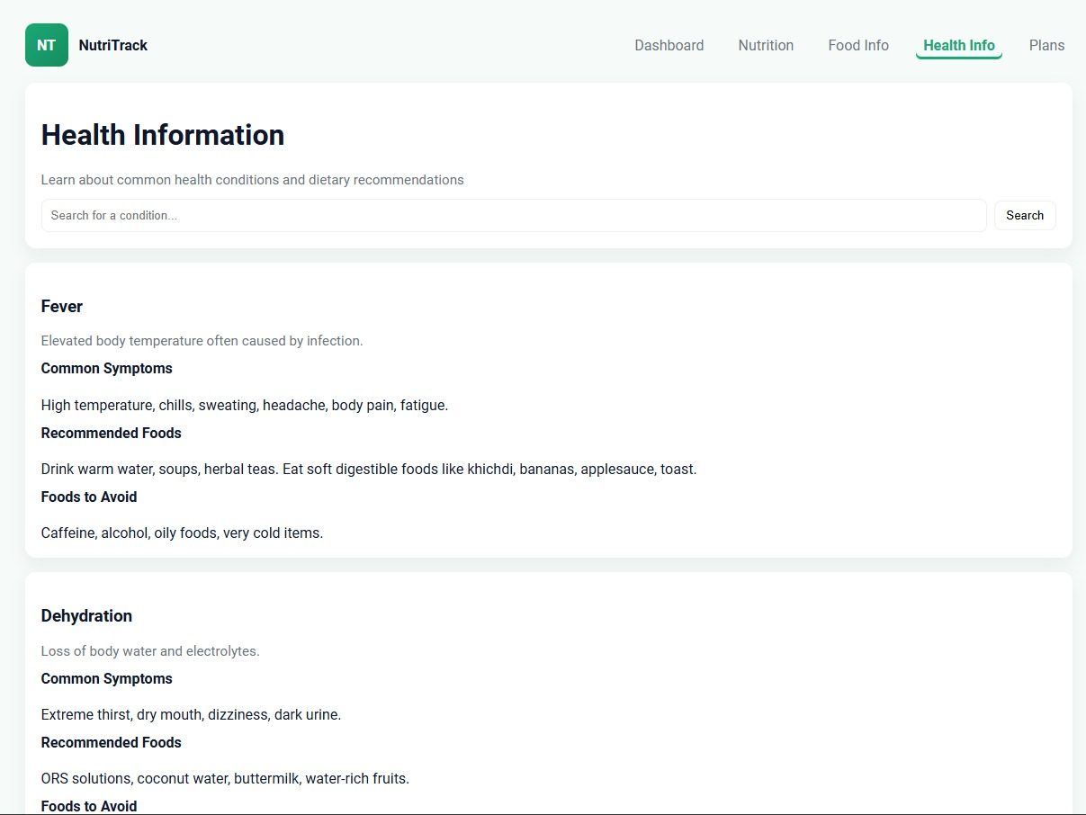

  - DIET PLANS
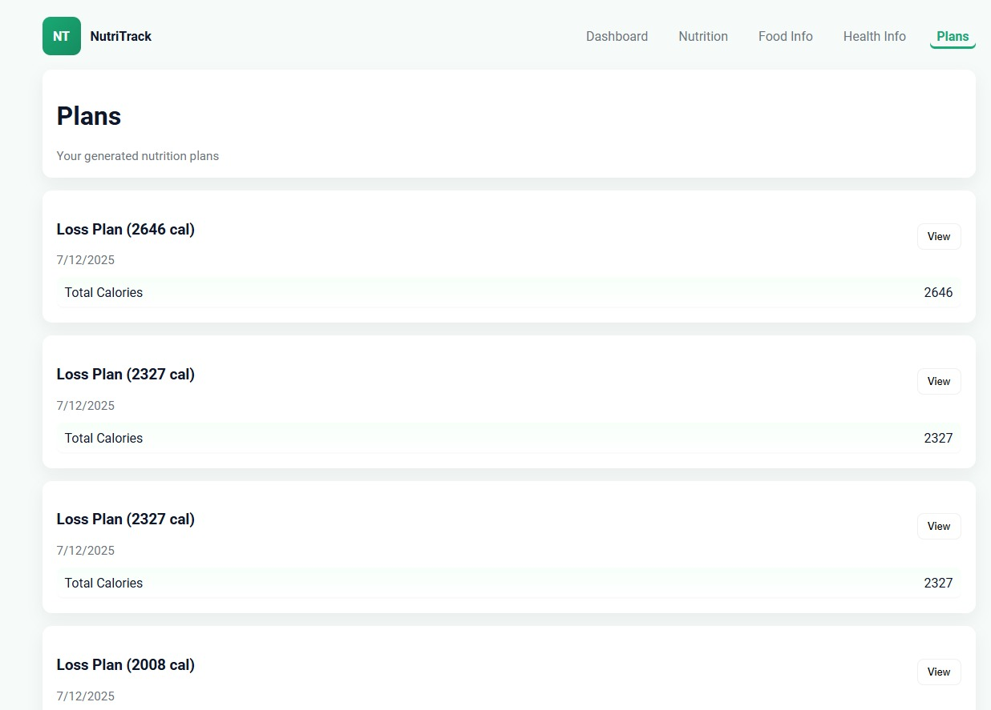

7.7 PLAN LOSS OR GAIN PAGE
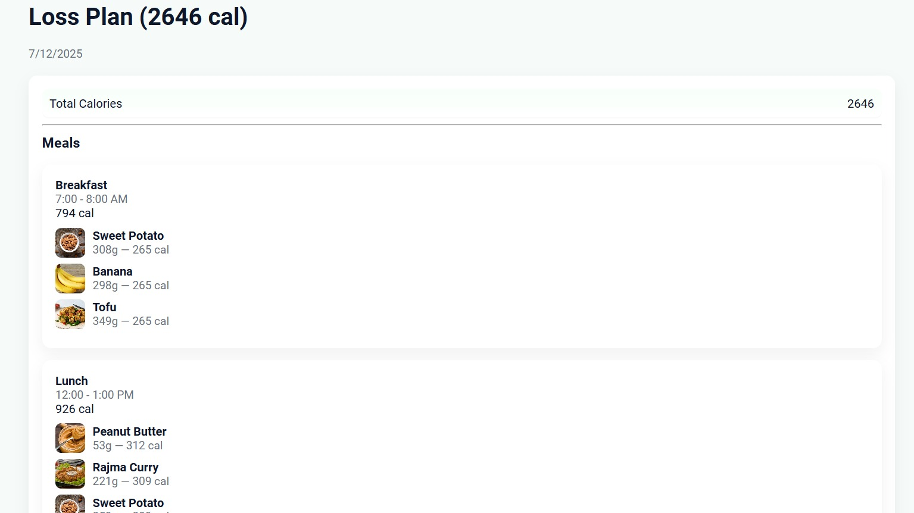

7.8 FOOD INFORMATON PAGE
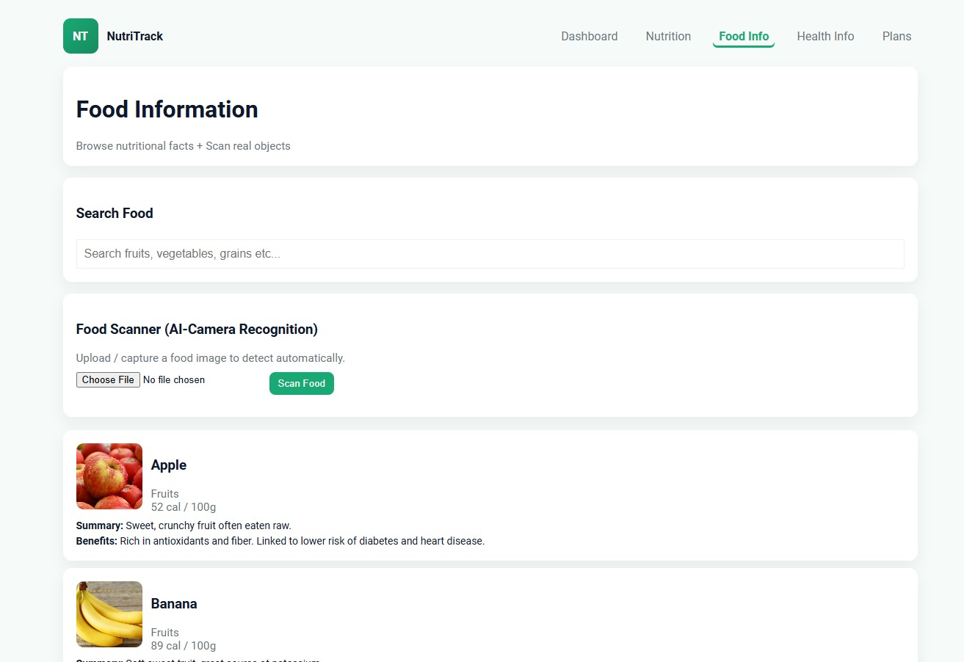

Conclusion
The Nutri Track Mini Project is a practical and web-based application designed to help users track their daily nutritional intake and manage their diet more effectively. The project successfully combines HTML, CSS, and JavaScript to provide a fully functional system that allows users to add, edit, and delete food items while calculating total calories in real time. By implementing local Storage, the application ensures data persistence, allowing users to retain their information even after refreshing the browser.

In terms of future improvements, the project can be enhanced by incorporating features such as:
A nutrient breakdown chart showing proteins, fats, and carbohydrates.
Daily or weekly diet recommendations based on user input.
Integration with a backend database for multi-user support and advanced analytics.
Mobile app adaptation for better portability and accessibility.

Overall, the Nutri Track Mini Project successfully achieves its objectives by providing a functional, reliable, and user-friendly platform for nutrition tracking. It demonstrates how small-scale applications can address real-world problems, encourageshealthy lifestyle habits, and provides hands-on experience in front-end web development. The project not only meets the functional requirements but also lays a strong foundation for further learning in software development and data management.

References

- World Health Organization. Body Mass Index (BMI) Classification. WHO, 2024.
- Centers for Disease Control and Prevention (CDC). Adult BMI Calculator and Guidelines. U.S. Department of Health & Human Services, 2023.
- National Institutes of Health (NIH). Dietary Guidelines for Americans 2020–2025.
- Harvard T.H. Chan School of Public Health. The Nutrition Source – Healthy Eating Plate. Harvard University, 2024.
- USDA. FoodData Central: Nutrient Database. United States Department of Agriculture, 2024.
- GeeksforGeeks. Python Dictionaries, JSON Handling, and File Operations.
- https://fdc.nal.usda.gov
- https://www.nutrition.gov
- https://nutritionsource.hsph.harvard.edu
- https://nutritionsource.hsph.harvard.edu
- https://www.eatright.org

