Bug Report - Shaadi.com Registration Flow
-by Dhruv Singh

Bug 1: Sign up form goes through even without ticking the T&C checkbox
What I found:
While filling out the registration form, I filled in all the fields correctly (Email, Password, Name, Gender, Date of Birth, Religion, Mother Tongue, Country) but purposely left the “I agree to the Privacy Policy and T&C” checkbox unticked, then clicked Submit. The form still went through like everything was fine.
Steps I did:
1. Go to the Shaadi.com registration page
2. Fill in all the required fields with valid data
3. Do NOT tick the “I agree to the Privacy Policy and T&C” checkbox
4. Click the Submit button
What should happen (Expected):
The system should not allow the form to submit and should show a message asking the user to accept the Privacy Policy and T&C first.
What actually happens (Actual):
The form gets submitted and the page moves forward even though the checkbox was never ticked. No validation message is shown.
How serious it is:
High - this is a compliance issue since accepting T&C is supposed to be compulsory before registering.
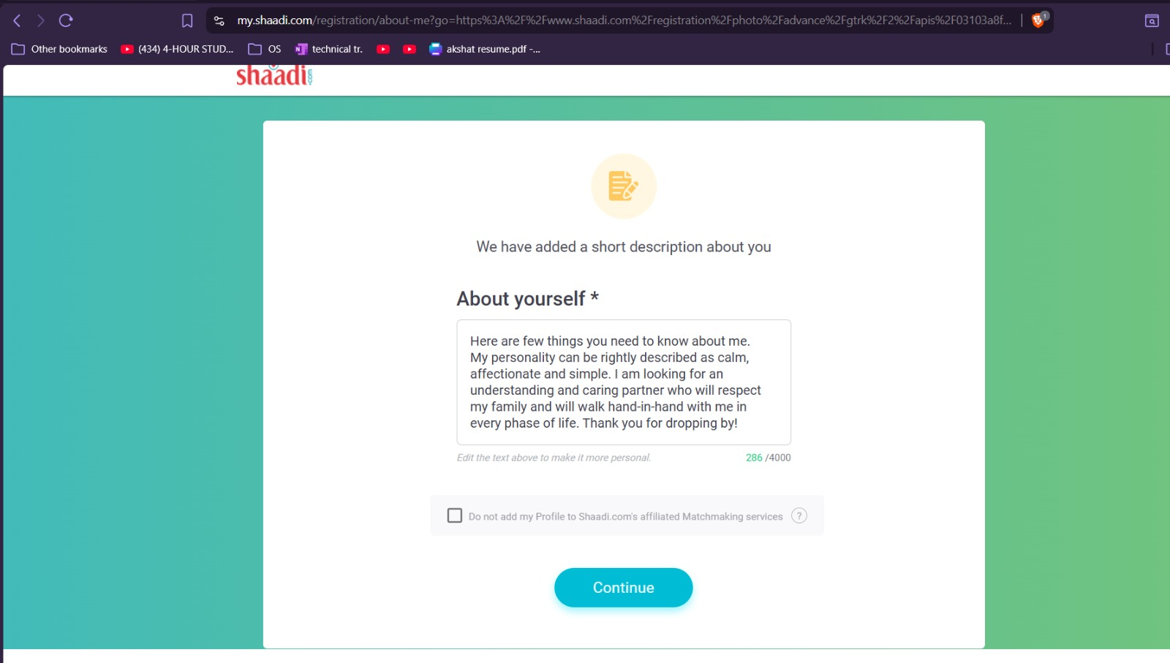

Bug 2: Month dropdown in Date of Birth doesn't show any values

What I found:
When filling the Date of Birth field, I clicked on the Month box to pick my birth month, but no list appeared. The box just stayed empty with nothing to select.
Steps I did:
1. Go to the Shaadi.com registration page
2. Scroll to the Date of Birth section
3. Click on the Month list box
What should happen (Expected):
Clicking the Month box should show a list of all 12 months (Jan-Dec) for the user to pick from.
What actually happens (Actual):
Nothing shows up when the Month box is clicked, so the user cannot select a month at all.
How serious it is:
Critical - the user cannot complete the Date of Birth field, which blocks the entire sign up.

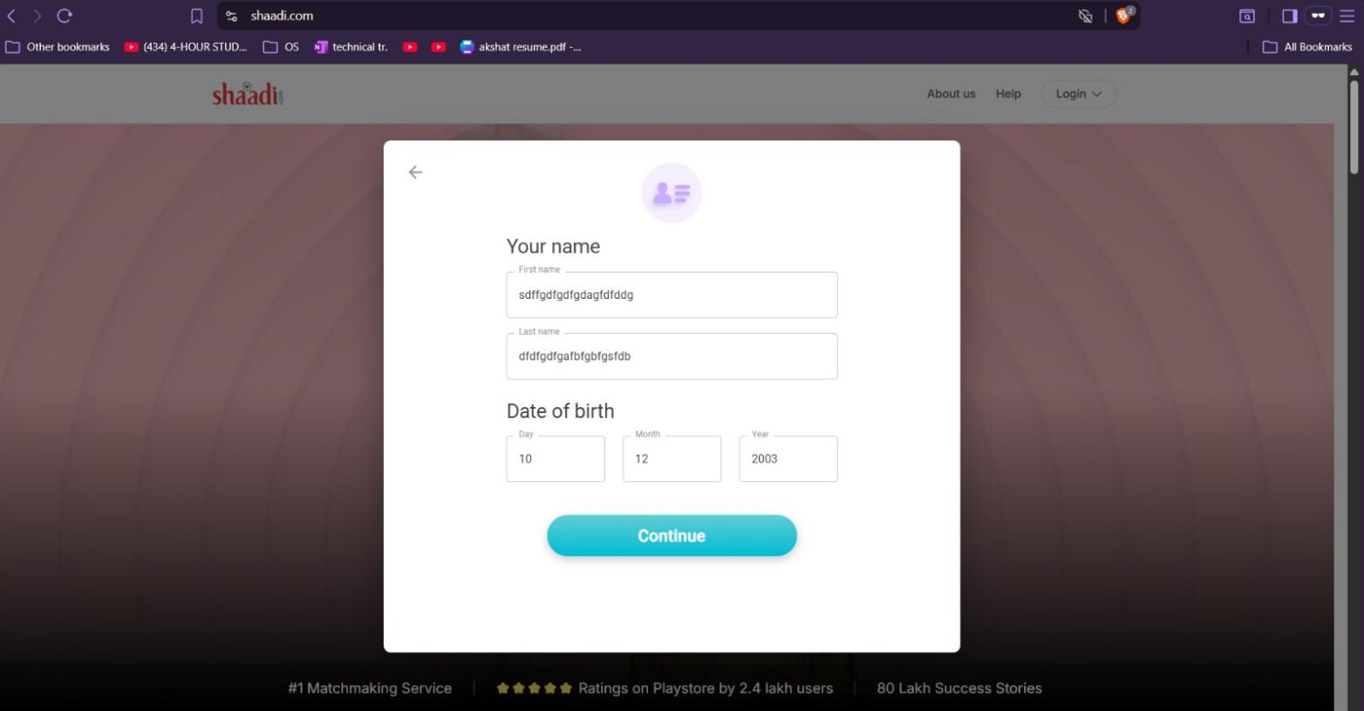

.

Bug 3: Continue button stays clickable even when Name fields are left empty

What I found:
On the registration page, I intentionally left both the First Name and Last Name fields empty without entering any values. Even though these fields are mandatory, the Continue button remained enabled and allowed me to proceed when clicked.
Steps I did:
1. Go to the Shaadi.com registration page
2. Leave the First Name and Last Name fields blank.
3. Fill the remaining required fields with valid information.
4. Click the Continue button.
What should happen (Expected):
The Continue button should remain disabled, or the system should display validation messages indicating that the Name fields are mandatory before allowing the user to proceed.
What actually happens (Actual):
The Continue button stays active even when the Name fields are empty, allowing the user to attempt to move to the next step without completing the required information.
How serious it is:
High – Mandatory fields are not properly validated, which can result in incomplete or invalid user profiles being submitted and negatively impact data quality.

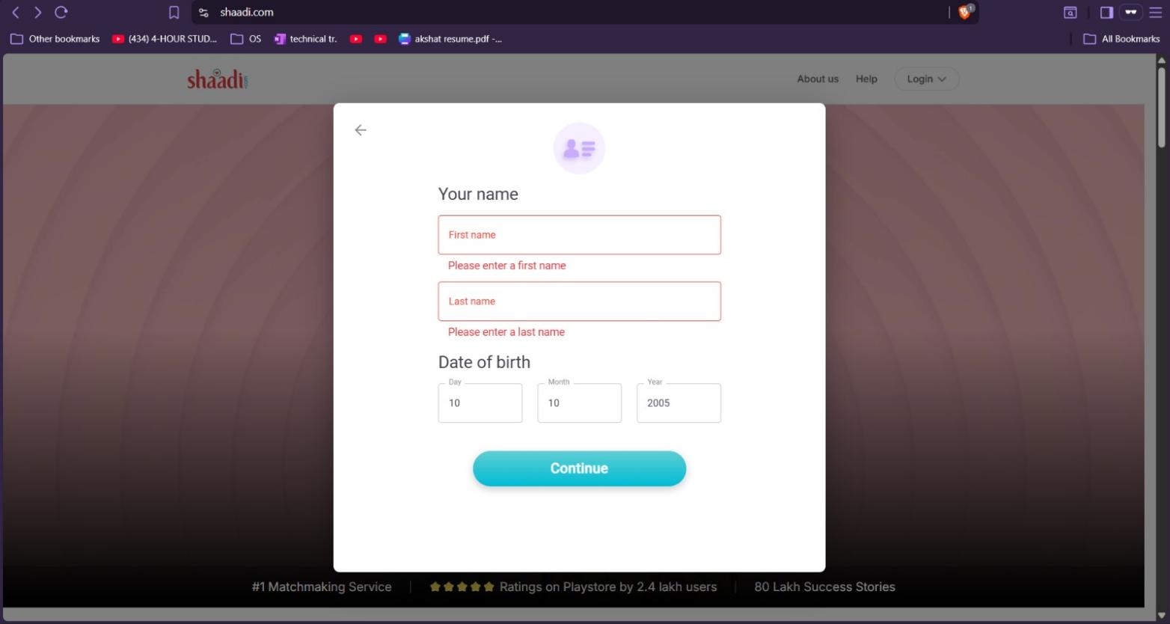

Bug 4: Email field accepts an obviously wrong email format
What I found:
In the Email field, I typed a value that clearly isn't a valid email (missing the domain part after the @ symbol) just to see what would happen, and the system accepted it without complaint.
Steps I did:
1. Go to the Shaadi.com registration page
2. In the Email field, type an invalid value such as “testuser@ggh.com” (any domain after the @)
3. Fill the rest of the fields correctly
4. Click Submit
What should happen (Expected):
The system should check that the email is in a proper format (e.g., name@domain.com) and show an error if it isn't.
What actually happens (Actual):
The invalid email is accepted with no error message and the form proceeds as if it were a valid address.
How serious it is:
Medium - can let junk/unusable emails get registered, which will cause problems later with login and password recovery.

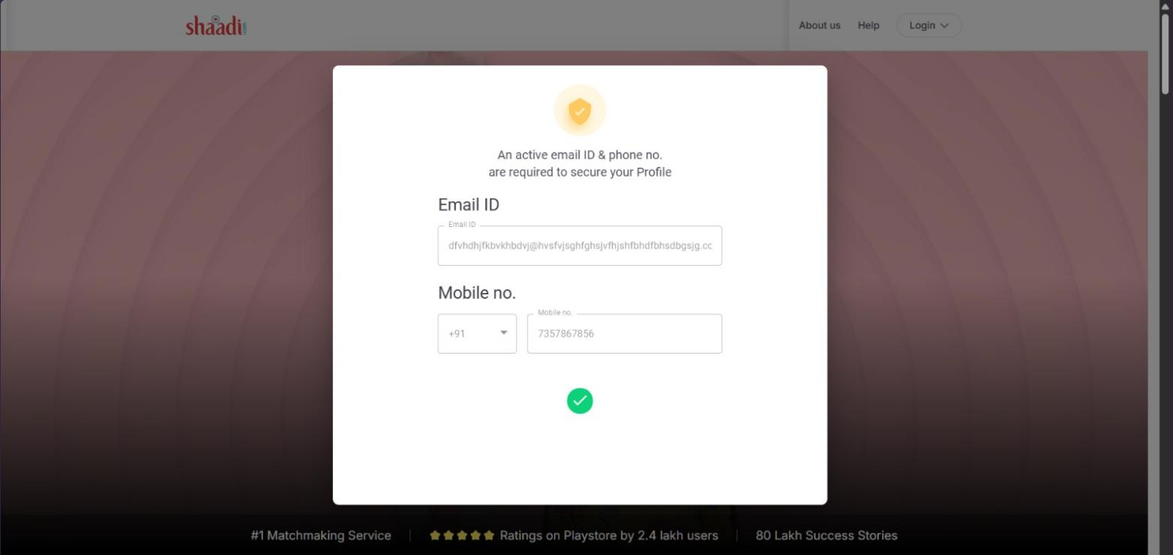

Bug 5: No visible maximum length restriction on Email field

What I found:
While testing the Email ID field, I entered an extremely long email address with a large number of characters before the @ symbol. The application accepted the entire input without displaying any warning or restricting the character length
Steps I did:
- Go to the Shaadi.com registration page.
- Navigate to the Email ID & Mobile Number section.
- Enter an excessively long email address (e.g.,a very long string of characters followed by @gmail.com).
- Fill the remaining details correctly and click the Submit/Continue button.
What should happen (Expected):
The Email field should enforce a reasonable maximum character limit and display a validation message if the entered email exceeds the allowed length.
What actually happens (Actual):
The application accepts the excessively long email address without any validation or warning, allowing the user to proceed normally.
How serious it is:
Medium – Accepting unusually long email addresses can lead to unnecessary database storage, validation inconsistencies, and potential issues with email processing in the backend.

