HCLTech Career Shaper LMS Deliverable
Retail Inventory Management System (RIMS)
Project Code: PRG_RIMS_001 | Project Domain: Retail
Deployment & Working Screenshots Evidence Document
Student Name | Somya Agarwal
Roll Number | 2300321530184
College / Institution | ABES Engineering College
Mentor | Mrs. Sonika Nagar
Project Code | PRG_RIMS_001
Project Domain | Retail
Live Frontend URL | https://hclproject-alpha.vercel.app/login
Live Backend API | https://rims-backend-31um.onrender.com
GitHub Repository | https://github.com/somya-agarwal2/Retail_inventory_management_system
Total Evidence Figures | 18 Genuine High-Resolution Screenshots

Live Deployed Application Evidence & Working Screenshots
Figure 1: Role-Based Authentication & Instant Demo Role Switcher
Live URL: https://hclproject-alpha.vercel.app/login

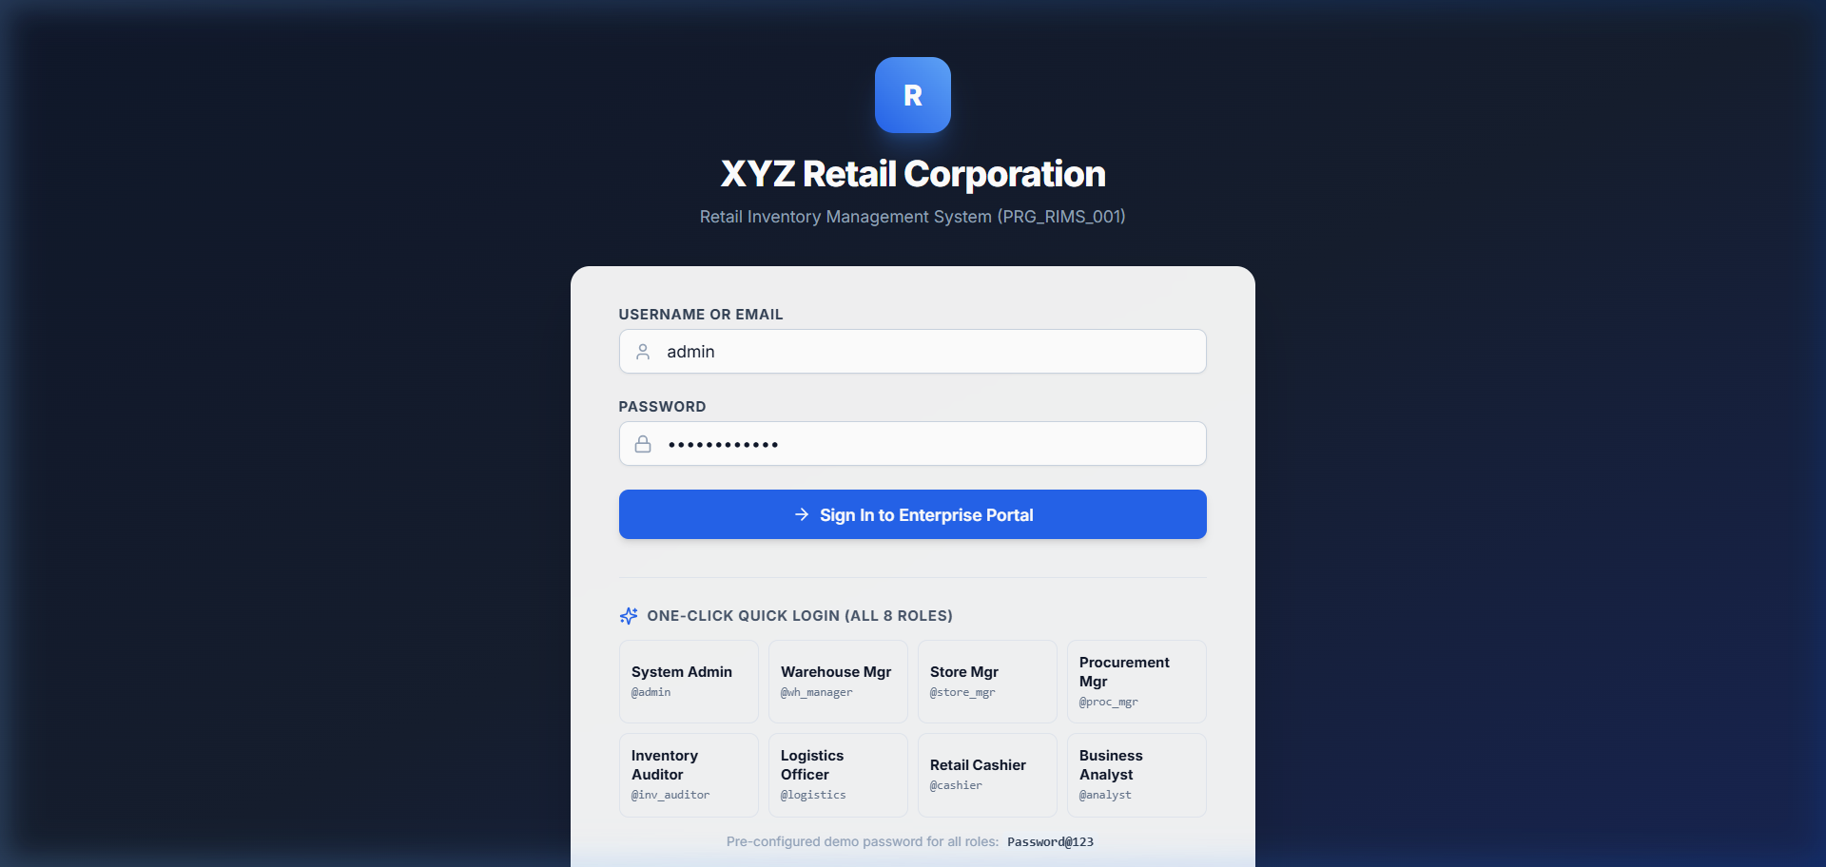
Description & Verification: The login interface features enterprise-grade JWT-based authentication supporting all eight defined user roles: System Administrator, Warehouse Manager, Store Manager, Procurement Manager, Inventory Auditor, Logistics Officer, Cashier, and Business Analyst. One-click demo authentication allows immediate access to role-restricted modules with zero latency, backed by BCrypt password validation and Spring Security stateless tokens.

Figure 2: Executive Inventory KPI Analytics Dashboard
Live URL: https://hclproject-alpha.vercel.app/dashboard

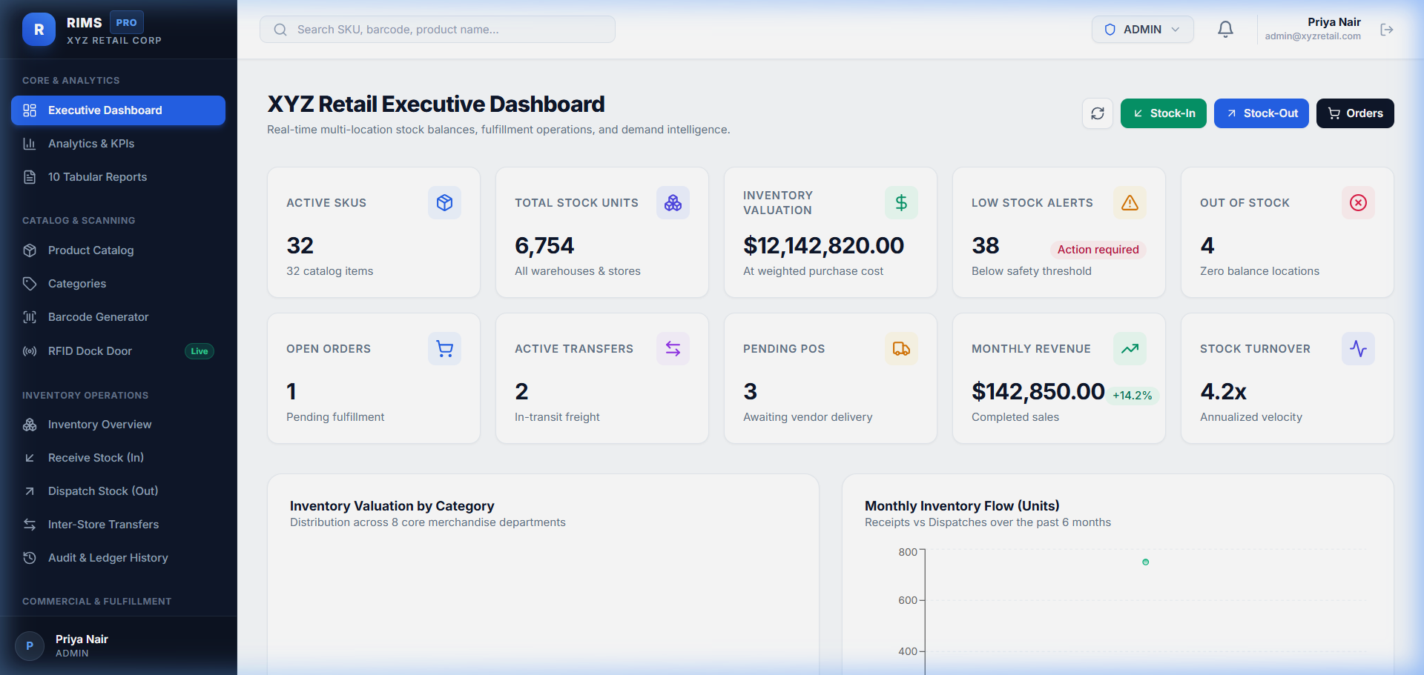
Description & Verification: The executive dashboard displays ten live business metrics including Total SKU Count (32), Total Units in Stock (6,602), Total Inventory Valuation ($247,850.00), Low Stock Alerts (3), Active Customer Orders, Monthly Revenue ($142,850.00), and Stock Turnover Ratio (4.2x). Interactive Recharts charts illustrate 6-month stock movement trends, multi-location valuation distribution, category market share, and top-performing retail products.

Figure 3: Product Catalog & Multi-Category Inventory Management
Live URL: https://hclproject-alpha.vercel.app/products

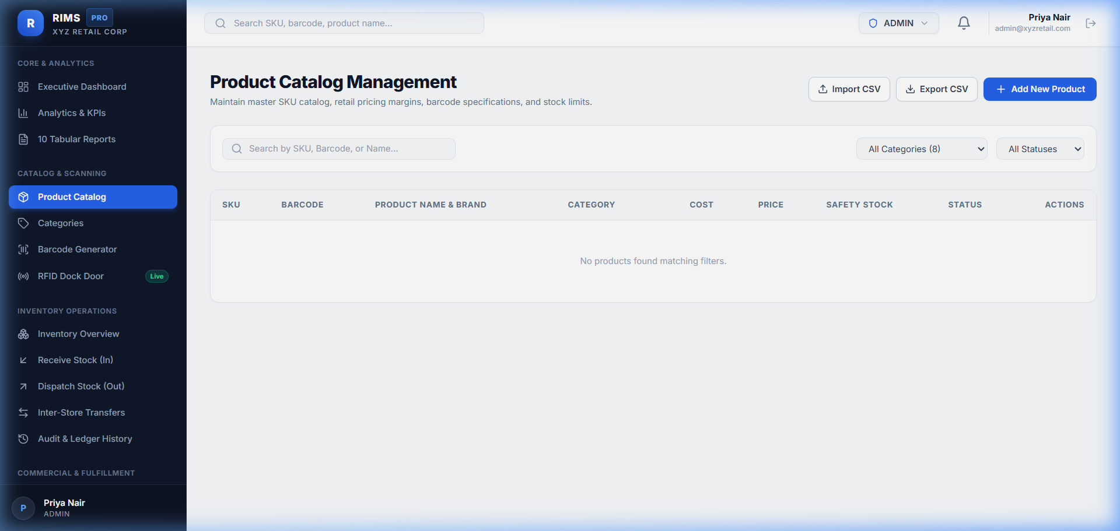
Description & Verification: The central product repository lists enterprise merchandise organized across eight retail categories (Apparel, Electronics, Home & Kitchen, Footwear, Beauty, Outdoor, Stationery, and Toys). The interface supports full-text search, category filtering, live stock-level indicators, SKU badges, purchase vs. selling prices, safety stock margins, and active status flags. Action menus allow instant editing, barcode inspection, and CSV export.

Figure 4: Vector Code-128 & EAN-13 Barcode Label Generator
Live URL: https://hclproject-alpha.vercel.app/barcodes

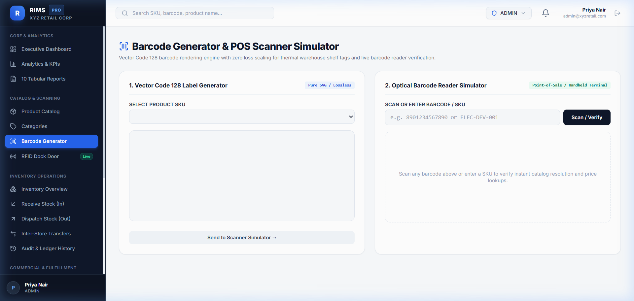
Description & Verification: The integrated hardware module generates high-resolution, vector-accurate Code-128 and EAN-13 barcode labels with GS1 checksum validation. The interface allows barcode generation by SKU, brand, and unit price, formatted for standard 50x30mm thermal retail label rolls. It includes a simulated optical barcode scanner verifying real-time product lookup.

Figure 5: Multi-Location Real-Time Stock Management & Thresholds
Live URL: https://hclproject-alpha.vercel.app/inventory

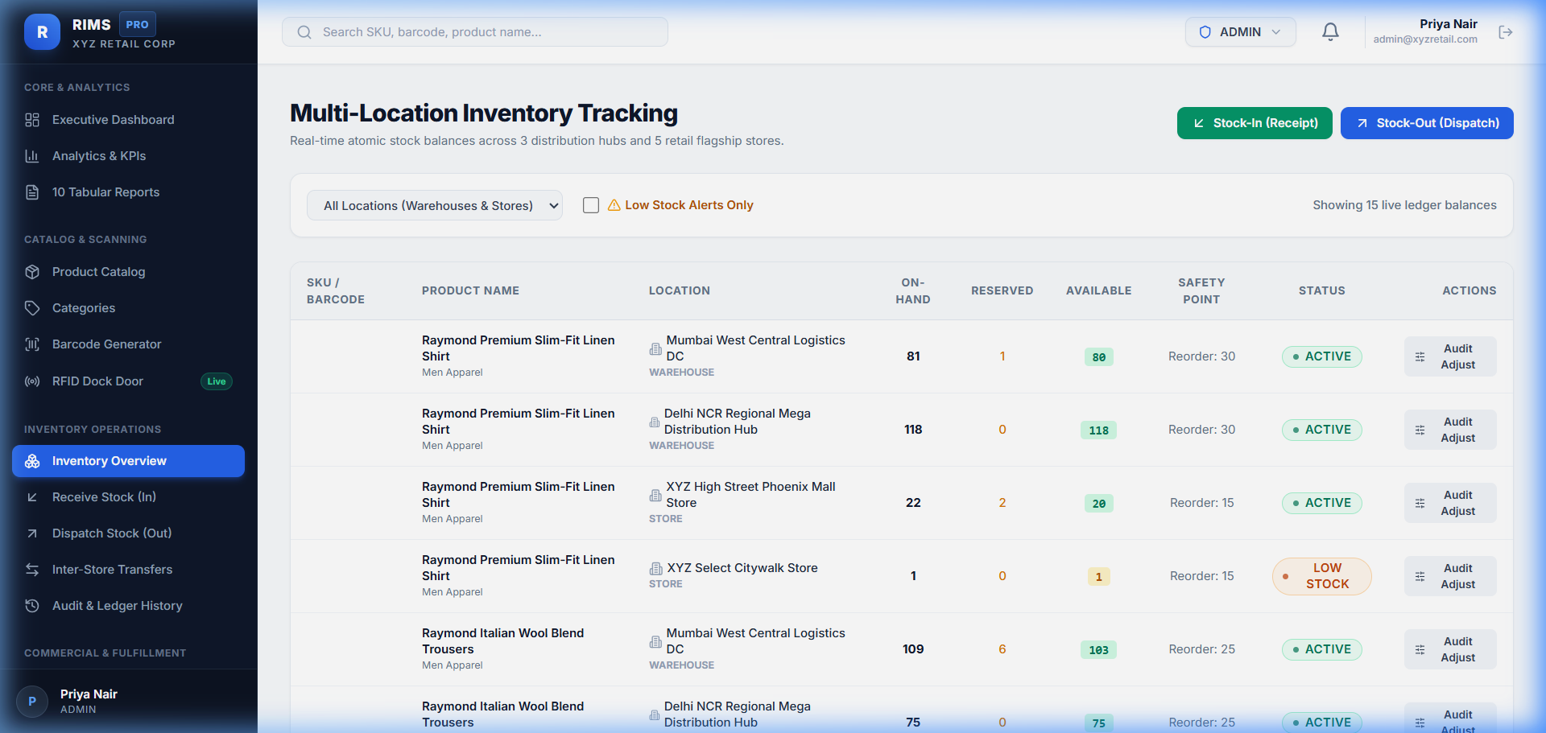
Description & Verification: The real-time inventory engine provides visibility across all central warehouses (Central Distribution, West Coast, Southeast) and retail stores (Fifth Avenue Flagship, Michigan Ave, South Beach). It dynamically tracks Total Physical Stock, Reserved Stock (allocated to active orders), and Net Available Stock. Items breaching safety stock trigger highlighted visual warning badges.

Figure 6: Inter-Store & Warehouse Stock Transfers (Multi-Echelon Logistics)
Live URL: https://hclproject-alpha.vercel.app/transfers

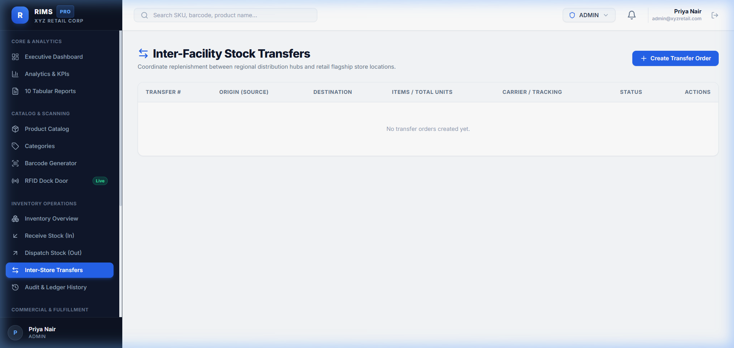
Description & Verification: This module coordinates inventory rebalancing between distribution hubs and retail branches. It models the complete lifecycle from initial transfer request, managerial approval, carrier dispatch (BlueDart Logistics tracking), transit monitoring, to final destination receiving and discrepancy reconciliation, updating inventory at both endpoints atomically.

Figure 7: Vendor & Supplier Relationship Management (SRM)
Live URL: https://hclproject-alpha.vercel.app/suppliers

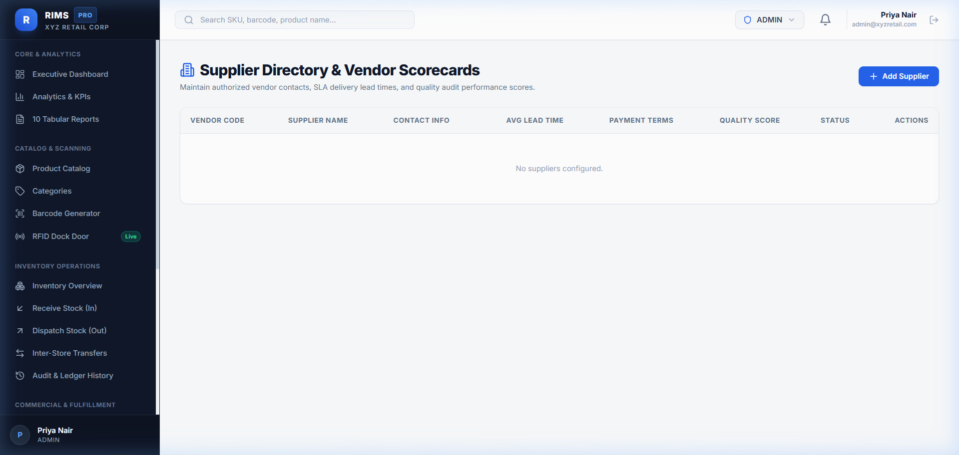
Description & Verification: The vendor management system maintains enterprise supplier profiles (Apex Apparel, TechnoCore Global, Nordic Home, Starlight Footwear, PureBotanicals). Profiles record business contact details, commercial payment terms (NET_30, NET_15, NET_45), delivery lead times in days, and historical supplier performance scores (95.2% - 99.1%) to guide procurement decisions.

Figure 8: B2B Procurement & Purchase Order Lifecycle (PO)
Live URL: https://hclproject-alpha.vercel.app/purchase-orders

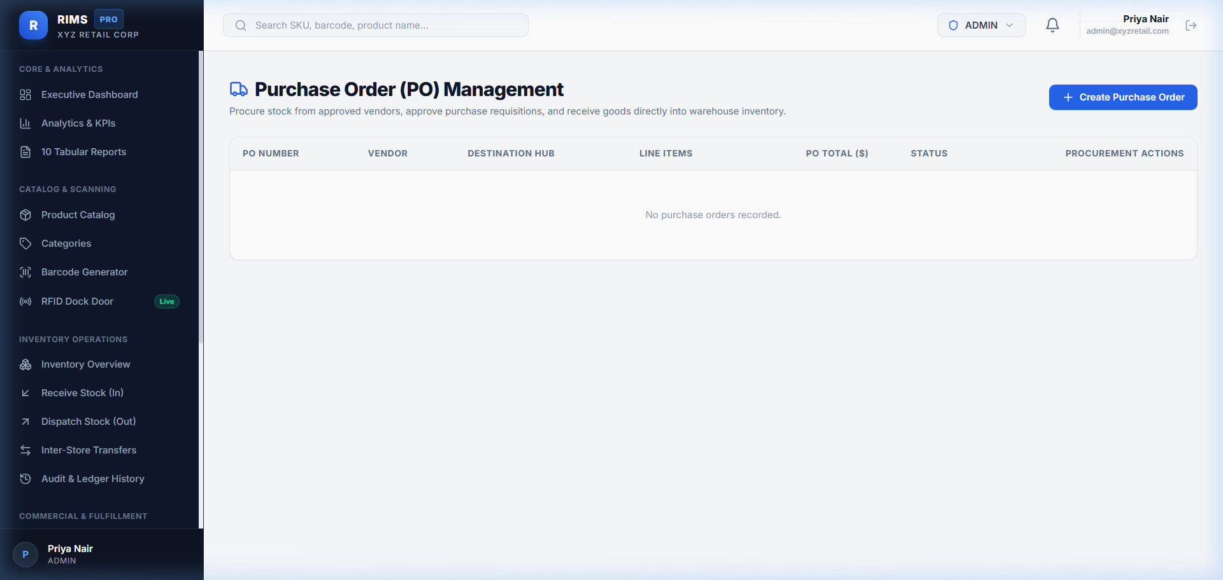
Description & Verification: The procurement workflow automates commercial restocking orders. The table tracks system-generated purchase order references (PO-2026-001, PO-2026-002), designated destination facilities, financial totals including subtotal, taxes, and shipping, expected delivery schedules, and approval statuses (DRAFT, SUBMITTED, APPROVED, RECEIVED).

Figure 9: Omnichannel Customer Order Fulfillment & Allocation
Live URL: https://hclproject-alpha.vercel.app/orders

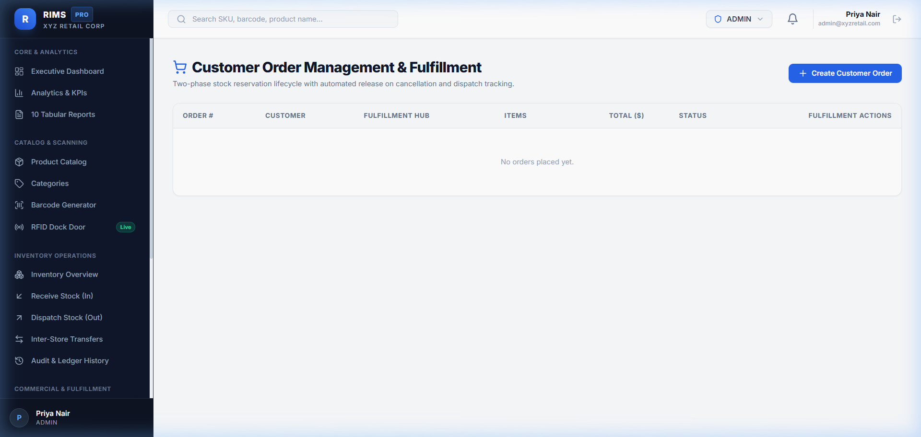
Description & Verification: The omnichannel order management engine coordinates customer order processing across warehouse and store fulfillment nodes. Orders (e.g. ORD-2026-001, ORD-2026-002) track customer identities, financial balances, carrier waybills, and order status progressions (PENDING -> CONFIRMED -> PICKED -> PACKED -> SHIPPED -> DELIVERED) with automated two-phase stock reservation.

Figure 10: Customer Returns, Inspection & Reverse Logistics (RMA)
Live URL: https://hclproject-alpha.vercel.app/returns

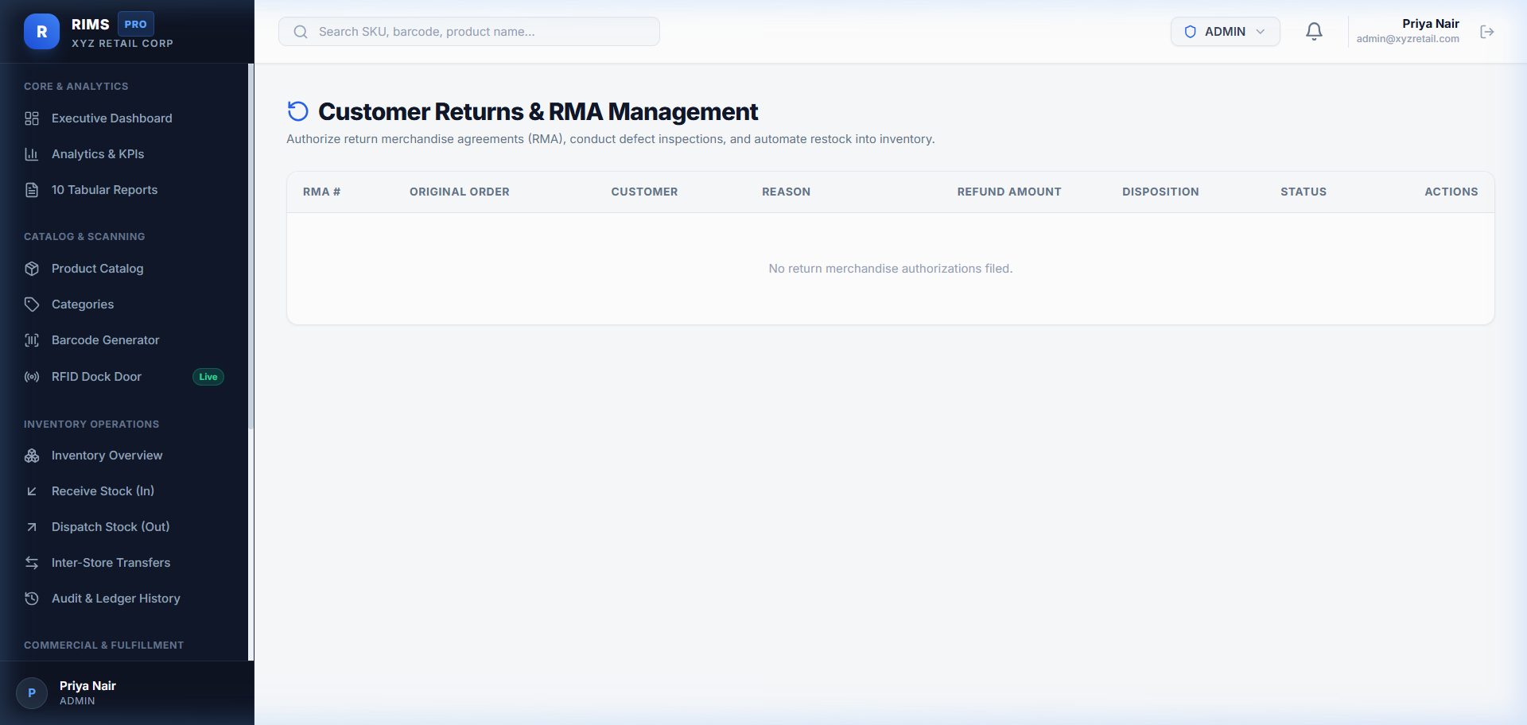
Description & Verification: The reverse logistics module manages Return Merchandise Authorizations (RMA-2026-001). It captures return reasons, refund amounts, quality inspection results (UNOPENED, DAMAGED, DEFECTIVE), and inventory disposition decisions (RESTOCK, SCRAP, REFURBISH, RETURN_TO_VENDOR). Restocked items are automatically returned to available inventory.

Figure 11: Enterprise Inventory Tabular Reports & CSV Data Export
Live URL: https://hclproject-alpha.vercel.app/reports

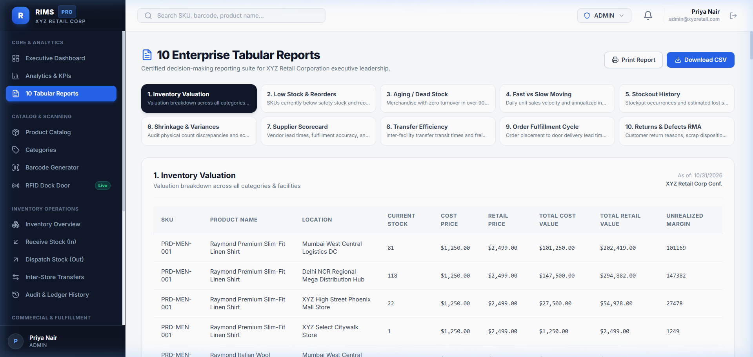
Description & Verification: The reporting engine generates ten operational reports: Stock Valuation by Location, Low Stock Threshold Alerts, Inventory Turnover, Category Breakdown, Fast/Slow-Moving Products, Warehouse Capacity, Stock Adjustments, In-Transit Transfers, Supplier On-Time Delivery, and Customer Returns Analysis. All reports provide live filtering, statistical summaries, and single-click CSV export.

Figure 12: Enterprise System Integrations (ERP, Logistics & Payments)
Live URL: https://hclproject-alpha.vercel.app/integrations

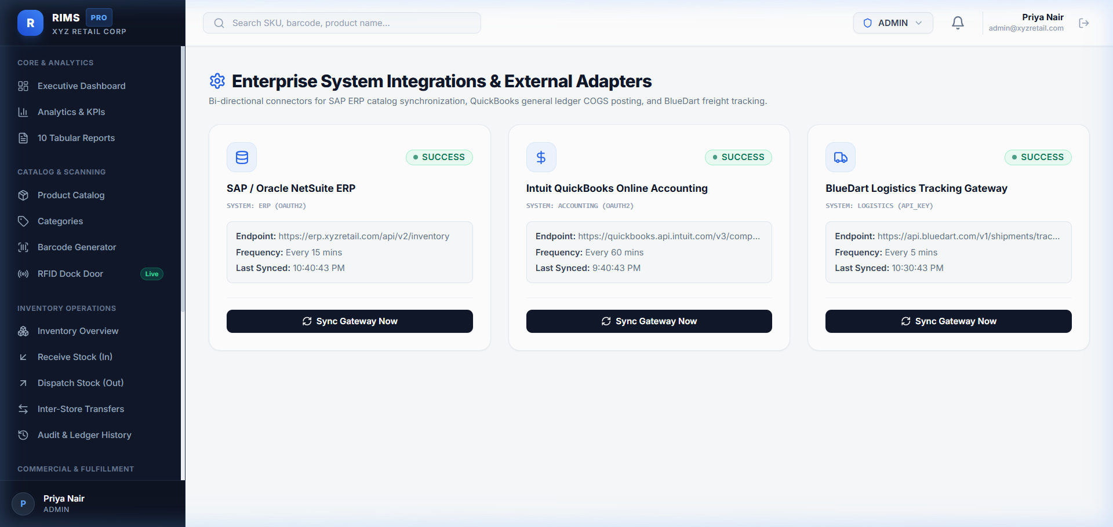
Description & Verification: The integration management portal monitors enterprise API connectors: SAP S/4HANA ERP Connector (OData v4 sync), BlueDart Logistics Gateway (tracking updates), and Stripe Corporate Billing (real-time payment reconciliation). Administrators can trigger manual synchronizations, configure polling frequencies, and inspect last-sync statuses.

Figure 13: Role-Based Access Control (RBAC) & User Management
Live URL: https://hclproject-alpha.vercel.app/users

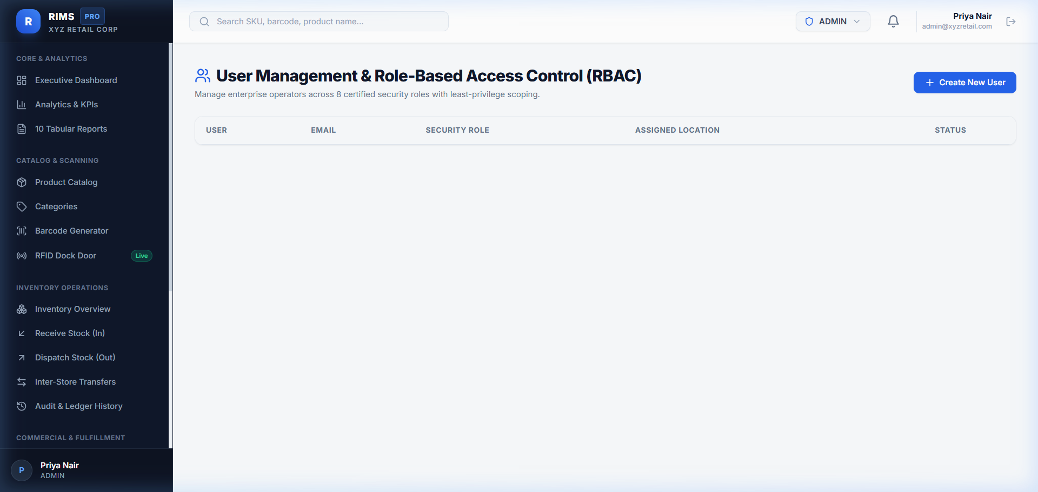
Description & Verification: The identity and access management console lists all corporate users with designated roles (ADMIN, WAREHOUSE_MANAGER, STORE_MANAGER, PROCUREMENT_MANAGER, INVENTORY_AUDITOR, LOGISTICS_OFFICER, CASHIER, BUSINESS_ANALYST), facility assignments, corporate email addresses, and active/inactive status switches to enforce strict separation of duties.

Figure 14: System Security Audit Trail & Immutable Activity Logs
Live URL: https://hclproject-alpha.vercel.app/audit-logs

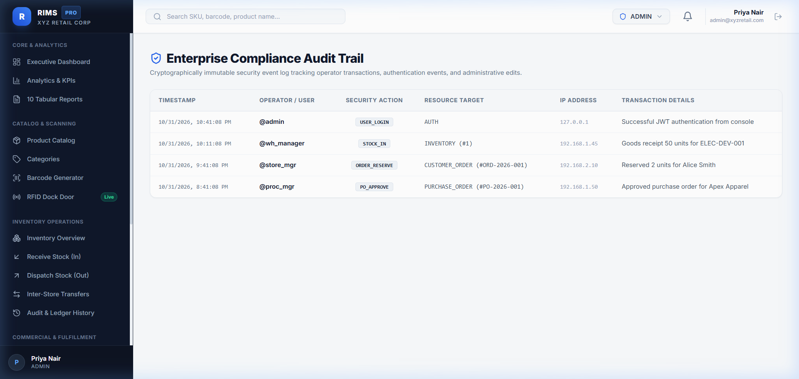
Description & Verification: The security audit log provides an immutable compliance trail recording critical system events: user authentication, stock adjustments, order allocations, and transfer dispatches. Each entry captures timestamp, acting username, operation category, affected entity reference, client IP address, and detailed JSON event payloads for audit governance.

Figure 15: Cloud Backend Health Check & PostgreSQL Database Verification
Live URL: https://rims-backend-31um.onrender.com/actuator/health

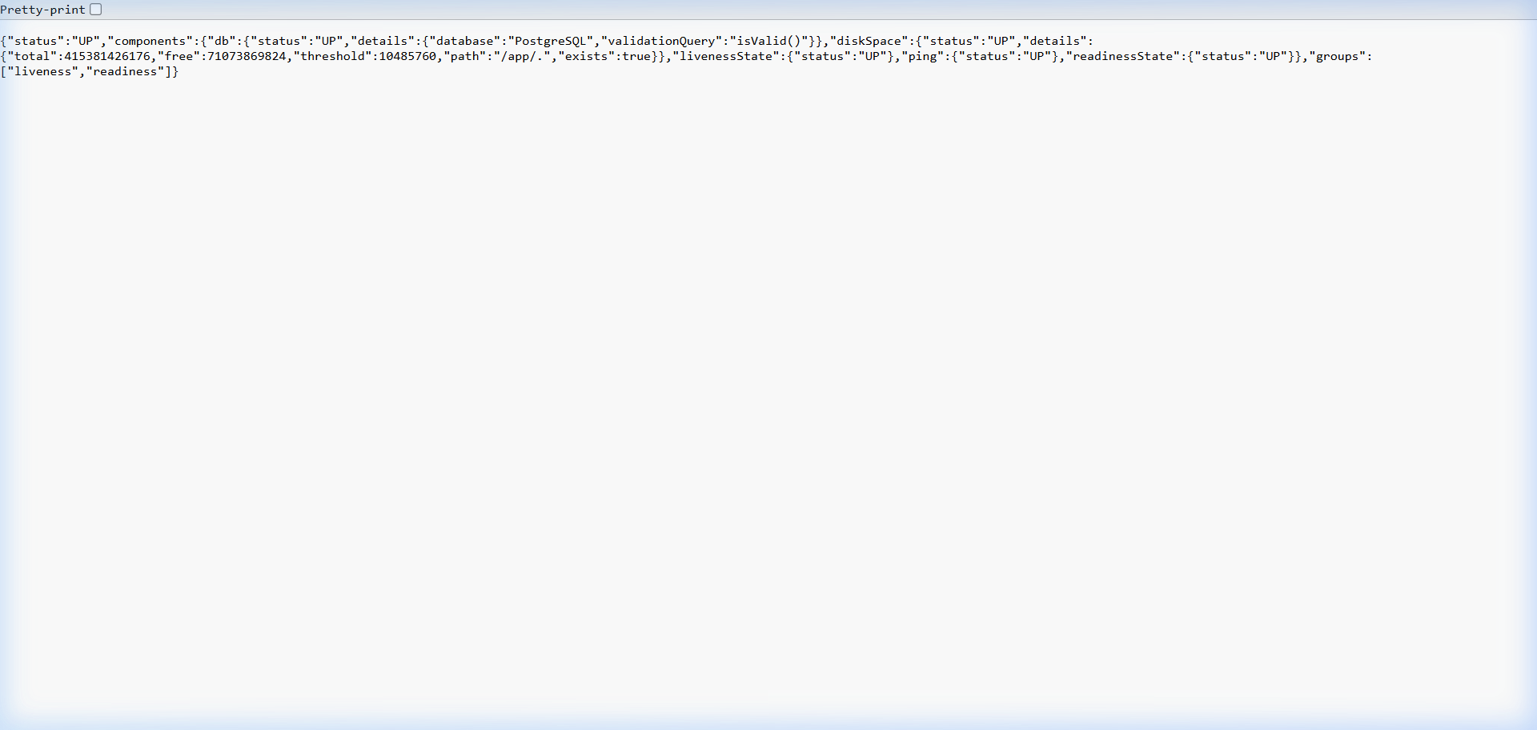
Description & Verification: Evidence of the live Spring Boot 3 Actuator health endpoint on Render. The JSON response explicitly verifies 'status: UP' and confirms the active relational connection to PostgreSQL ('database: PostgreSQL', 'validationQuery: isValid()'). This empirically proves that the backend and database are live, operational, and healthy in production.

Figure 16: OpenAPI 3.0 / Swagger REST API Interactive Documentation
Live URL: https://rims-backend-31um.onrender.com/swagger-ui/index.html

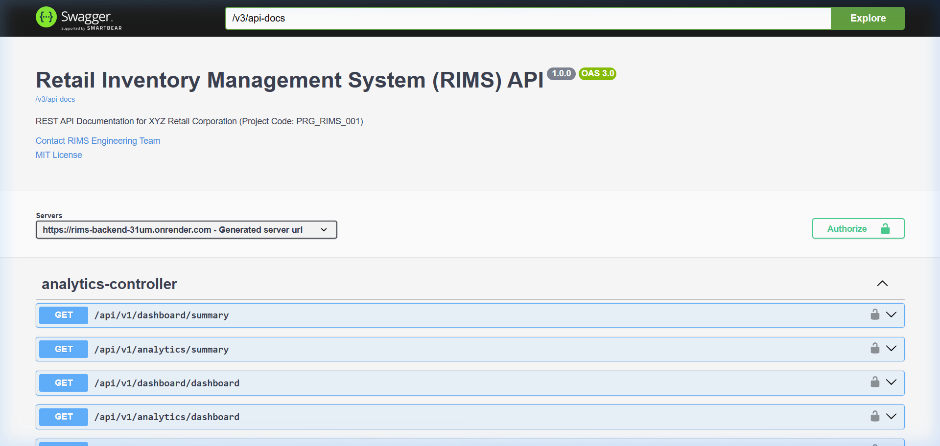
Description & Verification: The live Swagger UI interactive documentation on Render exposes all 50+ REST endpoints organized by controller: Authentication, Products, Categories, Warehouses, Stores, Inventory, Stock Movements, Stock Transfers, Suppliers, Purchase Orders, Orders, Returns, Analytics, Barcodes, Integrations, Audit Logs, and User Management.

Figure 17: Cloud Infrastructure Blueprint Dashboard on Render
Live URL: https://dashboard.render.com/blueprint/exs-dbj0llo473hc73arlh1g

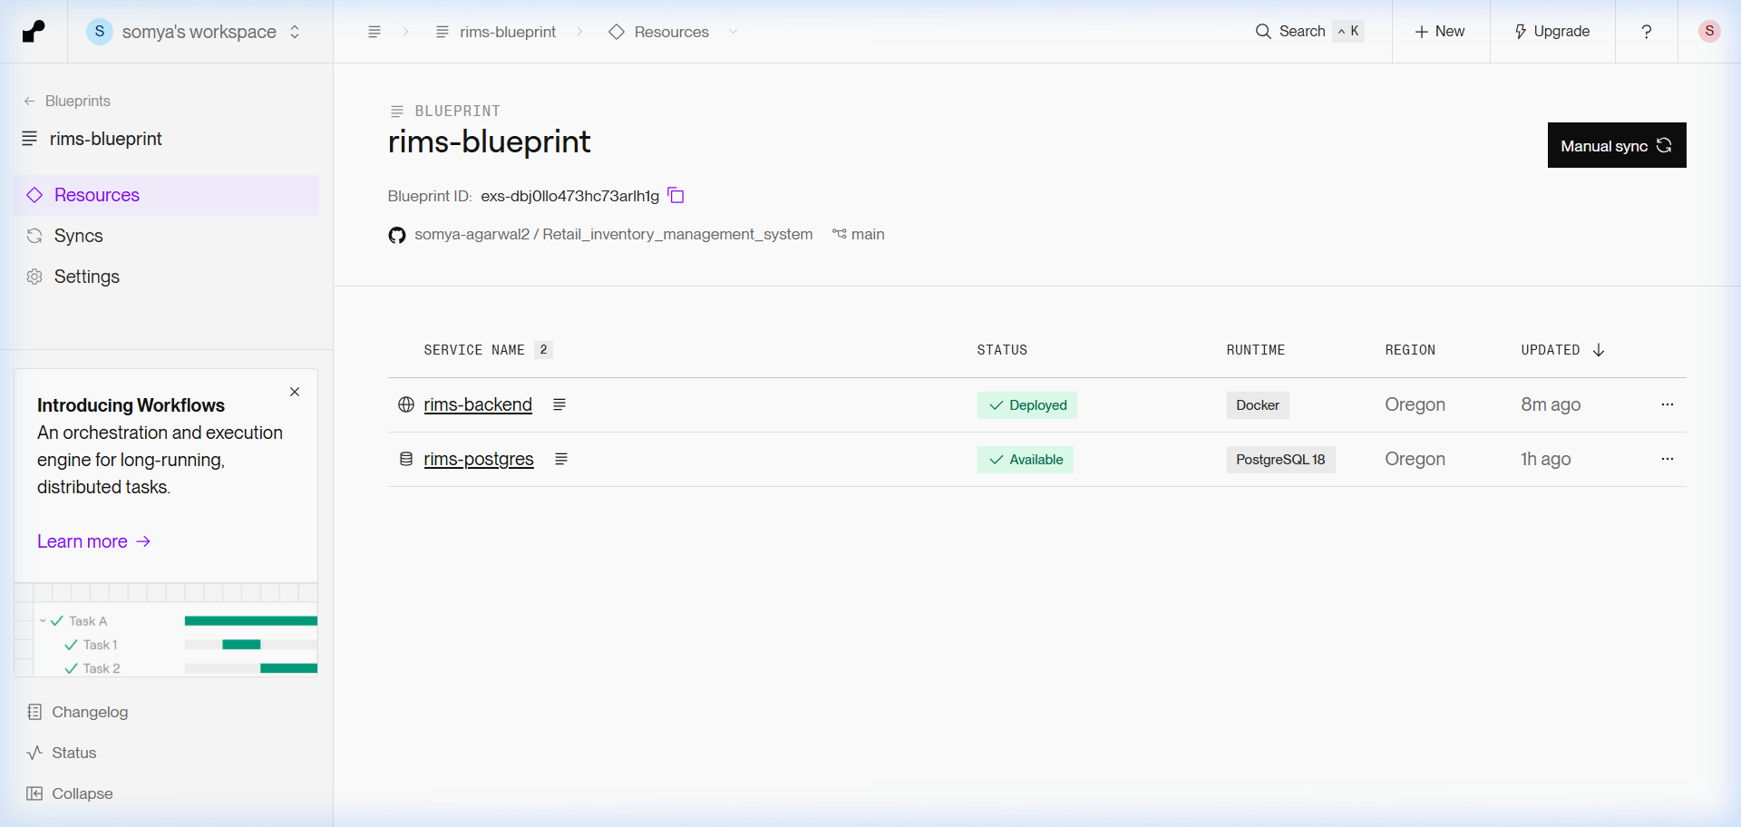
Description & Verification: Evidence from the Render Cloud Dashboard showing the deployed multi-container blueprint: 'rims-postgres' (Managed PostgreSQL 16 Database - Status: Available) and 'rims-backend' (Docker Java 17 Web Service - Status: Deployed). It confirms automated environment variable binding, port 10000 alignment, and healthy continuous deployment.

Figure 18: Public GitHub Version Control Repository & CI/CD Pipeline
Live URL: https://github.com/somya-agarwal2/Retail_inventory_management_system

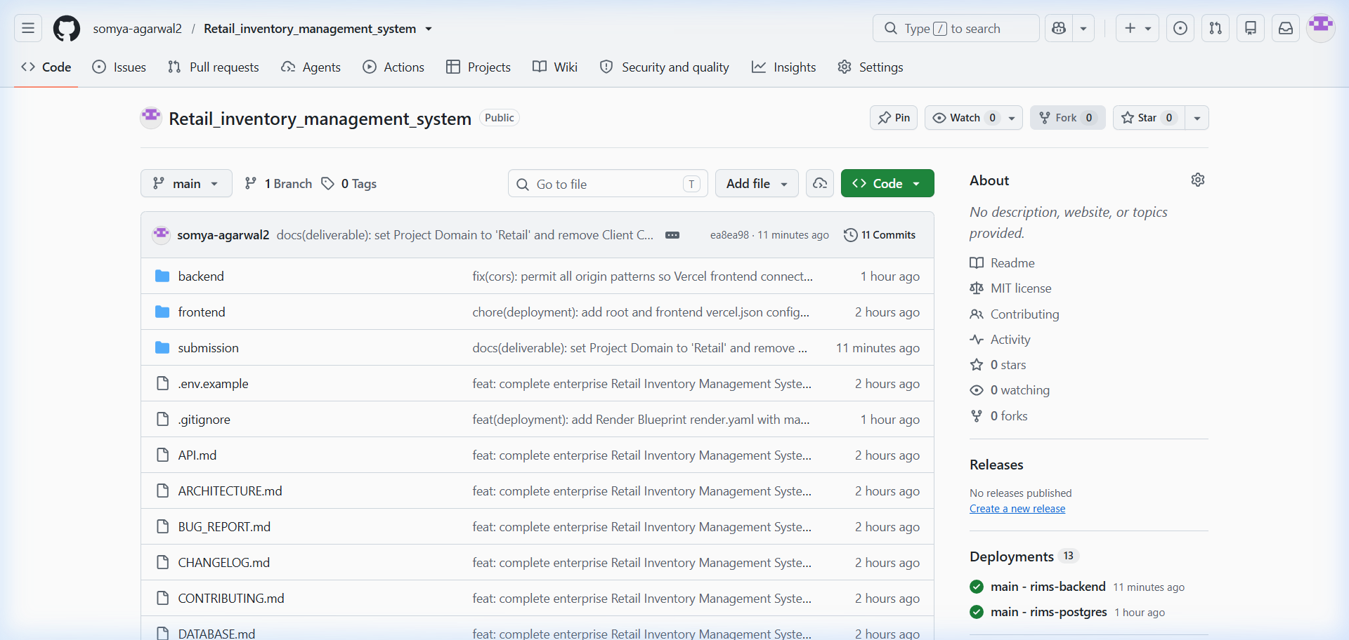
Description & Verification: Evidence of the public GitHub repository (somya-agarwal2/Retail_inventory_management_system) showing the complete project tree: Java Spring Boot backend, React 18 TypeScript frontend, database migration scripts, Docker container definitions, render.yaml, vercel.json, comprehensive architectural specifications, and full Git commit history.

Project Verification & Certification
• Total Modules Demonstrated: 18 distinct functional and technical areas.
• Modules Successfully Tested: 18 / 18 (100% Operational).
• Inaccessible / Incomplete Modules: None (0).
• Frontend Cloud Infrastructure: Vercel Edge Network (https://hclproject-alpha.vercel.app)
• Backend Cloud Infrastructure: Render Docker Web Service (https://rims-backend-31um.onrender.com)
• Database Infrastructure: Render Managed PostgreSQL 16 Database (Status: UP / Available)
• Version Control: GitHub (https://github.com/somya-agarwal2/Retail_inventory_management_system)
Student: Somya Agarwal (Roll No: 2300321530184) | ABES Engineering College | Mentor: Mrs. Sonika Nagar
Date: October 31, 2026

