MODULE 8

1.QUICK WARM UP
1.
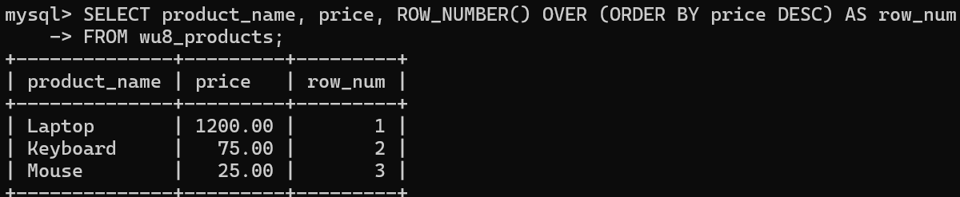
2.
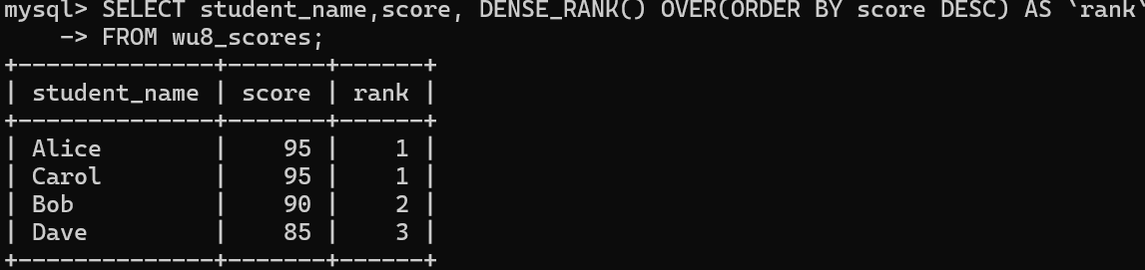
3.
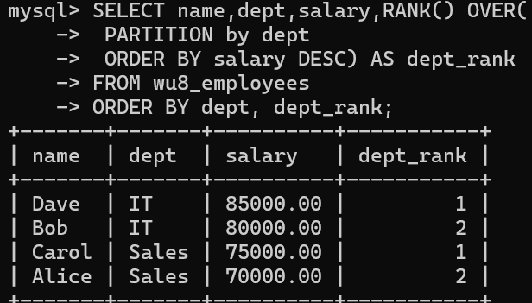
4.
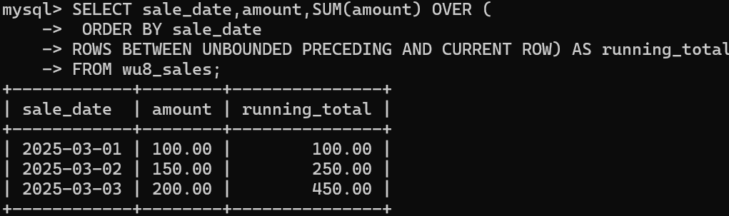
5.
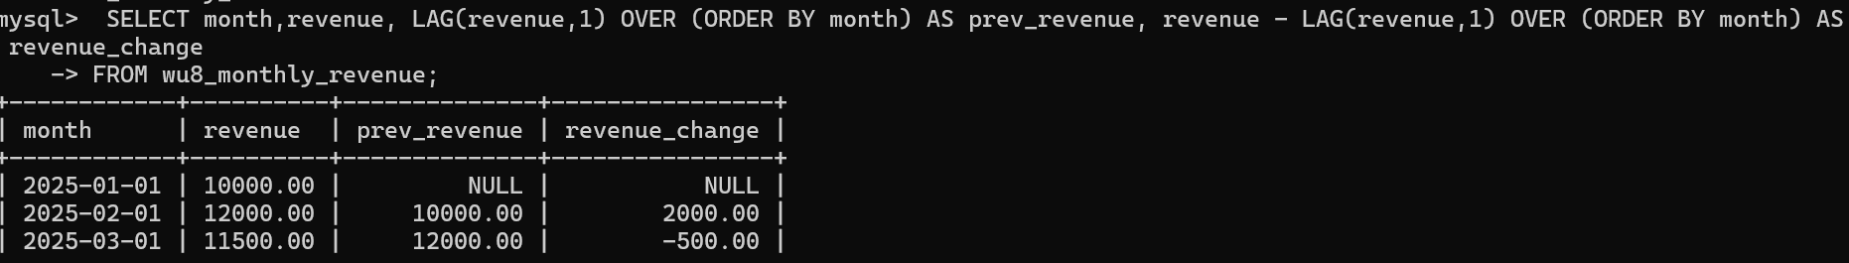

2.GUIDED STEP BY STEP
1.
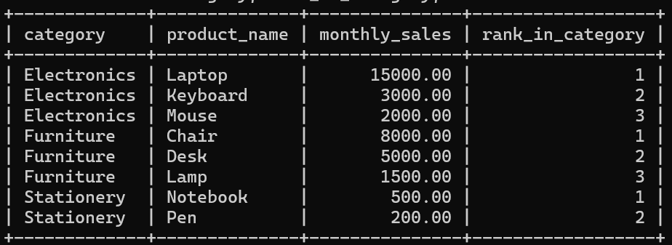
2.
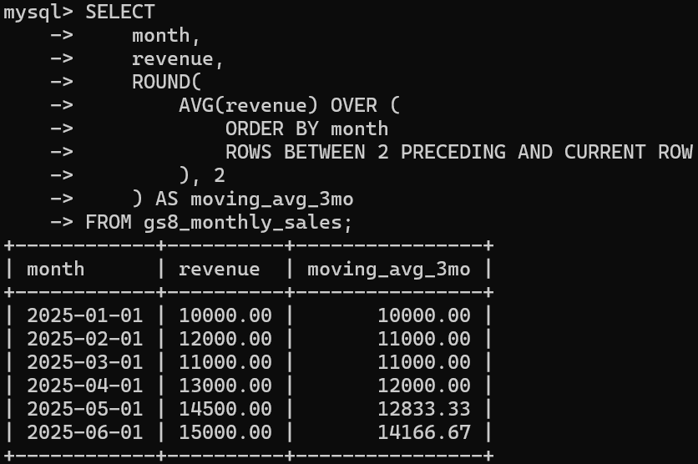
3.
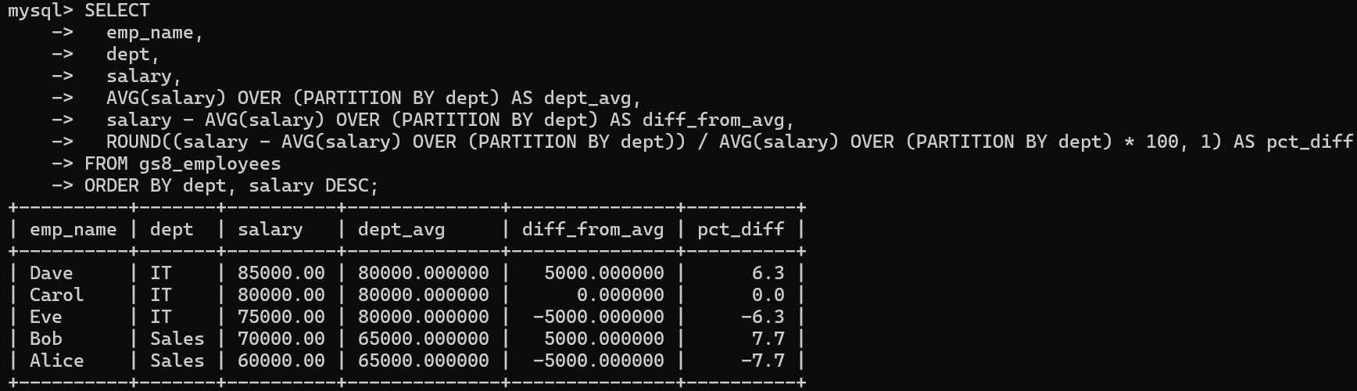

3. INDEPENDENT PRACTICE
1.
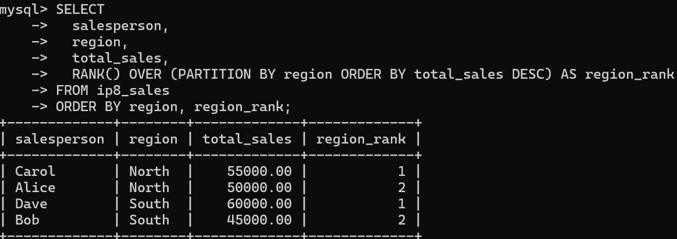
2.
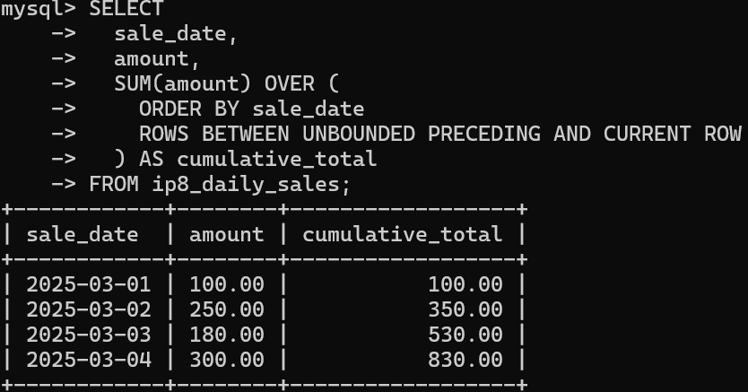
3.
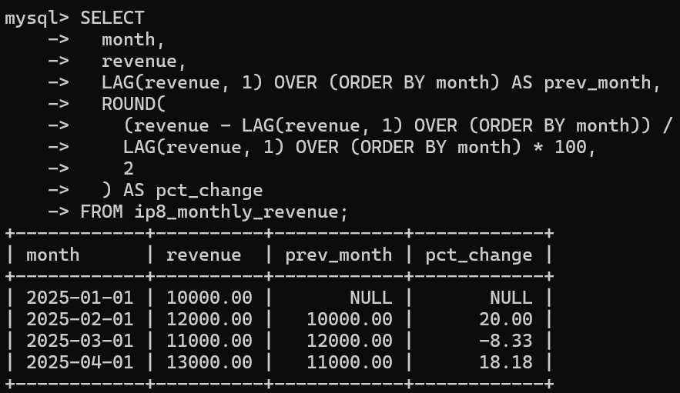
4.
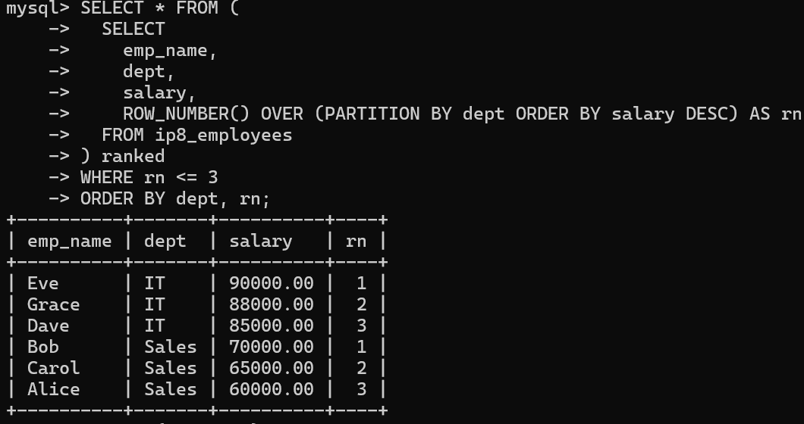
5.
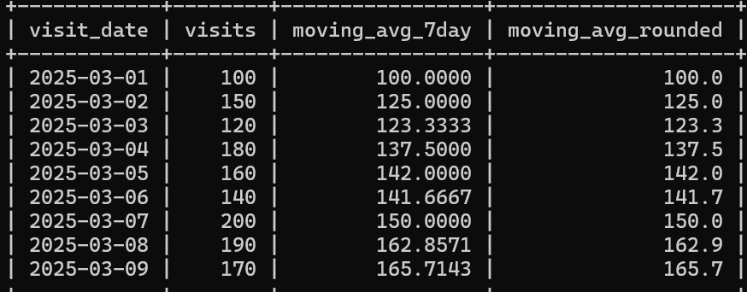
6.
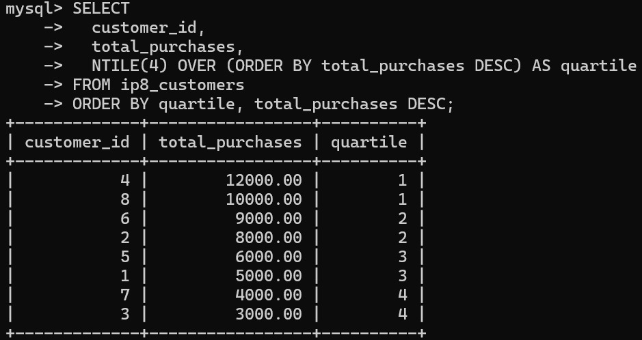

4.PAIRED PROGRAMMING
1.
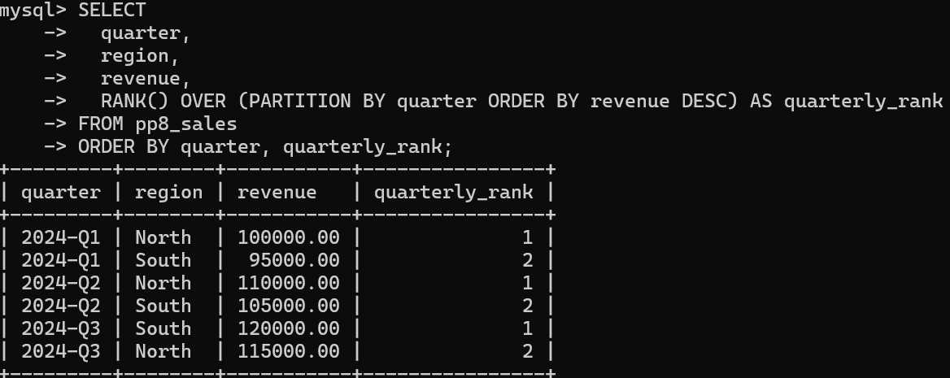
2.
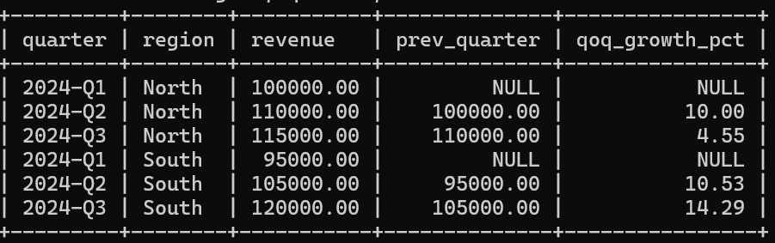
3.
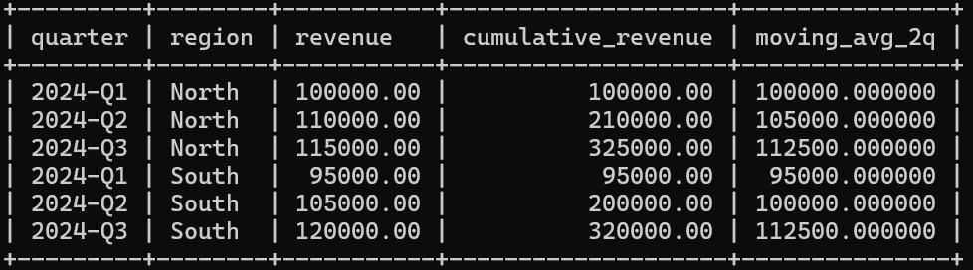

5. REAL WORLD PROJECT
1.
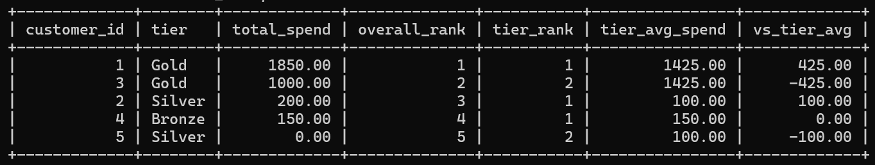
2.
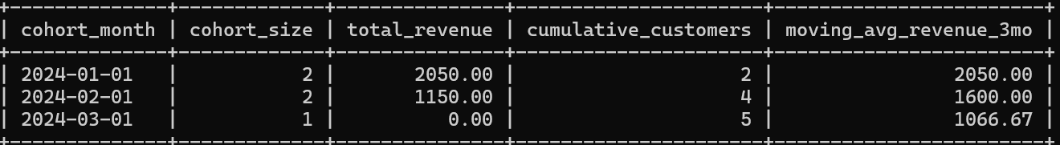
3.
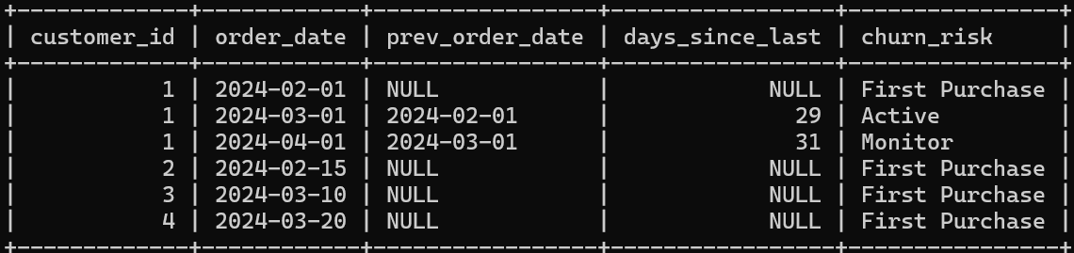

6. TAKE HOME CHALLENGES
1.
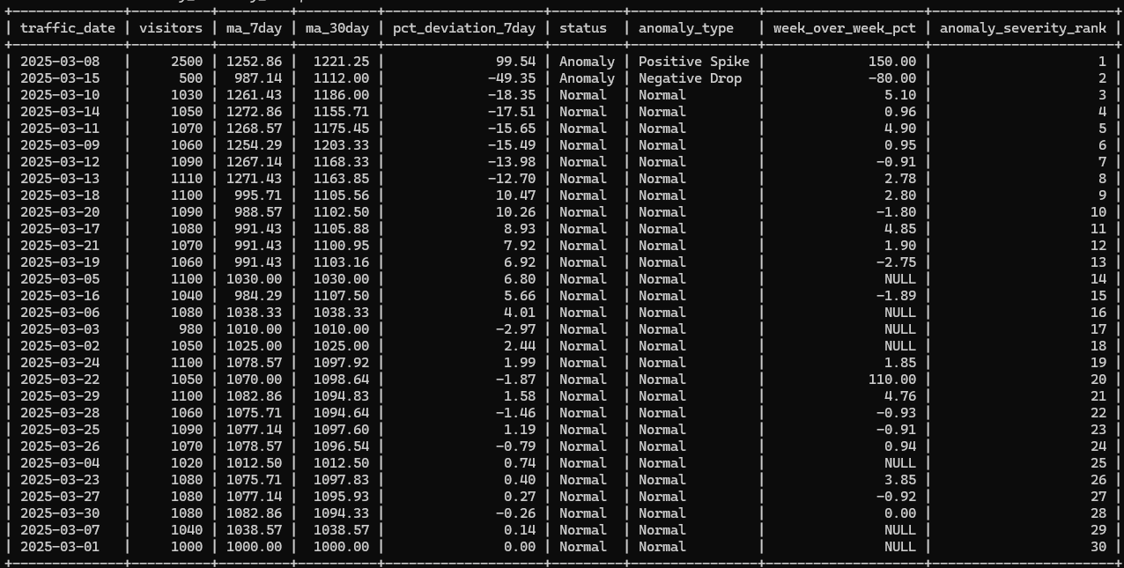
2.
