MODULE 10

1.QUICK WARM UP
1.
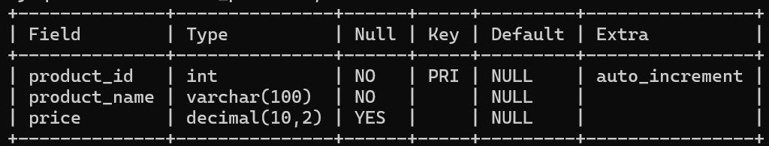
2.
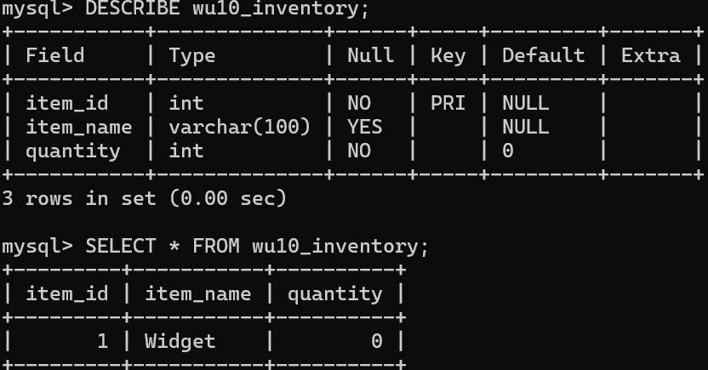
3.
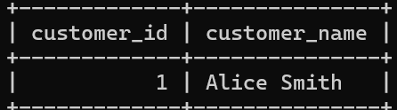
4.
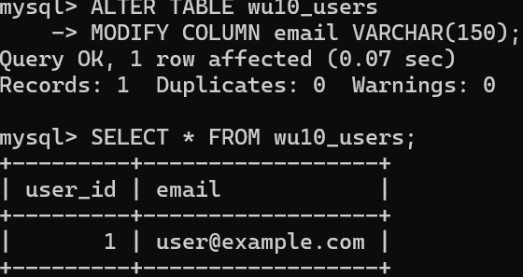
5.
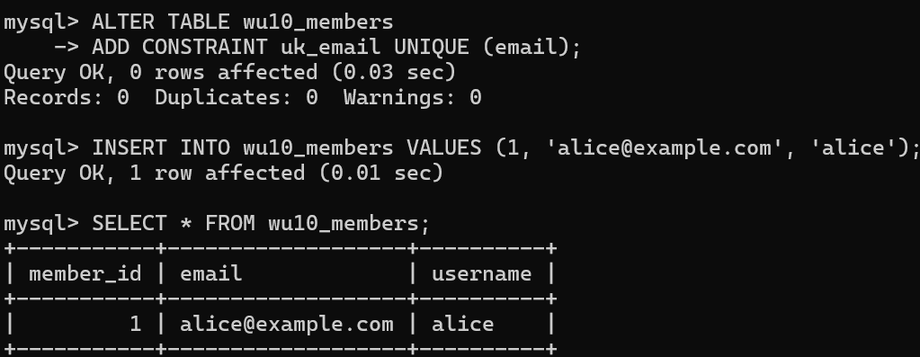

2. GUIDED STEP BY STEP
1.
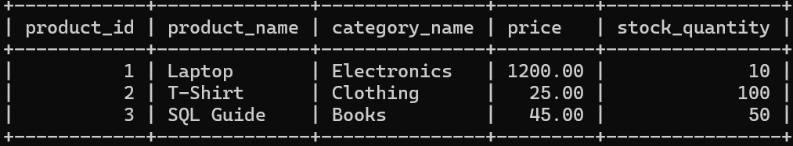
2.
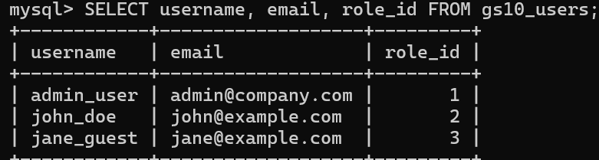

3. INDEPENDENT PRACTICE
1.
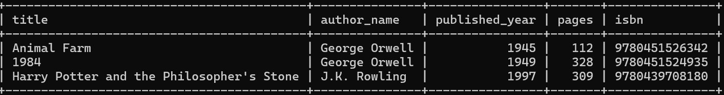
2.
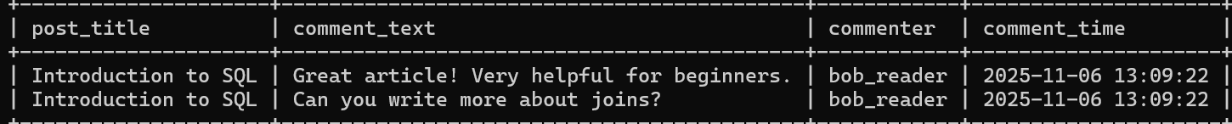
3.
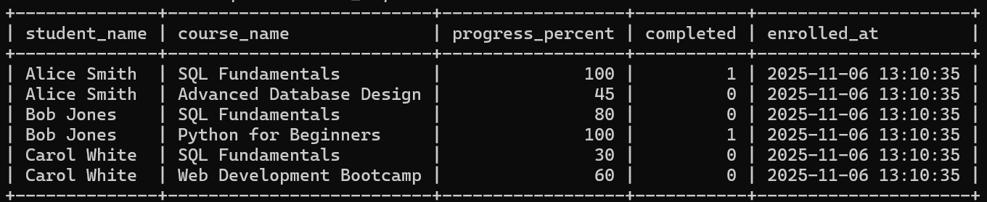
4.
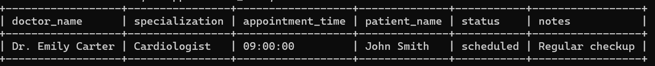

4. PAIRED PROGRAMMING
