MODULE 9

1.QUICK WARM UP
1.
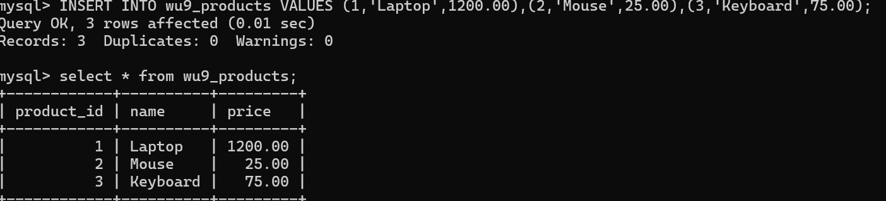
2.
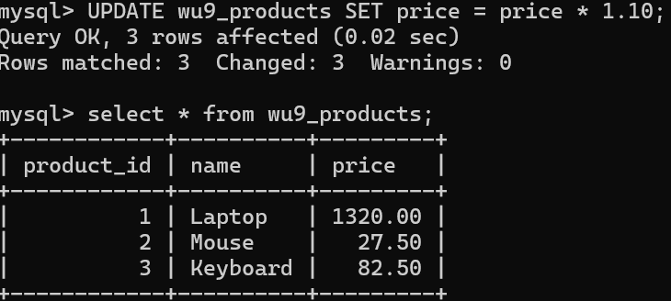
3.
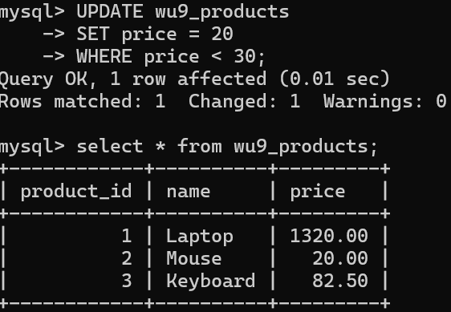
4.
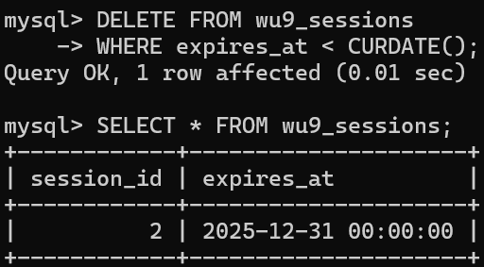
5.
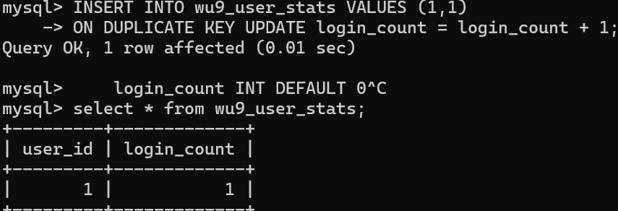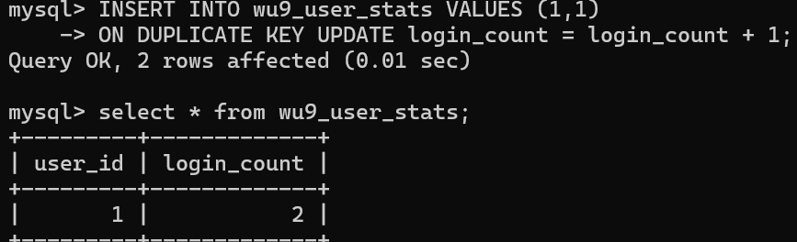

2. GUIDED STEP BY STEP
1.
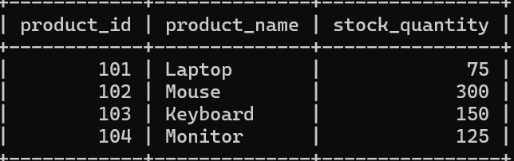
2.
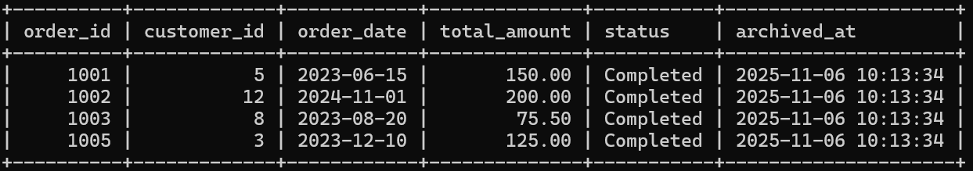
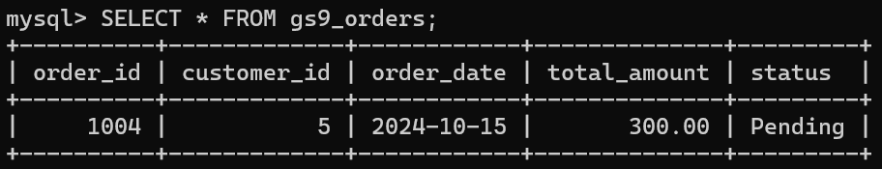
3.
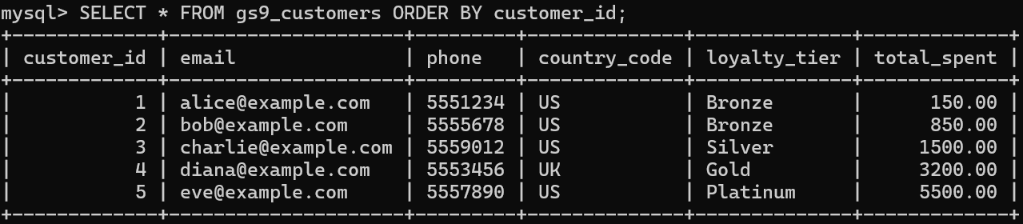

3. INDEPENDENT PRACTICE
1.
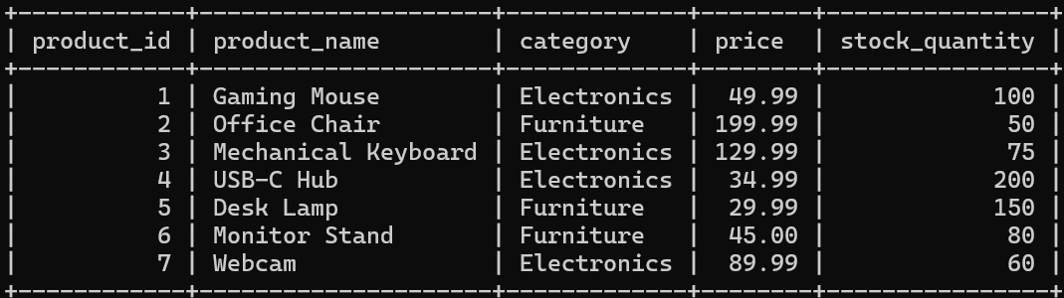
2.
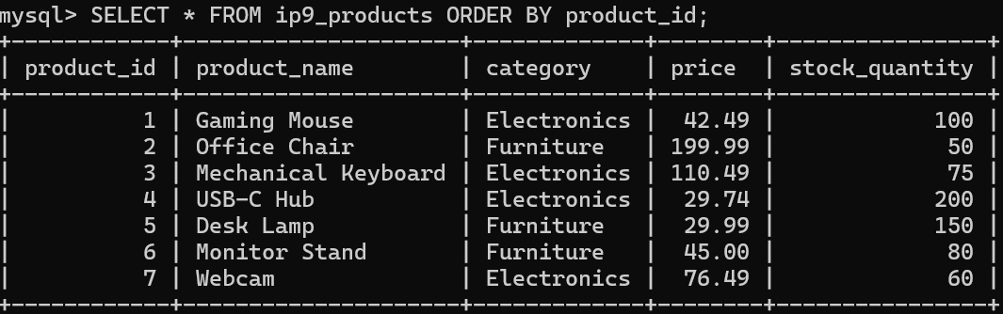
3.
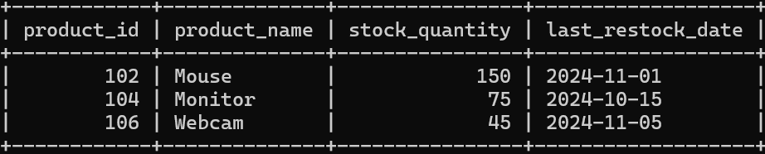
4.
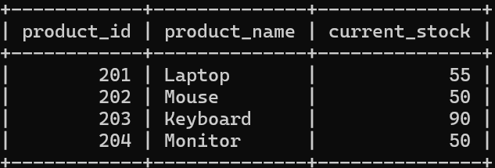
5.
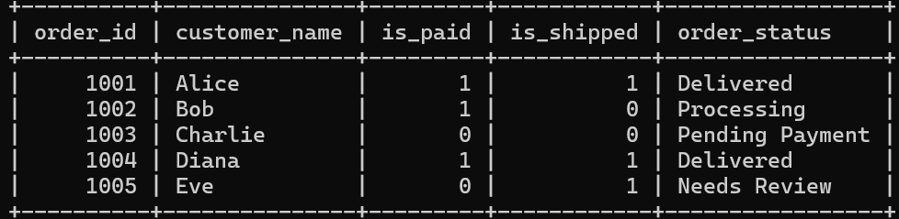
6.
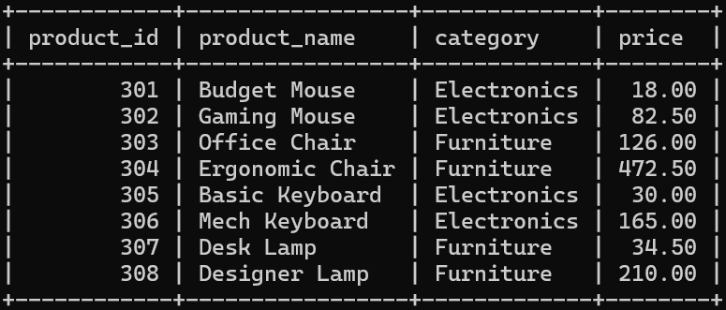
7.
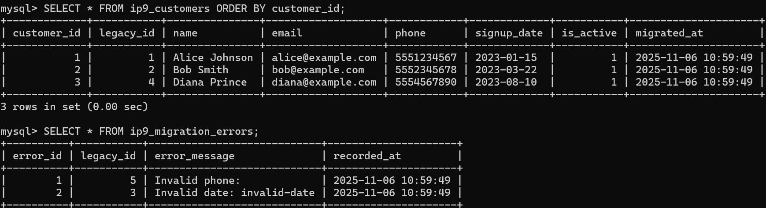

4. PAIRED PROGRAMMING
1.
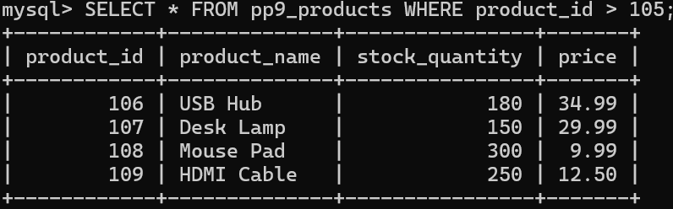
2.
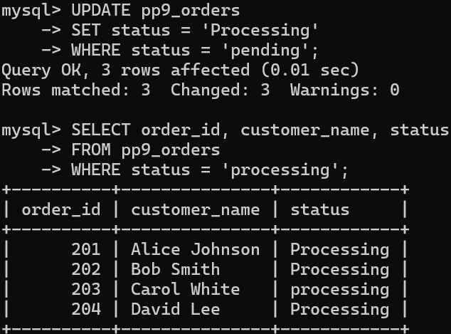
3.
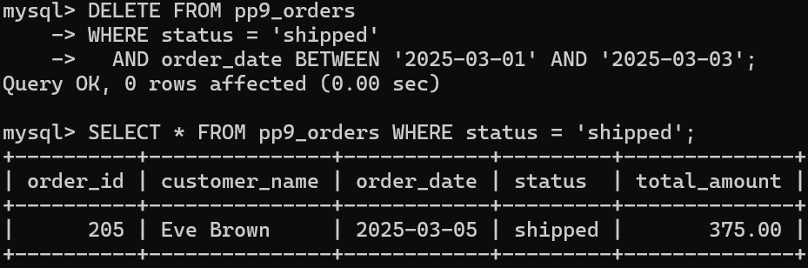

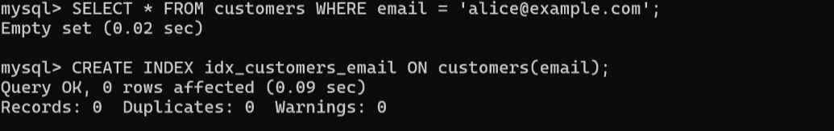

5. REAL-WORLD PROJECT
1.
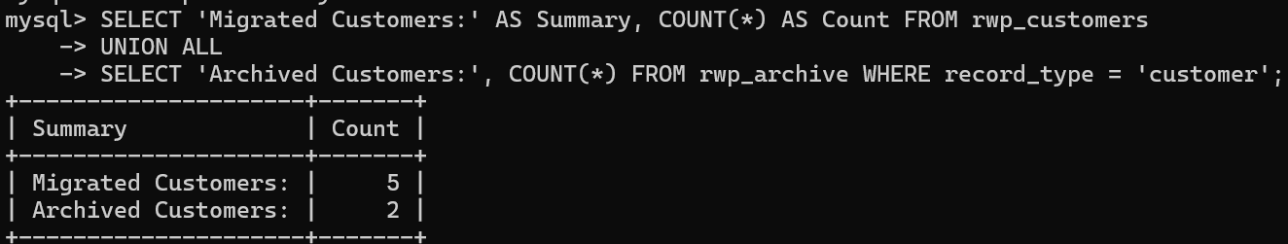
2.
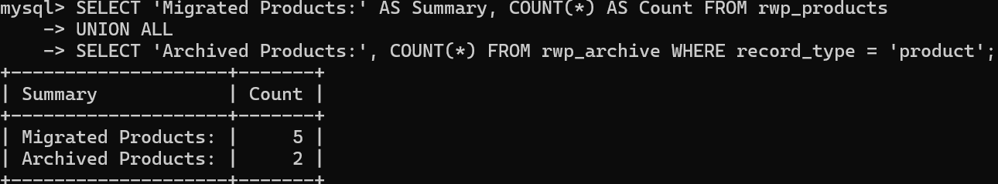
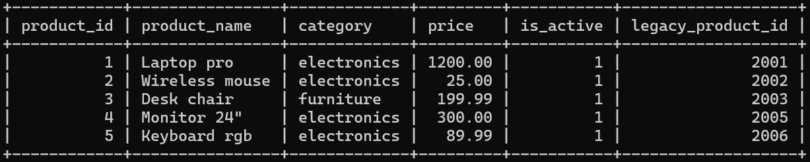
3.
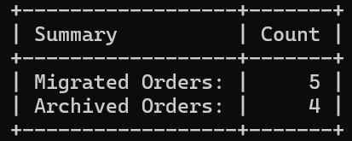

6. TAKE HOME CHALLENGES
CHALLENGE 1
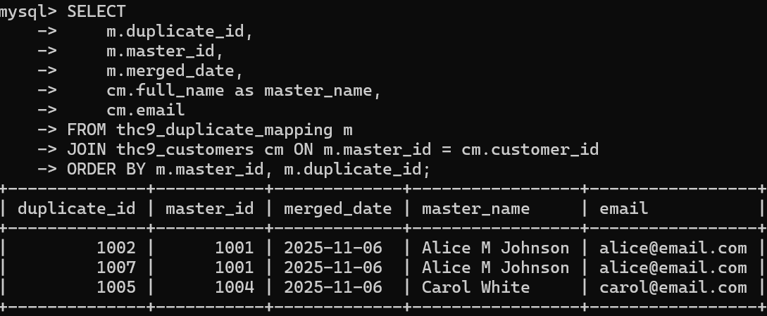
CHALLENGE 2
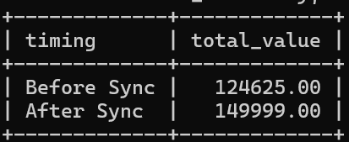
CHALLENGE 3
