WEEK 4
INTERNSHIP DOCUMENTATION
Supervised Learning Model Implementation
Regression-Based Property Price Prediction

Project Detail | Verified Value
INTERNSHIP TRACK | Virtual Internship in Data Science using Python
TECHNICAL DOMAIN | Data Science with Python
PROJECT FOCUS | Gurugram Real-Estate Property Price Prediction
PRIMARY TOOLS | Python 3, Pandas, NumPy, Scikit-learn, Matplotlib, Seaborn
LEARNING TASK | Supervised Learning — Regression
MODELS EVALUATED | Linear Regression, Random Forest, Gradient Boosting
FINAL MODEL | Random Forest Regressor
DATASET SIZE | 14,223 cleaned property records; 12 original columns
TRAIN / TEST | 11,378 training / 2,845 test observations
TARGET VARIABLE | price
TEST R² | 69.86%
MEAN 5-FOLD CV R² | 57.06%

Technical Verification Note
All reported Week 4 metrics, feature-importance values, prediction examples, and visualizations are derived from the executed Supervised Learning notebook and its exported regression-results dataset. No placeholder figures or estimated model results are used.

Prepared as the Week 4 technical milestone of the six-week virtual internship.

1. Introduction
Supervised learning is used when historical examples with known outcomes are available for learning a predictive relationship.
Week 4 applies supervised learning to the cleaned Gurugram real-estate dataset developed in the earlier internship stages. The selected problem is property price prediction, formulated as a regression task because price is a continuous numerical target. The workflow combines structured preprocessing, feature engineering, model training, held-out testing, cross-validation, model comparison, and interpretation.

1.1 Objectives
- Define a clear supervised regression problem with property price as the target.
- Prepare numerical and categorical predictors in a reproducible Scikit-learn pipeline.
- Convert RERA approval to a binary numeric indicator and one-hot encode categorical variables.
- Compare Linear Regression, Random Forest, and Gradient Boosting.
- Validate model performance with a held-out test set and 5-fold cross-validation.
- Interpret the final model through predictions, residuals, and feature importance.
- Export row-level actual, predicted, and residual values for the final model.

1.2 Dataset Snapshot
Attribute | Verified value
Rows after cleaning | 14,223
Original columns | 12
Missing values | 0
Target | price
Predictors | area, bhk_count, rera_approval, status, flat_type
Excluded leakage variable | rate_per_sqft
Excluded high-cardinality fields | property_type, locality, builder_name, society, company_name

1.3 Why regression rather than classification?
The model predicts an amount of money rather than a class label. Therefore, conventional classification accuracy is not an appropriate metric. R², MAE, MSE, and RMSE are used instead. For presentation convenience, the R² values are also expressed as percentages; this does not turn the regression task into an accuracy-based classification problem.
Primary result
Random Forest achieved the strongest held-out performance with a test R² of 69.86% and mean 5-fold cross-validation R² of 57.06%.

2. Data Preparation and Feature Engineering
The modeling pipeline ensures that the same transformations are applied consistently during training, testing, and cross-validation.

2.1 Target and predictor selection
X = df[
['area', 'bhk_count', 'rera_approval', 'status', 'flat_type']
].copy()
y = df['price'].copy()
The predictor matrix contains five variables and the target contains 14,223 price observations. The train-test split later produces 11,378 training and 2,845 test observations.

2.2 Numeric and categorical representation
X['rera_approval'] = X['rera_approval'].astype(int)
RERA approval is represented numerically as False = 0 and True = 1. The executed notebook verified 8,774 non-approved and 5,449 approved records. Status and flat type remain categorical and are one-hot encoded within the preprocessing pipeline.
Feature group | Variables | Treatment
Numerical | area, bhk_count, rera_approval | Median imputation + StandardScaler
Categorical | status, flat_type | Most-frequent imputation + OneHotEncoder
Target | price | Continuous numerical target

2.3 Leakage and high-cardinality controls
rate_per_sqft was deliberately excluded because it is derived from price and area. Including it as a predictor would expose target-derived information to the model and produce an unreliable evaluation. The fields property_type, locality, builder_name, society, and company_name were also excluded from this baseline because their high cardinality would create a large and less interpretable feature space.

2.4 Preprocessing pipeline
numerical_transformer = Pipeline(
steps=[
('imputer', SimpleImputer(strategy='median')),
('scaler', StandardScaler())
]
)
categorical_transformer = Pipeline(
steps=[
('imputer', SimpleImputer(strategy='most_frequent')),
('onehot', OneHotEncoder(
handle_unknown='ignore', drop='first'
))
]
)

2.5 Train-test split
X_train, X_test, y_train, y_test = train_test_split(
X, y, test_size=0.20, random_state=42
)
Verified split
Training set: 11,378 observations | Test set: 2,845 observations | Test proportion: 20%.

3. Model Implementation and Validation

3.1 Linear Regression — baseline
Linear Regression provides a simple reference model. Its purpose is to establish a baseline against which the nonlinear ensemble methods can be judged.
linear_model = Pipeline(
steps=[
('preprocessor', preprocessor),
('model', LinearRegression())
]
)
linear_model.fit(X_train, y_train)
linear_predictions = linear_model.predict(X_test)

3.2 Random Forest Regressor
Random Forest was selected as the primary nonlinear candidate because real-estate prices can depend on nonlinear relationships and interactions between size, BHK count, status, RERA approval, and flat type.
random_forest_model = Pipeline(
steps=[
('preprocessor', preprocessor),
('model', RandomForestRegressor(
n_estimators=100,
random_state=42,
n_jobs=-1
))
]
)
The implemented configuration uses 100 trees, random_state=42 for reproducibility, and all available CPU cores through n_jobs=-1.

3.3 Gradient Boosting Regressor
Gradient Boosting provides a second nonlinear ensemble benchmark. It builds trees sequentially so that later trees focus on reducing errors left by earlier trees.
gradient_boosting_model = Pipeline(
steps=[
('preprocessor', preprocessor),
('model', GradientBoostingRegressor(
n_estimators=100, random_state=42
))
]
)

3.4 Evaluation metrics
Metric | Meaning | Preferred direction
MAE | Average absolute prediction error in price units | Lower
MSE | Average squared prediction error; emphasizes large errors | Lower
RMSE | Square root of MSE, in price units | Lower
R² | Variation in price explained by the model | Higher

3.5 Cross-validation
Five-fold cross-validation was performed with scoring='r2'. Each fold provides an independent R² estimate, and the mean and standard deviation summarize average performance and variability across folds.

4. Model Evaluation and Final Selection
Model | MAE (₹) | RMSE (₹) | Test R² | Mean CV R²
Linear Regression | 26,157,218.16 | 59,533,165.64 | 6.93% | -16.67%
Random Forest | 11,532,540.78 | 33,875,860.34 | 69.86% | 57.06%
Gradient Boosting | 14,983,084.75 | 36,405,272.39 | 65.20% | 50.93%

4.1 Interpretation of the comparison
Random Forest is the strongest model on every primary comparison shown above: it has the lowest test MAE, the lowest test RMSE, the highest test R², and the highest mean cross-validated R². Its test R² of 69.86% indicates that approximately 69.86% of the variation in held-out property prices is explained by the fitted model.
Gradient Boosting is the second-best performer, with a test R² of 65.20% and mean CV R² of 50.93%. Linear Regression performs substantially worse on the held-out test set and is unstable across cross-validation folds, reflected by a negative mean CV R² and large standard deviation.

4.2 Final model
Random Forest selected
Random Forest Regressor is retained as the final Week 4 model because it provides the strongest combination of predictive performance and cross-validation results among the tested models.

4.3 Cross-validation stability
Model | Mean CV R² | CV Std
Linear Regression | -16.6724 | 33.4495
Random Forest | 0.5706 | 0.1439
Gradient Boosting | 0.5093 | 0.1421

The gap between Random Forest's 69.86% held-out R² and 57.06% mean CV R² shows that performance varies across data partitions. Extreme property prices in the dataset can affect fold composition and therefore influence R².

5. Prediction and Residual Analysis
The following figures are the executed notebook visualizations for the final Random Forest model.

5.1 Actual vs Predicted Prices
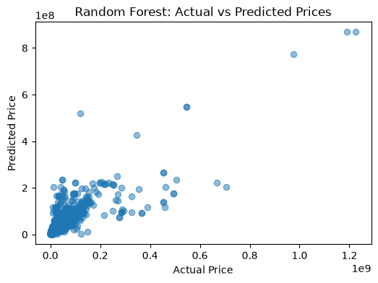
Figure 1. Random Forest actual versus predicted property prices on the test set.
The plot shows a clear overall upward relationship between actual and predicted prices, consistent with the model's positive R². Most observations are concentrated at lower price levels, while a smaller number of extreme-price properties stretch the scale and produce visible deviations.

5.2 Residual Analysis
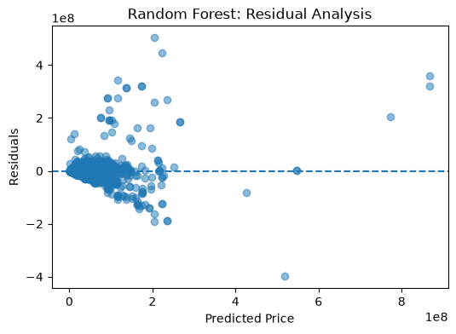
Figure 2. Random Forest residuals against predicted prices.
Most residuals are concentrated around the zero line, indicating that many predictions are reasonably close to their observed values. Large positive and negative residuals remain, particularly for some expensive properties, showing that extreme observations are harder to estimate accurately.

6. Feature Importance and Model Interpretation
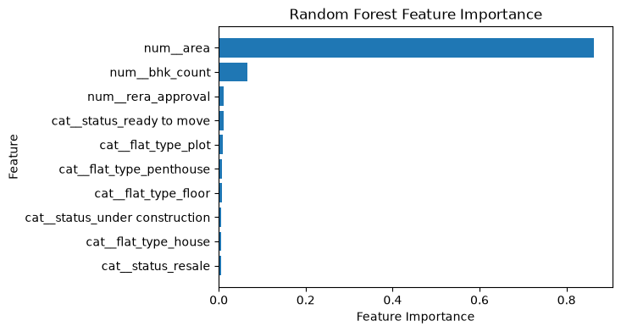
Figure 3. Feature importance from the final Random Forest model.
Rank | Feature | Importance
1 | area | 86.31%
2 | bhk_count | 6.62%
3 | rera_approval | 1.23%
4 | status — ready to move | 1.14%
5 | flat_type — plot | 0.99%
6 | flat_type — penthouse | 0.70%
7 | flat_type — floor | 0.66%
8 | status — under construction | 0.65%
9 | flat_type — house | 0.63%
10 | status — resale | 0.61%

6.1 Interpretation
Area is overwhelmingly the dominant feature in the fitted Random Forest, with an importance score of 86.31%. BHK count is the second most influential predictor at 6.62%. RERA approval and the individual encoded status and flat-type indicators have much smaller individual importance values.
Interpretation caution
Random Forest feature importance describes how the model used variables for tree splits. It is not a causal statement and should not be interpreted as a literal percentage contribution of each feature to property price.

7. Prediction Results and Practical Implications

7.1 Sample prediction results
Area | BHK | RERA | Status | Type | Actual ₹ | Predicted ₹ | Residual ₹
1531 | 4.0 | 1 | under construction | apartment | 15,300,000 | 22,134,990 | -6,834,992
1785 | 3.0 | 0 | ready to move | apartment | 12,200,000 | 15,320,840 | -3,120,837
1920 | 3.0 | 0 | ready to move | apartment | 11,500,000 | 13,428,790 | -1,928,795
2150 | 3.0 | 1 | under construction | apartment | 14,200,000 | 42,787,830 | -28,587,830
2404 | 3.0 | 0 | ready to move | apartment | 25,900,000 | 31,369,290 | -5,469,294

The complete test-set prediction file contains 2,845 observations with the original predictors plus Actual Price, Predicted Price, and Residual.

7.2 Final validation summary
Validation item | Verified result
Test R² | 69.86%
Mean 5-fold CV R² | 57.06%
MAE | ₹11,532,540.78 (≈ ₹1.15 crore)
RMSE | ₹33,875,860.34 (≈ ₹3.39 crore)
Test observations | 2,845

7.3 Business / research implications
- Price estimation: the model can provide a data-driven starting estimate for properties with the selected characteristics.
- Listing analysis: predicted values can help analysts identify observations that differ substantially from learned price patterns.
- Feature insight: area is the dominant predictive signal in the current feature set, making property size a key variable for price estimation.
- Decision support: the model can support exploratory analysis but should not be treated as an independent professional valuation.
- Future market analysis: richer location and market variables could extend the usefulness of the predictive system.

8. Strengths, Limitations and Improvements

8.1 Strengths
- Reproducible Scikit-learn preprocessing and modeling pipeline.
- Separate held-out test set plus 5-fold cross-validation.
- Comparison of a linear baseline and two nonlinear ensemble methods.
- Explicit avoidance of target leakage from rate_per_sqft.
- Prediction, residual, and feature-importance analysis for interpretability.

8.2 Limitations
- The baseline uses a limited predictor set and does not directly encode detailed locality effects.
- High-cardinality fields were excluded, so detailed location, society, builder, and company information does not contribute directly to prediction.
- Extreme property-price observations increase RMSE and contribute to cross-validation variability.
- Random Forest feature importance is model-specific and does not establish causality.
- Results can vary with a different train-test split or sampling strategy.

8.3 Recommended improvements
- Use controlled encodings or engineered representations for selected high-cardinality location variables.
- Investigate a log-transformed price target to reduce the influence of extreme values.
- Tune Random Forest and Gradient Boosting hyperparameters using cross-validated search.
- Evaluate additional tree-based and robust regression approaches.
- Add reliable market, location, amenities, and property-quality variables where available.
- Report performance by price band to identify where prediction errors are concentrated.

8.4 Conclusion
Week 4 successfully implemented a complete supervised-learning workflow for Gurugram property price prediction. The cleaned dataset was transformed through numeric and categorical preprocessing, and three regression models were trained and validated.
Random Forest was selected as the final model after outperforming Linear Regression and Gradient Boosting. It achieved a test R² of 69.86%, mean 5-fold CV R² of 57.06%, MAE of approximately ₹1.15 crore, and RMSE of approximately ₹3.39 crore. Feature-importance analysis showed that area is the dominant predictive feature in the current model.
Overall conclusion
The Week 4 implementation provides a strong, reproducible baseline for property price prediction and a clear foundation for future improvements using richer location and market information.

Appendix — Core Implementation and Final Outputs

A.1 Final Random Forest training
random_forest_model = Pipeline(
steps=[
('preprocessor', preprocessor),
('model', RandomForestRegressor(
n_estimators=100,
random_state=42,
n_jobs=-1
))
]
)
random_forest_model.fit(X_train, y_train)
rf_predictions = random_forest_model.predict(X_test)

A.2 Five-fold validation
rf_cv_scores = cross_val_score(
random_forest_model,
X,
y,
cv=5,
scoring='r2'
)
pd.Series({
'Mean CV R2': rf_cv_scores.mean(),
'CV Std': rf_cv_scores.std()
}).round(4)

A.3 Prediction export
prediction_results = X_test.copy()
prediction_results['Actual Price'] = y_test.values
prediction_results['Predicted Price'] = rf_predictions
prediction_results['Residual'] = y_test.values - rf_predictions
prediction_results.to_csv(
'real_estate_regression_results.csv',
index=False
)

A.4 Final validation output
pd.Series({
'Test R2 (%)': rf_r2 * 100,
'Mean CV R2 (%)': rf_cv_scores.mean() * 100,
'MAE': rf_mae,
'RMSE': rf_rmse,
'Test Samples': len(y_test)
}).round(2)
Output file | Purpose
Supervised Learning.ipynb | Executed Week 4 supervised-learning notebook.
real_estate_regression_results.csv | 2,845 test-set rows with actual price, predicted price, and residual.
Week_4_Internship_Report_Final_Aligned.docx | Submission-ready Week 4 documentation.

Final verified values
Test R² = 69.86% | Mean 5-fold CV R² = 57.06% | MAE = ₹1.15 crore | RMSE = ₹3.39 crore | Test observations = 2,845

