WEEK 3
INTERNSHIP DOCUMENTATION
Unsupervised Learning and Clustering Analysis
Project Detail | Verified Value
INTERNSHIP TRACK | Virtual Internship in Data Science using Python
TECHNICAL DOMAIN | Data Science with Python
PROJECT FOCUS | Gurugram Real-Estate Clustering and Property Segmentation
PRIMARY TOOLS | Python 3, Pandas, NumPy, Scikit-learn, Matplotlib, Seaborn
CLUSTERING METHODS | K-Means and Agglomerative Hierarchical Clustering
FINAL MODEL | K-Means with K = 4
DATASET SIZE | 14,223 unique property records; 12 original columns
MILESTONE TARGET | Week 3 Submission (6-Week Virtual Internship)
SOURCE NOTEBOOK | Real Estate Data Set(5).ipynb

Technical Verification Note: All reported clustering metrics, feature dimensions, cluster counts, profile values, and composition percentages are derived from the executed Week 3 notebook and the final clustered dataset. Visuals in this report are the executed notebook visualizations or directly generated from the verified final outputs; no placeholder figures or estimated results are used.

Prepared as the Week 3 technical milestone of the six-week virtual internship.

1. Introduction
Unsupervised learning is used when meaningful groups must be discovered without a predefined target label. In a real-estate setting, clustering can reveal groups of properties that share similar price, size, rate, configuration, regulatory, and market-status characteristics.
During Week 3, the cleaned Gurugram real-estate dataset from the earlier project stages was prepared for clustering. The workflow converted selected categorical information into numerical form, reduced the effect of extreme scale through logarithmic transformation, standardized the feature matrix, evaluated candidate cluster counts, compared two clustering algorithms, and profiled the resulting property segments.
The analysis deliberately avoided blindly encoding high-cardinality text fields such as property_type, locality, builder_name, society, and company_name. These fields contain many distinct categories and could create a very large, difficult-to-interpret feature space. Flat Type was also kept out of the clustering matrix because an earlier clustering attempt showed that it could dominate the segmentation and produce clusters that corresponded almost directly to flat-type categories.

2. Week 3 Objectives
- Apply an unsupervised clustering technique to the real-estate dataset.
- Prepare numerical and categorical variables so that they can be used consistently by clustering algorithms.
- Determine a suitable number of clusters using clustering-quality measures and the Elbow Method.
- Compare K-Means and Hierarchical Clustering using Silhouette, Davies-Bouldin, and Calinski-Harabasz metrics.
- Visualize the final clusters using PCA and analyze their characteristics.
- Derive practical business and research implications from the identified property segments.

3. Dataset and Feature Selection
The project uses the cleaned Gurugram real-estate dataset produced in the preceding internship stages. After duplicate removal and cleaning, the analytical dataset contains 14,223 unique property records and the original 12 standardized columns.
Dataset Attribute | Verified Value
Rows after cleaning | 14,223
Original columns | 12
Numerical variables available | price, area, rate_per_sqft, bhk_count
Categorical variables available | status, property_type, locality, builder_name, rera_approval, society, company_name, flat_type
Final clustering features | 8

The final clustering matrix uses price, area, rate_per_sqft, bhk_count, rera_approval, and three encoded property-status indicators. High-cardinality identifiers and Flat Type were excluded from the training matrix to reduce category-driven clustering and preserve a more meaningful numerical segmentation.

4. Data Preprocessing for Clustering

4.1 Categorical Encoding
RERA approval was converted from Boolean values to integer form, where False = 0 and True = 1. Property status was converted into one-hot indicator variables using drop_first=True, producing three status indicators: ready to move, resale, and under construction. The omitted status category is represented by the baseline.
df_model['rera_approval'] = df_model['rera_approval'].astype(int)
df_encoded = pd.get_dummies(
df_model,
columns=['status'],
drop_first=True,
dtype=int
)

4.2 Final Feature Matrix
Feature | Role in clustering
price | Property price
area | Property area in sq ft
rate_per_sqft | Price rate per square foot
bhk_count | Recorded BHK count
rera_approval | Binary RERA indicator: 0/1
status_ready to move | One-hot status indicator
status_resale | One-hot status indicator
status_under construction | One-hot status indicator

Observation: The final matrix contains 8 features and 14,223 observations. The notebook output confirms X_scaled has shape (14223, 8).

4.3 Log Transformation
Price, area, and rate per square foot contain strong right-skew and very large values. A log1p transformation was applied to these three variables before scaling. This reduces the influence of extreme magnitudes while preserving the ordering of observations.
df_cluster = df_encoded.copy()
log_columns = ['price', 'area', 'rate_per_sqft']
for col in log_columns:
df_cluster[col] = np.log1p(df_cluster[col])

4.4 Standardization
StandardScaler was applied so that the clustering algorithm operates on comparable feature scales. This is important because price, area, and rate_per_sqft are measured in very different numerical ranges, while the encoded categorical indicators are binary.
scaler = StandardScaler()
X_scaled = scaler.fit_transform(df_cluster)
# Output
(14223, 8)

Observation: Preprocessing produced a standardized 14,223 × 8 matrix used consistently for both K-Means and Hierarchical Clustering.

5. Selecting the Number of Clusters
K-Means requires the number of clusters to be specified in advance. Candidate values from K = 2 through K = 10 were evaluated. The Elbow Method was used as a visual diagnostic, while the Silhouette Score provided a direct quantitative measure of cluster separation and cohesion.
inertia = []
silhouette_scores = []
k_values = range(2, 11)
for k in k_values:
kmeans = KMeans(
n_clusters=k,
random_state=42,
n_init=10
)
labels = kmeans.fit_predict(X_scaled)
inertia.append(kmeans.inertia_)
silhouette_scores.append(
silhouette_score(X_scaled, labels)
)

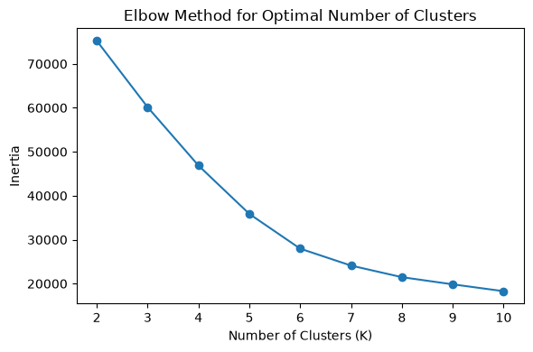
Figure 1. Executed notebook output — Elbow Method for candidate K values.
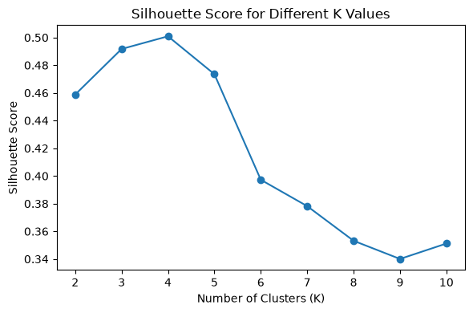
Figure 2. Executed notebook output — Silhouette Score for candidate K values.

5.1 Silhouette Results
Number of Clusters (K) | Silhouette Score
2 | 0.4588
3 | 0.4917
4 | 0.5009
5 | 0.4735
6 | 0.3972
7 | 0.3782
8 | 0.3532
9 | 0.3401
10 | 0.3512

Selection Decision: K = 4 was selected because it produced the highest Silhouette Score (0.5009) among the tested values from K = 2 to K = 10. The Elbow curve also shows a pronounced reduction in inertia through the lower K values, with the decline becoming less steep after the four-cluster solution.

6. K-Means Clustering
K-Means partitions observations into K groups by minimizing within-cluster squared distances to cluster centroids. The final model used the selected K = 4, random_state = 42 for reproducibility, and n_init = 10 to perform multiple centroid initializations and select a strong solution.
kmeans = KMeans(
n_clusters=best_k,
random_state=42,
n_init=10
)
kmeans_labels = kmeans.fit_predict(X_scaled)

6.1 K-Means Quality Metrics
Metric | K-Means Result | Interpretation
Silhouette Score | 0.5009 | Higher is better; indicates reasonably separated and cohesive groups.
Davies-Bouldin Index | 0.6154 | Lower is better; reflects compactness and separation.
Calinski-Harabasz Score | 6769.66 | Higher is better; indicates strong between-cluster separation relative to within-cluster dispersion.

The Silhouette Score of 0.5009 indicates a reasonably well-separated clustering structure in the standardized feature space. Together with the Davies-Bouldin and Calinski-Harabasz results, the metrics provide evidence that the four-cluster solution is suitable for the dataset.

7. Hierarchical Clustering and Model Comparison
Agglomerative Hierarchical Clustering was implemented with the same standardized feature matrix, the same selected number of clusters (K = 4), and Ward linkage. Keeping the preprocessing and K fixed makes the comparison focused on clustering behavior rather than different inputs.
hierarchical = AgglomerativeClustering(
n_clusters=best_k,
linkage='ward'
)
hierarchical_labels = hierarchical.fit_predict(X_scaled)

Model | Silhouette | Davies-Bouldin | Calinski-Harabasz
K-Means | 0.5009 | 0.6154 | 6769.66
Hierarchical Clustering | 0.4889 | 0.6326 | 6530.60

Model Decision: K-Means performs better on all three selected metrics: it has the higher Silhouette Score, lower Davies-Bouldin Index, and higher Calinski-Harabasz Score. Therefore, K-Means is retained as the final model.

8. PCA Visualization of Final Clusters
Principal Component Analysis (PCA) was used only to project the 8-dimensional standardized feature matrix into two dimensions for visualization. PCA is not the clustering model; the final K-Means labels were generated from the full standardized 8-feature space.
pca = PCA(n_components=2, random_state=42)
X_pca = pca.fit_transform(X_scaled)
print('PCA shape:', X_pca.shape)
print('Explained variance ratio:', pca.explained_variance_ratio_)
print('Total explained variance:',
round(pca.explained_variance_ratio_.sum(), 4))

PCA Output | Verified Result
PCA shape | (14223, 2)
PC1 explained variance | 0.35459244
PC2 explained variance | 0.28989659
Total explained variance | 0.6445 (64.45%)

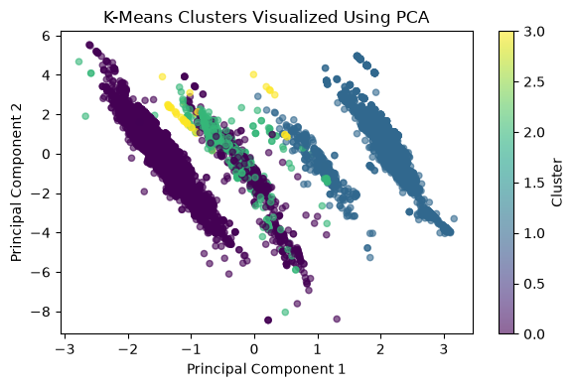
Figure 3. Final K-Means cluster assignments visualized in two PCA dimensions.
Observation: The first two principal components explain 64.45% of the standardized feature variance. The plot provides a compact visual representation of the four final groups; the actual model was trained in the original 8-dimensional standardized space.

9. Final Cluster Assignment and Profile
The selected K-Means labels were assigned back to the original cleaned dataset so that cluster characteristics could be interpreted in real-estate units. The final dataset contains the original 12 columns plus one cluster column, resulting in 13 columns.
df_analysis = df.copy()
df_analysis['cluster'] = final_labels
print('Final dataset shape:', df_analysis.shape)
print(df_analysis['cluster'].value_counts().sort_index())

Cluster | Properties | Share of Dataset
0 | 8,302 | 58.37%
1 | 5,585 | 39.27%
2 | 295 | 2.07%
3 | 41 | 0.29%

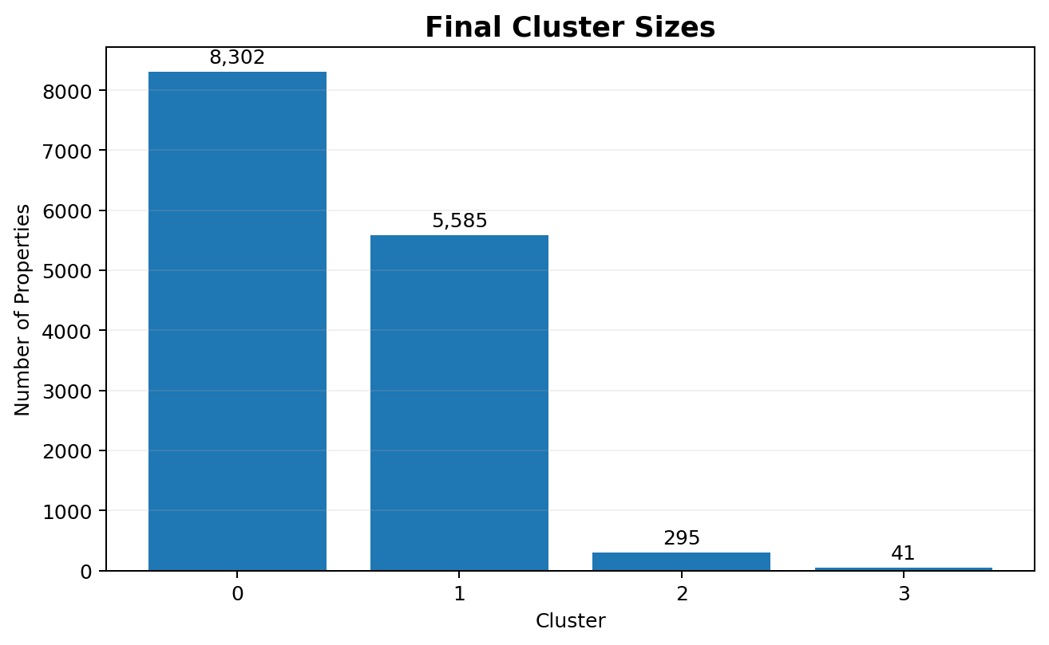
Figure 4. Final cluster sizes based on the verified K-Means assignments.

9.1 Numerical Cluster Profile
Cluster | Avg Price (₹) | Avg Area (sq ft) | Avg Rate/ sq ft (₹) | Avg BHK | Count
0 | 40,841,937.85 | 2,672.28 | 13,372.56 | 3.08 | 8,302
1 | 38,227,629.72 | 2,077.46 | 17,604.45 | 2.93 | 5,585
2 | 49,518,949.15 | 11,439.55 | 26,272.45 | 1.00 | 295
3 | 26,420,731.71 | 3,090.32 | 11,385.71 | 101.93 | 41

10. Cluster Composition Analysis

10.1 RERA Approval Composition
RERA approval was not used as a text category; it was encoded numerically for clustering. After clustering, the original approval field was cross-tabulated within each cluster to understand regulatory composition.
Cluster | Not RERA Approved | RERA Approved
0 | 100.00% | 0.00%
1 | 2.81% | 97.19%
2 | 95.93% | 4.07%
3 | 78.05% | 21.95%

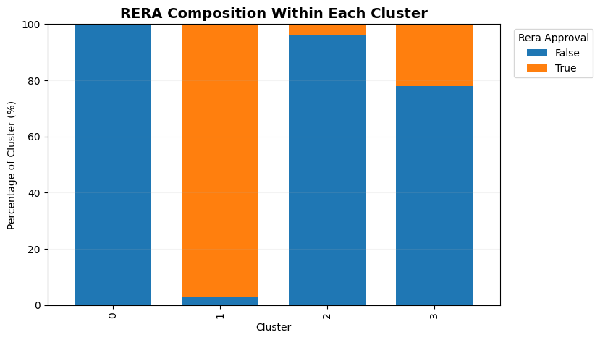
Figure 5. RERA approval composition within each final cluster.

10.2 Property Status Composition
Cluster | New | Ready to Move | Resale | Under Construction
0 | 5.77% | 94.23% | 0.00% | 0.00%
1 | 5.66% | 0.00% | 0.00% | 94.34%
2 | 0.00% | 0.00% | 100.00% | 0.00%
3 | 95.12% | 0.00% | 4.88% | 0.00%

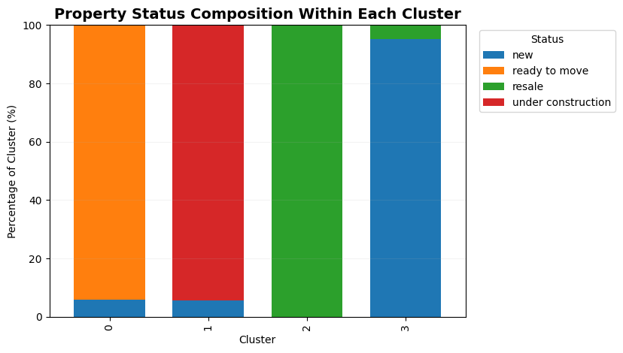
Figure 6. Property-status composition within each final cluster.

10.3 Flat Type Composition — Interpretation Only
Flat Type was intentionally excluded from the clustering feature matrix. It is analyzed here only to understand the composition of the clusters after the model has been trained. This avoids turning the clustering exercise into a direct reproduction of a categorical field.
Cluster | Apartment | Floor | House | Penthouse | Plot | Villa
0 | 71.32% | 8.64% | 0.37% | 0.37% | 16.85% | 2.45%
1 | 89.04% | 2.94% | 0.25% | 0.02% | 7.72% | 0.04%
2 | 0.00% | 0.00% | 0.00% | 0.00% | 100.00% | 0.00%
3 | 0.00% | 0.00% | 0.00% | 0.00% | 100.00% | 0.00%

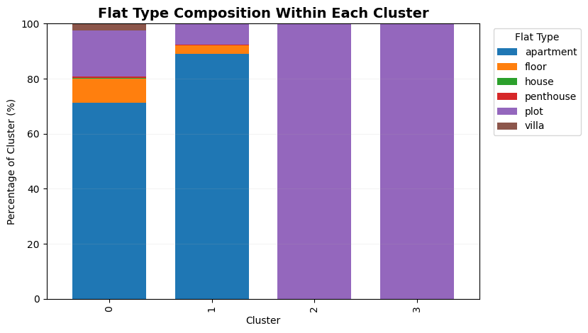
Figure 7. Flat-type composition of each final cluster, used for post-clustering interpretation.

11. Detailed Cluster Interpretation

Cluster 0 — Ready-to-Move Mainstream Segment
Cluster 0 is the largest group with 8,302 properties (58.37%). Its average price is ₹4.08 crore, average area is 2,672.28 sq ft, average rate is ₹13,372.56 per sq ft, and average BHK count is 3.08. It is 94.23% ready to move and 100% non-RERA approved. The group is mainly apartment-based (71.32%), with plots forming 16.85% and floors 8.64%.

Cluster 1 — RERA-Approved Under-Construction Segment
Cluster 1 contains 5,585 properties (39.27%). Average price is ₹3.82 crore, average area is 2,077.46 sq ft, average rate is ₹17,604.45 per sq ft, and average BHK count is 2.93. The cluster is 94.34% under construction and 97.19% RERA approved. Apartments account for 89.04% of the cluster, making it the clearest mainstream apartment segment in the final solution.

12. Detailed Cluster Interpretation (continued)

Cluster 2 — Large High-Value Resale Plot Segment
Cluster 2 is a specialized group containing 295 properties (2.07%). It has the highest average price at ₹4.95 crore, the largest average area at 11,439.55 sq ft, and the highest average rate at ₹26,272.45 per sq ft. Its average BHK count is 1.00. The cluster is 100% resale, 95.93% non-RERA approved, and 100% plot-type properties. Its combination of very large area, high unit rate, and resale status distinguishes it strongly from the two large mainstream clusters.

Cluster 3 — Small Unusual New-Property Plot Segment
Cluster 3 is the smallest group with only 41 properties (0.29%). Its average price is ₹2.64 crore and average area is 3,090.32 sq ft, while the average recorded BHK count is 101.93. It is 95.12% new and 4.88% resale, 78.05% non-RERA approved, and 100% plot-type. The very high average BHK value is therefore not interpreted as a conventional bedroom count; it is treated as an unusual data characteristic that warrants caution when describing this small segment.

13. Business and Research Implications
- Customer segmentation: The four clusters provide distinct property segments that can support different marketing messages, such as ready-to-move inventory versus under-construction properties.
- RERA-focused communication: Cluster 1 is strongly RERA approved, while Cluster 0 is entirely non-RERA approved. This contrast can help structure regulatory-information and buyer-communication strategies.
- Plot-focused strategy: Clusters 2 and 3 are entirely plot-based, but differ strongly in size, price, status, and scale. They can therefore be treated as specialized plot-market segments rather than one homogeneous category.
- Pricing strategy: Cluster 2 has the highest average unit rate and average price, suggesting a premium large-area segment. Cluster 1 has a higher average rate per sq ft than Cluster 0 despite having a lower average total price.
- Inventory planning: Most observations belong to Clusters 0 and 1. Business analysis can therefore prioritize these large segments while maintaining separate strategies for the smaller specialized clusters.

14. Key Findings
- K = 4 was selected because it produced the highest Silhouette Score among K = 2–10 (0.5009).
- K-Means outperformed Hierarchical Clustering on all three selected clustering metrics.
- The final segmentation contains two large mainstream clusters and two small specialized plot clusters.
- Cluster 0 is strongly associated with ready-to-move properties, while Cluster 1 is strongly associated with under-construction and RERA-approved properties.
- Cluster 2 is characterized by very large areas, high unit rates, resale status, and plot properties.
- Cluster 3 is very small and contains unusually high BHK_Count values; these should be interpreted cautiously rather than treated as conventional bedroom counts.

15. Limitations and Interpretation Notes
- Cluster labels are identifiers only; Cluster 0 is not inherently “better” than Cluster 1.
- The discovered groups depend on the selected variables and preprocessing pipeline. Excluding high-cardinality text fields makes the clustering more stable and interpretable, but it also means those fields do not contribute directly to cluster formation.
- Flat Type is used for interpretation rather than clustering because including it previously produced category-dominated groups.
- The very small Cluster 3 should be interpreted carefully because its average BHK_Count is driven by unusual values in only 41 records.
- PCA is a visualization technique here; it does not replace the original 8-dimensional clustering space.
- The analysis is segmentation-oriented and does not establish causal relationships between property characteristics and price.

16. Conclusion
The Week 3 unsupervised-learning workflow successfully segmented 14,223 Gurugram real-estate records into four data-driven clusters. After focused preprocessing, log transformation, and standardization, candidate values of K = 2–10 were evaluated. K = 4 achieved the highest Silhouette Score of 0.5009 and was selected for the final K-Means model.
K-Means was then compared with Agglomerative Hierarchical Clustering using the same standardized feature matrix and K = 4. K-Means achieved the stronger Silhouette Score, lower Davies-Bouldin Index, and higher Calinski-Harabasz Score, so it was retained as the final model.
The resulting segmentation separates the market into two dominant mainstream groups—ready-to-move and under-construction properties—and two smaller specialized plot groups. The cluster profiles and composition analysis provide an interpretable basis for property segmentation, targeted communication, inventory planning, and further research.

Appendix A — Core Implementation Code
The following consolidated snippets reproduce the principal executed steps used to prepare the clustering matrix, select K, train the final models, visualize the solution, and save the outputs.
# Load cleaned data
df = pd.read_csv('real_estate_cleaned.csv')
# Select clustering variables
df_model = df[
['price', 'area', 'rate_per_sqft', 'bhk_count',
'rera_approval', 'status']
].copy()
# Encode RERA and status
df_model['rera_approval'] = df_model['rera_approval'].astype(int)
df_encoded = pd.get_dummies(
df_model,
columns=['status'],
drop_first=True,
dtype=int
)
# Log transform skewed numeric variables
df_cluster = df_encoded.copy()
for col in ['price', 'area', 'rate_per_sqft']:
df_cluster[col] = np.log1p(df_cluster[col])
# Standardize
scaler = StandardScaler()
X_scaled = scaler.fit_transform(df_cluster)

# Select K using silhouette score
k_values = range(2, 11)
inertia = []
silhouette_scores = []
for k in k_values:
model = KMeans(n_clusters=k, random_state=42, n_init=10)
labels = model.fit_predict(X_scaled)
inertia.append(model.inertia_)
silhouette_scores.append(silhouette_score(X_scaled, labels))
k_results = pd.DataFrame({
'Number of Clusters': list(k_values),
'Silhouette Score': silhouette_scores
})
best_k = int(k_results.loc[
k_results['Silhouette Score'].idxmax(),
'Number of Clusters'
])
# Final K-Means
kmeans = KMeans(n_clusters=best_k, random_state=42, n_init=10)
kmeans_labels = kmeans.fit_predict(X_scaled)
# Hierarchical comparison
hierarchical = AgglomerativeClustering(
n_clusters=best_k, linkage='ward'
)
hierarchical_labels = hierarchical.fit_predict(X_scaled)

# PCA visualization
pca = PCA(n_components=2, random_state=42)
X_pca = pca.fit_transform(X_scaled)
# Final assignment and profile
df_analysis = df.copy()
df_analysis['cluster'] = kmeans_labels
cluster_profile = df_analysis.groupby('cluster')[
['price', 'area', 'rate_per_sqft', 'bhk_count']
].mean()
cluster_profile['property_count'] = (
df_analysis['cluster'].value_counts().sort_index()
)
# Save outputs
df_analysis.to_csv('real_estate_clustered.csv', index=False)
cluster_profile.to_csv('cluster_profile.csv')

Appendix B — Final Validation Output
Final dataset shape: (14223, 13)
Number of clusters: 4
Cluster counts:
0 8302
1 5585
2 295
3 41

Validation Item | Verified Result
Final dataset shape | (14223, 13)
Number of unique clusters | 4
Cluster labels | [0, 1, 2, 3]
Cluster 0 records | 8,302
Cluster 1 records | 5,585
Cluster 2 records | 295
Cluster 3 records | 41
Total records assigned | 14,223

Appendix C — Final Output Files
The completed workflow produced the final clustered dataset and the cluster profile used in this report.
Output File | Purpose
real_estate_clustered.csv | Cleaned real-estate dataset with the final K-Means cluster label added.
cluster_profile.csv | Original-scale cluster means and property counts.

