WEEK 6
INTEGRATIVE CAPSTONE PROJECT
End-to-End Data Science Pipeline for
Gurugram Real-Estate Price Prediction and Market Segmentation

Project Detail | Verified Value
Internship Track | Virtual Internship in Data Science using Python
Technical Domain | Data Science with Python
Project Area | Gurugram Real-Estate Analytics
Dataset After Cleaning | 14,223 unique records; 12 original columns
Supervised Learning | Random Forest Regressor — Test R² 69.86%
Unsupervised Learning | K-Means — K = 4; Silhouette 0.5009
Deep Learning | Scaled-Target ANN — Test R² 45.09%
Final Objective | Integrated data acquisition, preprocessing, EDA, clustering, prediction and evaluation

Technical verification: This capstone report consolidates the verified outputs documented across Weeks 1–5. Reported dimensions, metrics, cluster profiles, model results, code examples and visualizations are based on the supplied internship reports and their executed notebook outputs; no placeholder model results are introduced.

Six-Week Virtual Internship • Final Milestone

1. Executive Summary
This capstone project integrates the complete Data Science workflow developed during the six-week virtual internship using a Gurugram real-estate dataset. The work begins with acquisition and quality auditing of 19,515 raw property records, followed by cleaning and deduplication that produced 14,223 unique records with zero missing values. Exploratory analysis was then used to understand price distributions, property structure, unit rates, correlations, and statistical anomalies.
The project combines two complementary analytical goals. First, unsupervised learning is used to discover naturally occurring property segments without a target label. K-Means clustering with K = 4 was selected after evaluating candidate cluster counts and comparing K-Means with Agglomerative Hierarchical Clustering. Second, supervised learning and deep learning are used to predict property price as a continuous regression target.
Three conventional regression models were evaluated in Week 4. Random Forest was the strongest performer, achieving a held-out test R² of 69.86%, MAE of ₹11,532,540.78 and RMSE of ₹33,875,860.34, with a mean 5-fold cross-validation R² of 57.06%. Week 5 extended the same problem into deep learning through a compact Artificial Neural Network. The best neural-network configuration standardized the target and achieved a test R² of 45.09%, MAE of ₹17,913,580 and RMSE of ₹45,727,510.
The integrated findings show that the dataset supports meaningful property segmentation and useful price prediction, but extreme property values and a limited baseline feature set remain important challenges. The project therefore demonstrates not only model building, but also data-quality control, leakage prevention, model comparison, critical evaluation, and translation of analytical outputs into practical recommendations.
1.1 Capstone Objectives
- Demonstrate a complete and reproducible Data Science pipeline from raw data to final insights.
- Apply Python-based data cleaning and preprocessing to create a reliable analytical dataset.
- Use EDA to identify distributions, relationships, anomalies and important features.
- Apply unsupervised learning to discover meaningful property segments.
- Apply supervised regression and deep learning to predict property prices.
- Evaluate models using appropriate quantitative metrics and cross-validation where available.
- Compare methods critically and explain why the strongest model was selected.
- Translate findings into practical recommendations and future analytical improvements.
2. Problem Statement and Project Scope
Real-estate datasets contain a mixture of numerical measurements, categorical attributes, regulatory indicators and descriptive text. The central analytical problem in this project is to understand what can be learned from structured Gurugram property listings and to build reliable analytical models without introducing avoidable data-quality or target-leakage problems.
2.1 Problem Statement
The project addresses two related questions: (1) Can the available property characteristics be used to identify distinct groups of properties with similar market characteristics? and (2) Can the available characteristics be used to estimate the price of a property with useful predictive accuracy?
2.2 Analytical Scope
Stage | Purpose | Main Output
Data acquisition | Load and inspect the public/local CSV dataset | 19,515 × 12 raw DataFrame
Cleaning | Standardize schema, types, text and duplicates | 14,223 × 12 clean dataset
EDA | Understand distributions and relationships | Statistical and visual findings
Unsupervised learning | Discover property segments | 4 K-Means clusters
Supervised learning | Predict property price | Random Forest final model
Deep learning | Test neural-network regression | Scaled-target ANN
Integration | Compare evidence and derive recommendations | End-to-end capstone conclusions

2.3 Dataset Snapshot
Attribute | Verified Value
Raw records | 19,515
Records after duplicate removal | 14,223
Columns | 12
Missing values after cleaning | 0
Numerical focus | price, area, rate_per_sqft, bhk_count
Important categorical fields | status, property_type, locality, builder_name, society, company_name, flat_type
Model target | price
Core predictive features | area, bhk_count, rera_approval, status, flat_type

Data source context: The supplied Week 1 report documents the raw file as real_estate.csv containing residential property listings across Gurugram, including apartments, independent floors and plots.

3. Data Acquisition, Cleaning and Preprocessing
The first project phase established data quality. The raw dataset contained 19,515 rows and 12 columns. Initial inspection identified mixed-case column names, string-encoded financial fields, textual RERA approval values, inconsistent categorical formatting and duplicate records. The cleaning workflow addressed these issues systematically.
3.1 Cleaning Workflow
- Loaded the CSV into a Pandas DataFrame.
- Audited dimensions, columns, data types, missing values and duplicate records.
- Standardized column names to lowercase snake_case and corrected the Socity → society typo.
- Removed commas and whitespace from price and rate_per_sqft before converting them to float64.
- Removed exact duplicate rows, reducing the dataset from 19,515 to 14,223 records.
- Standardized categorical text using lowercase conversion and whitespace stripping.
- Mapped RERA approval text to Boolean values: approved by RERA → True and not approved by RERA → False.
- Validated the final schema and confirmed zero remaining duplicate records and zero null values.
df = pd.read_csv('real_estate.csv')
df.columns = (df.columns.str.strip()
.str.lower()
.str.replace(' ', '_'))
df = df.rename(columns={'socity': 'society'})
df['price'] = (df['price'].str.strip()
.str.replace(',', '')
.astype(float))
df['rate_per_sqft'] = (df['rate_per_sqft'].str.strip()
.str.replace(',', '')
.astype(float))
df = df.drop_duplicates()

3.2 Final Data Quality Status
Quality Check | Before Cleaning | After Cleaning
Rows | 19,515 | 14,223
Columns | 12 | 12
Exact duplicates | 5,292 duplicate records identified | 0 remaining
Missing values | Audited | 0
price datatype | String/object | float64
rate_per_sqft datatype | String/object | float64
RERA representation | Text status | Boolean
Column naming | Mixed case / spaces | lowercase snake_case

Interpretation: The 5,292 removed rows were exact duplicates. Unusual values such as very high BHK counts were retained because the project documentation treats them as unusual source characteristics requiring contextual interpretation rather than automatic deletion.

4. Exploratory Data Analysis
EDA was used to transform the cleaned dataset into evidence about distributions, relationships and anomalies. The analysis deliberately focused on variables that were useful for later modeling rather than producing unrelated charts.
4.1 Numerical Profile
Variable | Mean | Median | Minimum | Maximum
Price | ₹4.00 crore | ₹2.62 crore | ₹0.01 crore | ₹122.63 crore
Area | 2,621.8 sq ft | 2,015 sq ft | 60 | 958,320
Rate per sqft | ₹15,296 | ₹12,380 | ₹100 | ₹310,000
BHK Count | 3.27 | 3 | 0 | 132

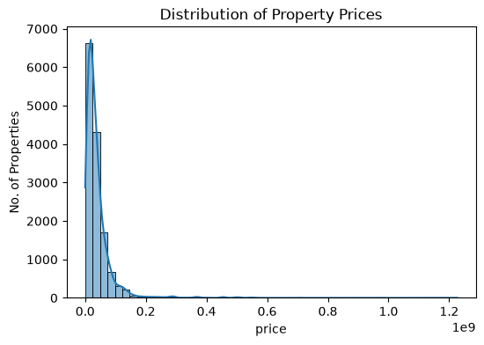
Figure 1. Distribution of property prices. The distribution is strongly right-skewed, with most observations at lower price levels and a long upper tail.
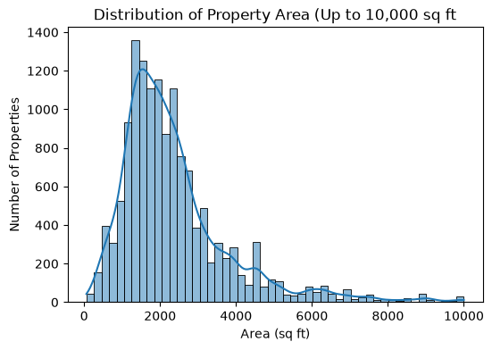
Figure 2. Distribution of property area for observations up to 10,000 sq ft. The plotting limit improves readability and does not modify the underlying dataset.
4.2 EDA Interpretation
- Property price is strongly right-skewed; a relatively small number of expensive properties extend the upper tail.
- Area is also highly skewed because the dataset contains very large properties and plots.
- Common residential configurations are concentrated around 2–4 BHK, while unusual high BHK values require contextual interpretation.
- The EDA indicates that robust target treatment and careful model evaluation are important for price prediction.
5. Relationships, Categories and Anomalies
5.1 Categorical Structure
Field | Key Observation
Status | Ready to move: 7,823; under construction: 5,269; new: 834; resale: 297
Flat type | Apartment: 10,894; Plot: 2,166; Floor: 881; Villa: 205; House: 45; Penthouse: 32
RERA | False: 8,774; True: 5,449
Company concentration | M3M is the most frequent company category in the supplied EDA

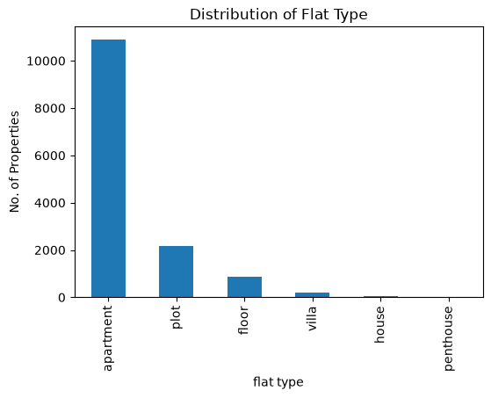
Figure 3. Distribution of flat type. Apartments dominate the inventory, followed by plots and floors.
5.2 Correlation Analysis
Relationship | Pearson r | Interpretation
Price vs Area | 0.1974 | Weak positive linear association
Price vs Rate per sqft | 0.6153 | Strongest simple linear association with price
Price vs BHK Count | 0.0581 | Very weak linear association

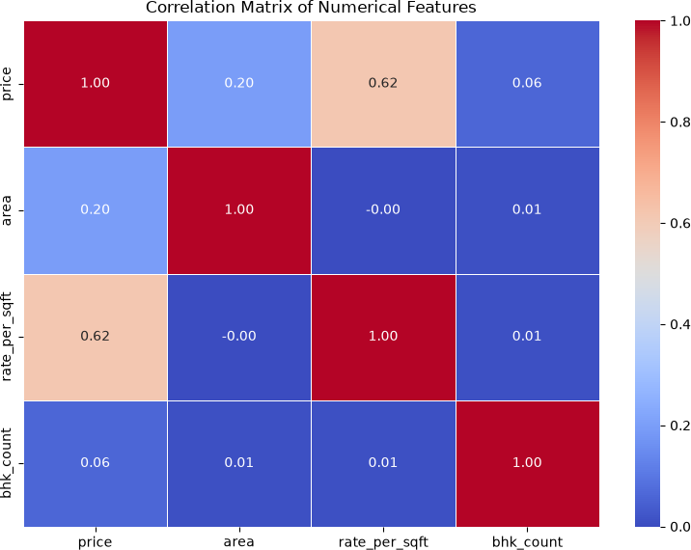
Figure 4. Correlation matrix of the four key numerical variables.
5.3 Outlier and Anomaly Analysis
The IQR analysis identified substantial upper-tail observations in price, area and rate per square foot. Approximately 6.8% of prices, 6.7% of areas and 3.3% of rate_per_sqft observations were beyond the corresponding IQR fences. These were treated as statistical outliers rather than automatically invalid records.
Important modeling decision: rate_per_sqft is useful for EDA and clustering, but it was excluded from the Week 4 supervised model and Week 5 neural network because it is derived from price and area and could expose target-derived information to a price-prediction model.

6. Unsupervised Learning: Property Segmentation
The unsupervised phase aimed to identify groups of properties without using a predefined target label. The final clustering matrix contained eight features: price, area, rate_per_sqft, bhk_count, rera_approval, and three one-hot status indicators. High-cardinality fields were excluded to avoid an excessively large and difficult-to-interpret feature space. Flat type was kept out of the clustering matrix because an earlier attempt showed that it could dominate the segmentation.
6.1 Preprocessing for Clustering
- Converted RERA approval to integer 0/1.
- One-hot encoded property status using drop_first=True.
- Applied log1p transformation to price, area and rate_per_sqft to reduce the influence of extreme magnitudes.
- Standardized all eight clustering features with StandardScaler.
- Evaluated K values from 2 through 10 using the Elbow Method and Silhouette Score.
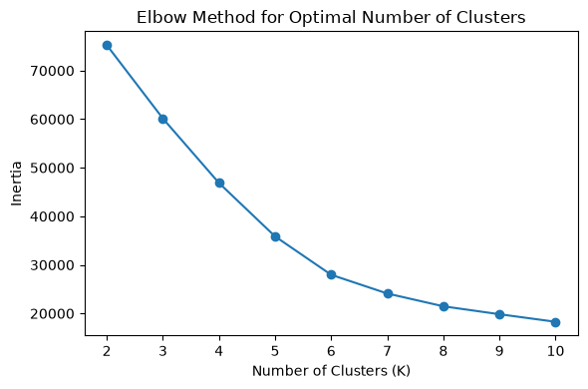
Figure 5. Elbow Method for selecting a suitable number of clusters.
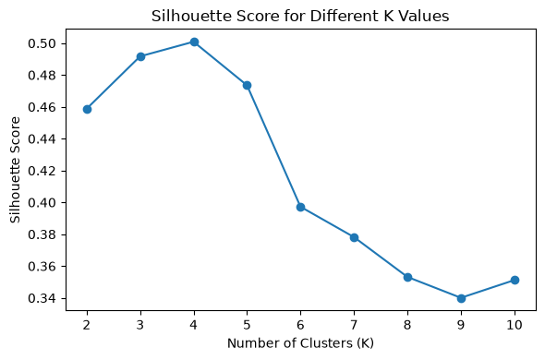
Figure 6. Silhouette scores for K = 2 through 10. K = 4 gives the highest score of 0.5009.
K | Silhouette
2 | 0.4588
3 | 0.4917
4 | 0.5009
5 | 0.4735
6 | 0.3972
7 | 0.3782
8 | 0.3532
9 | 0.3401
10 | 0.3512

Selection: K = 4 was selected because it produced the highest Silhouette Score among the tested values, while the Elbow curve also showed diminishing reductions in inertia after the four-cluster region.

7. Clustering Evaluation and Segment Profiles
7.1 K-Means vs Hierarchical Clustering
Model | Silhouette | Davies-Bouldin | Calinski-Harabasz | Decision
K-Means | 0.5009 | 0.6154 | 6769.66 | Selected
Agglomerative Hierarchical | 0.4889 | 0.6326 | 6530.60 | Not selected

K-Means outperformed hierarchical clustering on all three selected quality metrics: it had the higher Silhouette Score, lower Davies-Bouldin Index and higher Calinski-Harabasz Score. The four-cluster K-Means solution was therefore retained.
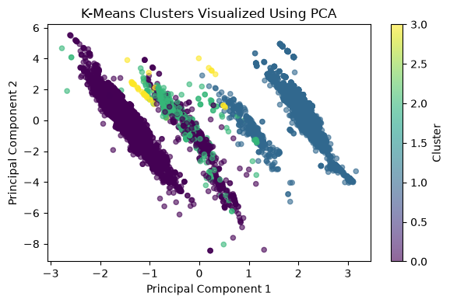
Figure 7. PCA projection of the final K-Means clusters. PCA is used only for visualization; the clustering itself was performed in the standardized eight-dimensional feature space.
7.2 Final Cluster Distribution
Cluster | Records | Share | High-Level Interpretation
0 | 8,302 | 58.37% | Ready-to-move mainstream segment
1 | 5,585 | 39.27% | RERA-approved under-construction segment
2 | 295 | 2.07% | Large, high-value resale plot segment
3 | 41 | 0.29% | Very small unusual plot segment with extreme BHK values

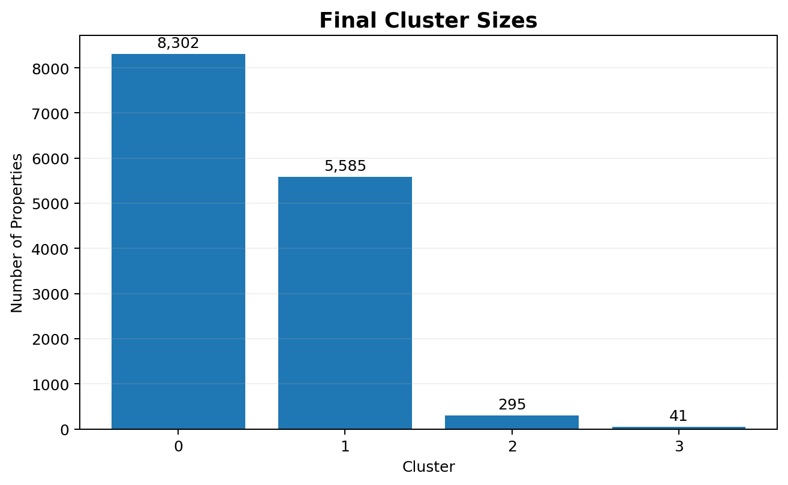
Figure 8. Final cluster sizes.
8. Detailed Market Segmentation Insights
Cluster | Average Price | Average Area | Avg Rate/sqft | Avg BHK | Key Characteristics
0 | ₹4.08 Cr | 2,672.28 | ₹13,372.56 | 3.08 | 94.23% ready; 100% non-RERA; 71.32% apartment
1 | ₹3.82 Cr | 2,077.46 | ₹17,604.45 | 2.93 | 94.34% under construction; 97.19% RERA; 89.04% apartment
2 | ₹4.95 Cr | 11,439.55 | ₹26,272.45 | 1.00 | 100% resale; 95.93% non-RERA; 100% plot
3 | ₹2.64 Cr | 3,090.32 | ₹11,385.71 | 101.93 | 95.12% new; 78.05% non-RERA; 100% plot

8.1 Interpretation
Cluster 0 is the dominant ready-to-move segment and represents the majority of the inventory. Cluster 1 is another large mainstream segment but differs strongly through its under-construction and RERA-approved composition. Cluster 2 is a specialized premium plot segment with very large average area and the highest average unit rate. Cluster 3 is extremely small and contains unusually high BHK_Count values; these should not be interpreted as conventional bedroom counts.
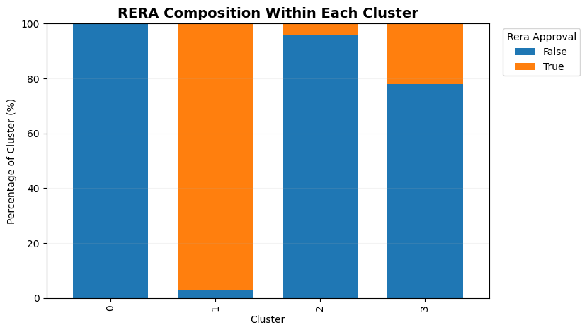
Figure 9. RERA approval composition within each cluster.
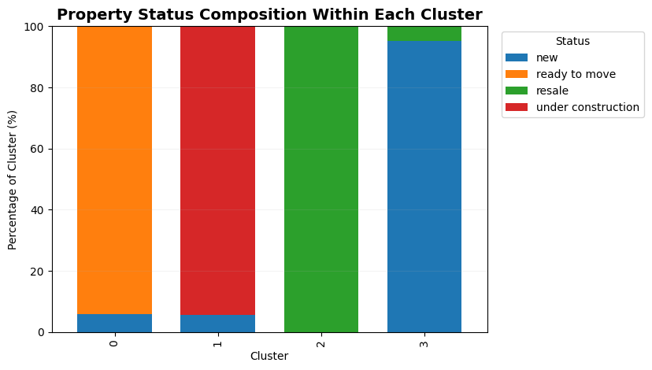
Figure 10. Property-status composition within each cluster.
8.2 Practical Value of Segmentation
- Customer segmentation can support different messaging for ready-to-move and under-construction inventory.
- RERA-related communication can be tailored because the large clusters have sharply different approval profiles.
- Plot-focused clusters can be treated separately from mainstream apartment inventory.
- Inventory planning can prioritize the two large clusters while maintaining specialized strategies for the smaller plot segments.
9. Supervised Learning: Property Price Prediction
The supervised-learning stage formulated property price as a regression problem because the target is continuous. The selected predictors were area, BHK count, RERA approval, status and flat type. The modeling workflow used consistent preprocessing, a 20% held-out test set and 5-fold cross-validation.
9.1 Feature Engineering and Leakage Control
Feature Group | Variables | Treatment
Numerical | area, bhk_count, rera_approval | Median imputation + StandardScaler
Categorical | status, flat_type | Most-frequent imputation + OneHotEncoder
Target | price | Continuous numerical target
Excluded | rate_per_sqft | Derived from price and area; potential target leakage
Excluded | property_type, locality, builder_name, society, company_name | High-cardinality baseline controls

X = df[['area', 'bhk_count', 'rera_approval', 'status', 'flat_type']].copy()
y = df['price'].copy()
X['rera_approval'] = X['rera_approval'].astype(int)
X_train, X_test, y_train, y_test = train_test_split(
X, y, test_size=0.20, random_state=42
)

9.2 Models Evaluated
Model | Role | Why Included
Linear Regression | Baseline | Simple reference for linear relationships
Random Forest Regressor | Nonlinear ensemble | Captures nonlinear effects and interactions
Gradient Boosting Regressor | Nonlinear ensemble | Sequentially reduces residual errors

9.3 Evaluation Metrics
MAE measures average absolute error in rupees; MSE penalizes large errors strongly; RMSE expresses the square root of MSE in price units; and R² measures the proportion of variation in held-out prices explained by the model. Because this is regression, classification accuracy is not an appropriate metric.
10. Supervised Model Evaluation
Model | MAE (₹) | RMSE (₹) | Test R² | Mean 5-Fold CV R²
Linear Regression | 26,157,218.16 | 59,533,165.64 | 6.93% | -16.67%
Random Forest | 11,532,540.78 | 33,875,860.34 | 69.86% | 57.06%
Gradient Boosting | 14,983,084.75 | 36,405,272.39 | 65.20% | 50.93%

10.1 Final Supervised Model
Random Forest was selected because it achieved the lowest test MAE and RMSE, the highest test R², and the highest mean cross-validated R² among the tested models. Its held-out R² of 69.86% indicates that approximately 69.86% of the variation in the test-set property prices is explained by the fitted model.
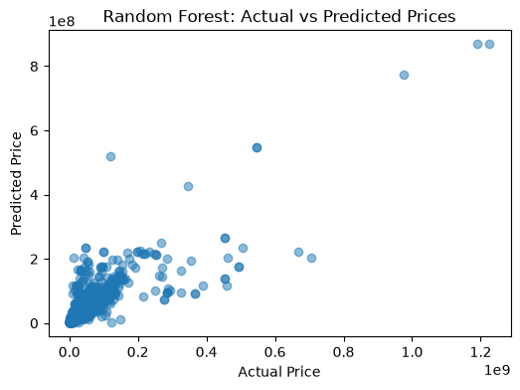
Figure 11. Random Forest actual versus predicted property prices on the test set.
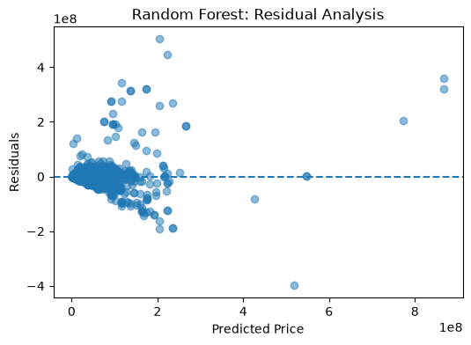
Figure 12. Random Forest residual analysis. Most residuals cluster around zero, while larger errors remain for some expensive properties.
10.2 Feature Importance
Rank | Feature | Importance
1 | area | 86.31%
2 | bhk_count | 6.62%
3 | rera_approval | 1.23%
4 | status — ready to move | 1.14%
5 | flat_type — plot | 0.99%

Interpretation caution: Random Forest feature importance describes how the model used variables for tree splits. It is not a causal statement and should not be interpreted as a literal percentage contribution to property price.

11. Deep Learning Application
The deep-learning stage extended the same regression problem into an Artificial Neural Network implemented with TensorFlow/Keras. The network used the same five core predictors as the supervised baseline, with numerical standardization and categorical one-hot encoding. The rate_per_sqft variable remained excluded to preserve leakage control.
11.1 Final ANN Architecture
Layer | Configuration | Purpose
Input | 11 processed features | Receives numerical and encoded categorical predictors
Dense 1 | 64 neurons, ReLU | Learns nonlinear representations
Dropout | 20% | Regularization
Dense 2 | 32 neurons, ReLU | Progressively smaller representation
Dropout | 20% | Regularization
Dense 3 | 16 neurons, ReLU | Compact nonlinear representation
Output | 1 linear neuron | Continuous price prediction

final_model = Sequential([
Dense(64, activation='relu', input_shape=(X_train_processed.shape[1],)),
Dropout(0.20),
Dense(32, activation='relu'),
Dropout(0.20),
Dense(16, activation='relu'),
Dense(1)
])
final_model.compile(optimizer='adam', loss='mse', metrics=['mae'])

11.2 Training Design
- Training/test split: 80% / 20% = 11,378 / 2,845 observations.
- Validation split: 20% of the training data.
- Maximum epochs: 100.
- Batch size: 32.
- Optimizer: Adam.
- Loss: Mean Squared Error.
- Early Stopping: patience = 10 with restore_best_weights=True.
- Final training history: 37 executed epochs; lowest validation loss 0.5543 at epoch 27.
Resource constraint: Training was performed on CPU because the supplied environment used native Windows TensorFlow without the standard CUDA GPU path for TensorFlow 2.11 and later. The compact network and Early Stopping kept the experiment manageable.

12. Deep Learning Experiments and Evaluation
Experiment | MAE (₹) | RMSE (₹) | R² | Decision
Baseline Neural Network | 26,499,670 | 60,081,280 | 5.20% | Baseline
Log-Transformed Neural Network | 25,269,770 | 61,653,280 | 0.18% | Rejected
Scaled-Target Neural Network | 17,913,580 | 45,727,510 | 45.09% | Selected

The baseline neural network was trained directly on raw price values and achieved only 5.20% R². A log1p(price) experiment slightly improved MAE but increased RMSE and reduced R² to 0.18%, so it was rejected. Standardizing the target before training produced a substantial improvement and became the final deep-learning configuration.
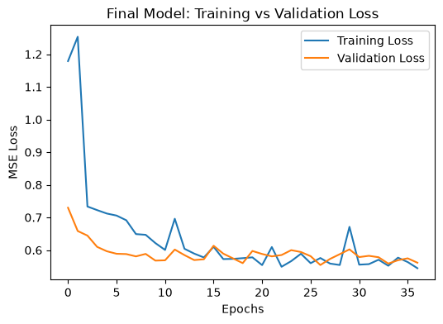
Figure 13. Final ANN training and validation MSE loss over 37 executed epochs. The curves stabilize without a sustained late-stage divergence.
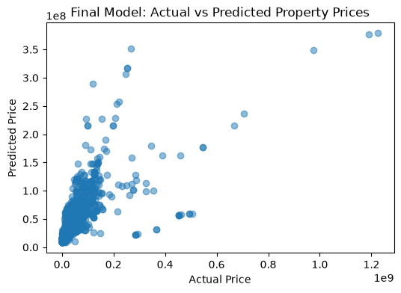
Figure 14. Final scaled-target ANN actual versus predicted prices.
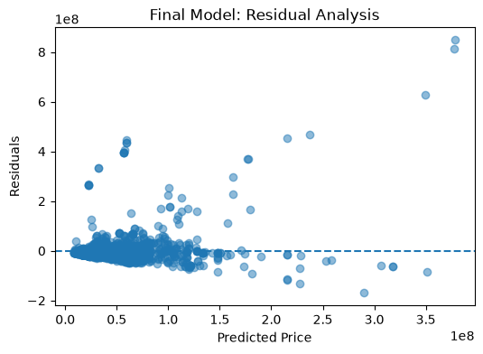
Figure 15. Final scaled-target ANN residual analysis.
Deep-learning conclusion: The scaled-target ANN learned meaningful price patterns, but it did not outperform the Random Forest model on this tabular dataset and feature set. This is an important capstone result rather than a weakness to hide: the project evaluates methods on evidence, not on the assumption that deep learning must always win.

13. Integrated Model Comparison
The capstone combines descriptive segmentation with two families of predictive models. The unsupervised method answers a different question from the regression models, so its quality metrics should not be compared numerically with R². Instead, the methods are evaluated according to their respective objectives.
Approach | Final Method | Primary Metric / Result | Main Contribution
Unsupervised | K-Means, K=4 | Silhouette 0.5009 | Discovers four interpretable property segments
Supervised | Random Forest | R² 69.86%; CV R² 57.06% | Strongest tested price-prediction model
Deep Learning | Scaled-Target ANN | R² 45.09% | Demonstrates neural-network regression and target-scaling benefit

13.1 Critical Evaluation
- Random Forest is the strongest predictive model in the executed project, outperforming Gradient Boosting and Linear Regression on the reported test and cross-validation metrics.
- The neural network benefits strongly from target standardization, but its 45.09% R² remains below Random Forest's 69.86% test R².
- The difference between Random Forest test R² and mean cross-validation R² indicates that performance varies across data partitions.
- Extreme property prices create larger residuals and make the regression problem harder.
- The feature set is deliberately focused and interpretable, but excluding detailed locality, builder, society and company information limits predictive richness.
- The rate_per_sqft feature has a strong EDA correlation with price, yet excluding it from price-prediction models is methodologically correct because it is derived from the target.
13.2 What the Models Teach Together
The integrated workflow shows that different Data Science methods provide different kinds of value. Clustering exposes market structure, Random Forest provides the strongest tested price prediction, and the neural network demonstrates how representation and target scaling can affect deep-learning optimization. Together, these results provide a more complete understanding than any single model alone.
14. Key Insights and Recommendations
14.1 Key Insights
- The cleaned dataset contains 14,223 unique property records with zero missing values.
- Property prices are highly right-skewed, with a long upper tail created by expensive properties.
- Rate per square foot has the strongest simple Pearson correlation with price (0.6153), followed by area (0.1974).
- Area is overwhelmingly the most important predictor in the Random Forest model, with 86.31% feature importance.
- The market naturally separates into two large mainstream segments and two smaller specialized plot segments under the selected K-Means solution.
- Cluster 0 is predominantly ready-to-move and non-RERA, while Cluster 1 is predominantly under construction and RERA approved.
- Cluster 2 represents a premium, large-area resale plot segment with the highest average unit rate.
- The supervised Random Forest provides the strongest price-prediction performance among the tested models.
- The scaled-target neural network substantially improves on the baseline ANN but remains below the Random Forest result.
14.2 Recommendations
Area | Recommendation
Marketing | Use cluster-specific messaging for ready-to-move, under-construction and specialized plot inventory.
Pricing | Use the Random Forest model as an analytical benchmark, while treating high-value predictions with additional caution.
Regulatory communication | Highlight RERA status explicitly because the major clusters show strong differences in approval composition.
Inventory planning | Prioritize the large Cluster 0 and Cluster 1 segments while maintaining separate strategies for specialized plot segments.
Data strategy | Collect richer location, builder, society, amenity and market-context features for future modeling.

14.3 Recommended Analytical Use
The models should be treated as analytical decision-support tools rather than professional property valuation systems. Predictions should be reviewed alongside actual market conditions, locality-specific information and property-specific factors that are not represented in the current baseline feature set.
15. Challenges, Limitations and Future Scope
15.1 Challenges Encountered
- Duplicate listings required substantial cleaning before analysis; 5,292 duplicate records were removed.
- Financial values were stored as formatted strings and required numeric conversion.
- The dataset contains extreme price and area observations that strongly influence distributions and regression errors.
- High-cardinality text fields complicate direct encoding and can create large, difficult-to-interpret feature spaces.
- Target leakage had to be actively controlled by excluding rate_per_sqft from price-prediction models.
- The neural-network experiments were trained on CPU, making a compact architecture and Early Stopping useful for computational efficiency.
- Some source attributes, especially unusual BHK counts, require contextual interpretation rather than automatic deletion.
15.2 Limitations
- The predictive models use a limited set of property characteristics.
- Detailed locality, builder, society, company and property-description information was not incorporated into the baseline predictive models.
- Extreme high-value properties remain difficult to predict accurately.
- Cluster labels describe groups rather than inherently better or worse properties.
- The current analysis is based on listing data and does not capture every market, temporal or transaction-level factor.
- Model performance should not be interpreted as professional valuation accuracy.
15.3 Future Scope
- Engineer locality-aware features using carefully controlled encoding methods.
- Add amenities, floor, age, furnishing, proximity and market-context variables where available.
- Perform systematic hyperparameter tuning for Random Forest, Gradient Boosting and neural networks.
- Evaluate performance separately across price bands and property types.
- Use repeated cross-validation or multiple random seeds to quantify stability.
- Experiment with robust target transformations and alternative loss functions for extreme-price observations.
- Compare the neural network against tuned tree ensembles using a consistent validation framework.
- Build a deployment-oriented pipeline only after stronger validation and richer feature coverage.
16. Conclusion
This capstone demonstrates a complete Data Science workflow using Python on a Gurugram real-estate dataset. The project begins with raw-data acquisition and quality auditing, progresses through cleaning and exploratory analysis, and then applies both unsupervised and supervised learning before extending the prediction task to deep learning.
The data-cleaning stage transformed 19,515 raw records into 14,223 unique and validated observations. EDA established that property prices are strongly right-skewed and that rate_per_sqft has the strongest simple linear association with price. The unsupervised phase identified four property segments, with K-Means outperforming Agglomerative Hierarchical Clustering across the selected clustering metrics.
For price prediction, Random Forest was the strongest executed model, achieving a test R² of 69.86% and mean 5-fold cross-validation R² of 57.06%. The deep-learning phase demonstrated that target representation matters: the scaled-target ANN reached 45.09% R², substantially improving on the raw-target baseline but remaining below the Random Forest model.
The final outcome is therefore not simply a single prediction model. It is an integrated analytical pipeline that connects data quality, EDA, segmentation, predictive modeling, deep learning, evaluation and practical interpretation. The project also demonstrates the importance of methodological discipline: avoiding target leakage, interpreting outliers carefully, validating models on held-out data, and selecting models based on evidence rather than algorithm popularity.
Overall capstone outcome: The project successfully demonstrates the core Data Science competencies required by the Week 6 task: data acquisition, preprocessing, exploratory analysis, unsupervised learning, supervised learning, deep learning, evaluation, critical analysis, insights and recommendations.

17. Representative Python Code and Workflow Appendix
17.1 Reproducible Preprocessing Pipeline
numerical_transformer = Pipeline([
('imputer', SimpleImputer(strategy='median')),
('scaler', StandardScaler())
])
categorical_transformer = Pipeline([
('imputer', SimpleImputer(strategy='most_frequent')),
('onehot', OneHotEncoder(handle_unknown='ignore', drop='first'))
])
preprocessor = ColumnTransformer([
('num', numerical_transformer, ['area','bhk_count','rera_approval']),
('cat', categorical_transformer, ['status','flat_type'])
])

17.2 Random Forest Implementation
random_forest_model = Pipeline([
('preprocessor', preprocessor),
('model', RandomForestRegressor(
n_estimators=100,
random_state=42,
n_jobs=-1
))
])
random_forest_model.fit(X_train, y_train)
random_forest_predictions = random_forest_model.predict(X_test)

17.3 K-Means and PCA Workflow
kmeans = KMeans(n_clusters=4, random_state=42, n_init=10)
kmeans_labels = kmeans.fit_predict(X_scaled)
pca = PCA(n_components=2, random_state=42)
X_pca = pca.fit_transform(X_scaled)
df_analysis = df.copy()
df_analysis['cluster'] = kmeans_labels

17.4 Deep-Learning Target Scaling and Evaluation
y_scaler = StandardScaler()
y_train_scaled = y_scaler.fit_transform(
y_train.values.reshape(-1, 1)
).flatten()
final_history = final_model.fit(
X_train_processed,
y_train_scaled,
validation_split=0.20,
epochs=100,
batch_size=32,
callbacks=[final_early_stopping],
verbose=1
)
y_pred_scaled = final_model.predict(X_test_processed).flatten()
y_pred_final = y_scaler.inverse_transform(
y_pred_scaled.reshape(-1, 1)
).flatten()

17.5 Final Project Outputs
Output | Purpose
Cleaned real-estate dataset | Validated 14,223-record analytical base
Clustered dataset / cluster profile | Property segments and segment-level statistics
Random Forest predictions | Held-out actual, predicted and residual values
Deep-learning predictions | ANN test predictions and residuals
Deep-learning training history | Training/validation loss and MAE across 37 epochs
Capstone report | Integrated documentation of the six-week workflow

