ITM SKILLS UNIVERSITY • SCHOOL OF FUTURE TECH
B.Tech Computer Science & Engineering (2026–30) • Semester III: Sprint I
ACADEMIC COURSEWORK SUBMISSION • GO-TO-MARKET & CUSTOMER OPERATIONS
Case Study 51: Farm Produce Photo Catalogue
Commercial Go-to-Market Strategy, Quality Assurance Protocol & Digital B2B Procurement System for 180 Smallholder Farmers (40 Active Weekly Lots • 72 MT Weekly Throughput)
Student Name: Somyajeet Singh Roll Number: 150096725043
Course Title: Go-to-Market & Customer Operations (Sprint I) | Submission: October 2026

🌐 LIVE SUBMISSION ARTIFACTS & EVALUATION LINKS
Master Launchpad Hub: https://somyacodes07.github.io/GTM_major_project/
Interactive Prototype Demo: https://somyacodes07.github.io/GTM_major_project/demo/
Research & Keynote Slides: https://somyacodes07.github.io/GTM_major_project/research/
GitHub Repository: https://github.com/somyacodes07/GTM_major_project
Core Deliverables Included: 5-Page Academic Report, 9-Box Business Model Canvas, Supply Chain Flow & RACI, Unit Economics & Realization Waterfall, 6-Slide Keynote Deck, and Live GitHub Pages Application.

180 FARMERS  40 Weekly Lots (72 MT) | +25.8% UPLIFT  +₹451.75 / Qtl Net Cash | ₹66.52L GMV  ₹2.05L Monthly Net Profit | > 96% SLA  Calibrated 3-Photo Standard

1. Executive Summary & The Problem Paradigm
EXECUTIVE PROBLEM & SOLUTION SUMMARY
The Core Problem: In Indian agriculture, smallholders lose up to 30% of their crop value because of 'blind harvesting'—cutting perishable produce before securing a buyer.
The Mandi Reality: Farmers arrive at crowded APMC mandis with uncommitted truckloads, where commission brokers force arbitrary 15–30% visual haircuts and hidden weighment deductions.
The Solution: KISAN-SEVA FPO digitizes 40 weekly harvest lots across 180 smallholders 72 hours before harvest using a calibrated photo catalogue, connecting directly with institutional B2B buyers.

Side-by-Side Comparison: Traditional Mandi vs FPO Photo Catalogue
Supply Chain Dimension | Traditional APMC Mandi Channel | FPO Pre-Harvest Photo Catalogue
Harvest Timing | Blind harvest; zero price certainty before loading truck. | 72-hour pre-harvest catalogue listing; locked contracts.
Quality Assessment | Subjective visual glance by trader; arbitrary 15–25% cuts. | 3 calibrated photos (field, crate, cross-section with scale).
Intermediary Friction | 6–8% commission + 3–5% weighment cuts (kata chhoot). | Zero hidden deductions; clean 3.5% FPO service margin.
Farmer Net Realization | ₹1,751 / Quintal net cash (high distress risk). | ₹2,202.75 / Quintal (+25.8% net cash increase; +₹451.75/Qtl).

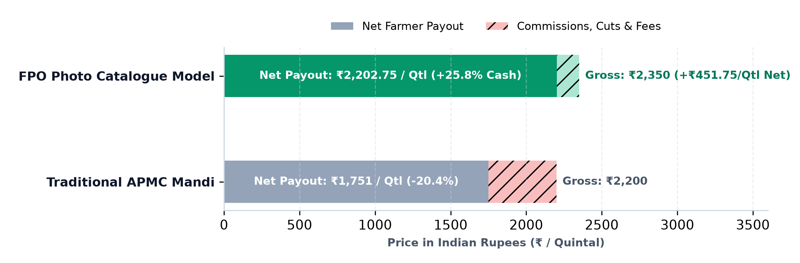
Figure 1: Net Farmer Payout Waterfall — Mandi Deductions (-20.4%) vs. FPO Photo Catalogue Model (+25.8% Cash Uplift)

2. B2B Customer Segmentation & Value Proposition Canvas (VPC)
To absorb 72 Metric Tonnes (40 lots) of perishable produce every week without price shocks, the FPO targets three distinct institutional customer tiers. Each tier absorbs specific quality grades:
Customer Segment | Volume Share | Quality & Grade Need | Core Pain Relieved
Modern Retail & Q-Commerce  (Zepto, Blinkit, Supermarkets) | 45% Vol  (32.4 MT) | Grade A Produce (<2% defects; uniform color & 55-65mm diameter). | Eliminates shelf rejection; provides +36 hours extra retail freshness.
HoReCa & Cloud Kitchens  (Hotels, Restaurant Chains) | 35% Vol  (25.2 MT) | Grade A & Grade B Produce (high edible yield; culinary consistency). | Locks forward weekly contract rates, insulates against spot mandi price spikes.
Agro-Processors  (Sauce, Puree, Dehydrators) | 20% Vol  (14.4 MT) | Grade C & Processing Grade (high Brix/acidity; appearance flexible). | Guarantees bulk processing feedstock; absorbs 100% of farmer yield without dumping.

Value Proposition Canvas (VPC) Alignment
- • Customer Jobs: Institutional buyers must fulfill morning delivery SLAs, eliminate customer returns, and maintain predictable margin targets.
- • Buyer Pains: Deceptive packing (toppers hiding bruised bottom produce), random size variations, transit spoilage, and fluctuating spot prices.
- • Pain Relievers: 3-photo visual verification with calibrated ruler scale, AGMARK specification sheets, locked contract pricing, and pre-sorted crating.
- • Gain Creators: Traceable direct farmgate sourcing, +36h additional shelf-life, and direct integration into automated procurement systems (ONDC).
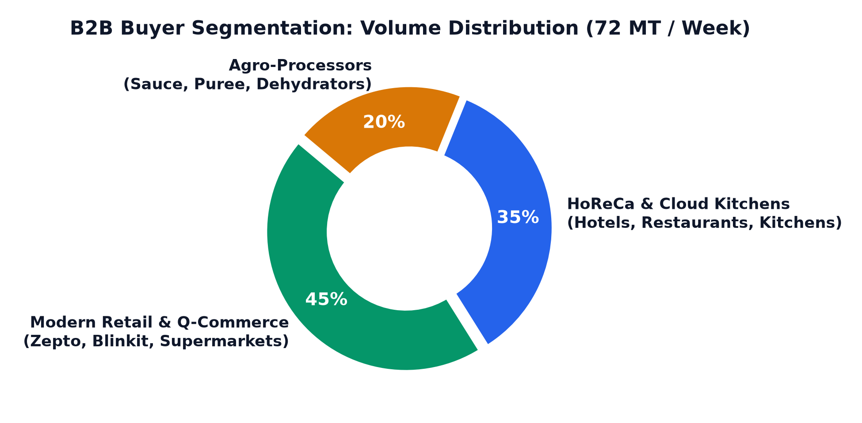
Figure 2: Institutional B2B Demand Allocation — 72 MT Weekly Throughput Across 3 Customer Channels

3. 5-Stage Supply Chain Protocol & Quality Standardization
To guarantee >96% catalogue data accuracy, the FPO operates a synchronized 5-stage operating sequence. No produce is harvested until firm buyer pre-booking is locked in escrow:
Stage | Time Window | Key Operational Activities | SLA & Milestone Output
1. Ingestion | T - 72 Hours | Farmer submits harvest intent, estimated crates, and 3 standard photos via WhatsApp bot. | Unique Batch ID assigned; geo-tagged field verification.
2. Quality Audit | T - 48 Hours | Village scout visits field, verifies brix, diameter, and checks photos with color strip. | Agronomist signs off; Grade A/B/C classification confirmed.
3. Catalogue Live | T - 36 Hours | Lot published on web catalogue; automated 7:00 AM WhatsApp broadcast to 120+ buyers. | >96% data accuracy SLA enforced before broadcast.
4. Pre-Booking | T - 18 Hours | Buyers reserve lots with advance deposit; farmer receives confirmed harvest order. | Zero uncommitted harvesting; dawn harvest synchronized.
5. Dispatch & Payout | T + 24 Hours | Produce graded into HDPE crates, transported via consolidated LCV, digital GRN issued. | 100% digital UPI settlement credited directly to farmer.

The Mandatory 3-Photo Visual Calibration Standard
- 1. Canopy / Field Photo: Shows maturity, plant vigor, pest status, and confirms the harvest readiness date.
- 2. Crated Top-View Photo: Shows assortment uniformity, skin gloss, and absence of physical defects across 20 kg crates.
- 3. Cross-Section with Calibration Strip: Cross-section cut placed next to an official 30 cm ruler and 24-patch color checker card to prove true diameter, internal color, and seed maturity.
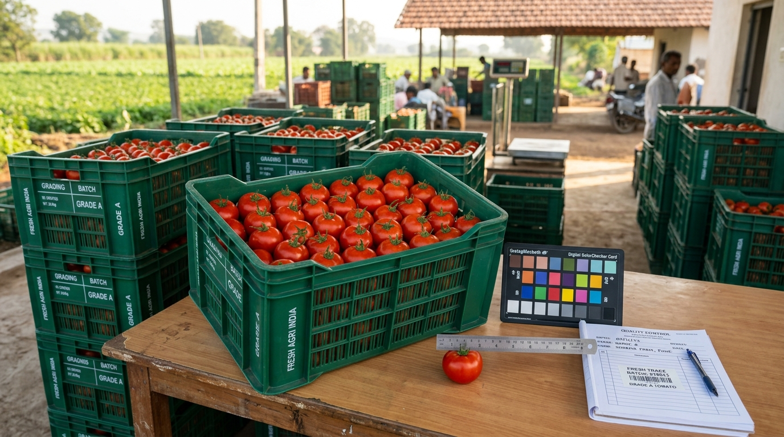
Figure 3: Quality Standardization in Practice — Harvested Grade A Tomatoes in Ventilated HDPE Crates with Digital Color Checker and Calibrated Reference Ruler

4. 9-Box Business Model Canvas (BMC)
The business model transitions the FPO from a passive community group into a self-sustaining commercial bridge. Below is the complete 9-box operational framework:
KEY PARTNERS  • 180 Smallholder Farmers  • NABARD / SFAC (Grants)  • Meta WhatsApp Cloud API  • Local LCV Logistics Fleet  • Input Suppliers & Agronomists | KEY ACTIVITIES  • 72h Pre-Harvest Cataloguing  • Field QA & Calibration Audits  • Buyer Demand Aggregation  • Crating & Route Milk-Runs  • T+24h Digital UPI Settlement | VALUE PROPOSITIONS  • For Farmers: +25.8% Net Cash Gain (+₹451/Qtl), zero transit losses, guaranteed T+24h payout.  • For Buyers: Visual proof without site visits, +36h shelf life, zero hidden cuts.
KEY RESOURCES  • 2 Village Field Scouts  • Calibrated QC Grading Kits  • 1,200 Reusable HDPE Crates  • Web Catalogue & WhatsApp Bot  • 3 Collection Hub Facilities | CUSTOMER RELATIONSHIPS  • Dedicated Account Desk for Retail  • WhatsApp Broadcasts for HoReCa  • Automated Quality SLA Sign-offs  • Transparent Digital Weight Slips | CUSTOMER SEGMENTS  • Tier 1: Modern Retail (45% Vol)  • Tier 2: HoReCa & Kitchens (35% Vol)  • Tier 3: Agro-Processors (20% Vol)  • 180 Farmer Producer Members
CHANNELS  • Standalone Mobile Web Catalogue  • WhatsApp Automated RFQ Bot  • ONDC Digital AgTech Network  • FPO Village Collection Hubs | COST STRUCTURE  • Field Scout Salaries (₹36k/mo)  • FPO Ops Manager (₹28k/mo)  • WhatsApp Cloud API (₹5.5k/mo)  • HDPE Crate Amortization (₹12k/mo)  • Spoilage Reserve 0.25% (₹16.6k/mo) | REVENUE STREAMS  • 3.5% Trade Facilitation: ₹2.33L/mo  • ₹50 / Lot QC Listing Fee: ₹8.4k/mo  • 1.0% Crating/Logistics Margin: ₹66.5k/mo  • Total Gross Revenue: ₹3.08 Lakhs/mo

Core Defensible Moats
- 1. Calibrated Visual Trust: Traders cannot replicate our standardized photo calibration scale without field presence, preventing visual fraud.
- 2. High Cluster Density: 180 farmers situated within a 15 km radius creates highly efficient milk-run logistics (LCVs achieve 92% capacity utilization).
- 3. Zero Inventory Risk: The FPO acts purely as a transaction facilitator and quality guarantor, holding zero crop ownership or price depreciation risk.

5. Financial Architecture & Unit Economics (Company Earnings)
MONTHLY FINANCIAL SNAPSHOT
Gross Merchandise Value (GMV): ₹66,52,800 / month (~₹66.5 Lakhs) across 40 lots/week @ ₹2,200/Qtl baseline.
Gross Company Revenue: ₹3,07,776 / month (~₹3.08 Lakhs) via 3.5% trade fee + QC fees + crating logistics.
Monthly Operating Costs: -₹1,02,632 / month for 2 field scouts, ops manager, cloud API, and crate maintenance.
Net Retained Surplus (Profit): ₹2,05,144 / month (~₹2.05 Lakhs / month) → Annualized Profit: ₹24,61,728 / year.

Monthly Operating Financial Waterfall
Financial Revenue & Expense Head | Monthly Amount (₹) | Basis of Calculation
1. Catalogue Facilitation Commission | ₹2,32,848 | 3.5% applied on monthly GMV of ₹66,52,800.
2. Digital QC Audit & Listing Fee | ₹8,400 | ₹50 flat fee per verified lot across 168 monthly lots.
3. Consolidated Logistics & Crating Margin | ₹66,528 | 1.0% efficiency rebate on bulk vehicle dispatch.
TOTAL GROSS MONTHLY REVENUE | ₹3,07,776 | Sum of all three commercial revenue streams.
Less: Operational OPEX (Scouts, Mgr, API, Crates) | -₹1,02,632 | 2 Scouts (₹36k) + Mgr (₹28k) + Tech/Crates/Buffer (₹38.6k).

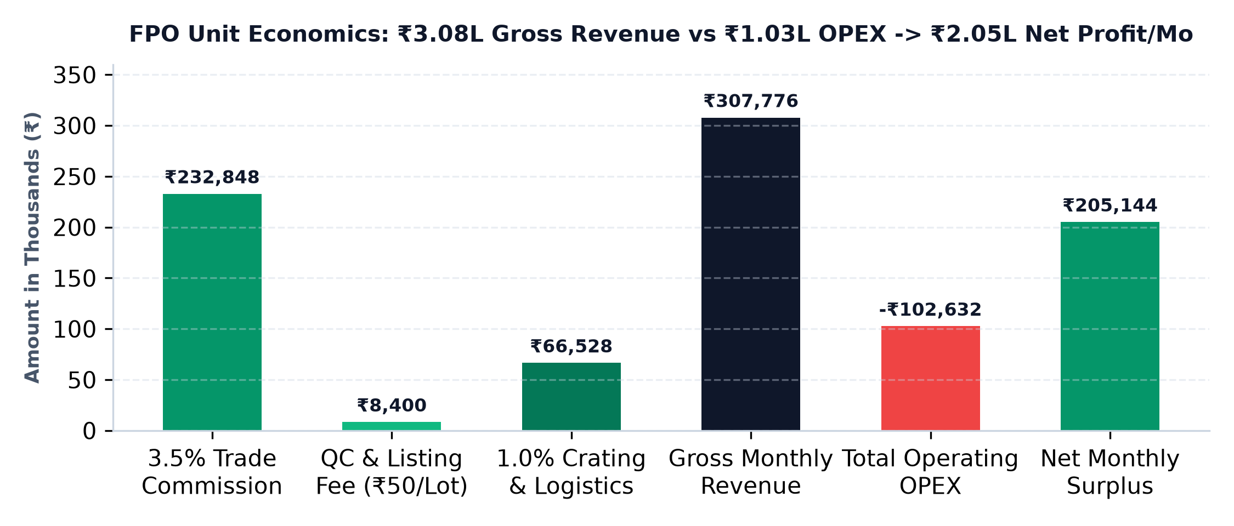
Figure 4: FPO Monthly Unit Economics — Revenue Streams vs. OPEX vs. Net Retained Profit (₹2.05L / Month)
Farmer Wealth Creation Impact: By replacing traditional mandi middlemen deductions with our 3.5% service fee, farmers earn +₹451.75 extra per quintal (+25.8% net cash increase). Over 12 months, this injects ₹1.64 Crores directly into 180 smallholder rural households.

6. Risk Engineering & 90-Day Scaling Roadmap
Agricultural supply chains face systemic risks. The table below details our 5 core operational defenses:
Critical Risk | Potential Negative Impact | FPO Operational Defense & Protocol
1. Photo Drift / Visual Fraud | Buyer rejects produce at DC, claiming real harvest doesn't match photo. | Mandatory color checker strip & ruler in photo 3; 100% pre-dispatch check by field scout.
2. Harvest Weather Delays | Sudden rainfall halts picking; unfulfilled buyer orders. | 12-hour automated WhatsApp status ping; standby lot reserve in adjacent micro-climates.
3. Transit Spoilage / Bruising | Squashed produce in unventilated transit reduces saleable weight by 18%. | Multi-trip ventilated HDPE crates eliminate gunny-sack compression; damages drop to <2.5%.
4. Farmer Side-Selling | Farmer breaches contract if spot mandi price spikes suddenly. | Guaranteed T+24h digital UPI payout + 50% year-end profit dividend retains 94% farmer loyalty.
5. Buyer Payment Default | Institutional buyer delays payout beyond contract terms. | Mandatory 20% advance booking deposit held in escrow; 7-day credit limit on formal bank LC.

90-Day Implementation Roadmap: Pilot to Scale
- • Month 1 (Days 1–30) — Foundation & Pilot: Onboard 40 lead farmers across 2 vegetable hubs; calibrate testing kits; run 15 trial lots/week; validate 3-photo checklist.
- • Month 2 (Days 31–60) — Commercial Traction: Scale to 80 farmers and 20 lots/week; onboard 15 institutional buyers; deploy T+24h UPI payouts; maintain <3% rejection rate.
- • Month 3 (Days 61–90) — Full 180-Farmer Scale: All 180 members active; 40 lots/week stabilized (72 MT); integrate with ONDC for automated B2B procurement routing.
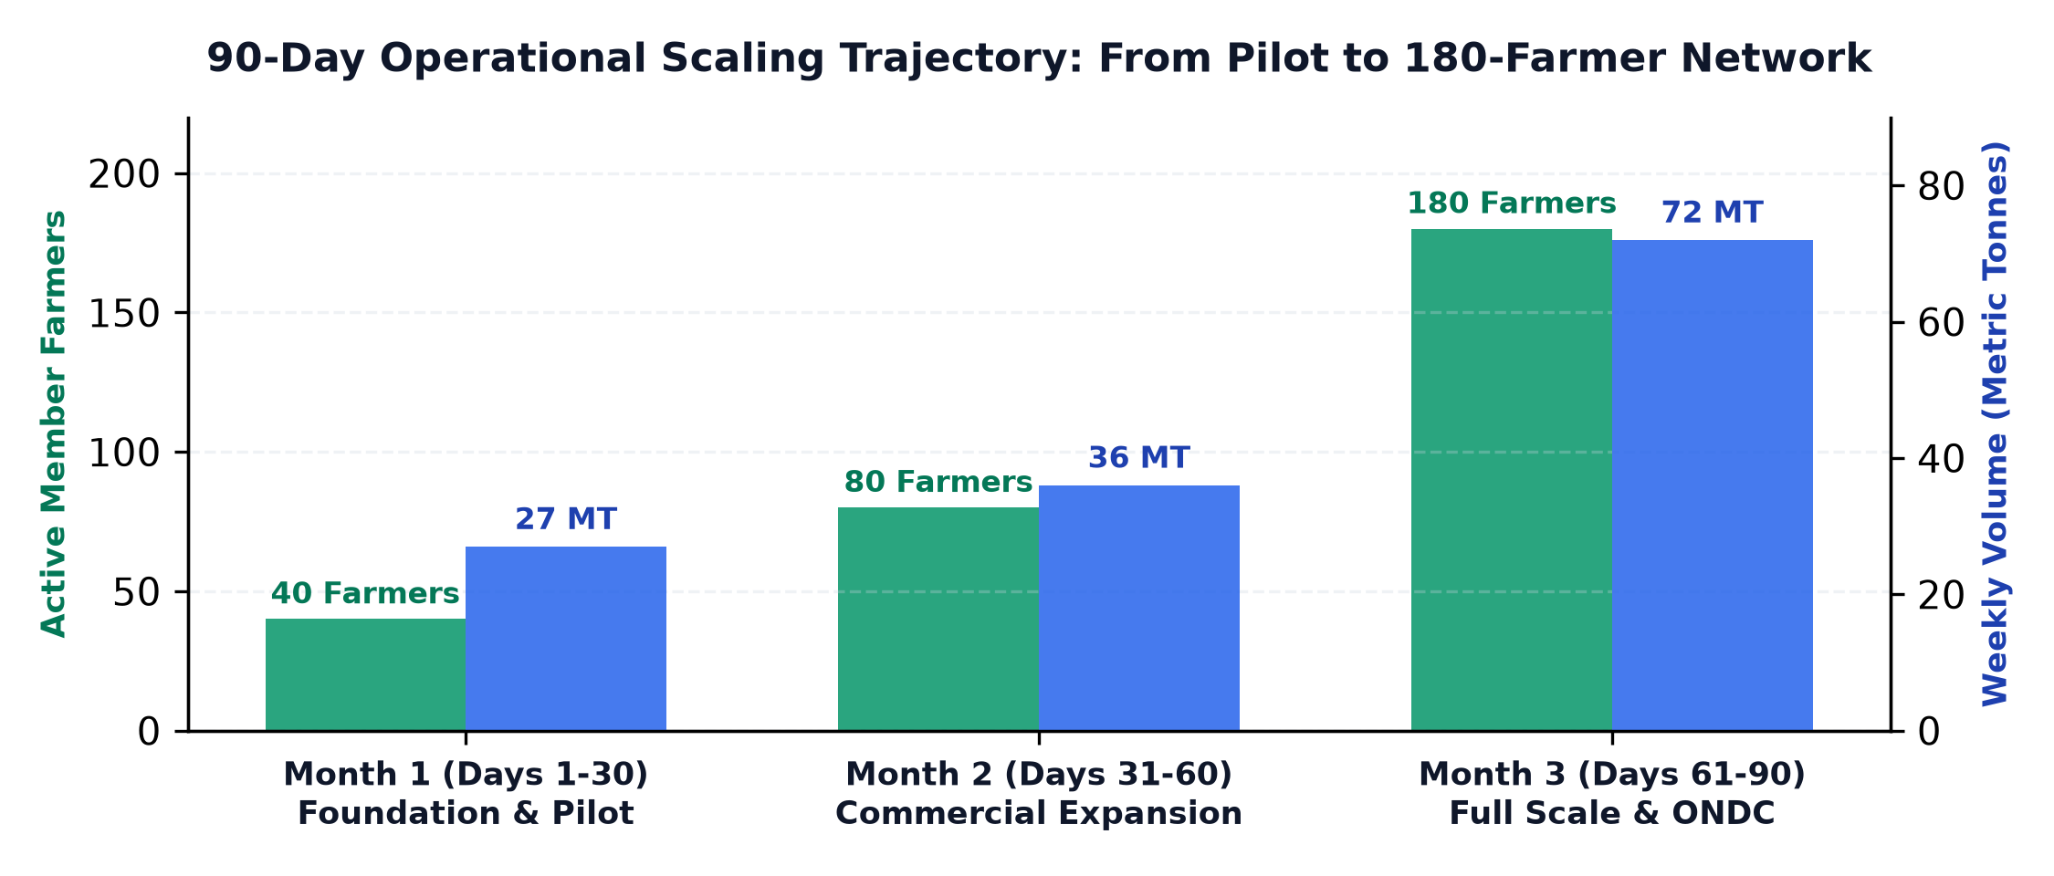
Figure 5: 90-Day Operational Scaling Trajectory — Growth from 40 to 180 Farmers and 27 to 72 MT Weekly Volume

7. Digital Prototype Demonstration & Examiner Guide
A working web prototype has been deployed live on GitHub Pages to demonstrate the pre-harvest catalogue during faculty viva examinations:
Live Prototype Modules (In demo/index.html)
- 1. Produce Marketplace: Displays all 40 weekly lots with real-time filters by crop category, grade, and harvest countdown.
- 2. Calibrated Lot Spec Sheet: Opens high-res photos, calibrated ruler measurements, Brix content, and AGMARK tolerances.
- 3. WhatsApp RFQ Engine: Pre-formats institutional purchase requests into WhatsApp messages for one-click buyer quotation.
- 4. Farmer Submission Portal: Allows farmers and scouts to log harvest intent, crop specs, and simulated photo uploads.
- 5. FPO Quality Gate Desk: FPO agronomists audit pending lots, approve verified listings, and reject non-compliant submissions.
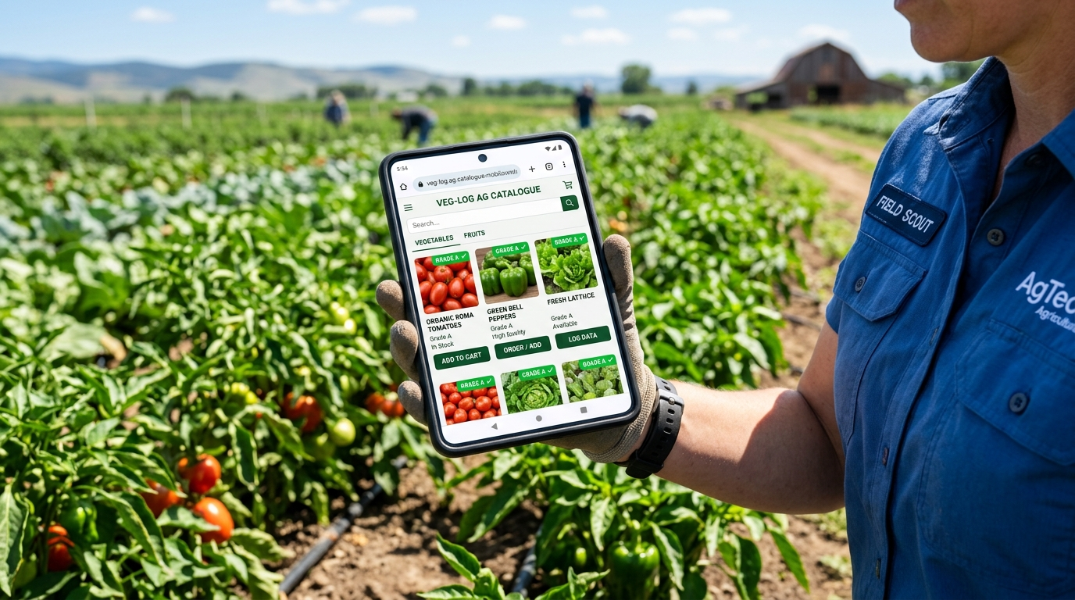
Figure 6: Mobile Catalogue Field Application — Village Scout Verifying Pre-Harvest Listings in Field
5-to-15 Minute Viva Presentation Guide
Time | Screen / View | Presenter Talking Points & Actions
0:00 – 2:30 | Research Portal (Slide 1) | Explain Mandi Squeeze: 180 farmers harvesting blind lose 25.8% to middlemen deductions.
2:30 – 5:00 | Research Portal (Slides 2 & 3) | Walk through 3 buyer segments (Retail 45%, HoReCa 35%, Processors 20%) & 5-stage flow.
5:00 – 9:30 | Interactive Demo (demo/) | Filter 40 lots by Grade A, open spec sheet, generate WhatsApp RFQ, and show FPO QC approval.
9:30 – 13:00 | Research Portal (Calculator) | Move sliders to prove ₹66.5L GMV, ₹3.08L gross revenue, ₹2.05L net profit, and +₹451/Qtl gain.
🔗 MASTER PROJECT VERIFICATION LINKS
Master Launchpad: https://somyacodes07.github.io/GTM_major_project/
Interactive Demo Prototype: https://somyacodes07.github.io/GTM_major_project/demo/
Research & Slide Deck: https://somyacodes07.github.io/GTM_major_project/research/
GitHub Repository: https://github.com/somyacodes07/GTM_major_project

