**Vehicle Parking Management System**

**Project Report**

**<Version 5.0>**

Mini Project (MCA363)

Degree

**MASTER OF COMPUTER APPLICATION**

|  |  |
| --- | --- |
| PROJECT GUIDE:  **Project Guide Name (External)**  **Mr. Vineet Saxena (Internal)** | SUBMITTED BY:  **Prashant Shivach (TCA2163072)**  **Prince Kumar Yadav (TCA2163073)**  **Ritik Yadav (TCA2163076)** |

Nov, 2022



**COLLEGE OF COMPUTING SCIENCES AND INFORMATION TECHNOLOGY**

**TEERTHANKER MAHAVEER UNIVERSITY, MORADABAD**

**ACKNOWLEDGEMENT**

To list who all have helped me is difficult because they are so numerous and the depth is so enormous.I would like to acknowledge the following as being idealistic channels and fresh dimensions in the completion of this project.I take this opportunity to thank the **College of Computing Sciences and Information Technology** of **Teerthanker Mahaveer University** for giving me chance to do this project.

I would like to thank my Principal, **Dr Rakesh Kumar Dwivedi** for providing the necessary facilities required for completion of this project.

I take this opportunity to thank our Coordinator  **Mr Amit Sharma** for his moral support and guidance.

I would also like to express my sincere gratitude towards my project guide  **Mr. Vineet Saxena** whose guidance and care made the project successful.

**Place: Moradabad**

**Date:**

**DECLARATION**

We hereby declare that this Project Report titled **Vehicle Parking Management System** submitted by us and approved by our project guide,the College of Computing Sciences and Information Technology (CCSIT), Teerthanker Mahaveer University, Moradabad, is a bonafide work undertaken by us and it is not submitted to any other University or Institution for the award of any degree diploma / certificate or published any time before.

|  |  |  |
| --- | --- | --- |
| **Project Group :** | Project Group Name/Id | |
| **Student Name:** | Prashant Shivach | Signature |
| **Student Name:** | Ritik Yadav | Signature |
| **Student Name:** | Prince kumar Yadav | Signature |
|  |  |  |
| **Project Guide: (External)** | Name | Signature |
| **Project Guide: (Internal)** | **Mr. Vineet Saxena** | Signature |

Table of Contents

1 Project Title 6

2 Problem Statement 6

3 Project Description 6

3.1 Scope of the Work 6

3.2 Project Modules 6

3.3 Context Diagram (High Level) 6

4 Implementation Methodology 6

5 Technologies to be used 6

5.1 Software Platform 6

5.2 Hardware Platform 7

5.3 Tools, if any 7

6 Advantages of this Project 7

7 Assumptions, if any 7

8 Future Scope and further enhancement of the Project 7

9 Project Repository Location 7

10 Definitions, Acronyms, and Abbreviations 8

11 Conclusion 8

12 References 9

**Appendix**

**A:Data Flow Diagram (DFD)**

**B:Entity Relationship Diagram (ERD)**

**C:Use Case Diagram (UCD)**

**D:Data Dictionary (DD)**

**E: Screen Shots**

# Project Title

**Vehicle Parking Management System**

# Problem Statement

In present all vehicles parking work done on the paper. The whole year vehicle parking record is stored in the registers. We can’t generate reports as per our requirements because its take more time to calculate the vehicle parking report.

# Project Description

Vehicle Parking Management system is a web-based technology that will manage the records of the incoming and outgoing vehicles in a parking house. It’s an easy for Admin to retrieve the data if the vehicle has been visited through number he can get that data. Vehicle parking management system is an automatic system which delivers data processing in very high speed in systematic manner.

## Scope of the Work

In the modern age. Many people have vehicles. Vehicle is now a basic need. Every place is under the process of urbanization. There are many corporate offices and shopping centers etc. There are many recreational places where people used to go for refreshment. So, all these places need a parking space where people can park their vehicles safely and easily. Every parking area needs a system that records the detail of vehicles to give the facility. With the help of this system we can deliver a good service to customer who wants to park their vehicle into the any organization’s premises.

The project has a wide scope, as it is not intended to a particular organization. This project is going to develop generic software, which can be applied by any businesses organization. More over it provides facility to its users. Also the software is going to provide a huge amount of summary data.

## Project Modules

The key Modules required in the system are as follows:

**Dashboard**: In these sections, admin can briefly view the number of vehicle entries in a particular period.

**Category**: In this section, admin can manage category (add/update).

**Add Vehicle**: In this section, admin add vehicle which is going to park.

**Manage Vehicle**: In this section, admin can manage incoming and outgoing vehicle and admin can also add parking charges and his/her remarks.

**Reports**: In this section admin can generate vehicle entries reports between two dates.

**Search**: In this section, admin can search a particular vehicle by parking number.

**Admin** can also update his profile, change the password and recover the password.

## Context Diagram (High Level)

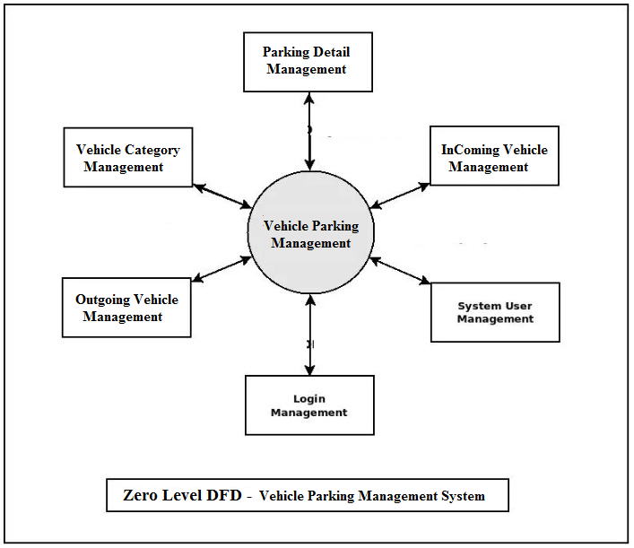

# Implementation Methodology

**Python**

Python is a widely used general-purpose, high level programming language. It was initially designed by Guido van Rossum in 1991 and developed by Python Software Foundation. It was mainly developed for emphasis on code readability, and its syntax allows programmers to express concepts in fewer lines of code.

Python is a programming language that lets you work quickly and integrate systems more efficiently.

Python is dynamically typed and garbage-collected. It supports multiple programming paradigms, including procedural, object-oriented, and functional programming. Python is often described as a "batteries included" language due to its comprehensive standard library.

**HTML**

HTML (Hypertext Markup Language) is the set of markup symbols or codes inserted in a file intended for display on a World Wide Web browser page. The markup tells the Web browser how to display a Web page's words and images for the user. Each individual markup code is referred to as an element (but many people also refer to it as a tag). Some elements come in pairs that indicate when some display effect is to begin and when it is to end.

**CASCADING STYLE SHEET (CSS)**

Cascading Style Sheets (CSS) are a collection of rules we use to define and modify web pages. CSS are similar to styles in Word. CSS allow Web designers to have much more control over their pages look and layout. For instance, you could create a style that defines the body text to be Verdana, 10 point. Later on, you may easily change the body text to Times New Roman, 12 point by just changing the rule in the CSS. Instead of having to change the font on each page of your website, all you need to do is redefine the style on the style sheet, and it will instantly change on all of the pages that the style sheet has been applied to. With HTML styles, the font change would be applied to each instance of that font and have to be changed in each spot.

CSS can control the placement of text and objects on your pages as well as the look of those objects.

HTML information creates the objects (or gives objects meaning), but styles describe how the objects should appear. The HTML gives your page structure, while the CSS creates the “presentation”. An external CSS is really just a text file with a .css extension. These files can be created with Dreamweaver, a CSS editor, or even Notepad.

**Javascript**

JavaScript is a programming language commonly used in web development. It was originally developed by Netscape as a means to add dynamic and interactive elements to websites. While JavaScript is influenced byJava, the syntax is more similar to C and is based on ECMAScript, a scripting language developed by Sun Microsystems.

JavaScript is a client-side scripting language, which means the source code is processed by the client's web browser rather than on the web server. This means JavaScript functions can run after a webpage has loaded without COMMUNICATING with the server. For example, a JavaScript function may check a web form before it is submitted to make sure all the required fields have been filled out. The JavaScript code can produce an error message before any information is actually transmitted to the server.

Like server-side scripting languages, such as PHP and ASP, JavaScript code can be inserted anywhere within the HTML of a webpage. However, only the output of server-side code is displayed in the HTML, while JavaScript code remains fully visible in the source of the webpage. It can also be referenced in a separate .JS file, which may also be viewed in a browser

**Django**

Django is a web application framework written in Python programming language. It is based on MVT (Model View Template) design pattern. The Django is very demanding due to its rapid development feature. It takes less time to build application after collecting client requirement.

This framework uses a famous tag line: **The web framework for perfectionists with deadlines.**

# Technologies to be used

## Software Platform

* Technology: Python Django
* IDE : Pycharm/Atom
* Client Side Technologies: HTML, CSS, JavaScript , Bootstrap
* Server Side Technologies: Python
* Data Base Server: Sqlite
* Operating System: Microsoft Windows/Linux

## Hardware Platform

* Processor: Pentium-III (or) Higher
* Ram: 64MB (or) Higher
* Hard disk: 80GB (or) Higher

# Advantages of this Project

“Vehicle Parking Management System” provides various features, which complement the information system and increase the productivity of the system. These features make the system easily usable and convenient. Some of the important features included are listed as follows:

* Intelligent User Forms Design
  + - Data access and manipulation through same forms
    - Access to most required information
* Data Security
* Restrictive data access, as per login assigned only.
* Organized and structured storage of facts.
* Strategic Planning made easy.
* No decay of old Records.
* Exact financial position of the business.

# Assumptions, if any

***None***

# Future Scope and further enhancement of the Project

Thisweb application involves almost all the basic features of the online vehicle parking management system. The future implementation will be online help for the users and chatting with website administrator.

# Project Repository Location

*<Guidelines: Mention the location of the latest Source Code and all related documents, like- Project Synopsis Report, Project Progress updates, Project Requirement Details, Project Report (Softcopy), Test Repository (all test scenarios, test cases etc.) used for Functional Testing of the project etc. The repository location must be somewhere in CCSIT-Lab>*

| **S#** | **Project Artifacts (softcopy)** | **Location** (Mention Lab-ID, Server ID, Folder Name etc.) | **Verified by Project Guide** | **Verified by Lab In-Charge** |
| --- | --- | --- | --- | --- |
|  | Project Synopsis Report (Final Version) |  | Name and Signature | Name and Signature |
|  | Project Progress updates |  | Name and Signature | Name and Signature |
|  | Project Requirement specifications |  | Name and Signature | Name and Signature |
|  | Project Report (Final Version) |  | Name and Signature | Name and Signature |
|  | Test Repository |  | Name and Signature | Name and Signature |
|  | Any other document, give details |  | Name and Signature | Name and Signature |

# Definitions, Acronyms, and Abbreviations

*<Guidelines: Provide the definitions of all terms, acronyms, and abbreviations required to properly interpret the SRS. This information may be provided by reference to one or more appendices in the SRS or by reference to documents. This information may be provided by reference to an Annexure >*

|  |  |
| --- | --- |
| **Abbreviation** | **Description** |
|  |  |
|  |  |
|  |  |
|  |  |

# Conclusion

The project entitled “Online Vehicle Parking Management System” is developed using HTML, CSS and Bootstrap as front end and Python Django and Sqlite database in back end to computerize the process of company visitor management. This project covers only the basic features required.

***Example:***

*Time and money are one of the most important factors to any organization. Implementing such software in the college stationery department can surely be a profitable deal as this application helps to carry out tasks with ease and thereby reduces time and money on manpower and materials. This is an open source application so that others can edit and transform this system application according to their needs.*

# References

* Wikipedia
* <https://www.geeksforgeeks.org/python-django/>
* <https://www.javatpoint.com>
* <https://www.python.org/>
* <https://www.tutorialspoint/>
* **REFERENCE BOOKS**
* Two scoops of Django for 1.11 by ***Daniel Greenfeld’s and Audrey Greenfield***
* Lightweight Django *by* ***Elman and Mark Lavin***

|  |  |  |  |  |
| --- | --- | --- | --- | --- |
| **S#** | **Reference Details** | **Owner** | **Version** | **Date** |
|  | Project Synopsis | <Project Group ID> | 1.0 | DD-MM-YY |
|  | Project Requirements | <Project Group ID> |  |  |
|  |  |  |  |  |

**Annexure A**

**Data Flow Diagram (DFD)**

**(Mandatory)**

**Admin**

**DFD (Data Flow Diagram)**



**Annexure B**

**Entity-Relationship Diagram (ERD)**

**(Mandatory)**

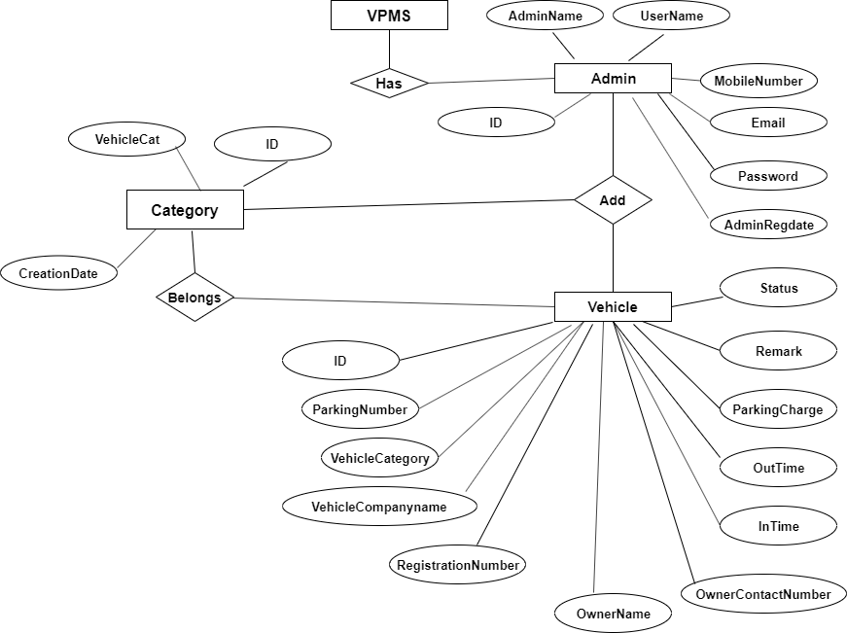

**Annexure C**

**Use-Case Diagram (UCD)**

**(Optional)**

**Sequence Diagram For Administrator:-**

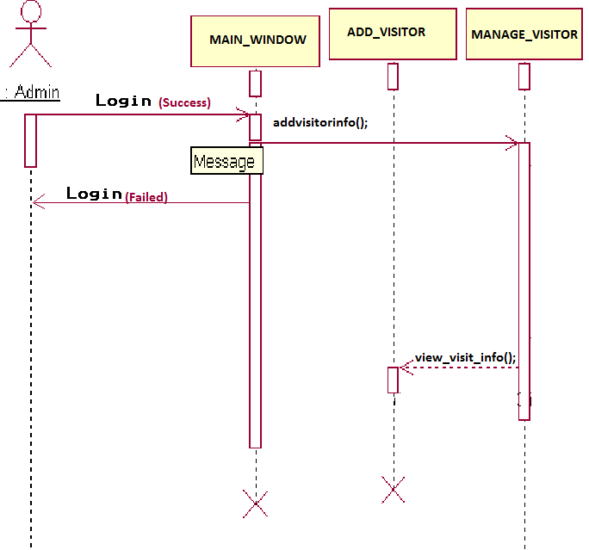

**Annexure D**

**Data Dictionary (DD)**

**(Mandatory)**

**Example:**

**User Table (USR)**

|  |  |  |
| --- | --- | --- |
| **Fields** | **Data type** | **Description** |
| USR-Name | Text | Admin name |
| USR-Password | Text | Admin password |
| USR-Contact-No | Number | Admin Contact |
| USR-Address | Text | City |

**Supplier Table (SUPP)**

|  |  |  |
| --- | --- | --- |
| **Fields** | **Data type** | **Description** |
| SUPP-ID | Number | Supplier ID |
| SUPP-Name | Text | Supplier Name |
| SUPP-Address | Text | Supplier Address |
| SUPP-Contact | Number | Supplier Contact |
| SUPP-Credit-Limit | Number | Credit Limit |

**Annexure E**

**Screen Shots**

*<Guidelines: Show all Pages>*

**Home Page:**

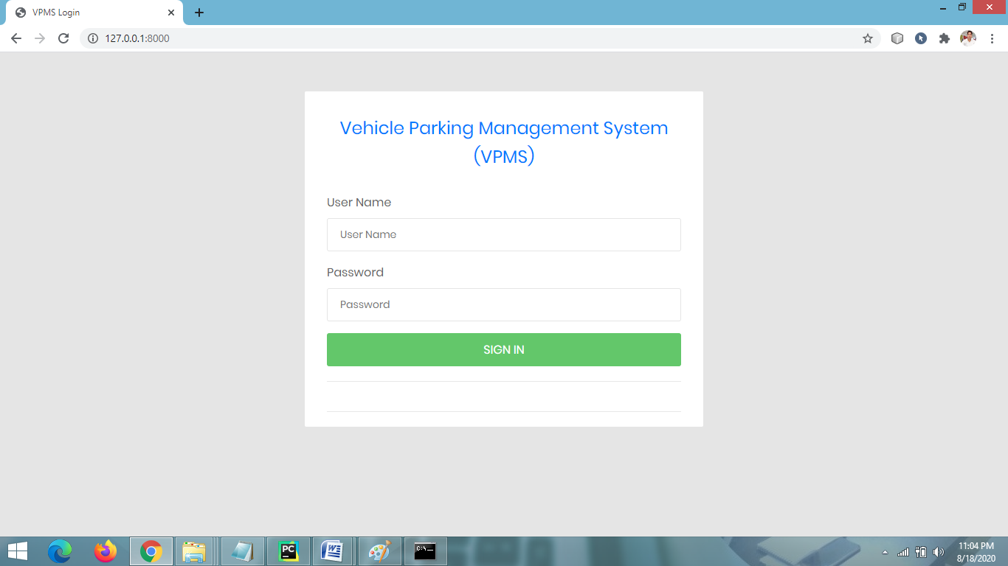

**ADMIN DASHBOARD PAGE**

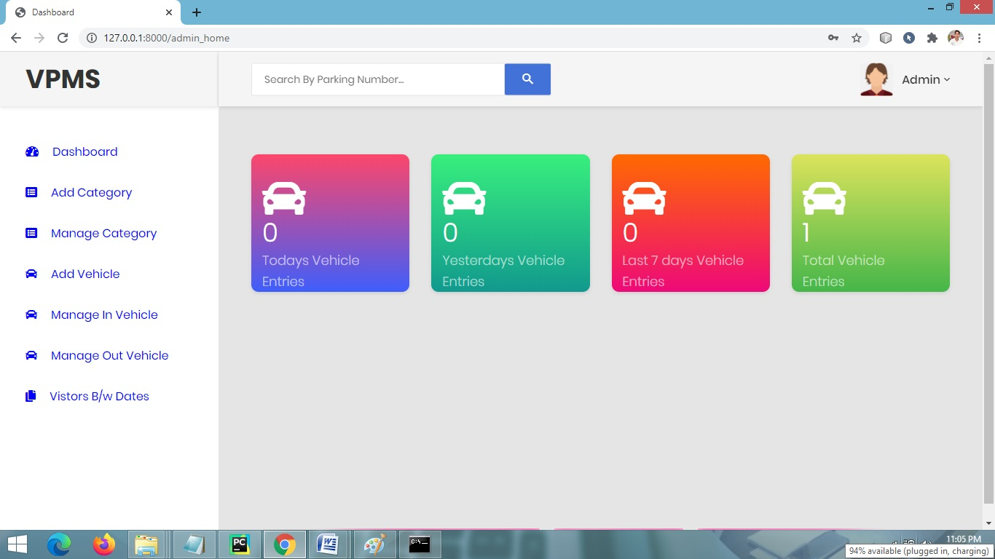

**ADD NEW CATEGORY PAGE**

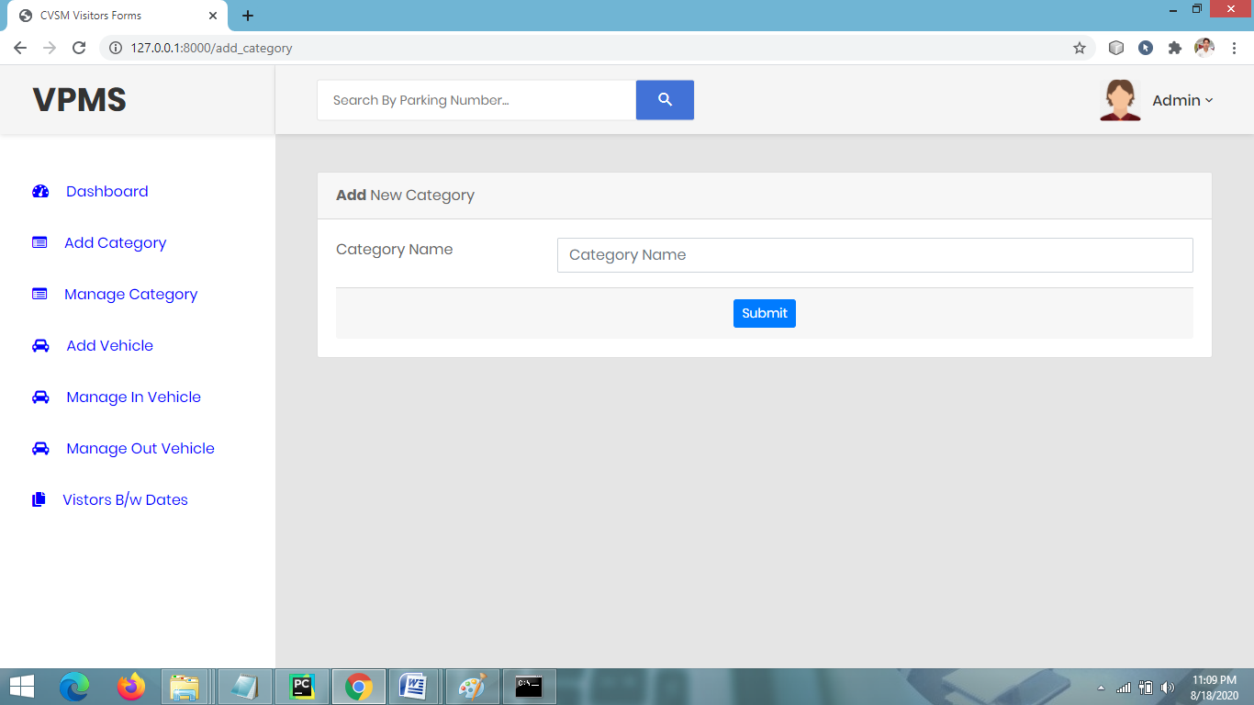

**MANAGE CATEGORY PAGE**

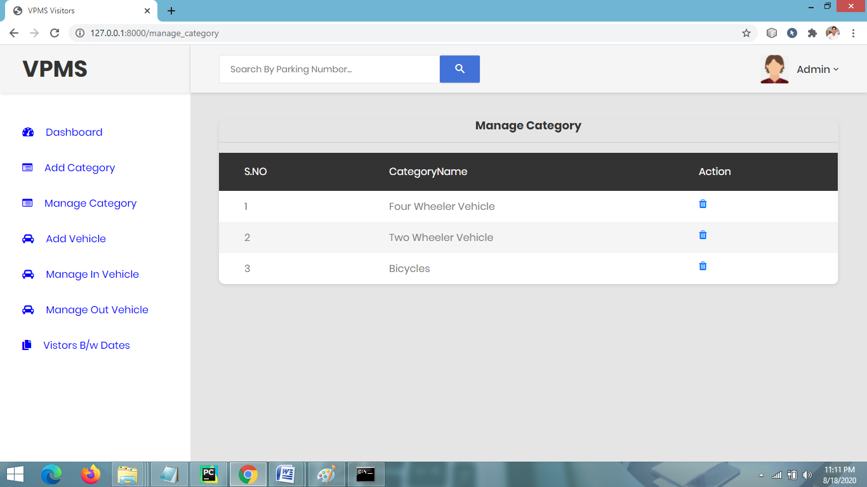

**ADD VEHICLE PARKING DETAIL PAGE**

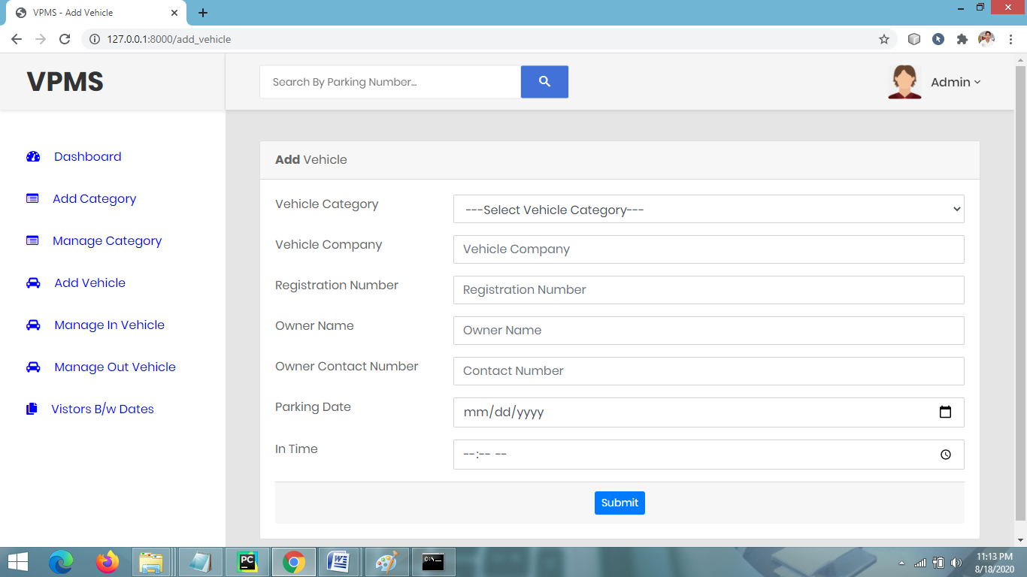

**MANAGE OUTGOING VEHICLE PAGE**

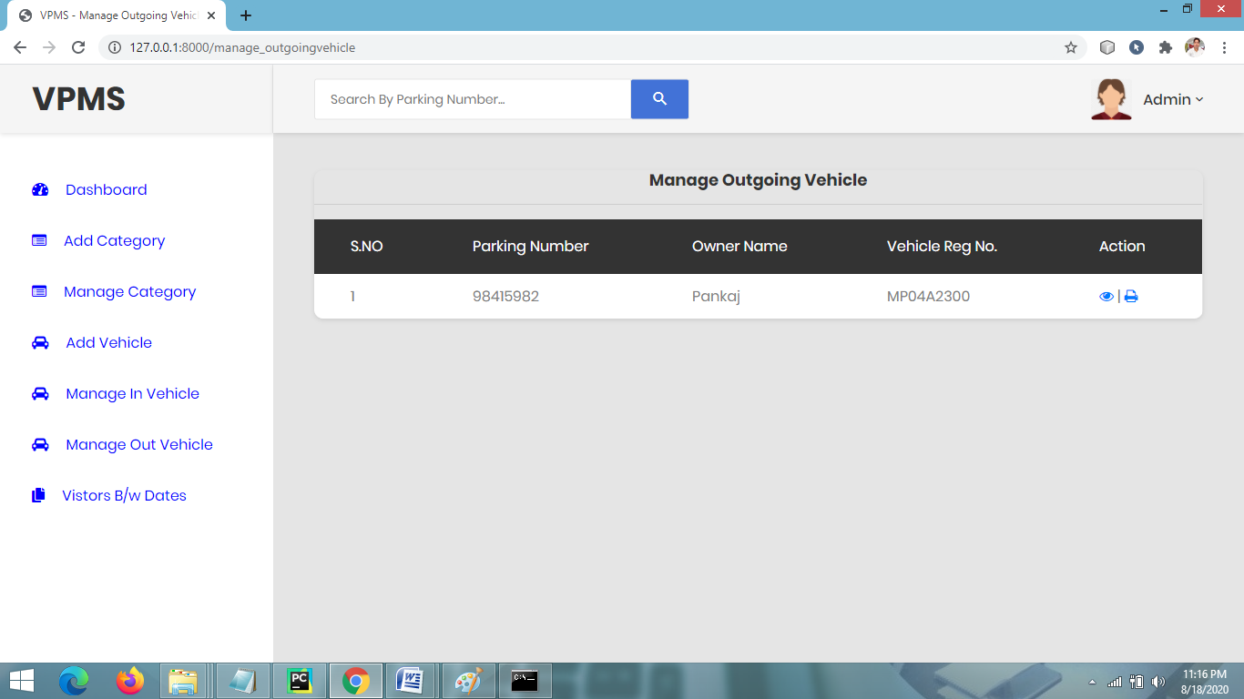

**BETWEEN DATE REPORTS**

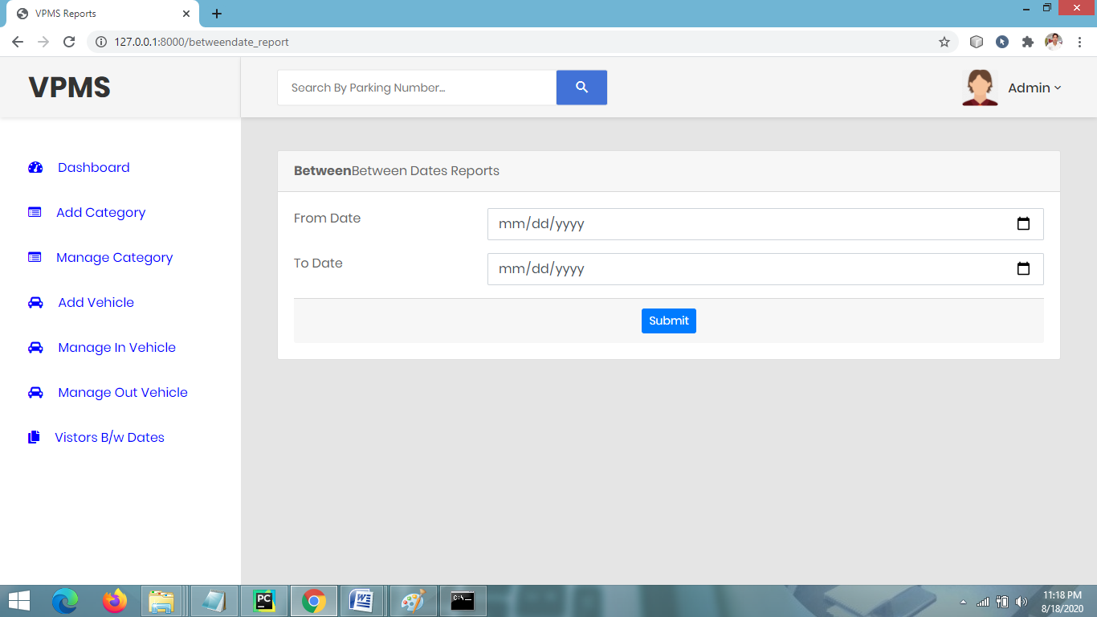

**VIEW BETWEEN DATES REPORTS**

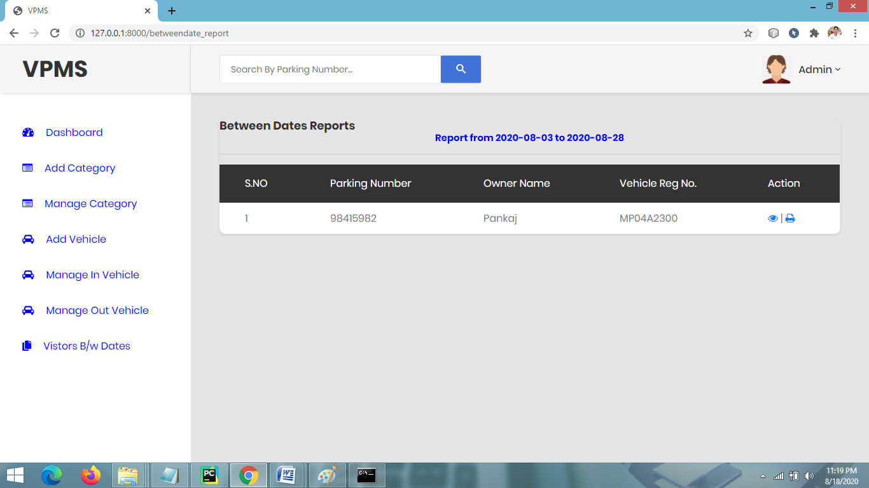

**CHANGE PASSWORD PAGE**

