Spa Service

Use-Case Specification: Use-Case Booking

Version 1.0

Revision History

|  |  |  |  |
| --- | --- | --- | --- |
| **Date** | **Version** | **Description** | **Author** |
| <dd/mmm/yy> | <x.x> | <details> | <name> |
|  |  |  |  |
|  |  |  |  |
|  |  |  |  |

Table of Contents

1. Use-case Model 4

2. Use-case Specifications 4

2.1 Use-case: Booking Service 4

2.2 Use-case: Create a new account 5

# Use-case Model (Mô hình use-case)

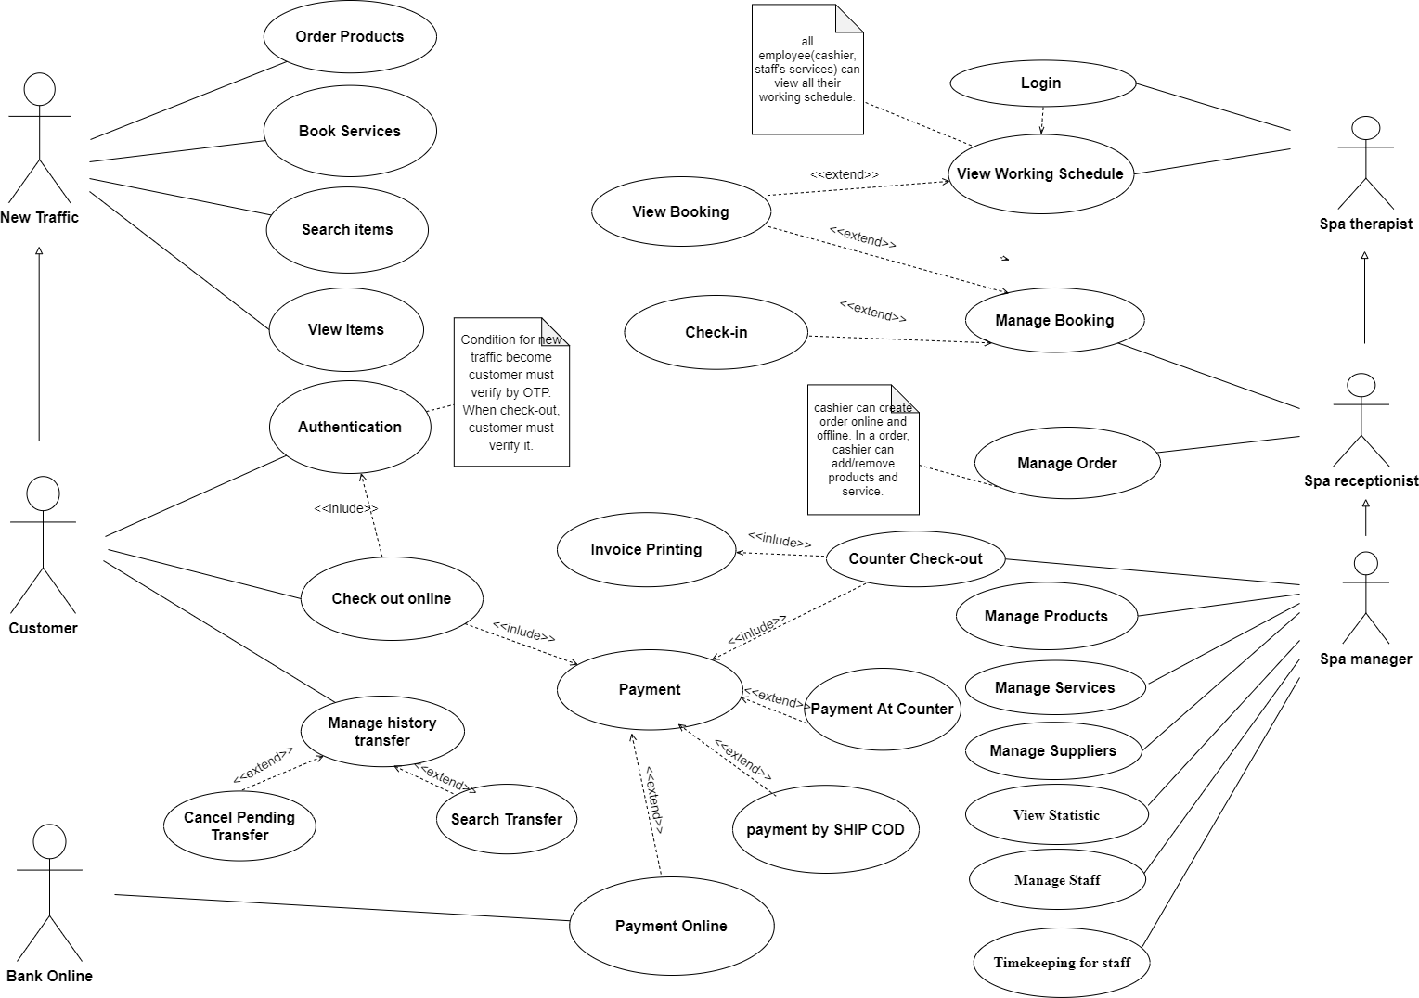

# Use-case Specifications (Đặc tả use-case)

## Use-case: Booking Service

|  |  |
| --- | --- |
| Use case Name  (Tên use-case) | Booking Service |
| Brief description  (Mô tả) | This use case describes how the Customer can booking Spa’s service |
| Actors  (Actors) | Customer |
| Basic Flow  (Luồng cơ bản) | 1) The system will display the welcome page when visitors visit the website  2) The system displays 2 services for customers  + 2.1. Service Reference  + 2.2 Make an appointment to use the service  3) If the customer chooses to refer to the service. The system will display all spa services along with the operating hours of each service group.    4) If the customer chooses to make an appointment. The system will display the date and time  Time for customers to choose  5) After the customer has entered the date and time. Based on the date and time, the system will display the corresponding service list   1. If the customer chooses to use translation in the time frame from   + 6.1. From 9am -> 5pm : the system will display all services for customers to choose  + 6.2. From 6pm -> 10pm: the system will display services except massage   1. After the customer chooses the service, the system will automatically check if the number of people ordering the translation at that time is more than 10 people or not.   + 7.1. If there are more than 10 people, the system will display a message that the current service is out of space. Please try again !  + 7.2. If there are not enough 10 people, the system will make an appointment for customers   1. Ask the user to enter information and phone number. The system will send an OTP code to the user's phone number to confirm the reservation.   + 8.1. If successful, the system will save user information to the database and display message “Booking Success“ and information of booking  + 8.2. If customer does not confirm success, the system display a message “Booking Error” and requires OTP again |
| Alternative Flows  (Các luồng thay thế) | If the system fails to book, customer can call the system to book an appointment in advance |
| Pre-conditions  (Điều kiện đầu vào) | PRE-1: Service booking choices existed on platform  PRE-2: Service booking choices are not larger than 3 |
| Post-conditions  (Điều kiện đầu ra) | POST-1: Successfully store booking service in database  POST-2: Customer receive code check-in |

## Use-case: Manage Booking Status

## 2.2.1 State-Chart

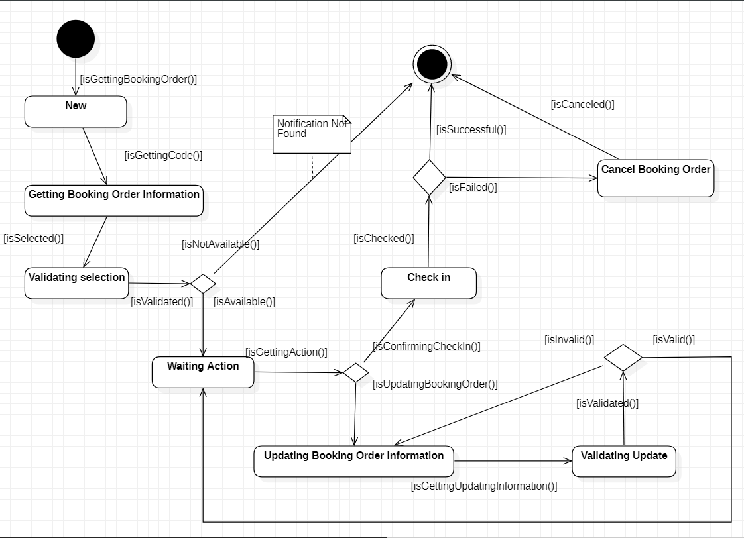

## 2.2.2 Use case specification

|  |  |  |  |
| --- | --- | --- | --- |
| Use case Name  (Tên use-case) | | Booking Status | |
| Brief description  (Mô tả) | This use case describes how the Status when Customers request a Booking Service | |
| Actors  (Actors) | | Customer, Employee | |
| Basic Flow  (Luồng cơ bản) | | 1. System getting Booking Order code. 2. System getting Booking Order by code.   **2.1** If Booking Order is invalid, system send notification “Not Found”.  **2.2** If Booking Order is valid, system getting Booking Order information and send to “Waiting Action” list.   1. System received request to Booking Order. 2. System send the Booking Order to be viewed and update by Employee.   **4.1** Update Booking Order: System getting update information.  **4.1.1** if the update is successful, system sends booking order back to waiting action.  **4.1.2** if the update fails, updated information will be canceled and the system will send the Booking Order back to **4.1**  **4.2 Check-in:**  **4.2.1** If the staff confirms that the customer has checked-in successfully. The system will confirm the Booking Order has been “Succeed”.  **4.2.2** If the staff confirms that the customer has checked-in fails or canceled. The system will set the Booking Order has been “Canceled”. | |
| Alternative Flows  (Các luồng thay thế) | | If Booking Status is not confirmed on time, The system will automatically confirm that Booking Status has “expired”.  If If the customer cancels Booking Services. After being confirmed by customers and employees. The system will confirm that Booking Status has been “canceled”. | |
| Pre-conditions  (Điều kiện đầu vào) | | Booking Order have been made by the customer of Spa services. | |
| Post-conditions  (Điều kiện đầu ra) | | POST-1: Successfully store booking service in database.  POST-2: Customer will receive notification when Booking Status ends. | |