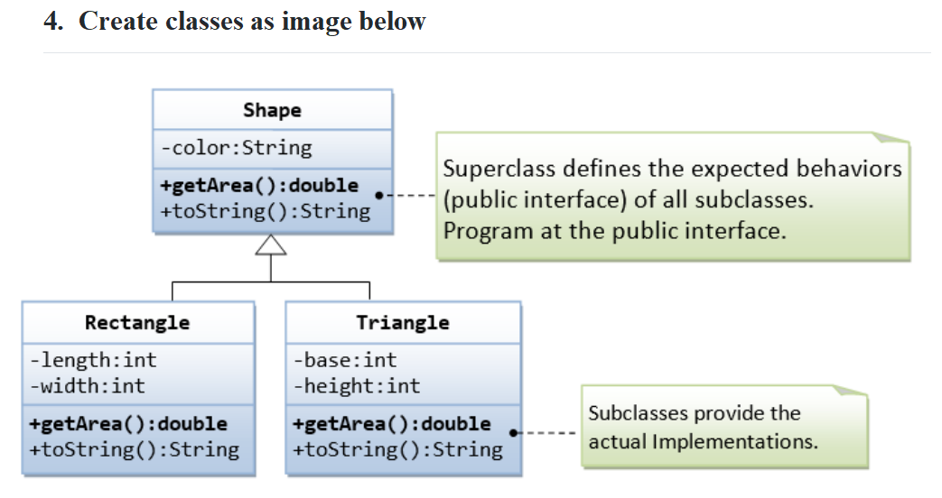

Đoạn code :

Class shape:

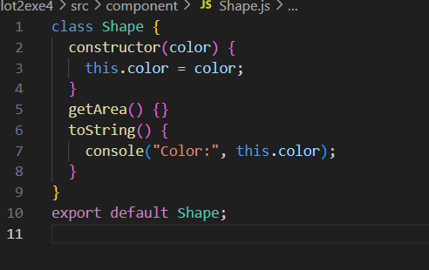

Class Rectangle:

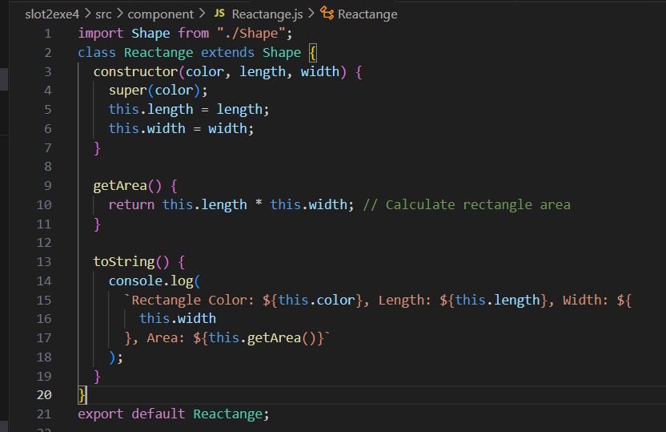

Class Triagle:

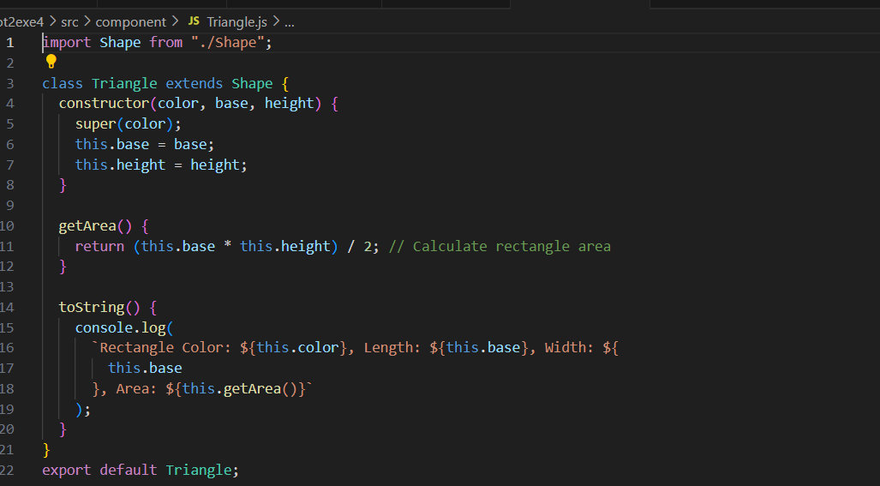

Code app :

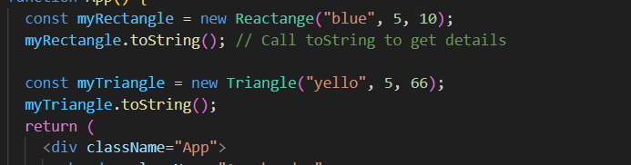

Kết quả :

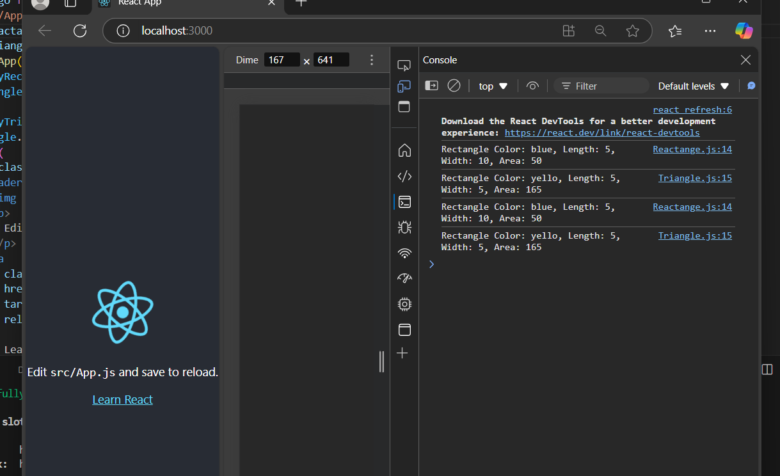

3:

* Print the name of each company using forEach:
* 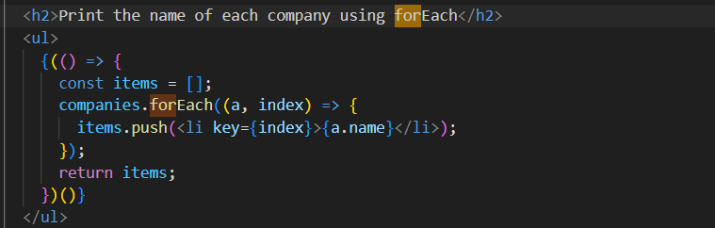
* 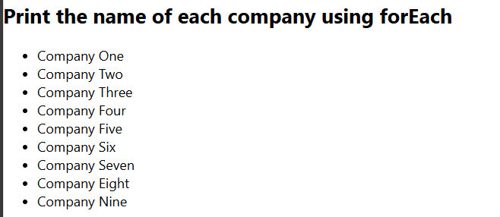
* Print the name of each company that started after 1987
* 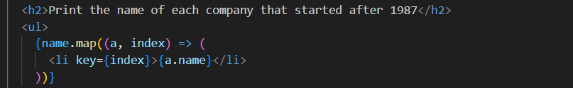
* 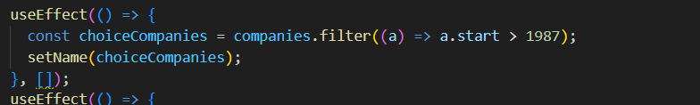
* 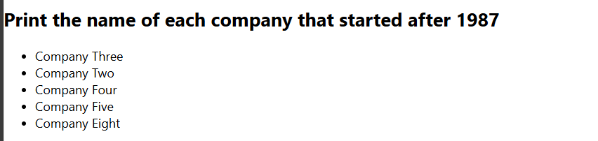
* Sort the companies based on their end date in ascending order
* 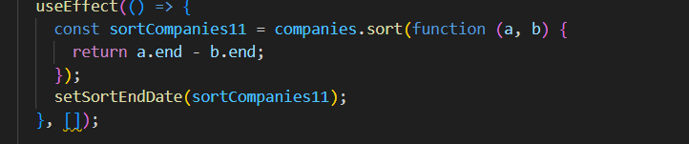
* 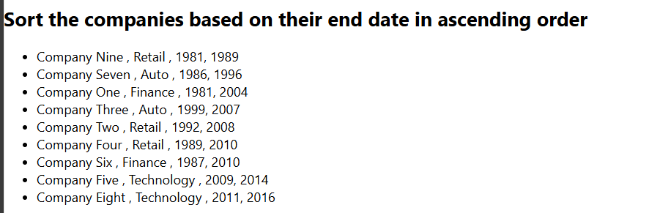
* Sort the ages array in descending order
* 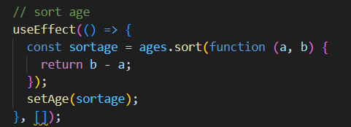
* 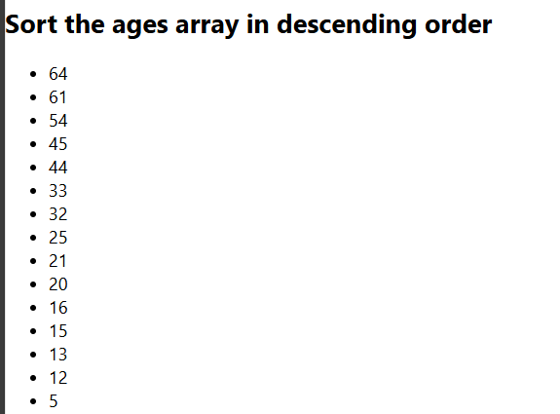
* Print the sum if you add all the ages using reduce
* 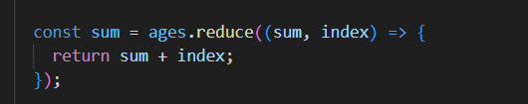
* 
* Write a function that every time you call it, it returns a number that increments starting from 0
* 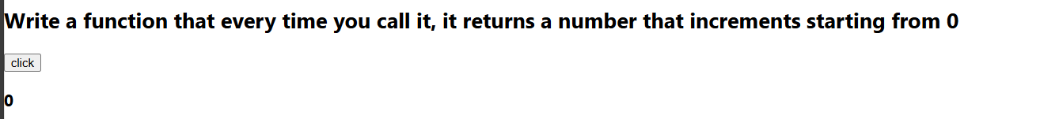
* 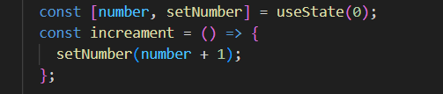
* Create a function that takes an unknown number of arguments that are numbers and return their sum;
* 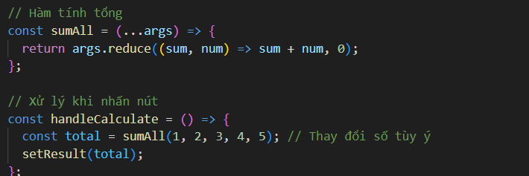
* 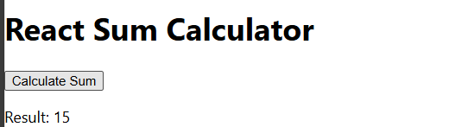
* Make a new object that has the properties of name and category same as the companies [0] and a method print that prints out the name, use object restructuring and ES6 JS
* 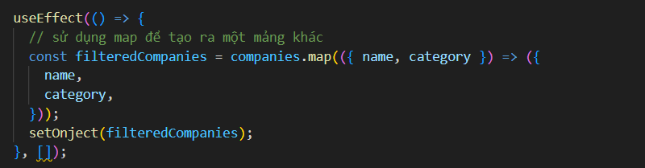
* 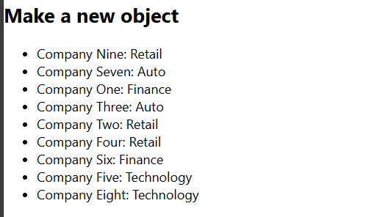
* Destructuring the property street in a variable named street from the object person
* 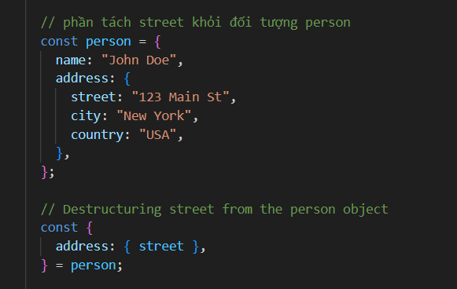
* 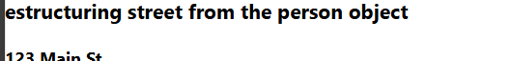
* Create a function that destructors the query parameters of a URL and adds them in an object as key value pairs and then returns the object
* 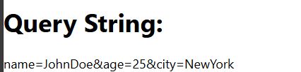
* 2:
* 
 