1. **Jquery Ajax:**

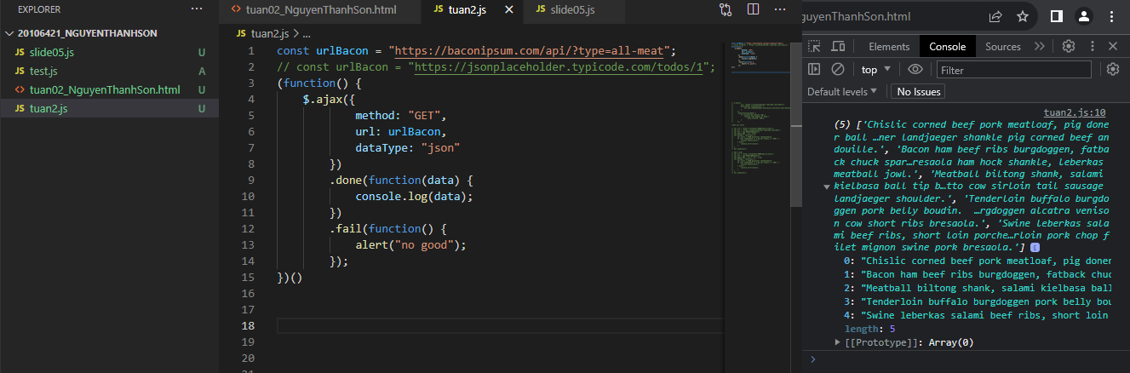

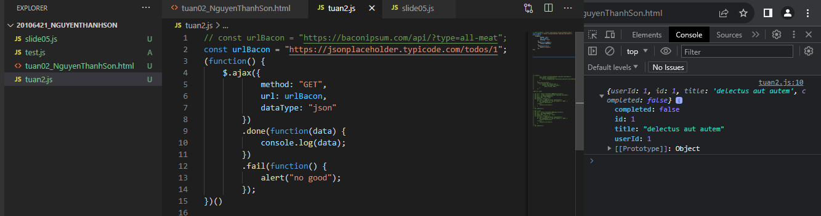

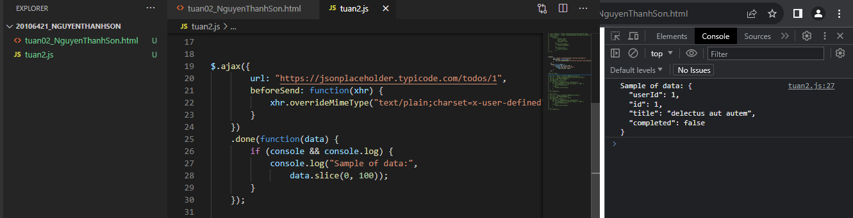

1. **XMLHttpRequest RESTful GET:**

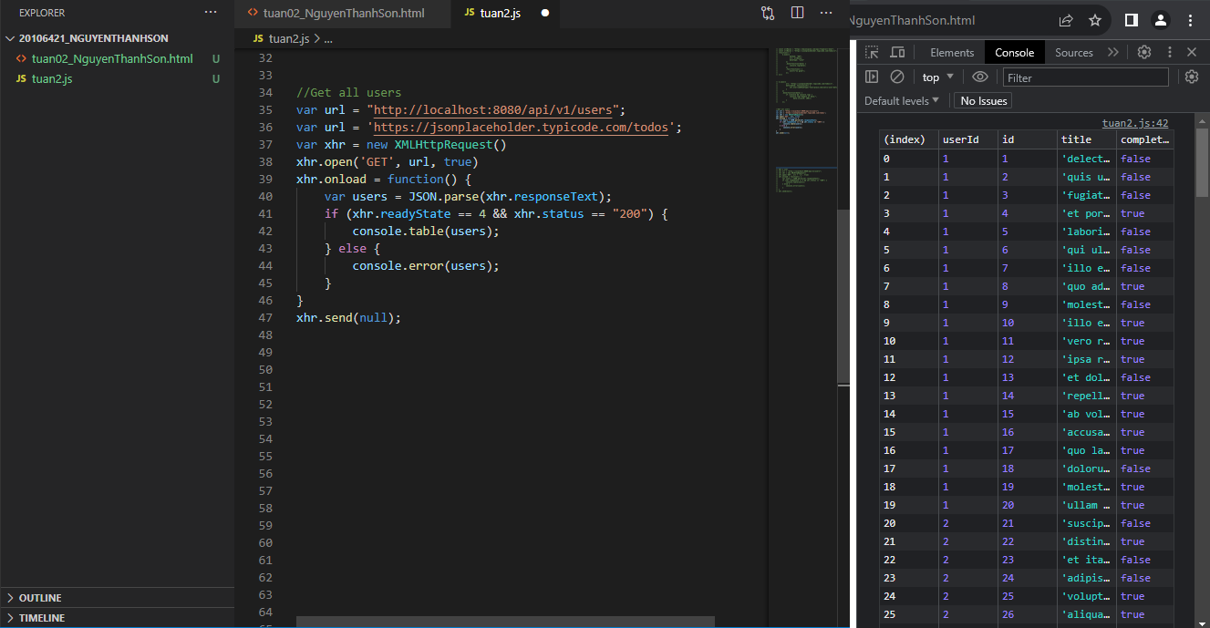

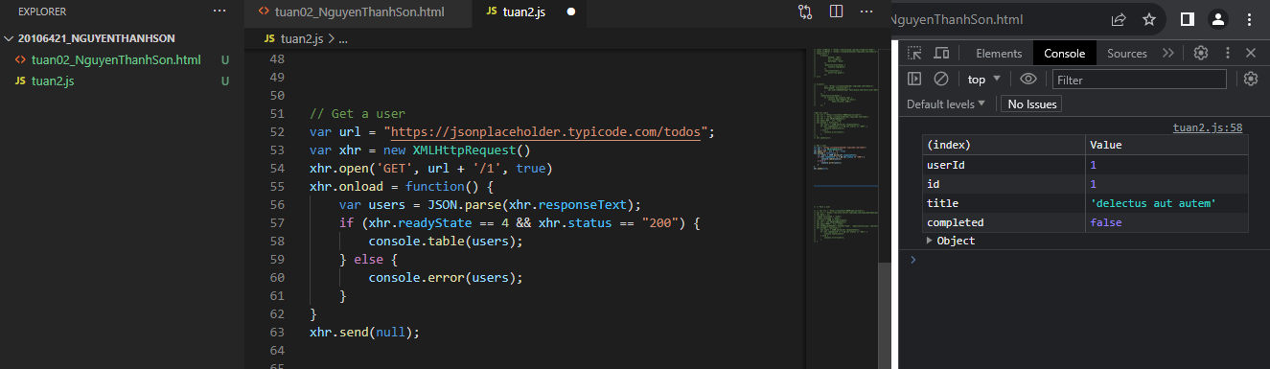

1. **XMLHttpRequest RESTful POST:**

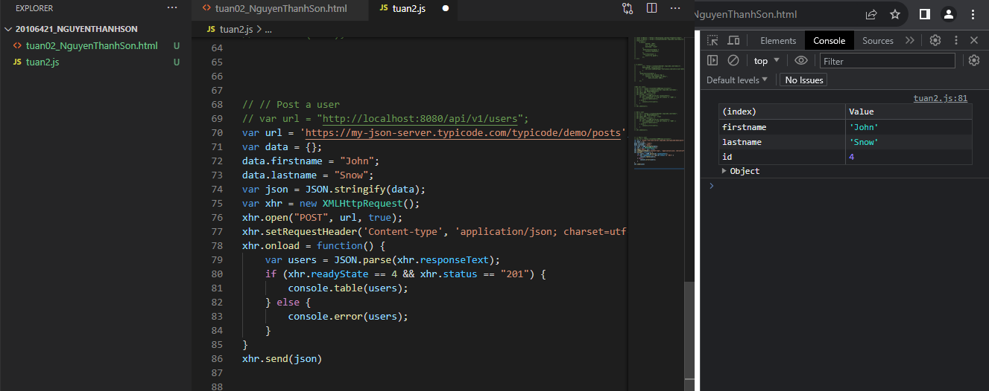

1. **XMLHttpRequest RESTful PUT:**

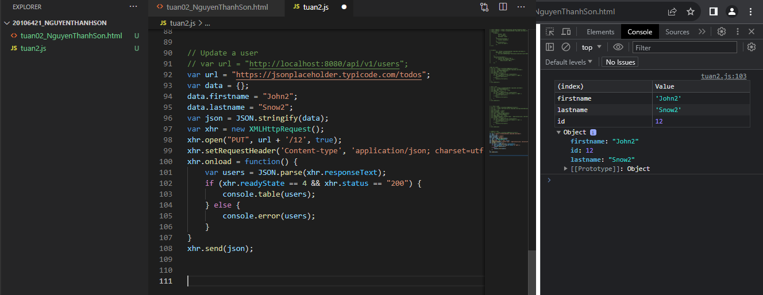

1. **XMLHttpRequest RESTful DELETE:**

