

**Handikrafts**

**Documentation**

|  |  |
| --- | --- |
| **Authors** | **Group 5** |
| **Son Tran Ngoc**  **Bui An Thien**  **Long Le Thanh** |
| **Date** | **13-Apr-2019** |
| **Instructor** | **Le Viet Bach** |

Hanoi,13-Apr-2019

**1)** **Problem Definition**

1.1) Problem Abstraction

In the era of industry 4.0 developed rapidly. Information Technology (IT) has been changing the world quickly . Website system is growing in the world and increasingly playing an important role for people. Enterprises gradually use the commercial website to replace the old business form by its superiority from entertainment, marketing and trade. Business website has many advantages: faster, more convenient, more efficient, not limited in space and time, cost effective . Therefore Venus Handicrafts specializes in handicrafts that want to create a website to advertise and trade goods.This project can contribute to widely promoting the company, attracting customers, increasing revenue for the company.

1.2   ) The Current System

The current mode of operation is sell products at the company so that those who need to buy them will come to the store to see and buy . That causes many disadvantages for buyers and companies. Buyers will be hard to update the new goods, waste of time as possible on the days the company to pick g door. Can run out without knowing. May cause the company to lose customers and be less profitable.

1.3) The Proposed System

With the current way of operation requires that the company need a website to operate to improve the way it works and overcome the disadvantages.

❖        Name Website: Venus Handicrafts company.

❖        Form: Provide items of handicrafts, ornaments, accessories for customers who have needs .

❖        System function:

⮚        For system management:

* + - Goods management.
    - Provide information about goods sold on the Website.
    - Quickly update new products.
    - Manage customer orders.

⮚        For customers:

* + - Find goods quickly and conveniently.
    - You can contact quick answers.
    - Order quickly, conveniently, ensure quality, receive goods at the place.

1.3.1) Boundaries of the System

              Customers can only pay by door-to-door payment after delivery, or to the place of payment. Customers can view goods without registration, but are required to register / login for purchases. Customers can only place orders to the location, name, and phone number registered at the member registration page.

              1.3.2) Hardware and Software Requirements

❖        Hardware :

⮚        A minimum computer system will help you access all có the tools in the courses is a Pentium 166 or better.

⮚        64 Megabytes of RAM or   better .

❖        Software :

⮚        IE 5.0 / Netscape 6.0 .

⮚        XAMPP.

⮚        Browser

⮚        MySQL / SQL Server.

**2)** **Customer Requirements Specification**

              2.1) User of the System

                            -Customers: Website visitors see goods, choose goods, buy goods.

-Manage the system : Be the system manager, manage product information, handle orders of CO .

              2.2) System functions

❖        Customer:

⮚        Function to view product information:

* + - Description: For customers who can view information about items sold on the system.
    - Input: No import required , just click on the link of the item to view.
    - Handling: Accessing the Database (Database) , retrieving detailed information about the item to view.
    - Display: Displays product details such as pictures of products, product prices.

⮚        Product search function :

* + - Description: Search for information on items sold on the Website.
    - Enter: Ask the customer to enter the name of the product to search (eg table, chair, photo frame, ...).
    - Handling: Retrieving The database filters out products that match the customer's search.
    - Display: Display products that match the customer's search. If there is no matching product, the error cannot be found

⮚        Shopping cart function:

* + - Description: The shopping cart has the function to store information about the items you choose to buy.
    - Enter: When customers enter the link to buy, the cart will store information about that product.
    - Processing: receive and store information about products that customers choose to buy, access databases with the necessary information to prepare for payment and billing.
    - Display: If the customer makes a payment or continues to choose to purchase.

⮚        Function to view invoice information:

* + - Description: Review the information of orders placed
    - Enter: When customers enter the order link , customers can review the order details.
    - Processing: receive and store information about products that customers choose to buy, access databases with the necessary information to prepare for payment and billing.
    - Display: K customers make payment or continue to choose to purchase.

❖        System management:

⮚        Product delete function, product catalog:

* + - Input: The administrator clicks on the "Delete" button next to the product name.
    - Handling: Access the database to delete the product to be deleted.
    - Display: Notice the result of the session is work.

⮚        Function of adding products, product catalog:

* + - Enter: Enter the additional product information .
    - Handling: Add the information you just entered into the database.
    - Display: Notice the result of the session.

⮚        But c correction product information, product catalog:

* + - Input: Select the product to modify the information, then re-enter the information to correct.
    - Handling: Check for new information, if valid, replace the old information, otherwise keep it.
    - Display: Notice the session result is the job.

⮚        Function to view member information:

* + - Enter: Select the member to view information
    - Handling: Retrieved from the database for information related to that member.
    - Display: Show detailed information through .

⮚        Function to view invoice information:

* + - Enter: Select the invoice to view.
    - Processing: Find the invoice information in the database.
    - Display: Provide detailed information about the invoice to see.

3)System Design

3.1)Entity Relationship Diagram

- Entity Relationship:

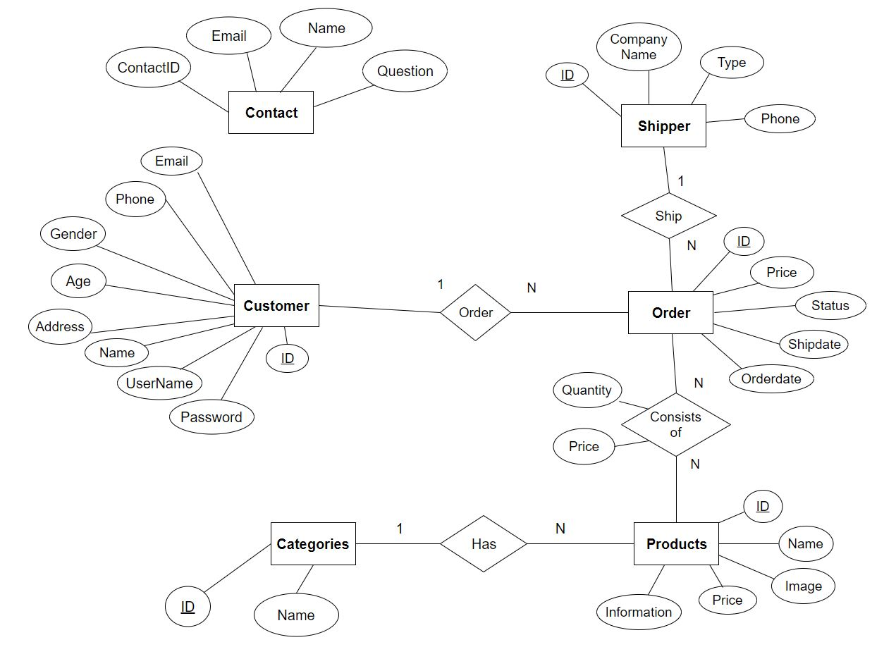

3.2)Database Design

-Diagram

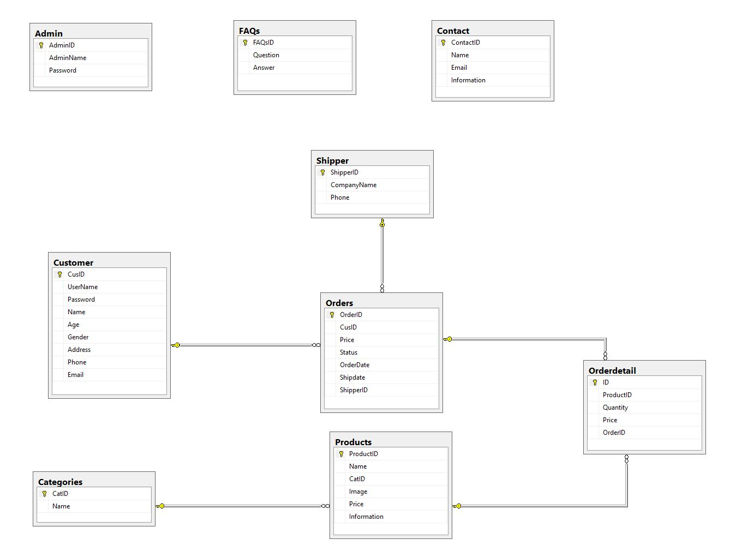

­­­­­­

-Admin:

|  |  |  |  |
| --- | --- | --- | --- |
| **Properties** | **Data Type** | **Length** | **Key** |
| AdminID | Int |  | Primary key |
| AdminName | Char | 100 |  |
| Password | Char | 64 |  |

-Customer:

|  |  |  |  |
| --- | --- | --- | --- |
| **Properties** | **Data Type** | **Length** | **Key** |
| CusID | Int |  | Primary key |
| UserName | Char | 250 |  |
| Password | Char | 64 |  |
| Name | Varchar | 250 |  |
| Age | Int |  |  |
| Gender | Char | 6 |  |
| Address | Varchar | 250 |  |
| Phone | Char | 10 |  |
| Email | Char | 250 |  |

-Shipper:

|  |  |  |  |
| --- | --- | --- | --- |
| **Properties** | **Data Type** | **Length** | **Key** |
| ShipperID | Int |  | Primary key |
| CompanyName | Varchar | 100 |  |
| Phone | Char | 10 |  |

-Orders:

|  |  |  |  |
| --- | --- | --- | --- |
| **Properties** | **Data Type** | **Length** | **Key** |
| OrderID | Int |  | Primary key |
| CusID | Int |  | Foreign key |
| Orderdate | Datetime |  |  |
| Shipdate | Datetime |  |  |
| Price | Float |  |  |
| Status | Varchar | 500 |  |
| ShipperID | Int |  | Foreign key |

-Categories:

|  |  |  |  |
| --- | --- | --- | --- |
| **Properties** | **Data Type** | **Length** | **Key** |
| CatID | Int |  | Primary key |
| Name | Varchar | 100 |  |

-Products:

|  |  |  |  |
| --- | --- | --- | --- |
| **Properties** | **Data Type** | **Length** | **Key** |
| ProductID | Int |  | Primary key |
| Name | Varchar | 100 |  |
| CatID | Int |  | Foreign key |
| Image | Image |  |  |
| Price | Float |  |  |
| Information | Varchar | 1000 |  |

-Orderdetail:

|  |  |  |  |
| --- | --- | --- | --- |
| **Properties** | **Data Type** | **Length** | **Key** |
| ID | Int |  | Primary key |
| ProductID | Int |  | Foreign key |
| Quantity | Int |  |  |
| Price | Float |  |  |
| OrderID | Int |  | Foreign key |

-Contact:

|  |  |  |  |
| --- | --- | --- | --- |
| **Properties** | **Data Type** | **Length** | **Key** |
| ContactID | Int |  | Primary key |
| Name | Varchar | 100 |  |
| Information | Varchar | 1000 |  |
| CusID | Int |  | Foreign key |

-FAQs:

|  |  |  |  |
| --- | --- | --- | --- |
| **Properties** | **Data Type** | **Length** | **Key** |
| FAQs | Int |  | Primary key |
| Question | Varchar | 1000 |  |
| Answer | Varchar | 2000 |  |

3.3)Sitemap

-Client:

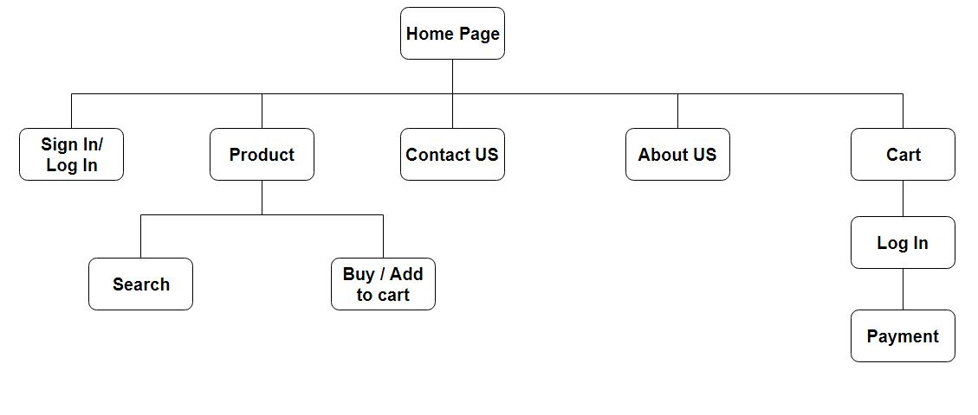

-Admin:

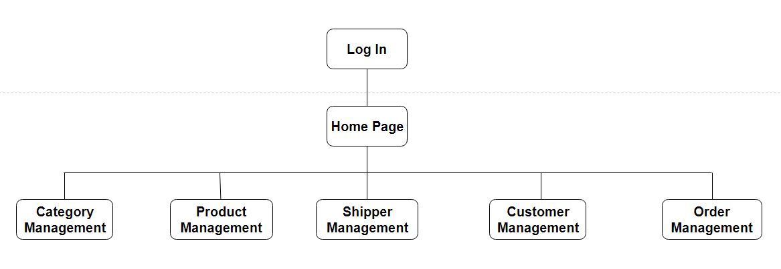

3.3)System Functions Design

-Login:

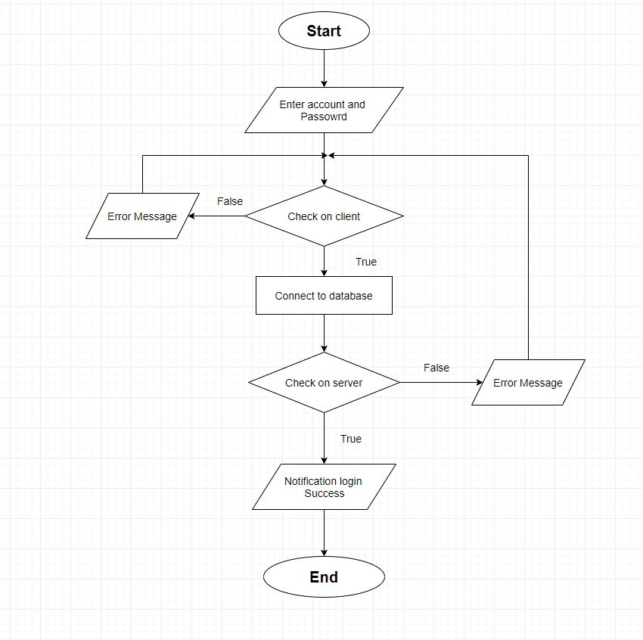

-Search:

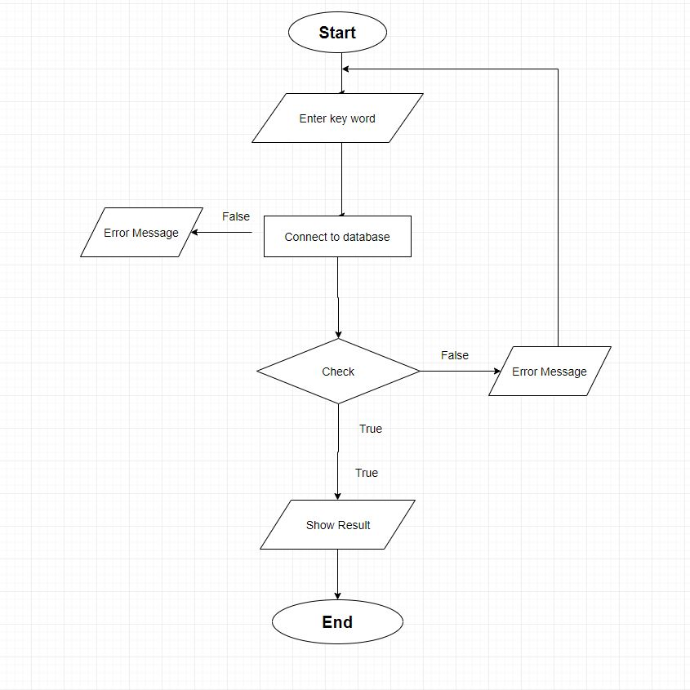

-create,update product:

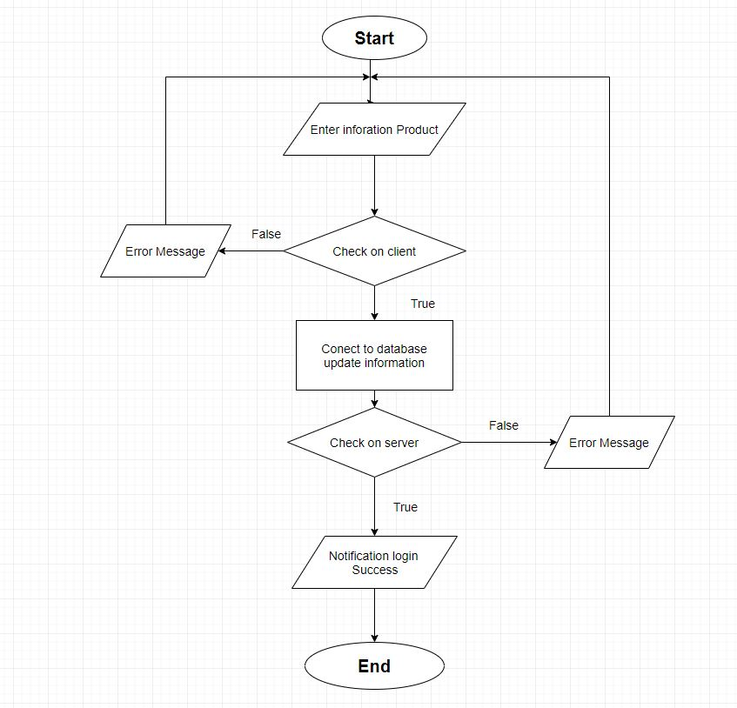

3.4)Theme

-Client:

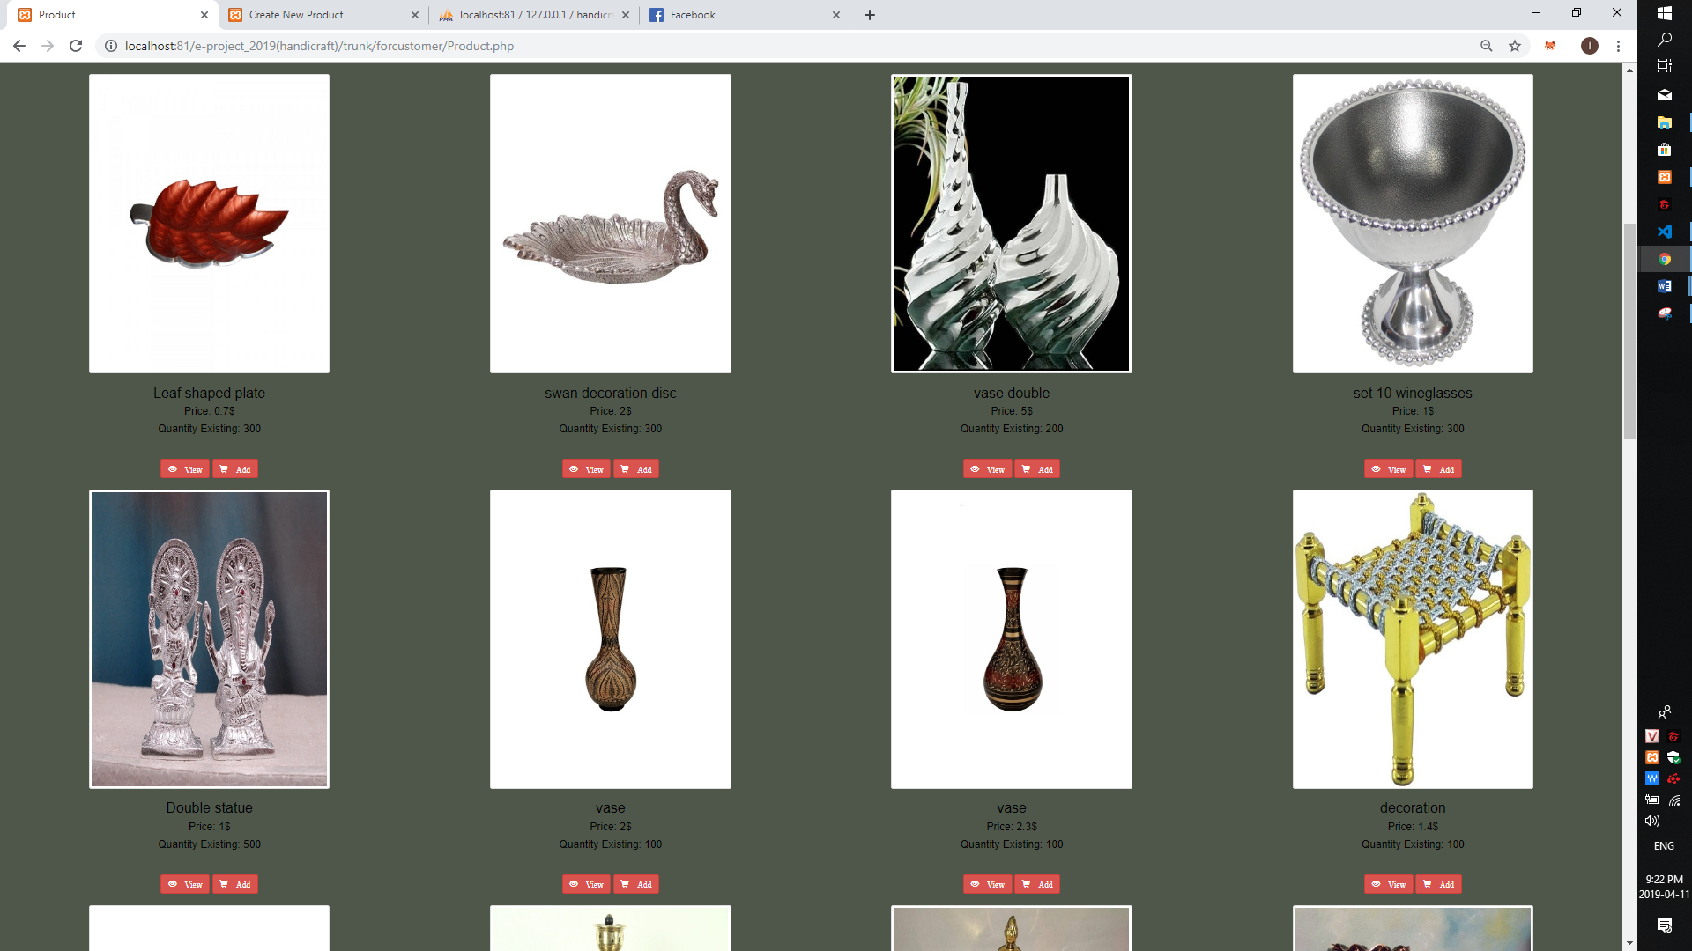

Image1:Product for customer

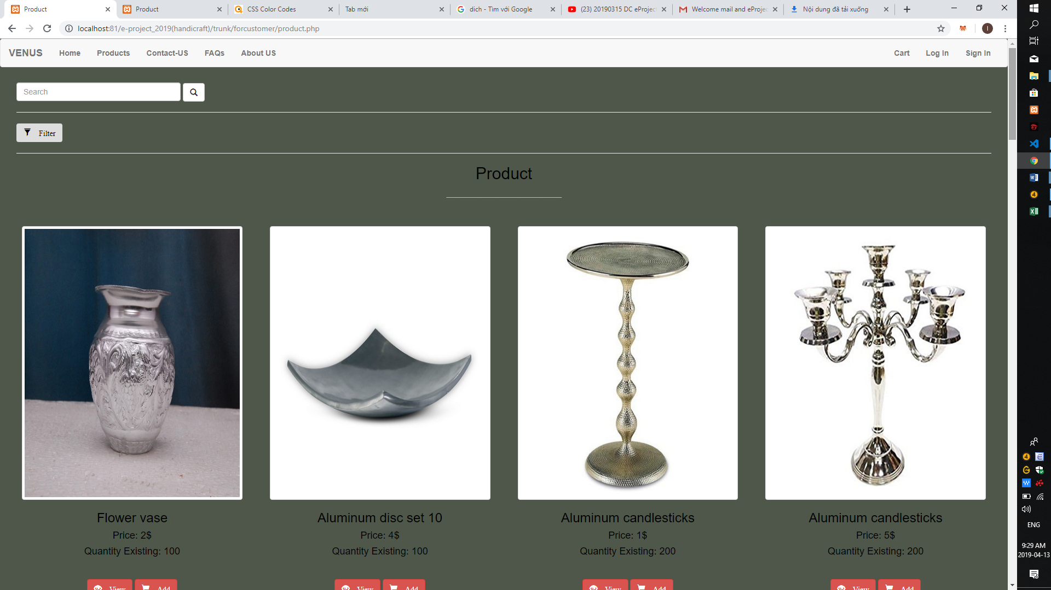

Image2:Product for customer

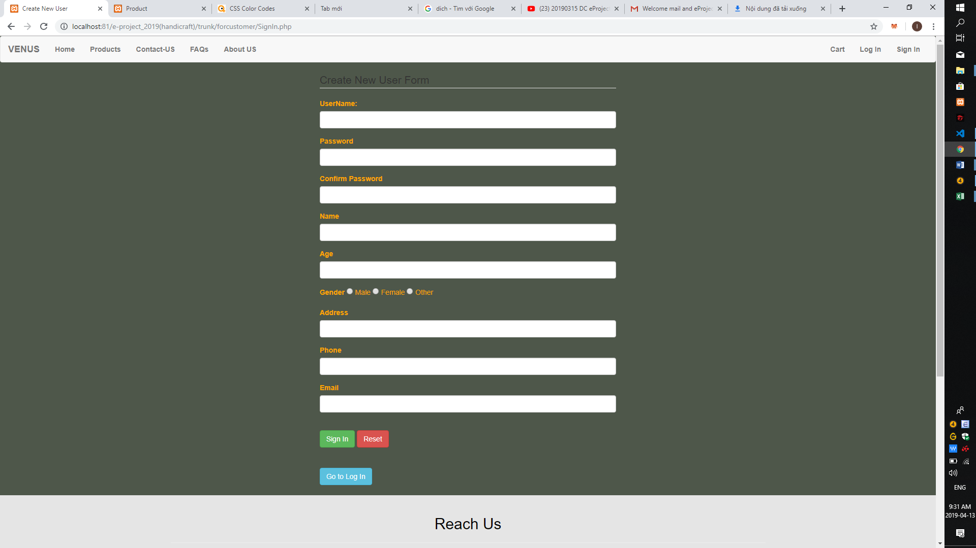

Image3:Sign In for customer

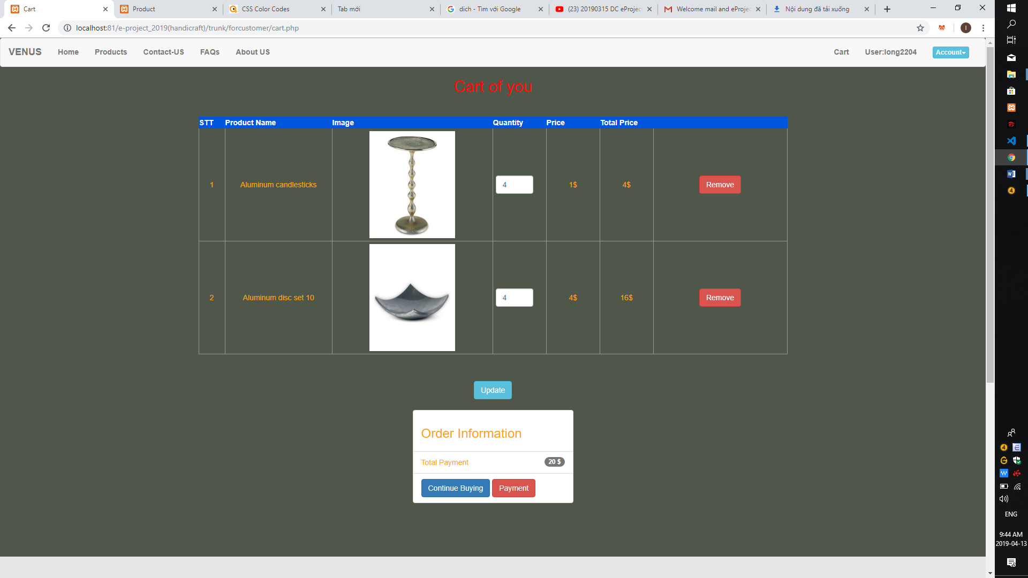

Image4:Cart

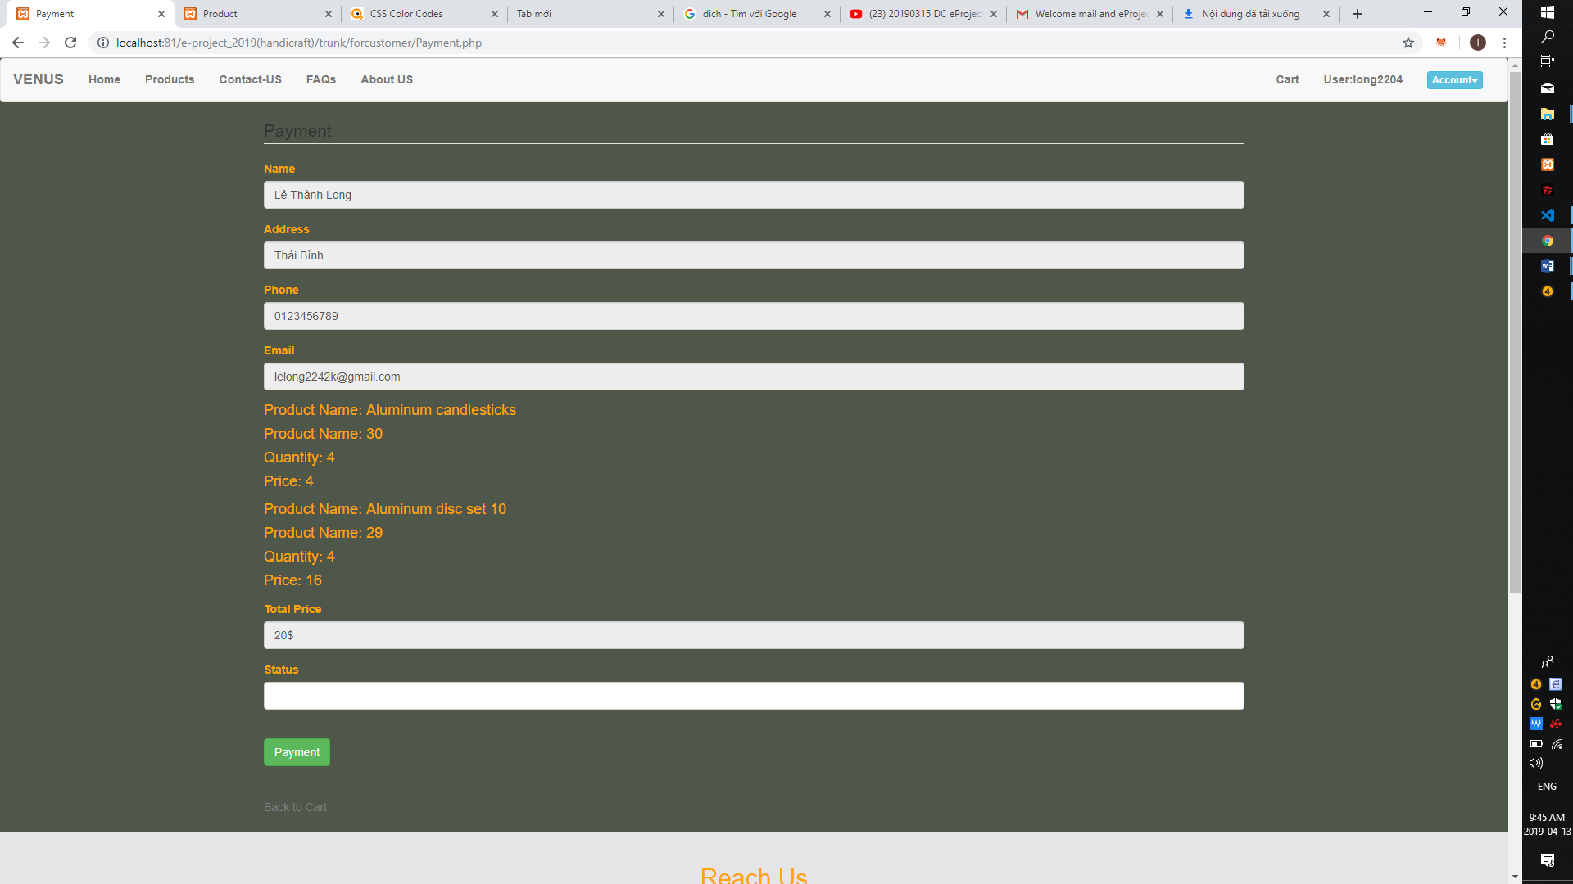

Image5:Payment

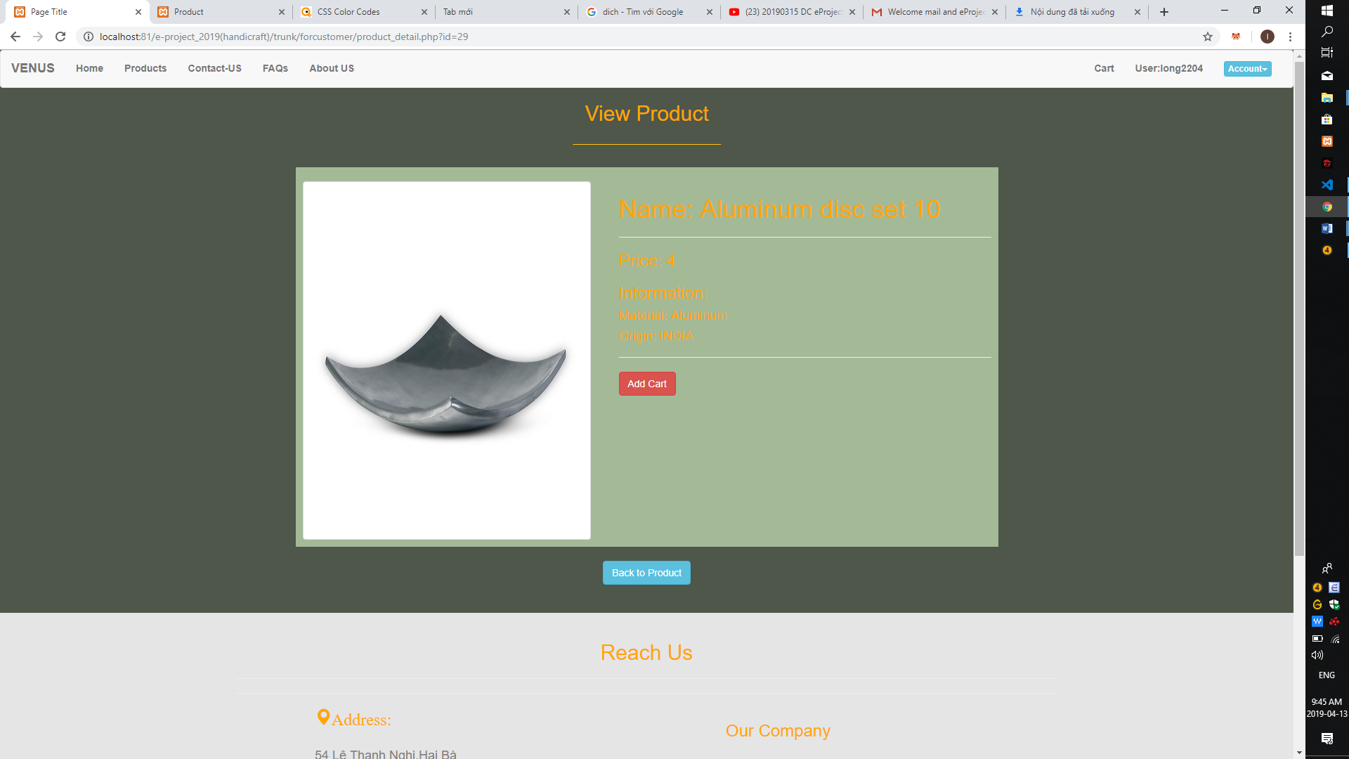

Image6:Order detail

-Admin:

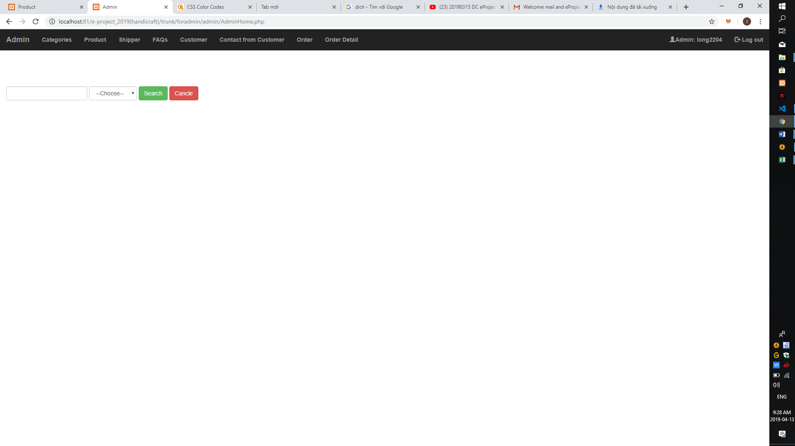

Image1:Home for admin

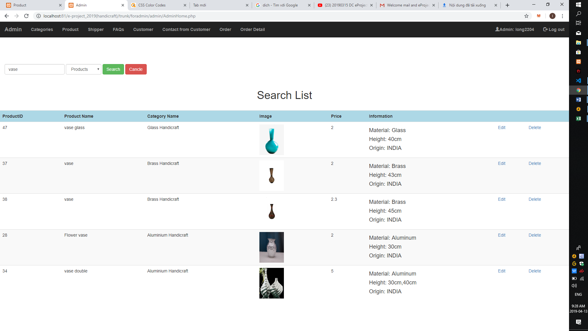

Image2:Product for admin

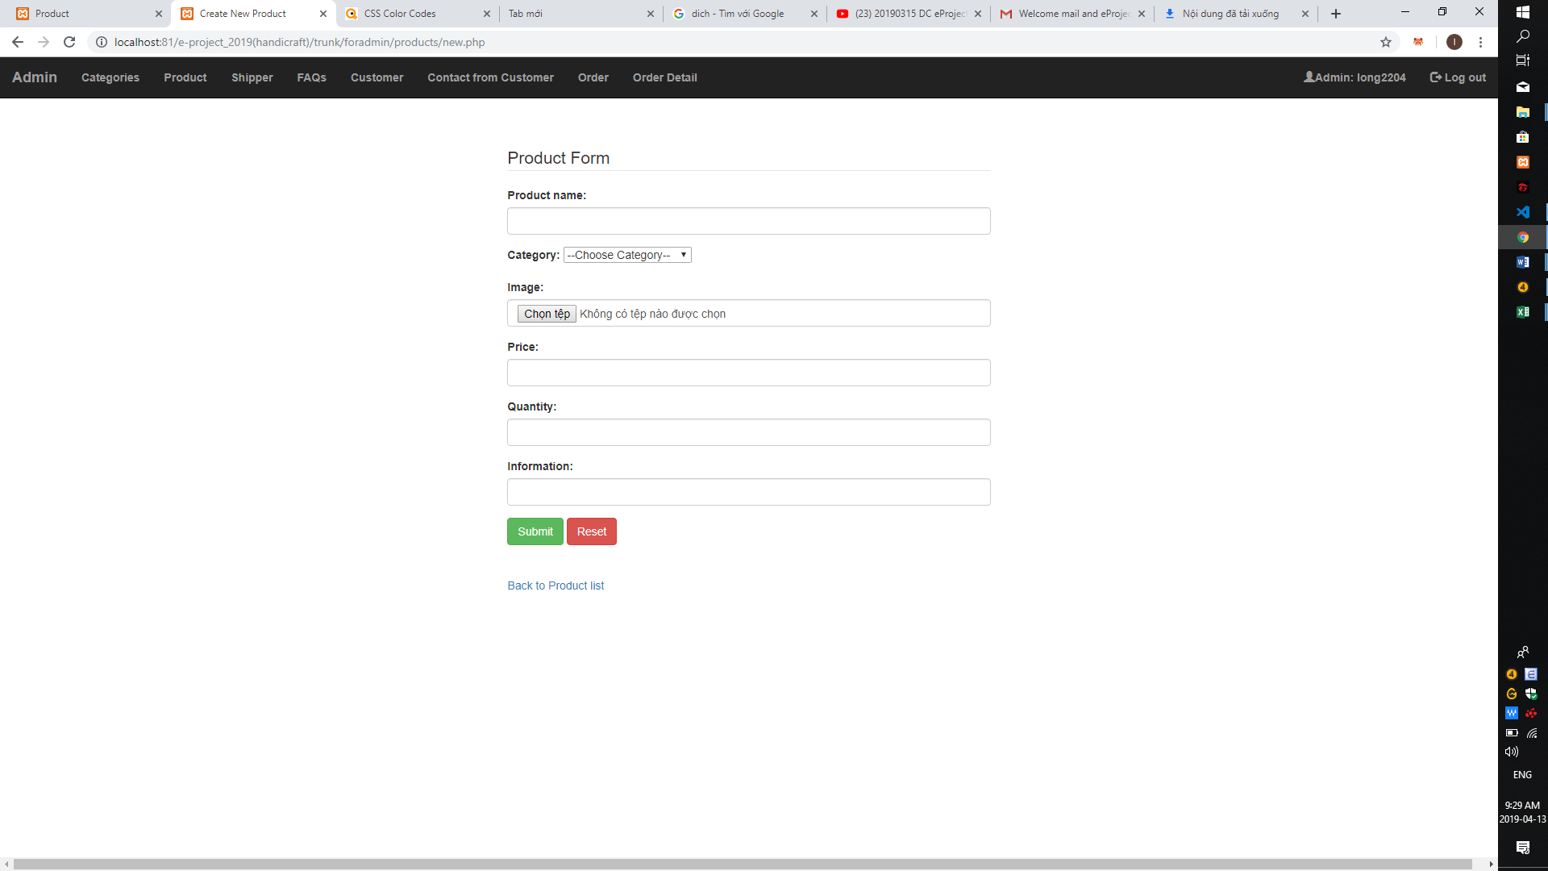

Image3:Create new product

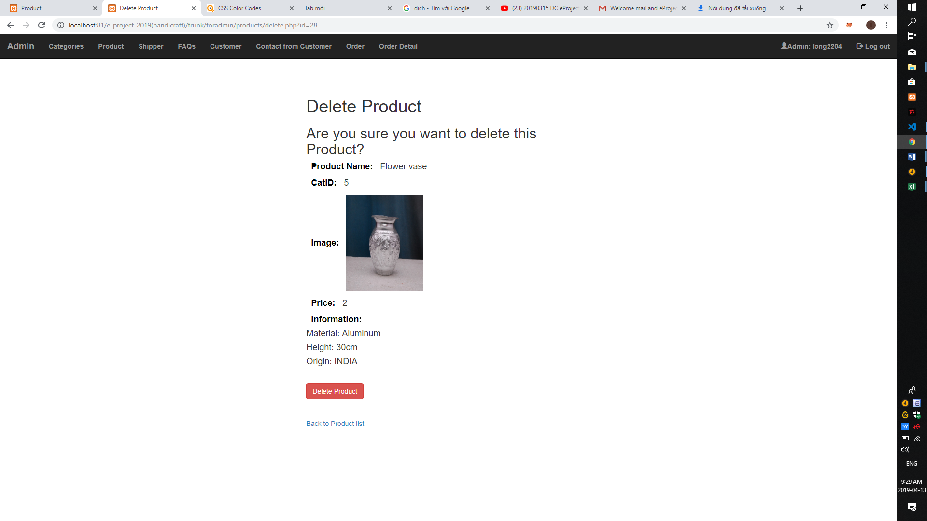

Image4:delete Product