Create MS Word document that contains screenshots of your activities completed after the following steps.

1. Create the package.json file
2. Connect to MongoDB
3. Insert a Document
4. Update a document
5. Directory Structure
6. Code
7. Create a package.json file

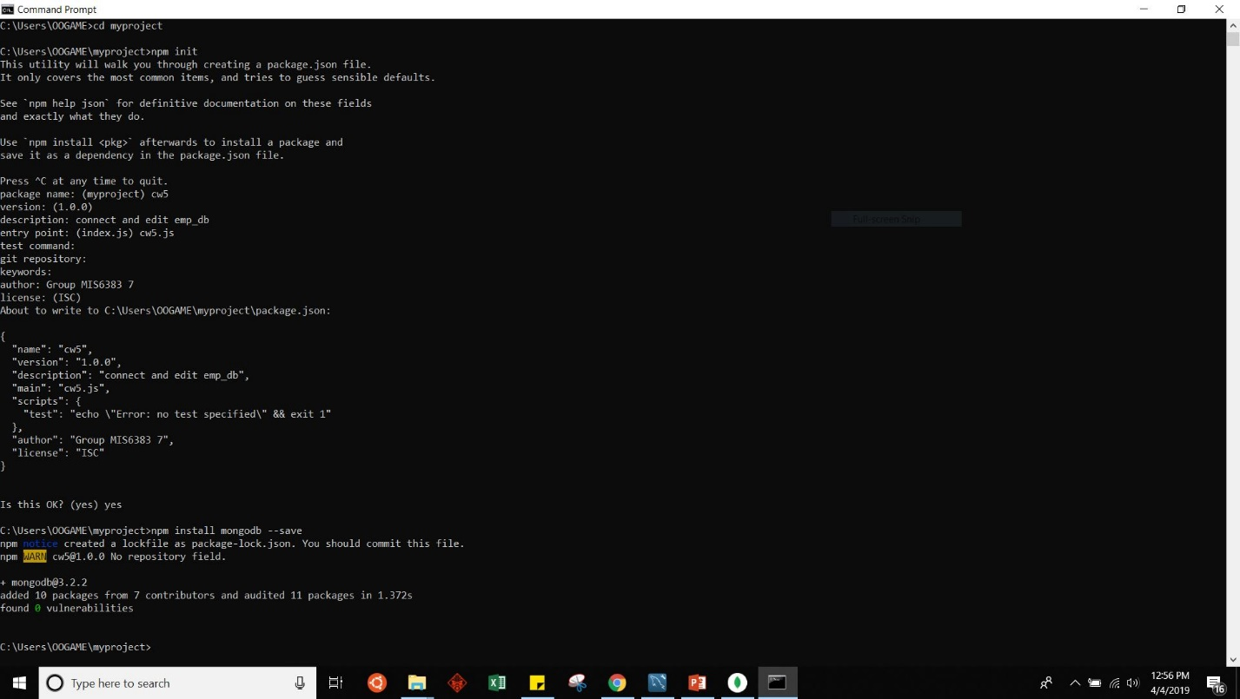

1. Connect to mongodb

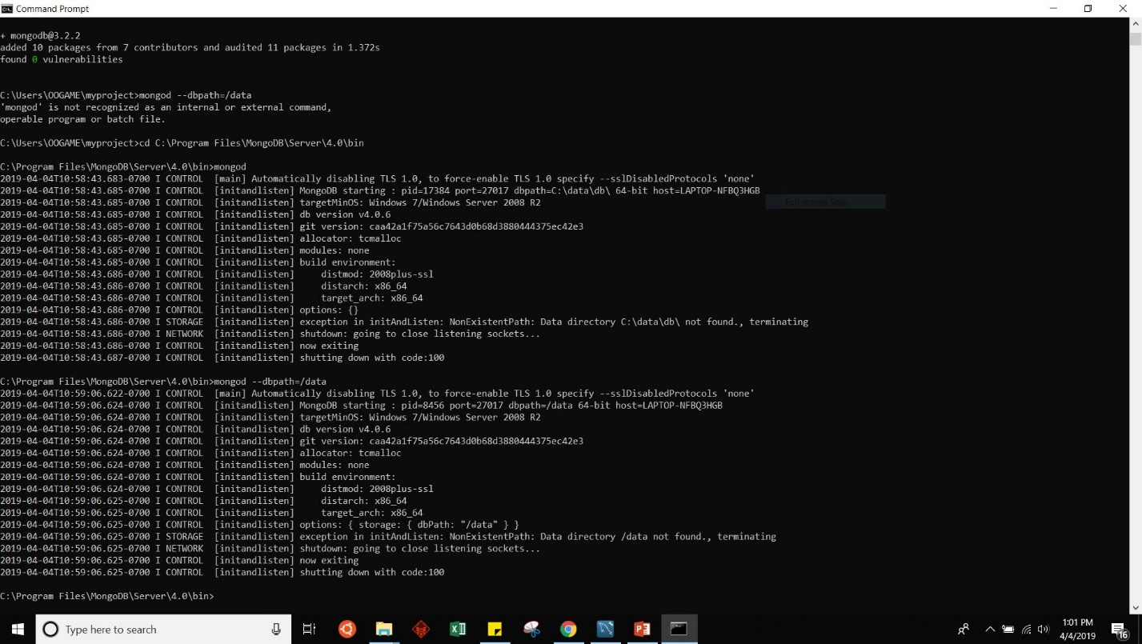

3 & 4. Insert & Update document

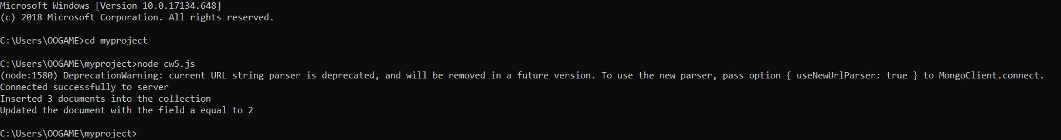

5. Directory Structure

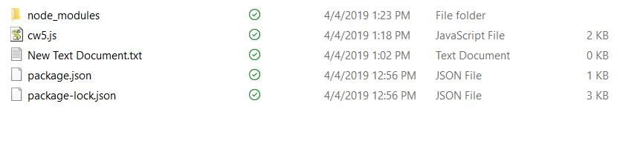

6.CODE:

const MongoClient = require('mongodb').MongoClient;

const assert = require('assert');

// Connection URL

const url = 'mongodb://localhost:27017';

// Database Name

const dbName = 'myproject';

const client = new MongoClient(url);

// Use connect method to connect to the server

client.connect(function(err) {

assert.equal(null, err);

console.log("Connected successfully to server");

const db = client.db(dbName);

insertDocuments(db, function() {

updateDocument(db, function() {

client.close();

});

});

});

const insertDocuments = function(db, callback) {

// Get the documents collection

const collection = db.collection('documents');

// Insert some documents

collection.insertMany([

{a : 1}, {a : 2}, {a : 3}

], function(err, result) {

assert.equal(err, null);

assert.equal(3, result.result.n);

assert.equal(3, result.ops.length);

console.log("Inserted 3 documents into the collection");

callback(result);

});

}

const updateDocument = function(db, callback) {

// Get the documents collection

const collection = db.collection('documents');

// Update document where a is 2, set b equal to 1

collection.updateOne({ a : 2 }

, { $set: { b : 1 } }, function(err, result) {

assert.equal(err, null);

assert.equal(1, result.result.n);

console.log("Updated the document with the field a equal to 2");

callback(result);

});