Resources  You can find our current catalog and up-to-date information about all our products on www.wingtiptoys.com. Visit us any time of the day, and day of the week!  Our customer service associates are available 24 hours a day for live chat or telephone support.  Wholesale program support is available from your regional sales representative.  Contact Us  Contact your regional sales representative to place an order, or for additional support, please contact:  Lola Jacobsen, National Sales Manager  Phone: (940) 555-0142  Email: lola@wingtiptoys.com  Our Toymakers welcome your input! If you have feedback about our toys or ideas for new toys that would do well in your market, please contact:  Sarah Jones, Creative Design Manager  Phone: (940) 555-0155  Email: sarah@wingtiptoys.com  Visit Us  315 Wingtip Way  High Flying, TX 71234  Website: http://www.wingtiptoys.com   Wingtip Toys 315 Wingtip Way High Flying, TX 71234 |  |  | Spring Catalog Preview  Wingtip Toys  - Creators of sky-high fun!!

Table of Contents  New Electronic Favorites 1  My First Keyboard  My Robot Friend  My Red Rocket  Why Buy Wingtip Toys? 2  Our Employees Go the Extra Mile  Our Customers Make the Difference  Recognition 3  Make It Your Own 4  Customize in Almost No Time  Make It Picture Perfect  Hand-Carved Toys 5  Simple Animals  Pull Toys  Whimsical Classics  Resources 6  Contact Us  Visit Us |  |  | Hand-Carved Toys  Simple Animals   Your child can create a barnyard in the backyard with this colorful collection of hand-carved wooden animals. Decorated with non-toxic paint in coordinating, yet lifelike, colors. Carved to scale.  Pull Toys   What could be more fun than taking your dog for a walk? How about taking it for a roll! These hand-carved wooden pals feature smooth-rolling wheels and handles that are easy for little hands to hold.  Whimsical Classics  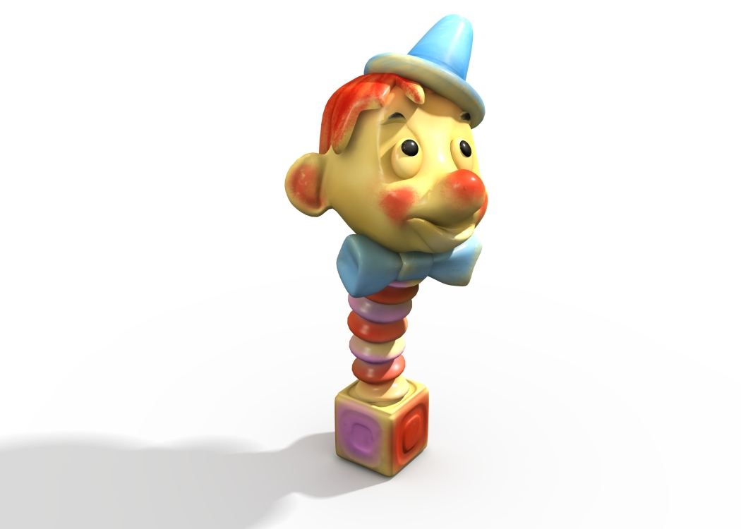 What better way to celebrate Spring than with this springy Jack-in the Box! This winsome character will surprise and delight young children each time he pops out of his hand-carved wooden box.

Make It Your Own  If you think a document that looks this good has to be difficult to format, think again!  We've created styles that let you match the formatting in this brochure with just a click. On the Home tab of the ribbon, check out the Styles gallery.  This is the Quote style. It’s great for calling out a few very important points.  Customize in Almost No Time  To try out other looks for this brochure, on the Design tab of the ribbon, check out the Themes, Colors, and Fonts galleries.  Have your own company fonts or colors? No problem! Those galleries give you the option to add your own.  Make It Picture Perfect  To replace any photo with your own, just right-click it and then click Change Picture.  If your photo is not a flawless fit for the space, you can crop it to fit in almost no time. Just select the picture and then, on the Picture Tools Format tab, click Crop. |  |  | New Electronic Favorites  My First Keyboard  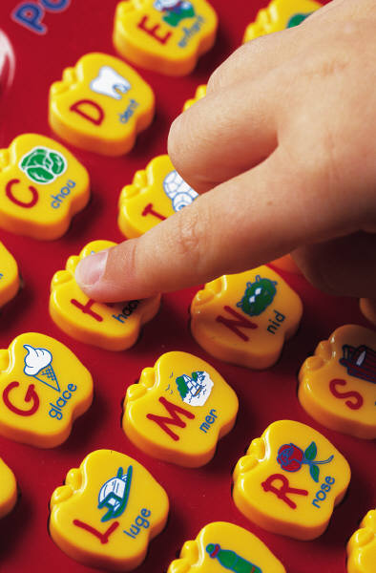 Whether your child prefers Beethoven, the Beatles, or Bruce Springsteen, he can play favorite tunes, hear letters and words, and experiment with making new music on this fun keyboard. Decorated in bright primary colors, the sturdy keyboard features apple-shaped keys with visual labels.  My Robot Friend   This walking, talking, robotic marvel will be more than a toy for your child, he will be an electronic buddy! My Robot Friend responds to verbal interaction and can perform many basic tasks including cleaning up a bedroom, setting the table, and putting away laundry.  My Red Rocket  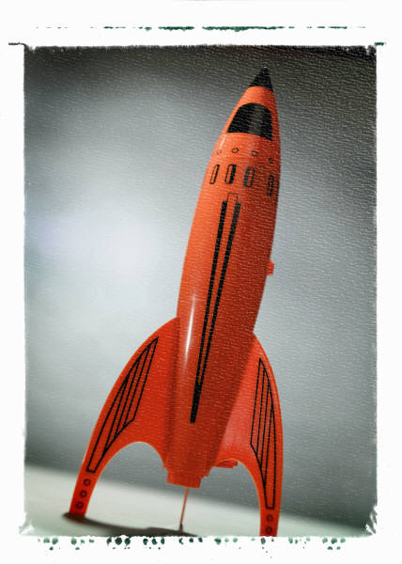 To the moon and beyond! This deceptively sleek rocket really flies. Featuring a two-stage electronic ignition and reusable landing parachute, this high-flying toy soars to great heights and then returns safely to your young space explorer.

Why Buy Wingtip Toys?  Our Employees Go the Extra Mile  At Wingtip Toys, we are honored to employ America’s Finest Toymakers. Each of our Toymakers and Associates—whether in the office, in the factory, or on the road—is fully committed to creating a great toy experience for our Customers and their lucky friends and family members. No idea is ignored, so don’t hesitate to share your dreams and let us create them in reality!  “Your company is the greatest. I can’t imagine anyone living without you.” —Very smart customer  Our Customers Make the Difference!  The contents of this catalog have been selected from suggestions received from you, our Customers. Yes, we spell Customer with a capital “C” because without you, our Toymakers, Associates, and other Team Members would not have achieved the continued success that they have.  We would particularly like to acknowledge the support of the following Customers who have each contributed to our success for over five years:  - Blue Yonder Airlines  - Northwind Traders  - Tailspin Toys  Additionally, you could include a bulleted list of products, services, or major benefits of working with your company. Or just summarize your finer points in a few concise paragraphs. |  |  | Recognition   We are proud to announce that Wingtip Toys has earned its fifth consecutive Gold Medal of Achievement! This prestigious award honors not only our Team Members but also you, our Customers, who drove our Toymakers and Associates to achieve excellence in their work lives and in their communities. In addition, the highly coveted Great Big Cup of Awesomeness holds pride of place in our Chairman’s office yet again. This trophy is presented each year by members of the National Toy Association to a member who has contributed to the overall success of the industry. We credit our Customers for driving us to new heights of awesomeness every year! Thank you!

