Sona Padinjarekutt

CS1660

Assignment Three

Due: October 4th, 2020 at 11:59 PM

**Screenshot of your AWS Account with IAM (25%)**

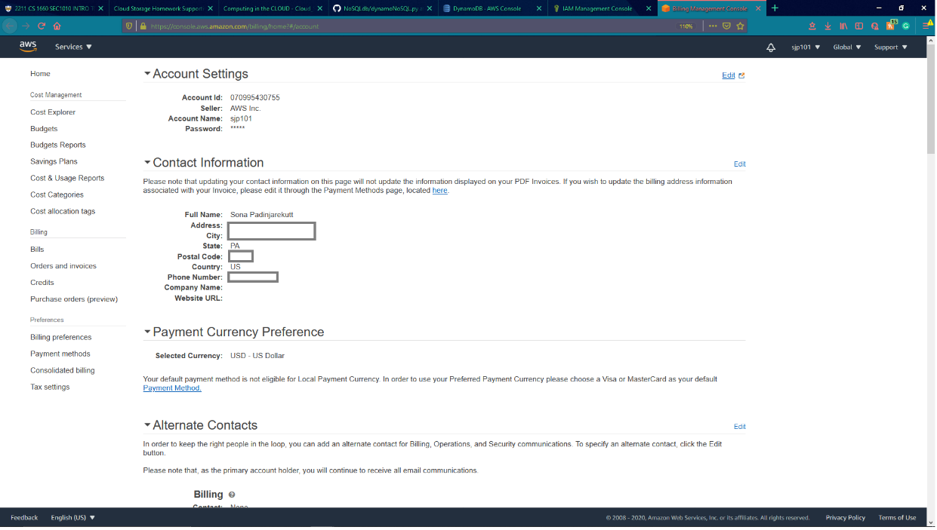

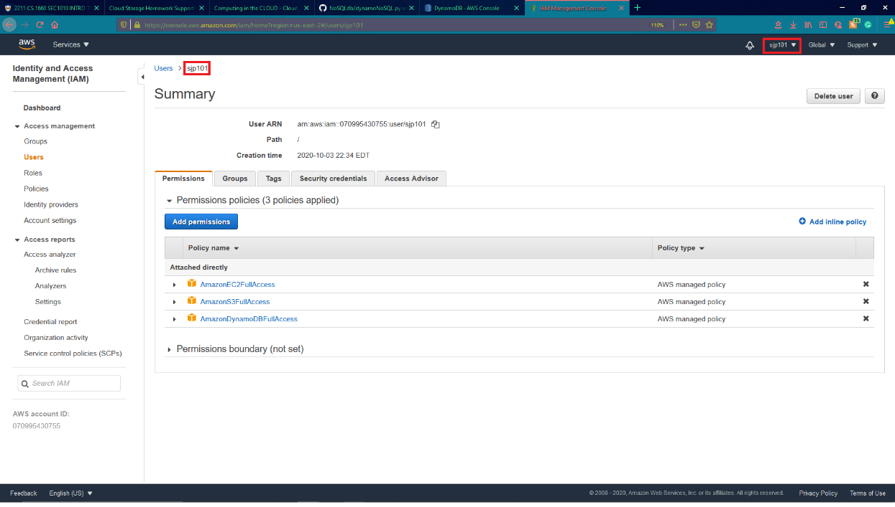

**Screenshot showing you installed Amazon Python Boto3 SDK (25%)**

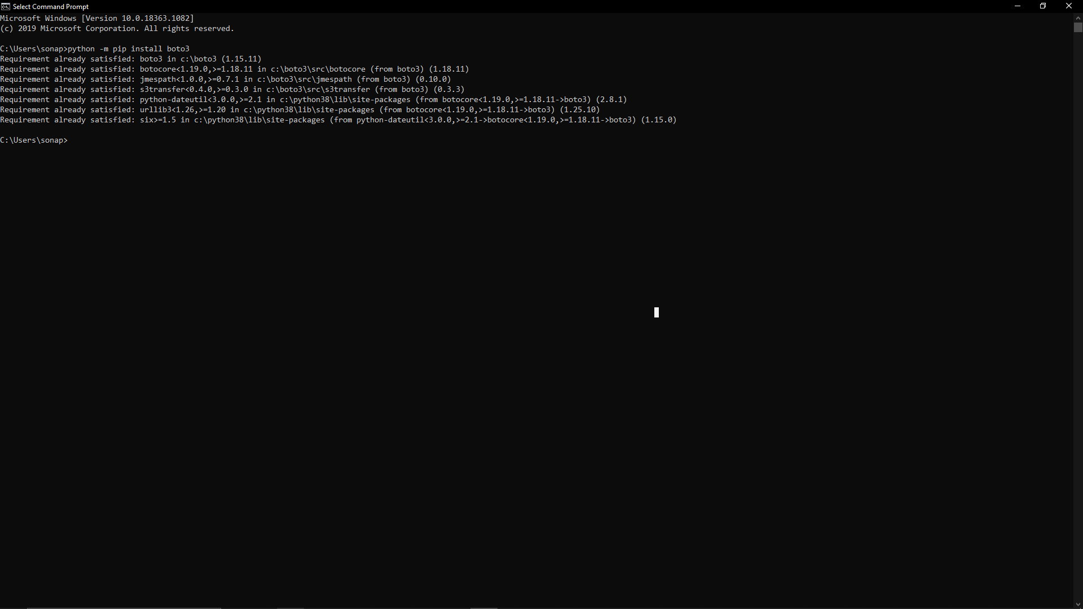

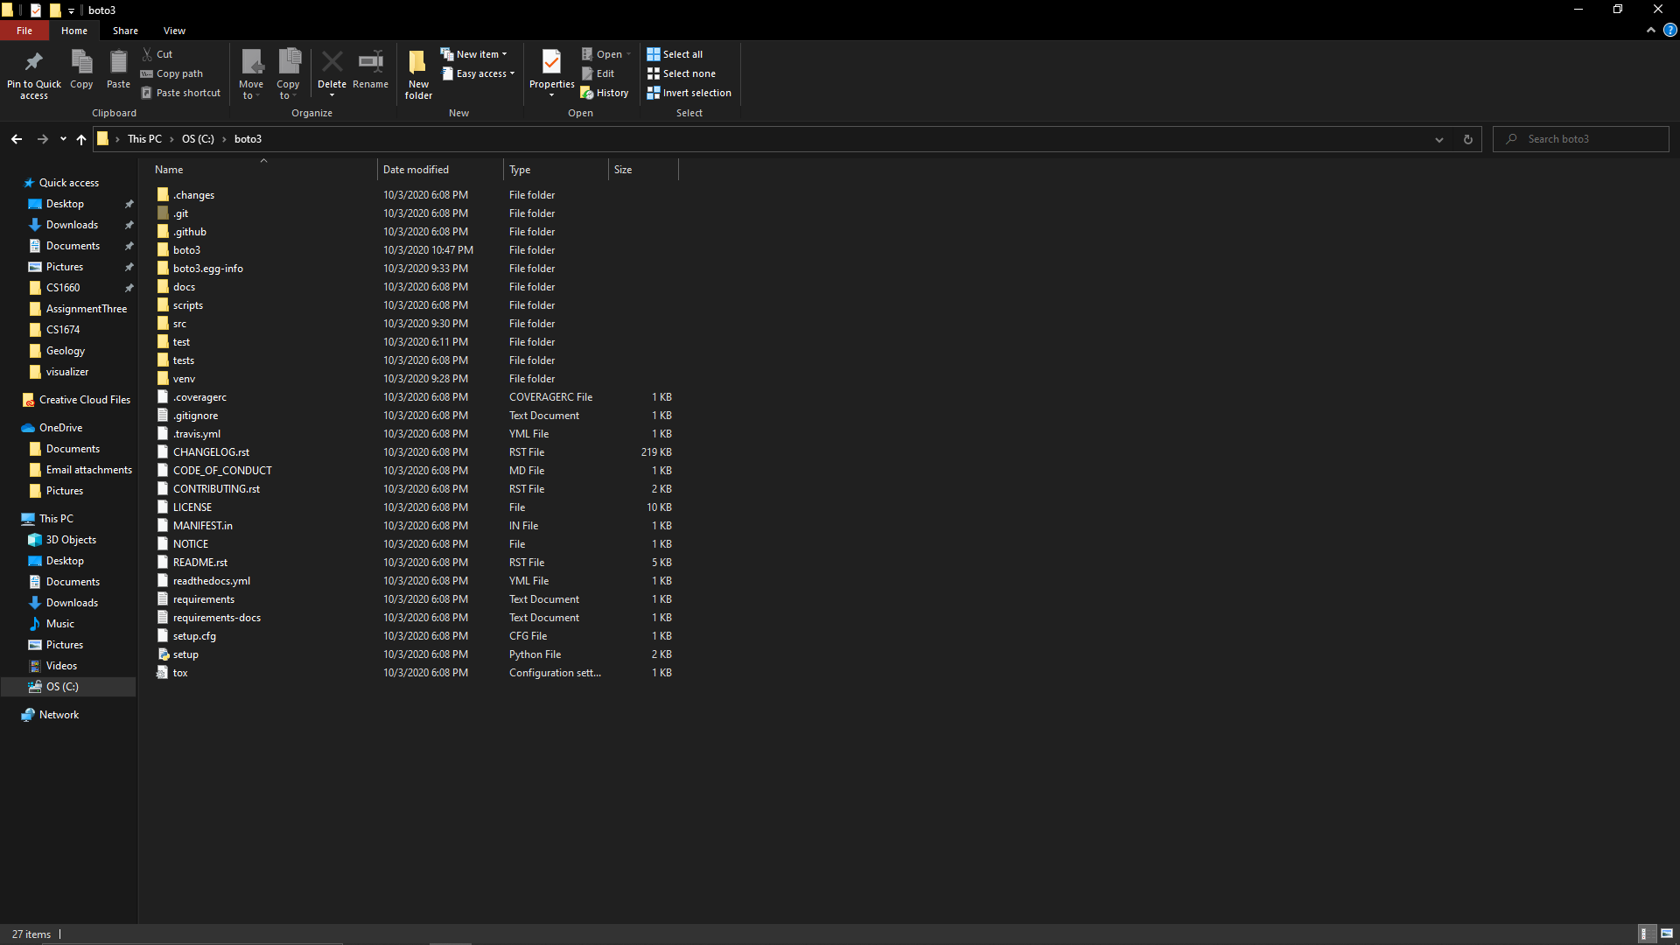

**A print of your code (25%)**

--Located in the repo. The file is called dynamoNoSQL.py , and it can be reached through this link: <https://github.com/sona-padin/NoSQLdb/blob/master/dynamoNoSQL.py>

**Screenshot of your query to the newly constructed table (25%)**

