Create a hive table and load the dataset into the table and evaluate the below problem statements

Solution:

Creating the table and loading the data



1. Find out the average HP (Hit points) of all the Pokémons

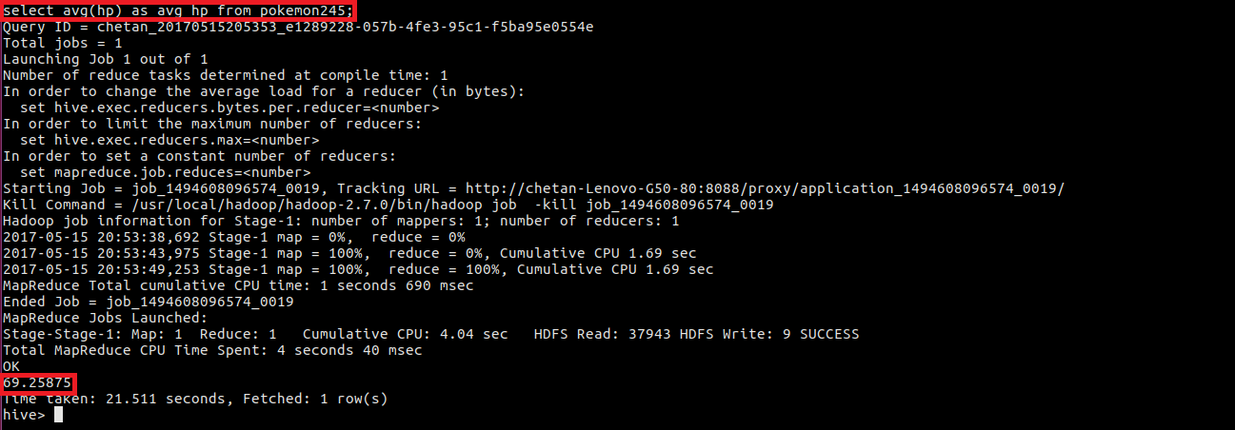

1. Find out the average Defense of all the pokemon

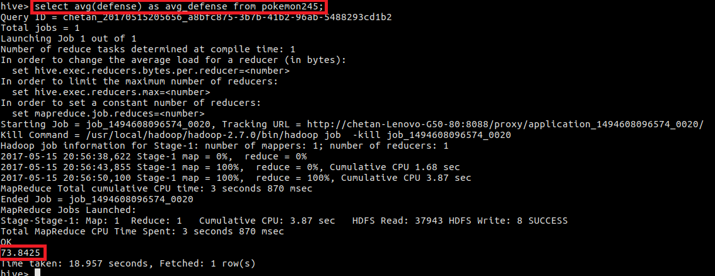

1. Find out the average Sp.Atk of all the pokemons

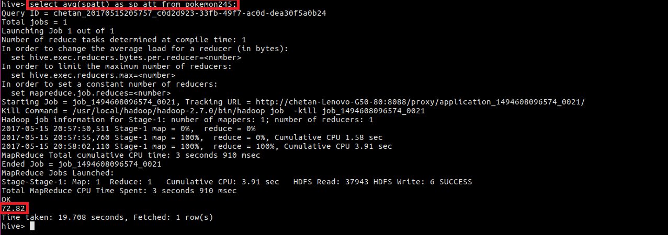

1. Find out the average sp.Def of all the pokemons

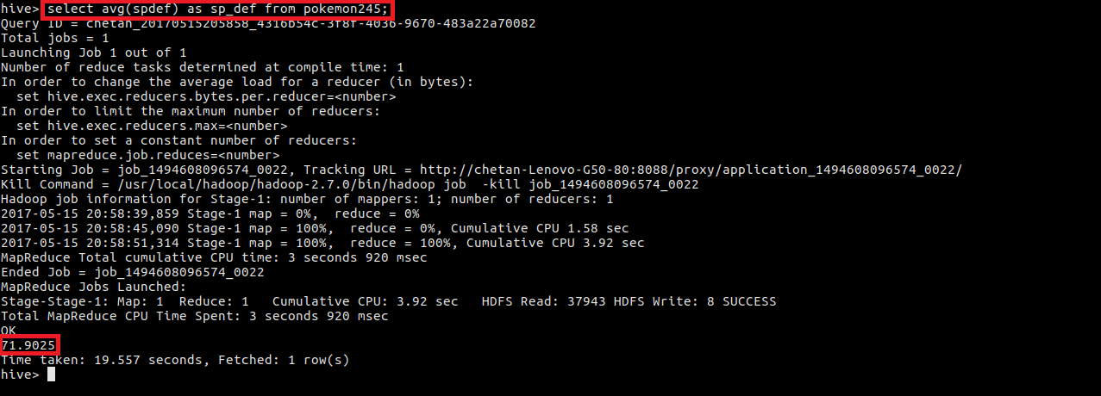

1. Find out the average Speed of all the pokemons

