Perform join optimizations in hive by following the steps in the below blog link <https://acadgild.com/blog/join-optimization-in-apache-hive/>

Solution:

Creating table empl and loading the data

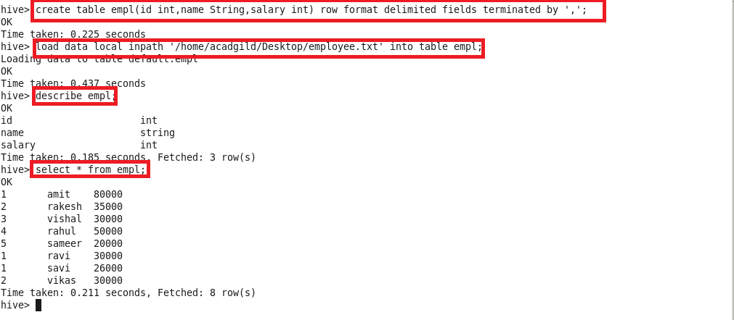

Creating table dept and loading the data

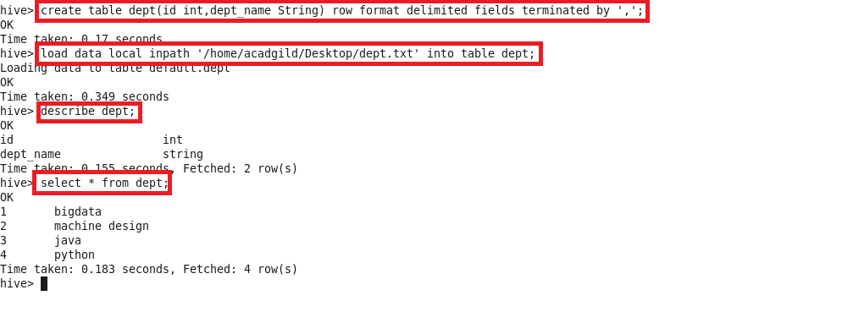

**Join table ordering (Largest table last)**.

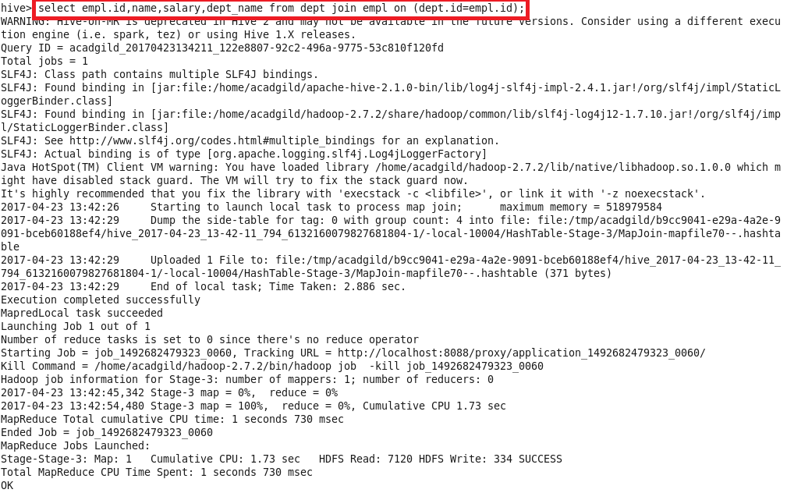

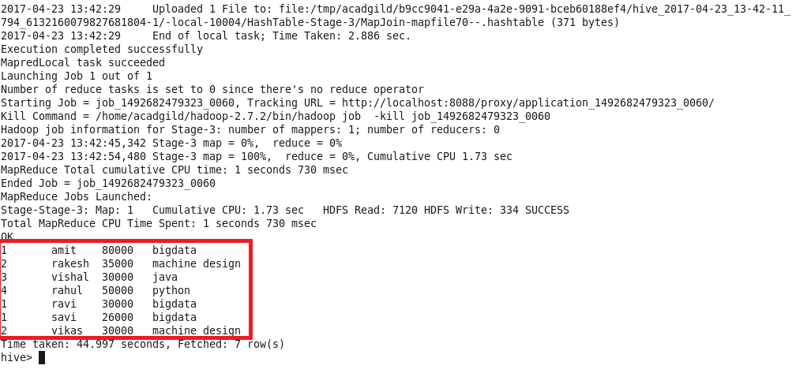

**Map Side Join:**

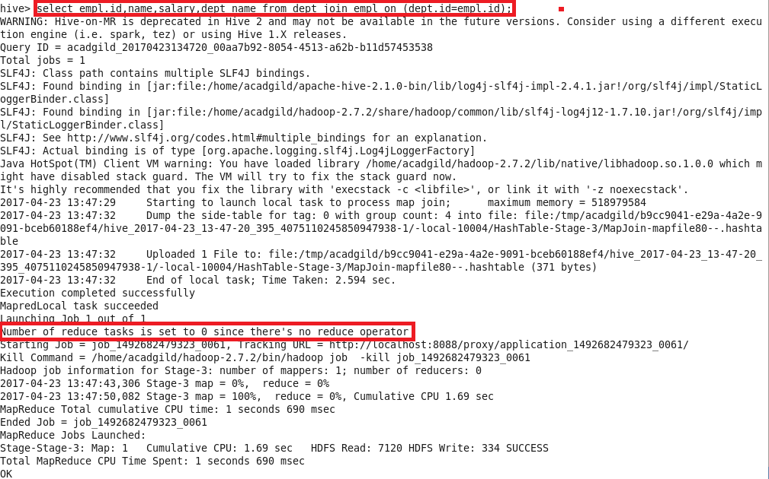

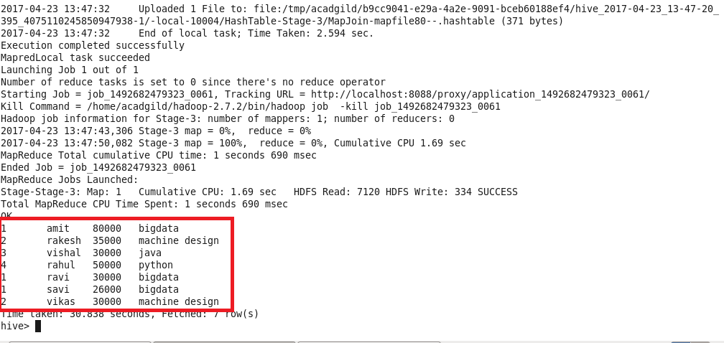

**Sort-Merge-Bucket (SMB) Map Join:**

**Creating bucketed tables:**

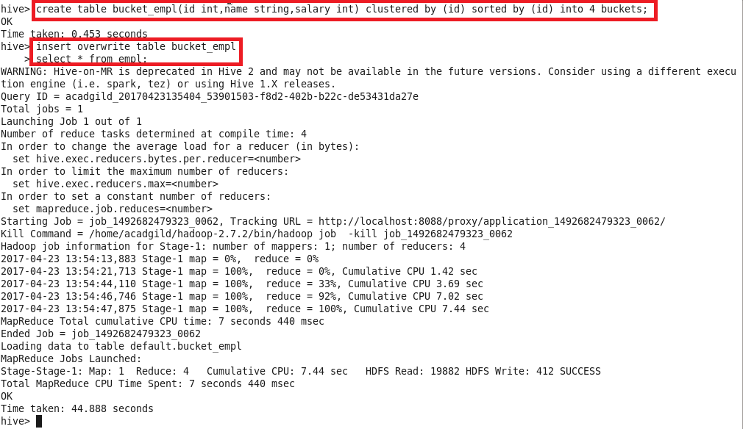

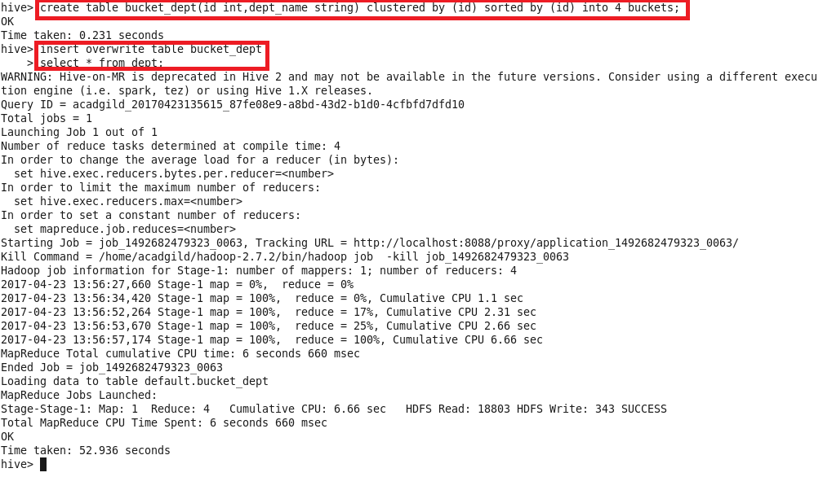

Performing SMB Map Join

