Using the below given two datasets you need to give a demo on the below joins in hive.

Bucket Map join

Sort-Merge Bucket join

Sort-Merge Bucket Map join

Left semi join

**Solution:**

**Bucket Map join**

**Creating two tables and loading the data in these tables:**

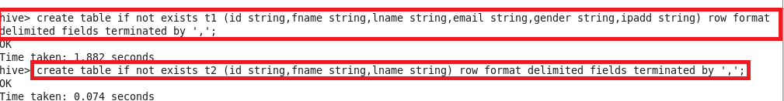

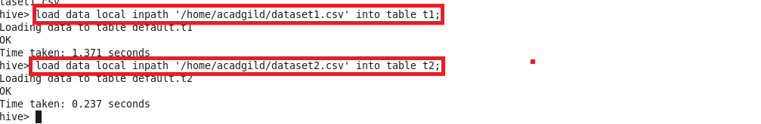

**Creating 2 bucket tables with 4 and 8 buckets:**

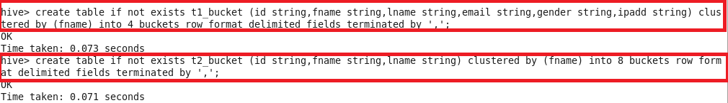

**Loading the data into bucket tables:**

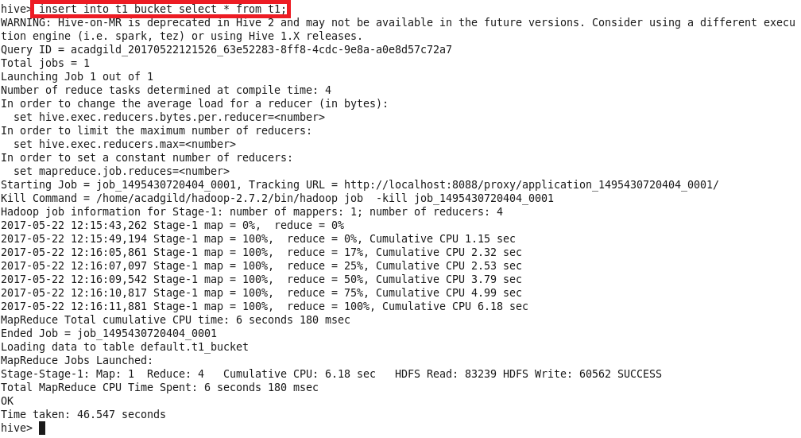

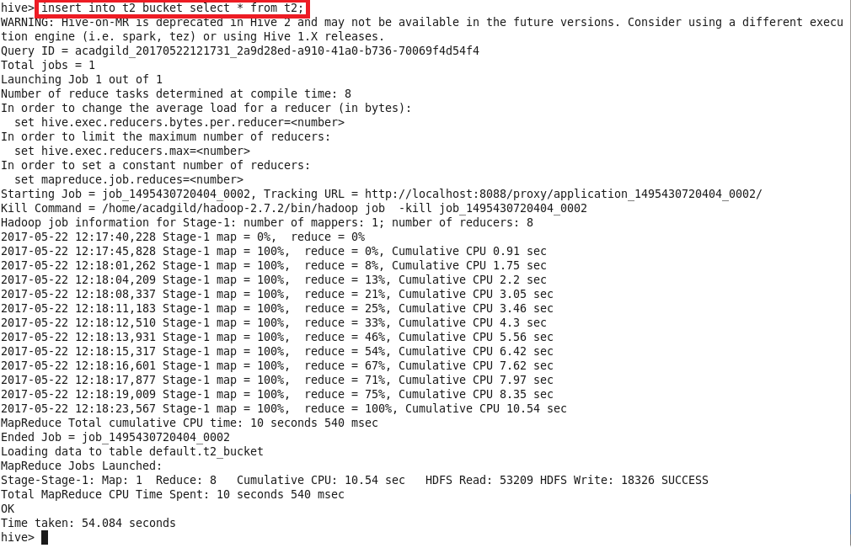

For performing Bucket-Map join, we need to set

sethive.optimize.bucketmapjoin = true

andwriting query for bucket map join

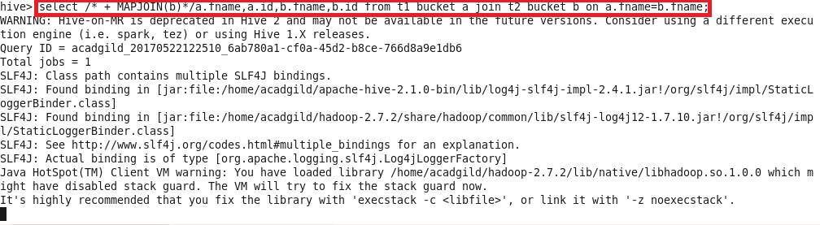

**Output:**

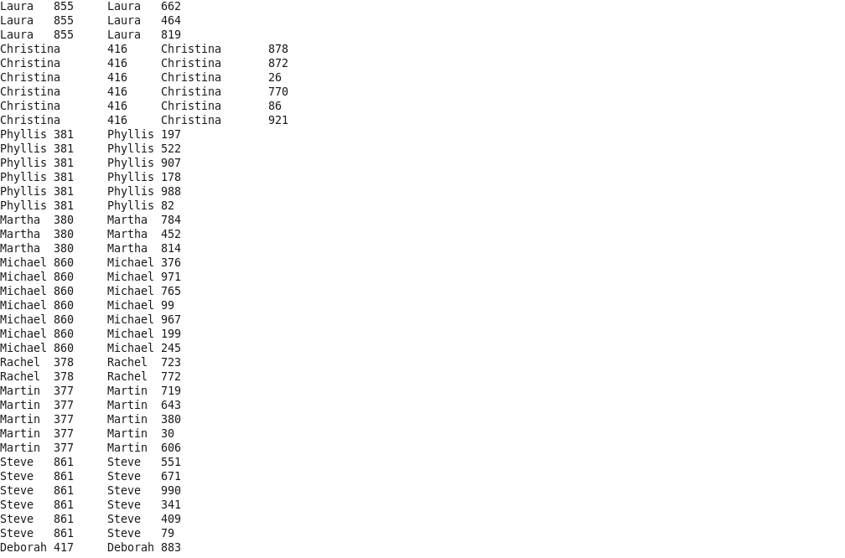

**Sort-Merge Bucket join**

We need to set :



**Sorting the contents of bucket tables:**

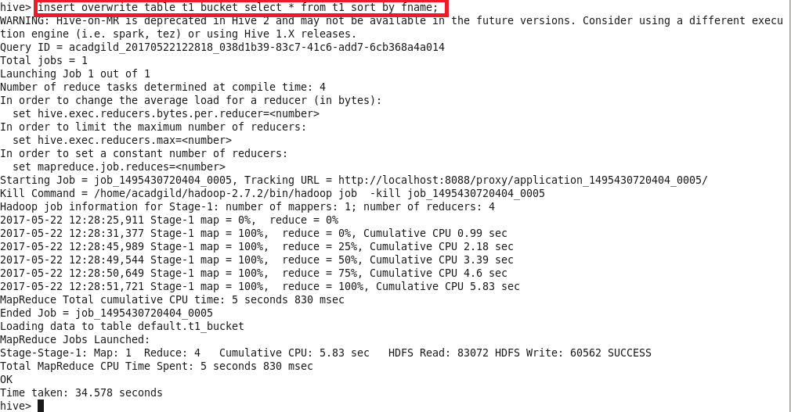

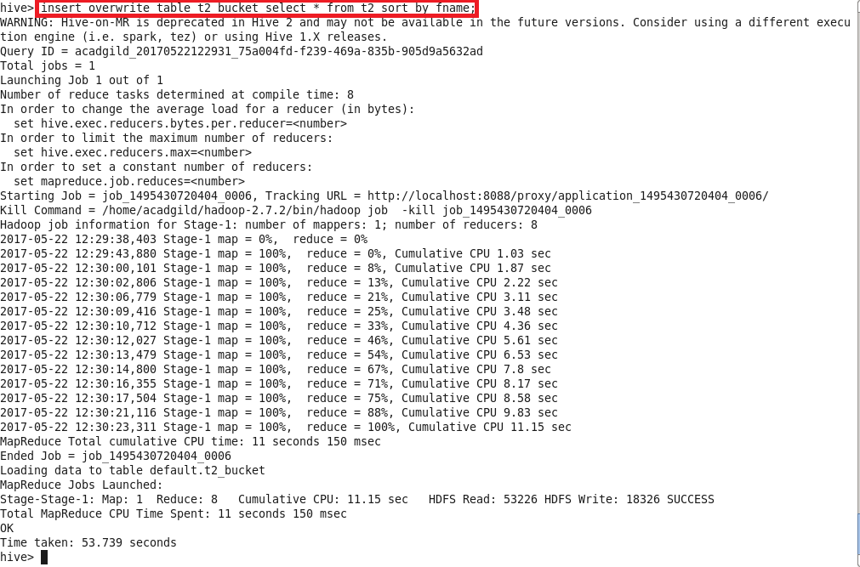

**Writing query for sort merge bucket join:**

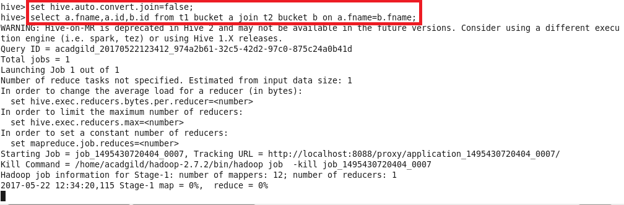

**Output:**

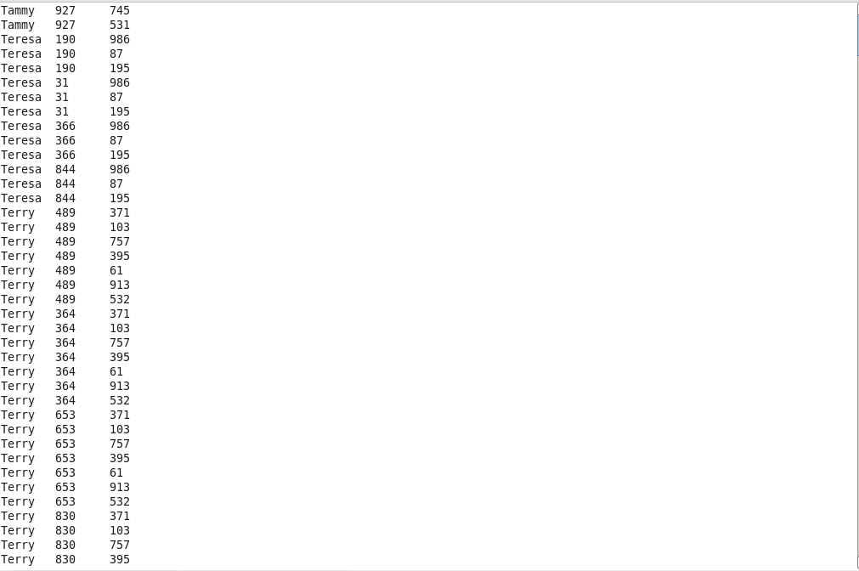

**SORT-MERGE BUCKET MAP JOIN:**

**Using the same bucketed tables previously used,**

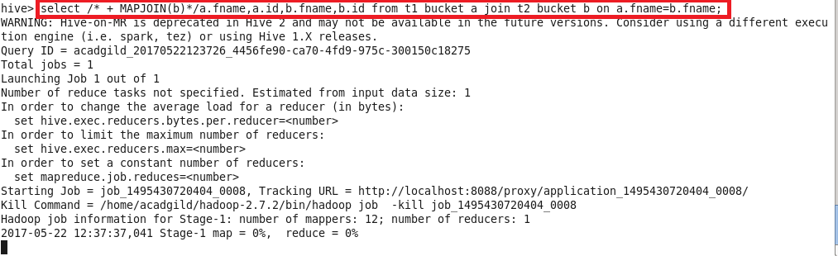

**Output:**

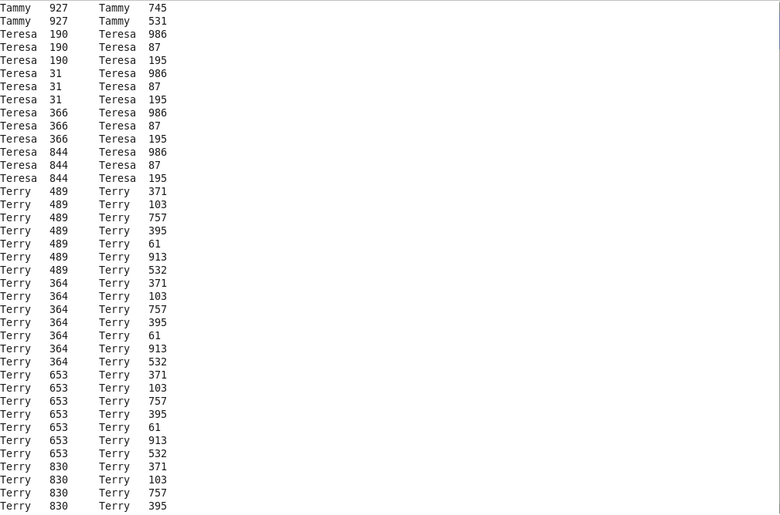

**Left Semi Join:**

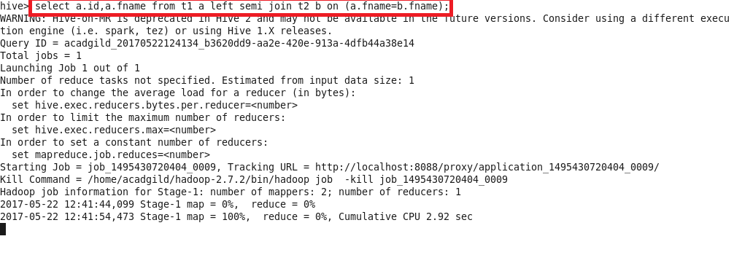

**Output:**

