**Problem Statement:**

● Create a employee table in Mysql and columns as Emp_id, Emp_name, Dept_name(Hadoop Developer), Emp_sal.

● Import the employee table contents into the HDFS directory using Sqoop.

● Create a employee2 table in Mysql and Export employee details file from HDFS directory to Mysql table employee2 using Sqoop.

● Explain the procedures performed, Share the screenshots of commands and results for the same.

**Solution:**

**Creating table employee, inserting data and displaying data:**

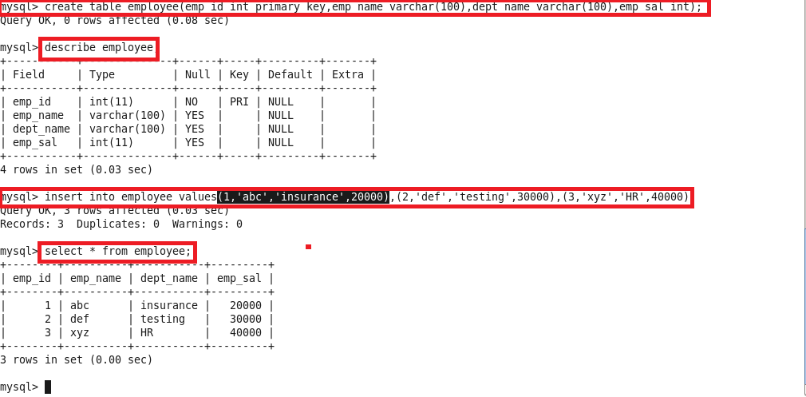

**Sqoop import command:**

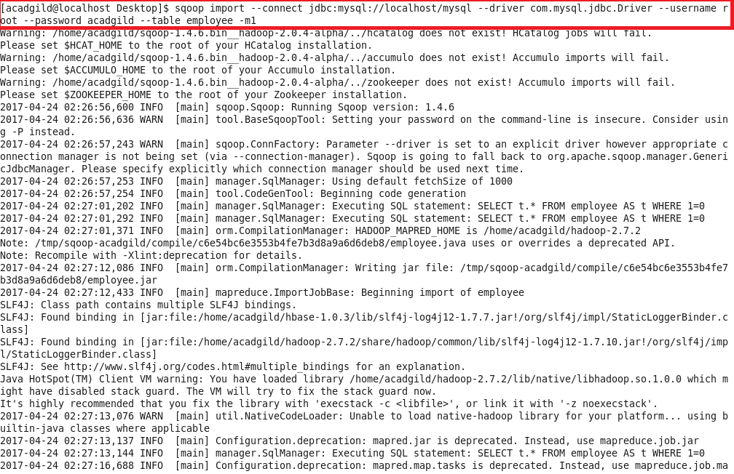

**Records imported:**

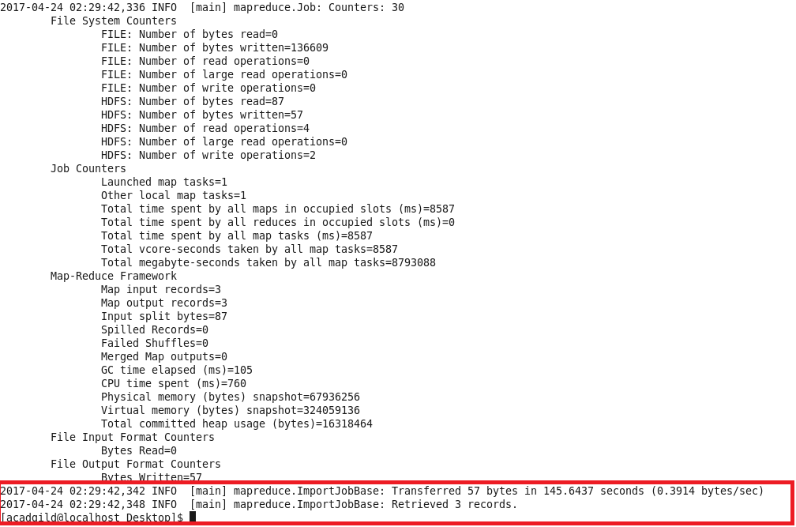

**Displaying the contents of the file in hdfs:**

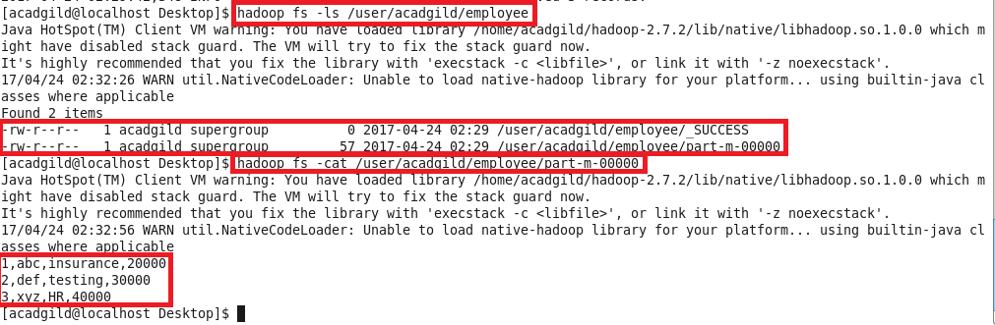

**Creating table employee1:**

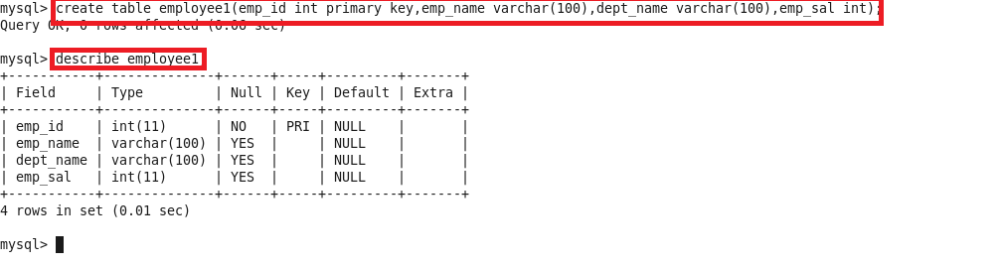

**Sqoop export command:**

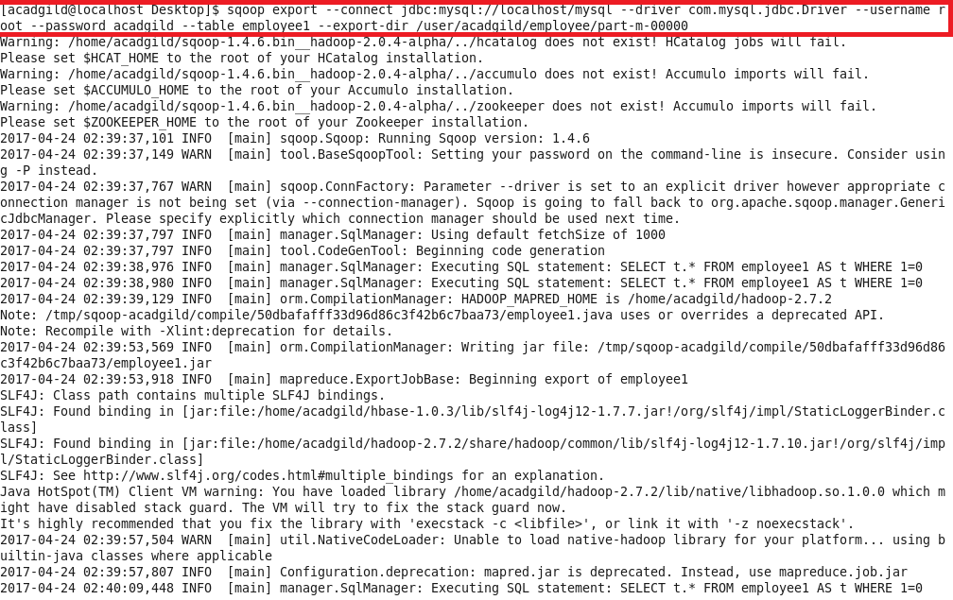

**Records exported:**

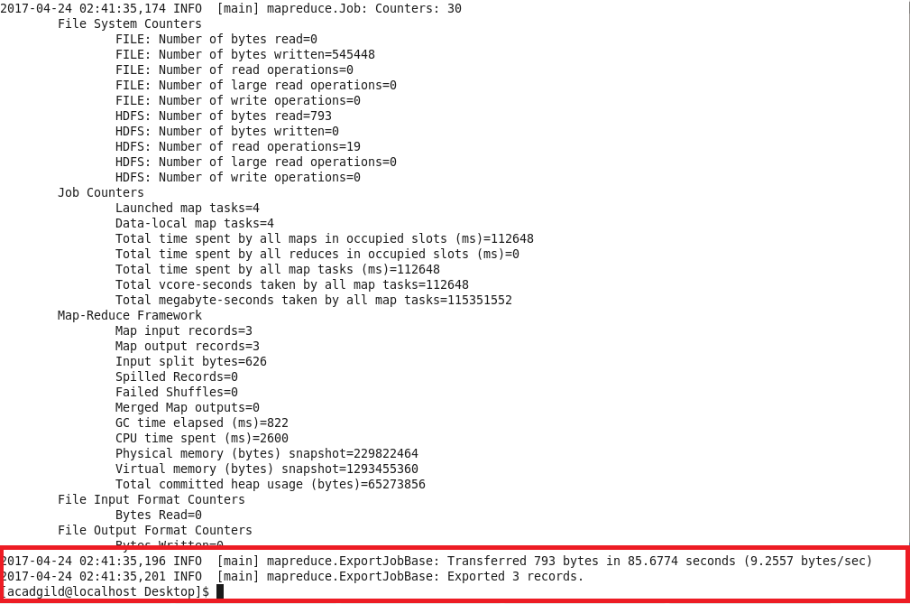

**Displaying the contents of table employee1:**

