Problem Statement:

● Explain and perform Importing table contents from Mysql to Hive using Sqoop.

● Explain and perform Importing table contents from Mysql to HBase using Sqoop.

● Explain the procedures performed, Share the screenshots of commands and results for the same.

Create a database by using the below command:

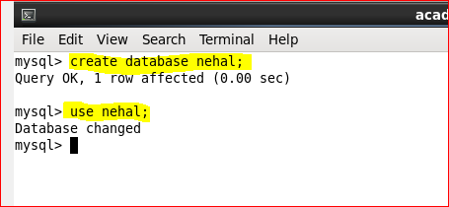

Create a table **employee**by using the below command:

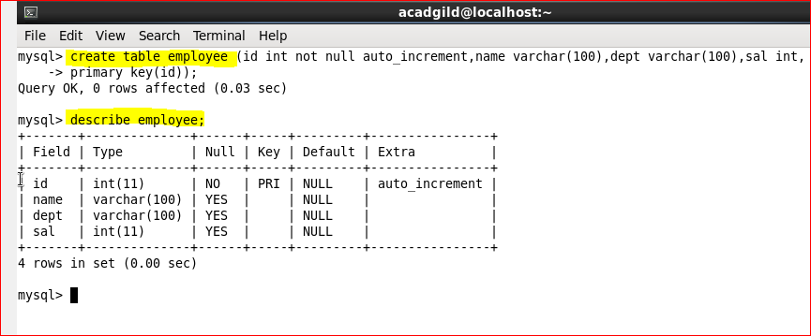

A table has been created with name **employee**and with the columns **id, name, dept and sal.**Let’s now try inserting some sample data into the created table by using the below command:

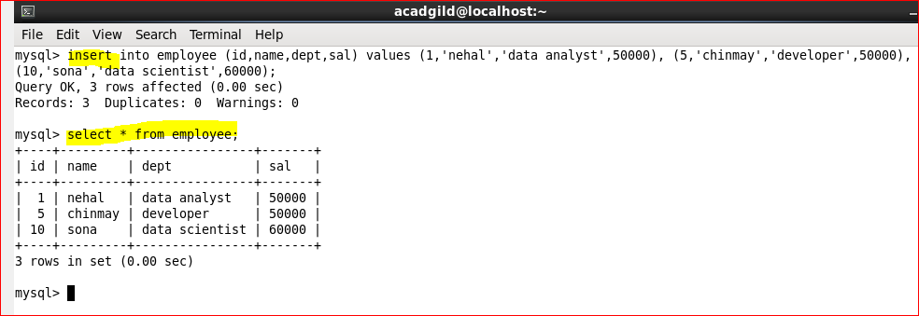

Let’s manually insert few extra values in nehal/employee table.

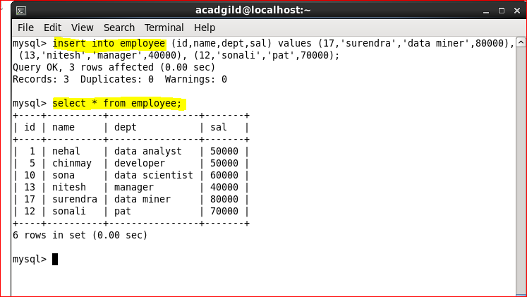

**Importing table contents from Mysql to Hive using Sqoop:**

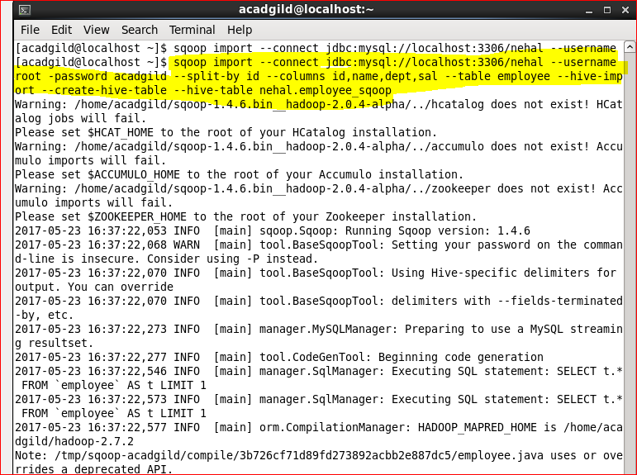

Each individual Sqoop command option means:

* **connect –** Provides jdbc string
* **username** – Database username
* **-Password**  – Will ask for the password in console
* **table –**Tells the computer which table you want to import from MySQL. Here, it's customer.
* **split-by –**Specifies your splitting column. I am specifying id here.
* **hive-import** – Import table into Hive (Uses Hive’s default delimiters if none are set.)
* **create-hive-table** – Determines if set job will fail if a Hive table already exists. It works in this case.
* **hive-table** – Specifies <db_name>.<table_name>. Here it's sqoop_workspace.customers, where sqoop_workspace is my database and customers is the table name.

 Let’s verify the output in Hive:

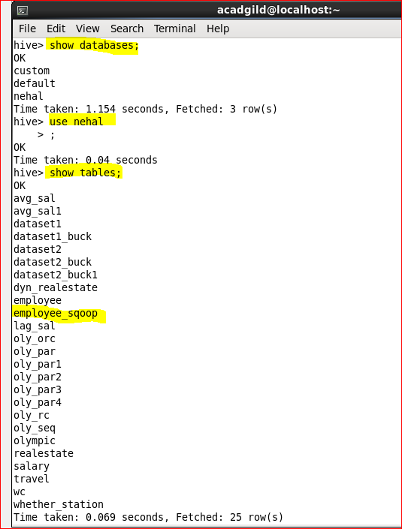

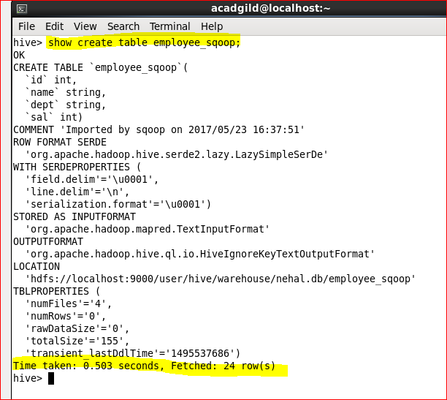

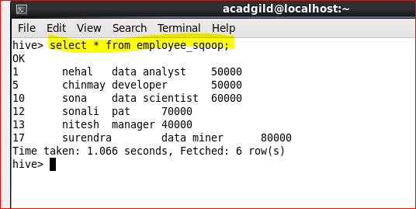

**Importing table contents from Mysql to HBase using Sqoop:**

We can use below command to grant superuser permission to root.

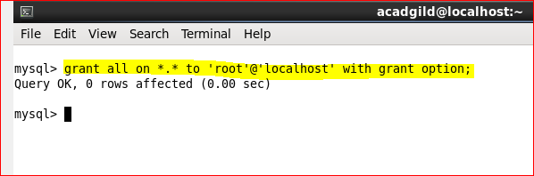

we need to create a new table in Hbase to import table contents from Mysql database.

command to enter HBase shell:

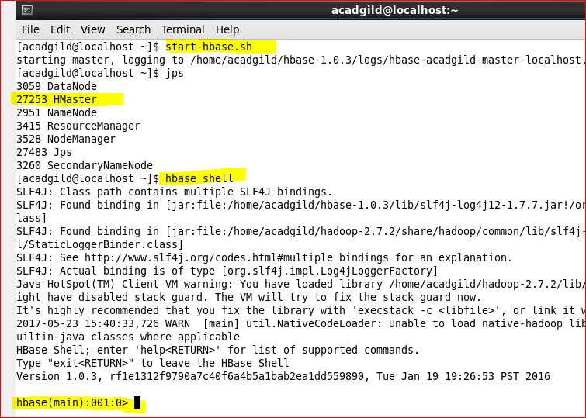

**Create table:**

We can use create command to create a table in Hbase.

**Scan table:**

We can use **scan**command to see a table contents in Hbase.

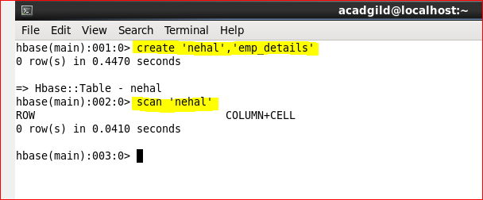

We can observe from the above image no contents are available in the table

**Sqoop import command:**

Now use below command to import Mysql **employee** table to HBase **nehal** table.

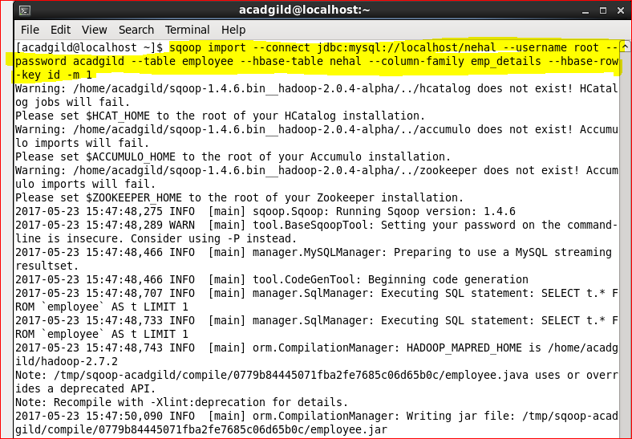

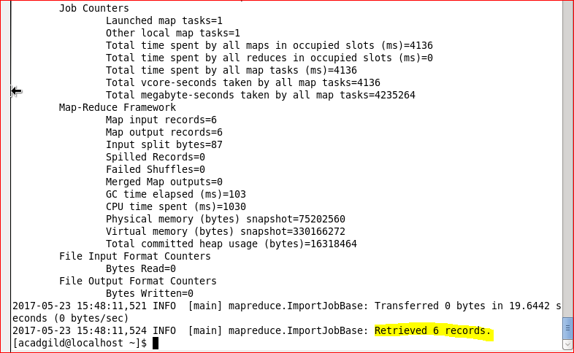

**Scan HBase table:**

Now again use Scan ‘**nehal** command to see the table contents which is successfully imported from the Mysql **employee** table.

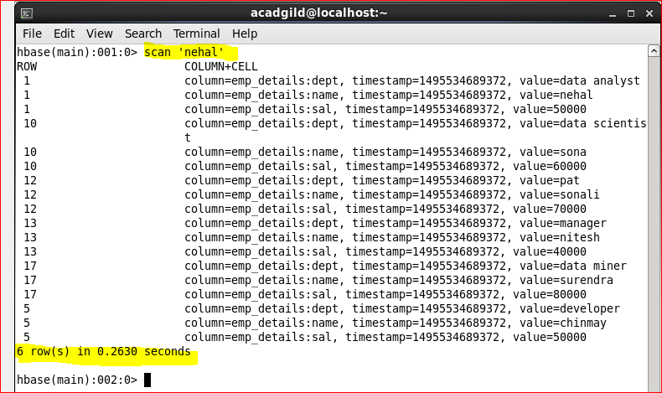

We can observe from the above image we have successfully imported contents from a Mysql table to HBase table using Sqoop.