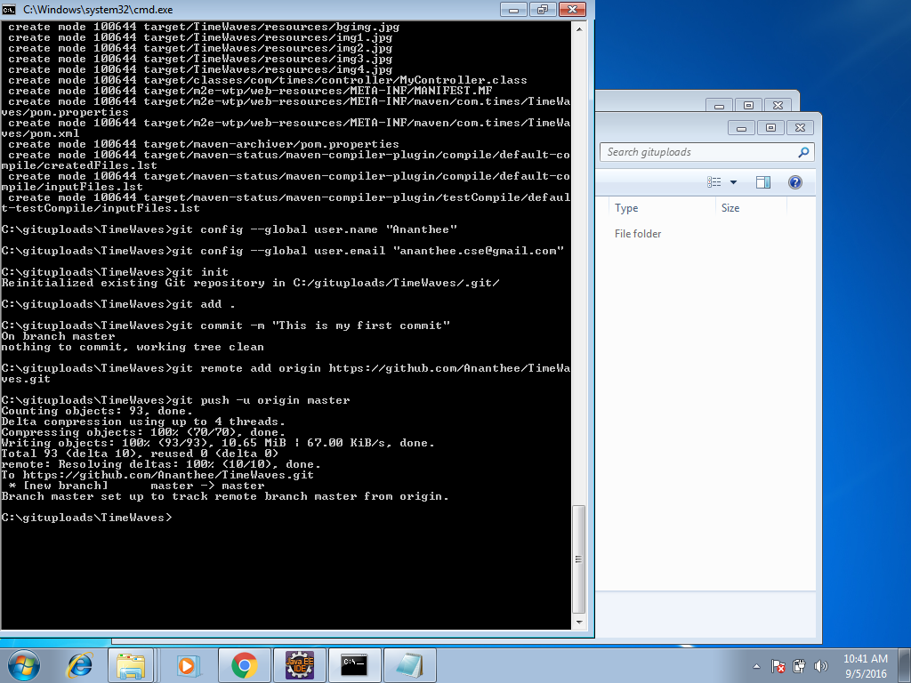

1.set the project location in cmd prmt

2. type git and enter to check git hub installed

3.type git config --global user.name "git hub name"

4.type git config --global user.email "git hub email"

5.type git init

6.type git add .

7.type git commit -m "This is my first commit"

8.go to git hub page create a new repository from or create a new repository copy git remote add orgin line and paste in cmd and give enter

9.then from the same block copy git push line and paste in cmd and enter, it will ask for user name and password then upload wil start wait till 100% completion

10.type git status to know the status

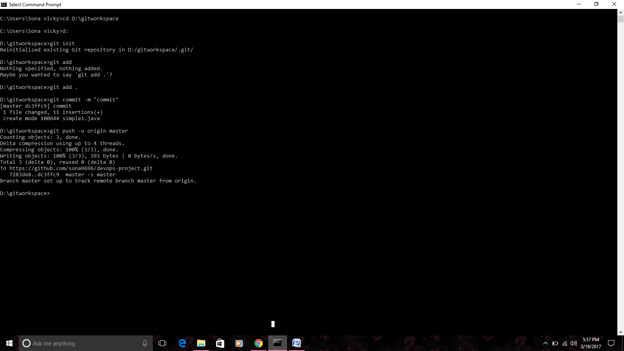

Helen – S171165200090/86 - 8939335475

85260722797 – prasanth

Mykong