### Project report

### on

Intern Management System

Using PHP

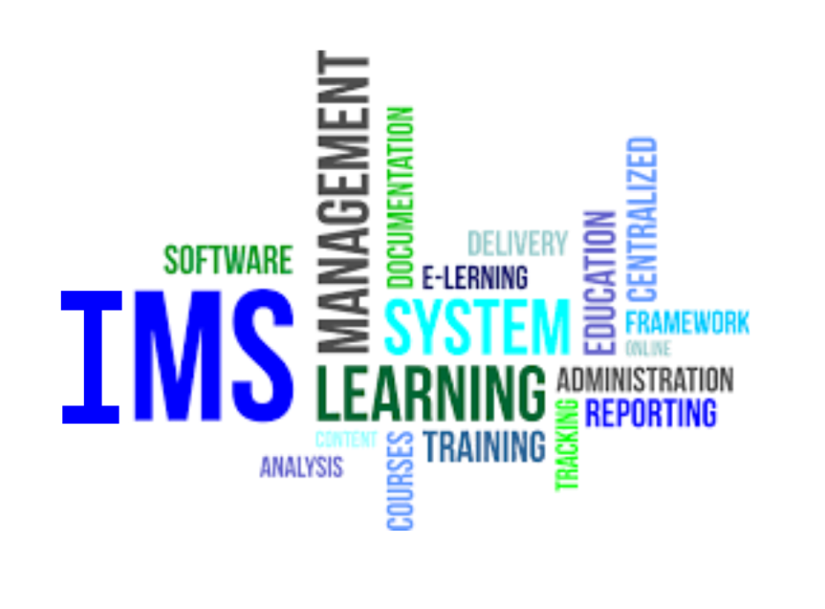

Submitted by:-

Sukriti Gupta

(B.Tech-3rd SEM SRM University)

Project done at:-

Infocom Services ONGC

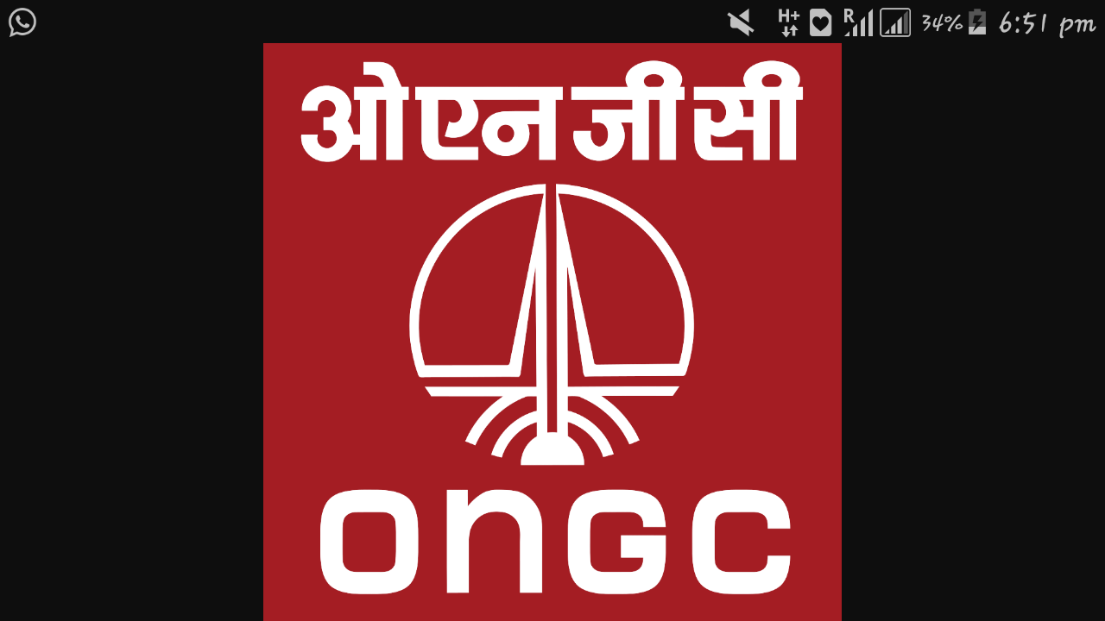

GEOPIC DEHRADUN

Certificate

I hereby certify that the report entitled “INTERN MANAGEMENT SYSTEM” presented by SUKRITI GUPTA (B.Tech), is in the partial fulfilment of the requirement of reward of the certificate of 1 month industrial training dated from 5th Dec 2016 to 4th Jan 2017, submitted to The Computer Services ONGC , (s/w) GEOPIC Dehradun, is an authentic record of their own work carried out under my supervision.

I wish her all the best in their academic endeavour.

Name/Signature:

Designation:

Index

**1. Acknowledgment**

**2. Abstract**

**3. Introduction**

**4. Organisational profile: ONGC**

**5. Operations**

**6. Background study**

**7. Requirement analysis  
8. Present work**

**9. Problem definition**

**10. Implementation**

**11. Testing**

**12. Scope of the system**

**13. Conclusion and future scope**

**14. Languages used**

**15. Bibliography**

**16. Problems faced during completion of the project.**

1. Acknowledgement

The satisfaction that accompanies the successful completion of any task would be incomplete without paying my gratitude to the Mr C Kumar Head CS (s/w) , who has made it possible, and Mr. Arvind Kumar Sr Prog.Officer (s/w) div ,whose constant guidance and encouragement have crowned our efforts with success.

I am grateful to you for providing me an opportunity to work on this project.

I express our sincere thanks to all members of Computer Services (s/w) ONGC, Geopic who have helped us directly or indirectly. Without their help and guidance I would not have been able to successfully complete the project.

2. Abstract

Training refers to teaching /learning activities done for the primary purpose of helping interns of an organisation to acquire and apply the knowledge skills, abilities and attitude needed by the organisation to acquire and apply for the same. For such an activity that needs to be performed in such a huge organisation we need a proper system to manage this activity known as a training management system.

# What is Training and Intern management?

“Training is a temporary endeavour to create unique service in relation to capacity building “. Before examining the meaning of the training management here is the definition of project management.

3. Introduction

Intern management is the application of knowledge, skills, tools and techniques to the training activities to realise the outcome of training.

The definition raises a question: what are the required knowledge, skills, tools and techniques for training management?

The seven steps of intern management program are as follows:

1. Control: checks progress and then compare to plan take corrective action audit performance.

2. Planning: define project pick strategy schedule work

3. Information: historical current cost progress quality.

4. Methods: CAD modelling scheduling

5. Culture: values beliefs attitudes behaviours traditions

6. Organisation: authority responsibility accountability

7. Human: motivation leadership negotiation team building communication decision making.

4. Organizational Profile: Oil and Natural Gas Corporation

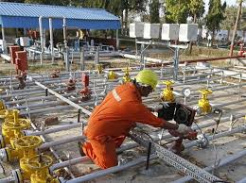

Oil and Natural Gas Corporation Limited (ONGC) is an Indian multinational oil and gas company headquartered in Dehradun, Uttarakhand, India. It is a Public Sector Undertaking (PSU) of the Government of India, under the administrative control of the Ministry of Petroleum and Natural Gas. It is India's largest oil and gas exploration and production company. It produces around 77% of India's crude oil (equivalent to around 30% of the country's total demand) and around 62% of its natural gas

On 31 March 2013, its market capitalization was INR 2.6 trillion (US$48.98 billion), making it India's second largest publicly traded company. In a government survey for FY 2011–12, it was ranked as the largest profit making PSU in India. ONGC has been ranked 449th in the Fortune Global 500 list of the world's biggest corporations for the year 2015. It is ranked 17th among the Top 250 Global Energy Companies by Platts.

ONGC was founded on 14 August 1956 by Government of India, which currently holds a 68.94% equity stake. It is involved in exploring for and exploiting hydrocarbons in 26 sedimentary basins of India, and owns and operates over 11,000 kilometres of pipelines in the country. Its international subsidiary ONGC Videsh currently has projects in 17 countries. ONGC has discovered 6 of the 7 commercially producing Indian Basins, in the last 50 years, adding over 7.1 billion tonnes of In-place Oil & Gas volume of hydrocarbons in Indian basins. Against a global decline of production from matured fields, ONGC has maintained production from its brownfields like Mumbai High, with the help of aggressive investments in various IOR (Improved Oil Recovery) and EOR (Enhanced Oil Recovery) schemes.

ONGC has many matured fields with a current recovery factor of 25–33%. Its Reserve Replacement Ratio for between 2005 and 2013 has been more than one. During FY 2012–13, ONGC had to share the highest ever under-recovery of INR 494.2 billion (an increase of INR 49.6 million over the previous financial year) towards the under-recoveries of Oil Marketing Companies (IOC, BPCL and HPCL).



5. Operations

ONGC’s operations include conventional Exploration and Production, refining and Progressive development of alternate energy resources like coal-bed methane and shale gas. The company’s domestic operations are structured around 11 assets [predominantly oil and producing properties], 7 basins [exploratory properties], 2 plants [a Hazira and Uren] and services [for necessary inputs and support such as drilling, geo-physical, logging and well services.

6. Background study.

In today’s world storage of data in files and folders manually leads to:

**1.** Data redundancy:

It is a duplication of the same information in several files

2. Integrity constraints:

The data values we need to satisfy some integrity constraints which cannot be handled manually and needs to be done through program code.

3. Difficulty in accessing data:

Convenient and efficient information retrieval is almost impossible using maybe in conventional file processing system.

4. Data isolation:

Data are scattered in various files and the files in different format writing new application program to retrieve data is difficult.

5. Concurrent access anomalies:

If multiple users are updating the same data simultaneously it will result in inconsistent data state. In file processing system it is very difficult to handle this using program code. This results in concurrent access anomalies

This application helps in removing the major drawbacks of the conventional file processing system.

7. Requirement analysis:

# Software interfaces:

1. Installing XAMP platform:

This phase consists of installing XAMP and configuring it

XAMP is a cross platform web server where

X: Cross platform

A: Apache server

M: My SQL for database interaction

P: PHP

2. Notepad++:

For providing fast and easy access of PHP documents and to enable document formatting.

3. Google chrome:

For browser requirements of the html/PHP files.

# 2. Hardware requirements:

* AMD A4 3330 MX APU Radeon™ HD Graphics (2.20 Ghz CPU)
* 2 GB RAM
* Microsoft windows 10 based system.

# 3. Functional requirements:

1. Creating login and admin, student’s homepage.

2. Insert, view, and update, details in database.

# Non- functional requirements

1. Performance of system depends upon the amount of data entered.
2. Maintaining data base records is a tough job.
3. System should not crash while entering a new record.
4. System should run perfectly without any feature limitations.

# User requirements

User name is set as username and password as given by the organisation.

8. Present work.

# Project Objective

The objective of this project is to create an application that can help in keeping the record of the interns in the various departments of ONGC. The primary objective is to create a robust and a flexible application.

# Sub- objectives

# 1. Filtration based on the year of training:

To enable the user to filter the interns based on the year in which they did the internship.

# 2. Low cost:

The application does not require any expensive infrastructural changes to accomplish the task.

# 3. Intuitive user interface:

The application has an easy-to-use UI that helps in storing the information.

# Purpose

1. Providing internal communication system for the employees of an organization.
2. Provide security.
3. Improve delivery and maintain credibility.

9. Problem definition

# Existing system:

Training management is a tedious and a huge task system may not be supporting modern management techniques and adequately be less responsive for a some unusual conditions .security is an ignorable feature current system architecture is out-dated difficult to use n modify

# Proposed system

The currently proposed system overcomes all the anomalies of the existing system the current system provides the following features:

1. Strategic analysis to support management activities.

2. System security

3. Support for modern inventory management and tools

4. Efficient means to input data.

10. Implementation

# 5. Implementation through XAMP

1 .Create a database and enter fields in the database.

2. Enter constraints or data types for different fields and specify the required keys in the table such as primary key candidate key foreign key

3. Similarly create all the different tables required for the database and relationships between the different tables of the database by using the keys and fields. Depending on the database needs a relationship may be of different types:

1.1 **one to one:** a row in a table a can have no more than one matching row in table b and vice versa.

1.2 **One to many:** in this kind of relationship a row a in a table can have many matching rows in table b. But a row in table b can have only one matching row in table a.

1.3 **many too many:** a row in table a can have many matching rows in table b and vice versa. Relationship prevents redundant data and help to track information efficiently.



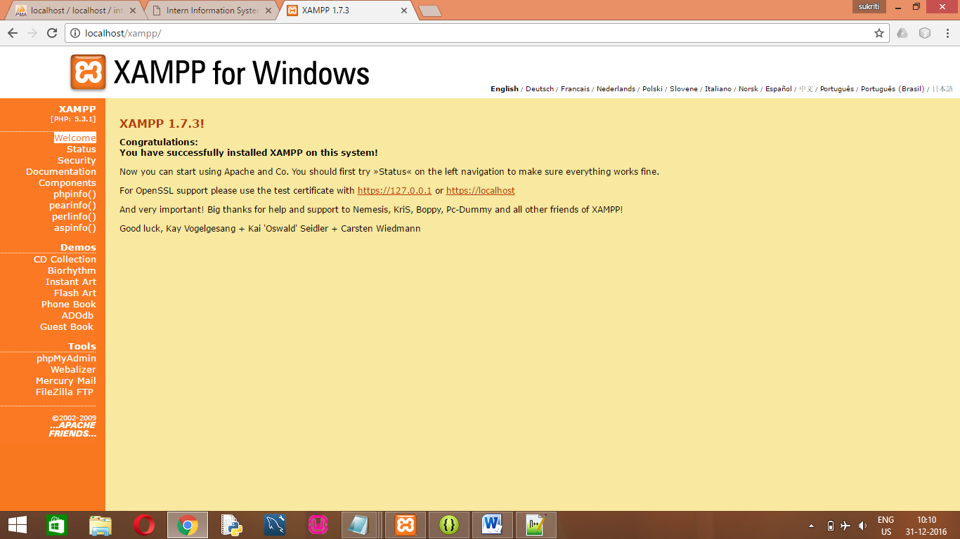

**Implementation through PHP:-**

**Creating front end through notepad ++**

1. Choose a new project.
2. Create a form and add related components to it such as text fields, radio buttons etc.
3. Add different functionality to the above created components.
4. To provide connectivity with the database we use simple statements in PHP.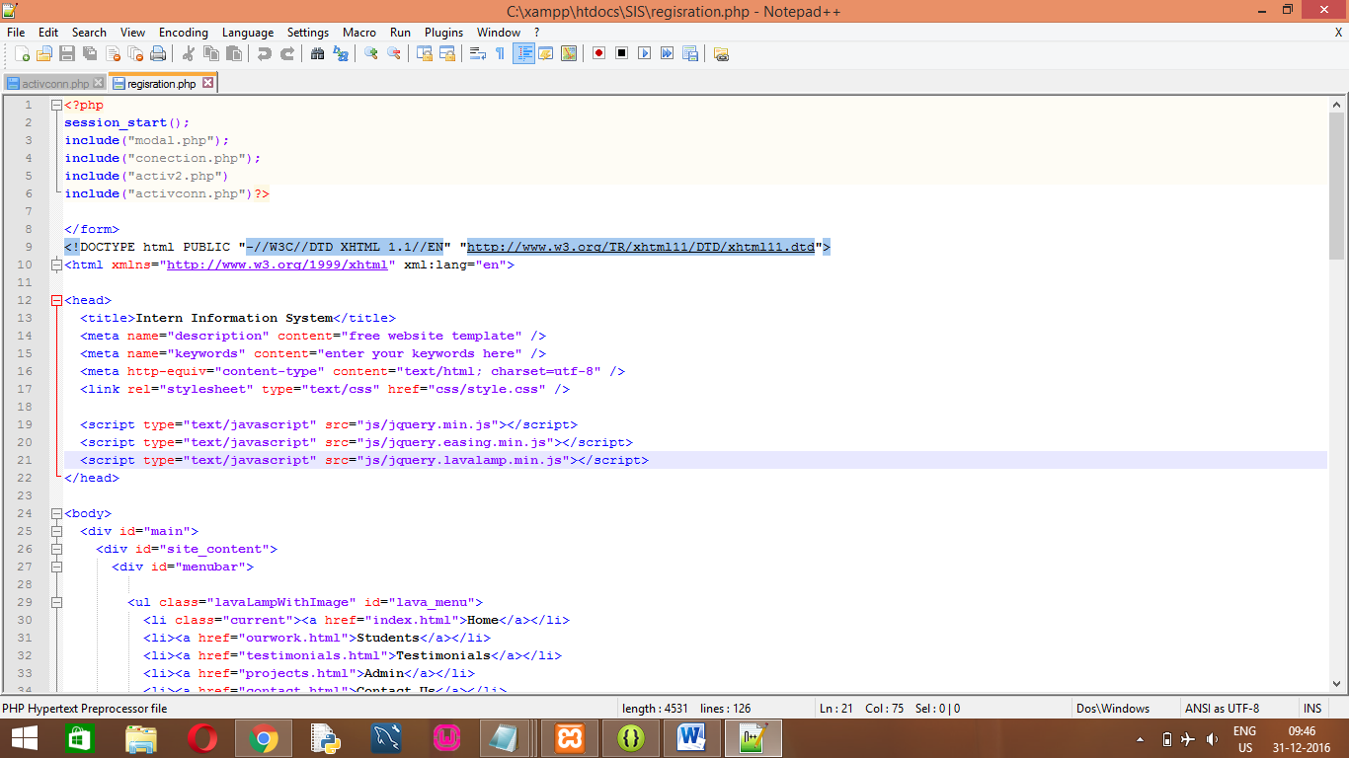

11. Testing

1.first part is to create database “intern” in “phpmyadmin” in “localhost/xamp” that includes the following details that are needed:-

* Admin login details
* Student details
* Attendence
* Contact details
* Subject details

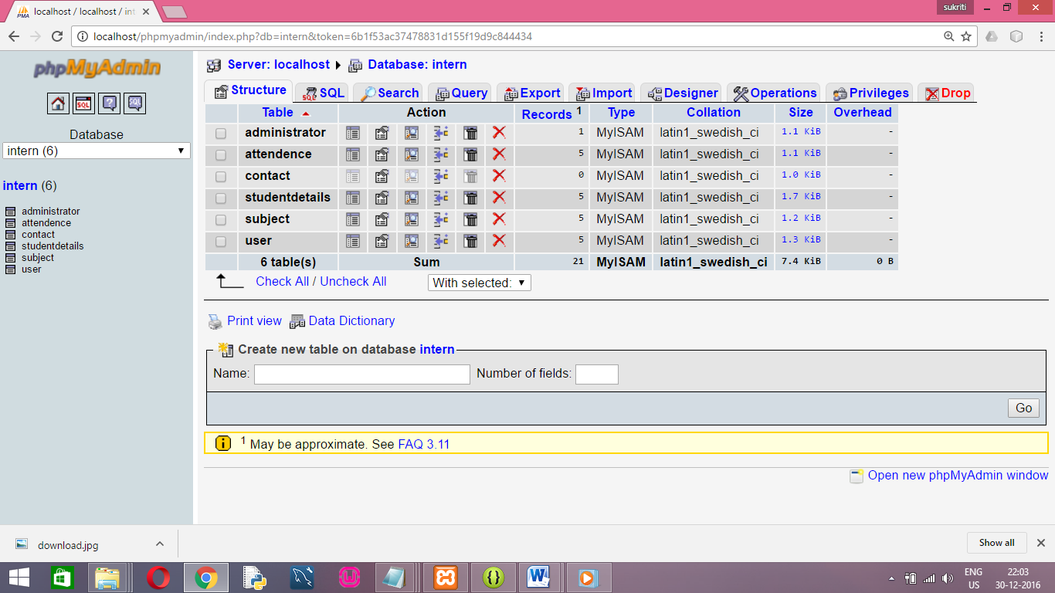

2. The table student details include first name, last name, age, college id, college name, father name, date of birth, cgpa and personal details etc.

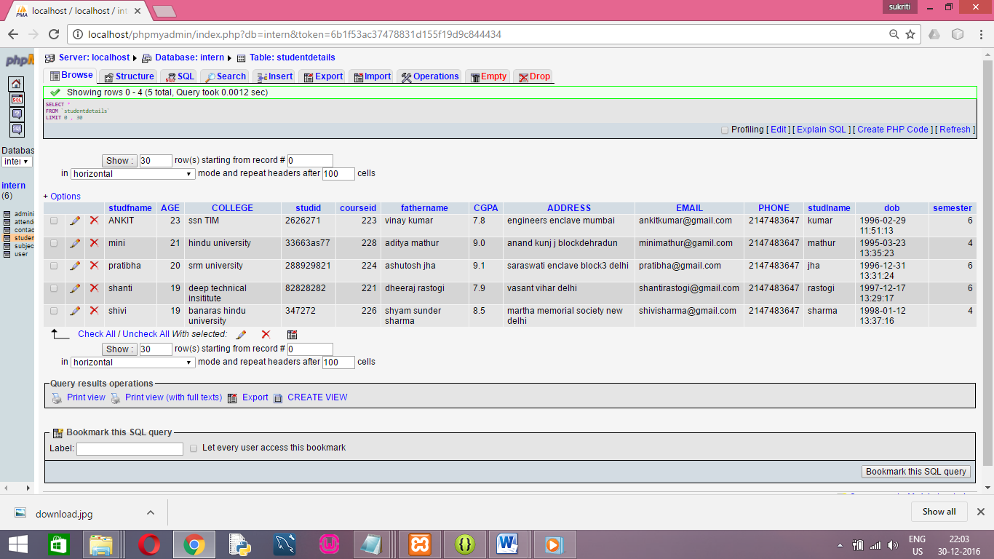

3.subject table involves which department are you in and according to that what subject code of internship should be alotted.

* Course name
* Course key

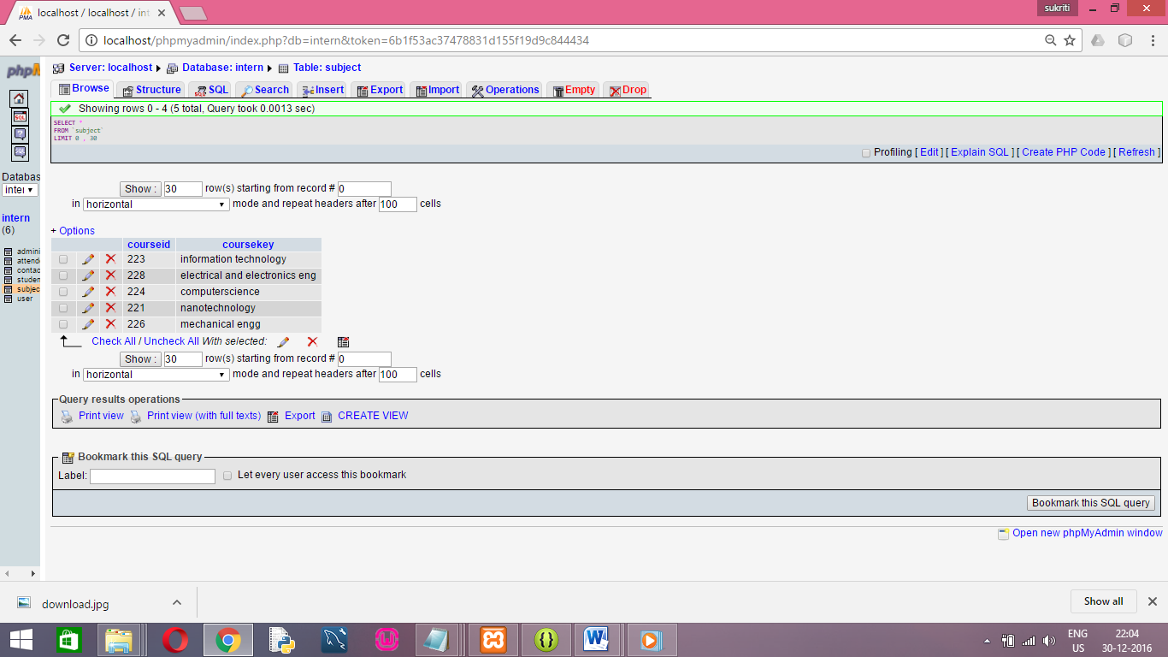

4. The attendance table contains the name of the student and the attendance of the same during the course of an internship.

* Name
* Attendance

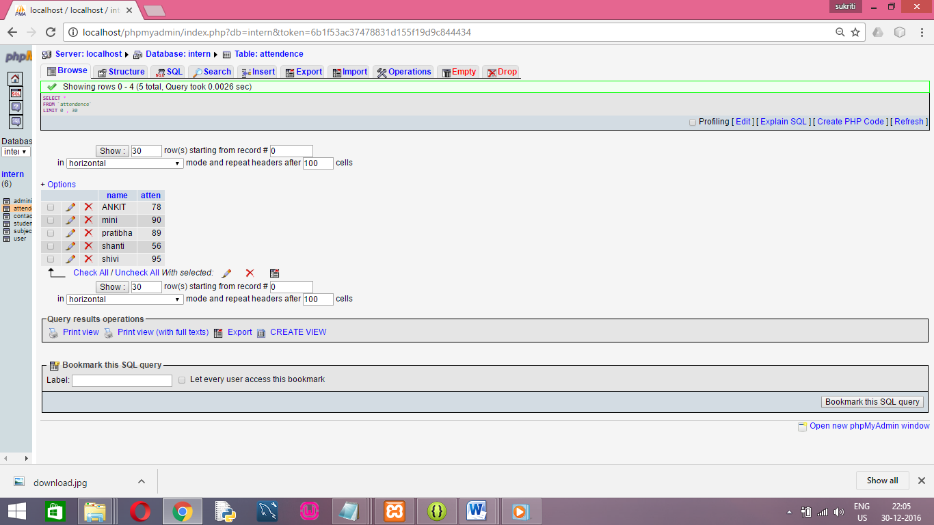

6. Now we come to the user interface of the site.

**Admin login page:**

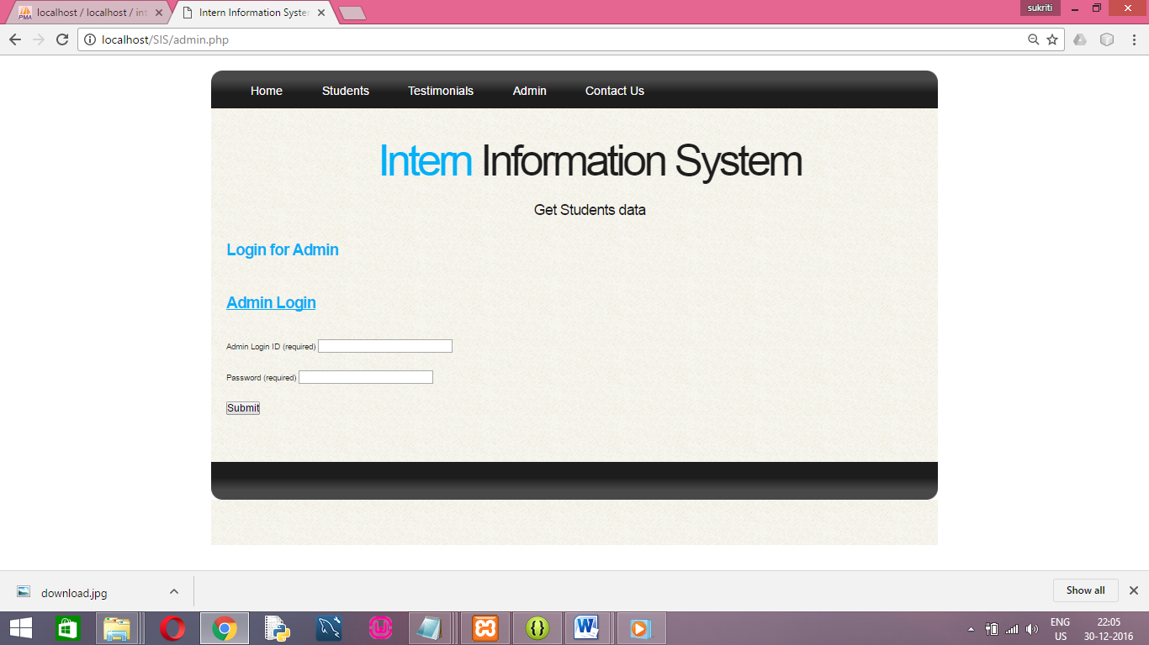

**After admin login comes “The dashboard” that only the admin can access**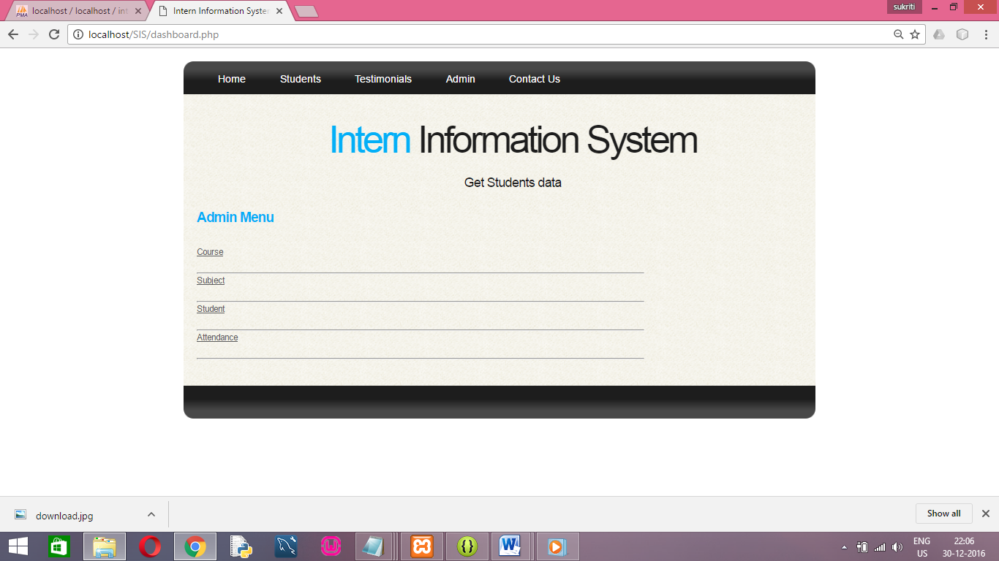

**The registration page for students to enrol in for the internship, this page sends the activation link for student for opening the login page.**

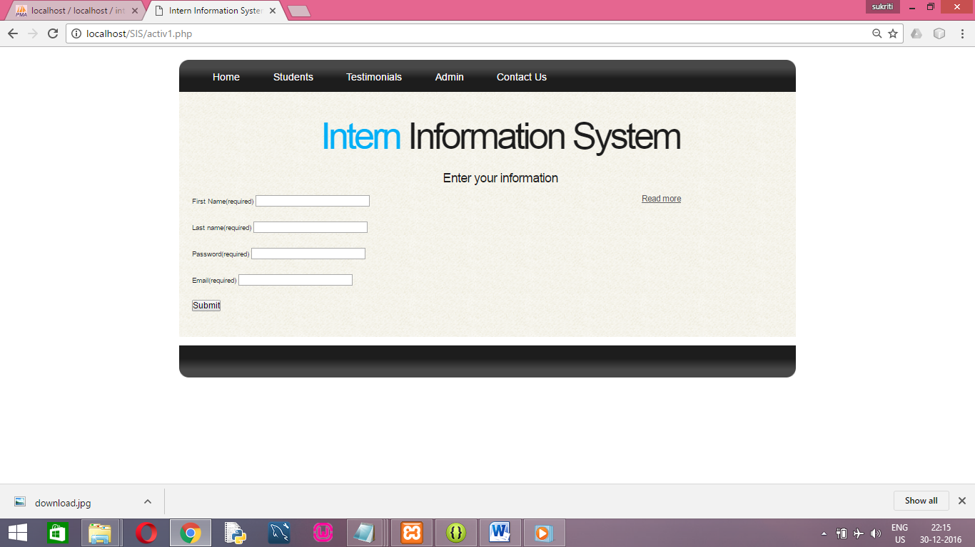

**“THE STUDENT LOGIN PAGE”**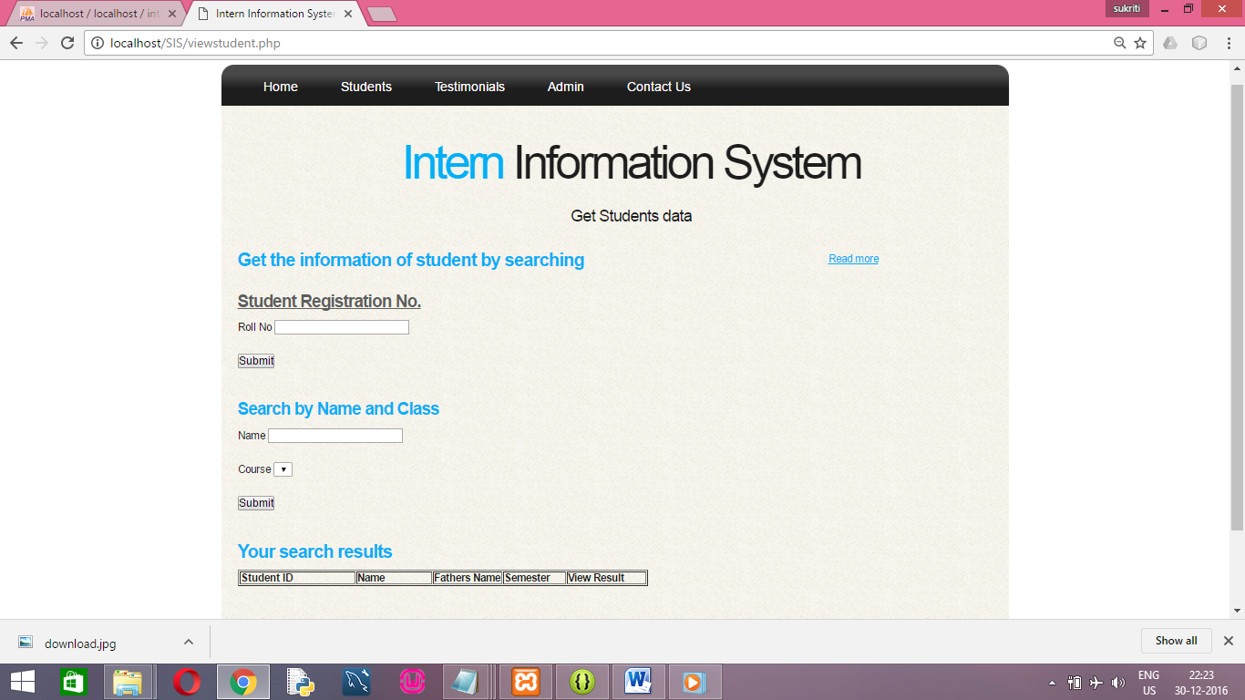

12. Scope of the system

The scope of the system covers the depth, the various training practises, modules and formats being followed and is limited to the company ONGC and its trainees.

Intern management system is a web based portal which has given the admin the privileges of inserting editing viewing the values which have been entered by the admin of the details of student who have interned in ONGC. A separate form has been made which enables the user to add experience the various details of the students as well as the admin where in the values are then stored in the database.

The admin can view the details and has the authority of editing as well as deleting the unnecessary values. A separate option has also been provided where in the admin can store on the basis of the year in which the training has been done.

13. Conclusion and future scope

# Conclusion:

Basic objective is to replace existing manual processing system with error free high speed and low cost approach. It shall save time of management and students. It was a good learning experience for us to work on the project. We learnt the importance of various phases required to build a web application

# Future scope:

1. Student training is not only limited to b Tech but all other departments also.

2. Spreading the website across all colleges and universities.

3. Working more on the front end to make it more attractive.

14. Languages used

1. PHP (Hypertext Pre-processor) PHP has been used to design the code and create session and for database connectivity.
2. HTML (hypertext mark-up language) to create static pages.
3. CSS(cascading style sheet) I to provide style and format to static pages created by using html
4. JavaScript: client side validation is done using JavaScript as in registrations page.
5. SQL (structured query language) for connecting with the database.

15. Bibliography

# List of websites referred is as follows:

[Www.stackoverflow.com](http://Www.stackoverflow.com)

[Www.wikipedia.com](http://Www.wikipedia.com)

[Www.studytonight.com](http://Www.studytonight.com)

16. Challenges faced during completion of the project

The completion of the project led to fruitful experience of knowledge and implementation.

1. System designing phase

Being an important phase required an efficient approach in order to develop an overall architecture of the system.

2. Database designing

I faced problems in inserting values in the database .most of the times the value which inserted did not reflected in the database. To resolve this I had to learn quite a number of details of XAMP.

**Experience**

I learnt the practical implementation on new things that I was not aware of previously.

I learned and experienced the atmosphere of technical work which is one of the major necessities of industries. I think this training not only gave me an academic knowledge, in spite it has polished me up as a trainee by giving me an employee like experience.