
Industrial Internship Report on
“Customer Churn Prediction Using Machine Learning”
Prepared by
Sonakshi Mishra
B.Tech, Computer Science (AI & ML)
Lokmanya Tilak College of Engineering, Mumbai University
Industrial Partner | UniConverge Technologies Pvt Ltd (UCT)
Program | upSkill Campus x The IoT Academy Internship
Duration | 6 Weeks (1st July 2026 – 11th August 2026)
Mode | Virtual
Stipend | Unpaid

Executive Summary
This report presents the details of the Industrial Internship provided by upSkill Campus and The IoT Academy, in collaboration with Industrial Partner UniConverge Technologies Pvt Ltd (UCT).
The internship was focused on a project/problem statement provided by UCT and was completed, along with this report, within a 6-week duration.
My project was “Customer Churn Prediction Using Machine Learning” — a system that identifies customers who are likely to discontinue a company's services, using a Random Forest classifier trained on customer data and deployed through an interactive Streamlit web application.
This internship gave me a valuable opportunity to work on a real industrial problem, apply the end-to-end machine learning workflow, and deliver a deployable solution. It was an overall great learning experience.

Table of Contents

1 | Preface | 3
2 | Introduction | 4
2.1 | About UniConverge Technologies Pvt Ltd | 4
2.2 | About upSkill Campus | 4
2.3 | About The IoT Academy | 4
2.4 | Objectives of the Internship Program | 4
2.5 | Reference | 5
2.6 | Glossary | 5
3 | Problem Statement | 6
4 | Existing and Proposed Solution | 7
4.1 | Code Submission (GitHub link) | 7
4.2 | Report Submission (GitHub link) | 7
5 | Proposed Design / Model | 8
5.1 | High Level Diagram | 8
5.2 | Low Level Diagram | 8
5.3 | Interfaces | 8
6 | Performance Test | 10
6.1 | Test Plan / Test Cases | 10
6.2 | Test Procedure | 10
6.3 | Performance Outcome | 10
7 | My Learnings | 11
8 | Future Work Scope | 11

1. Preface
This report summarizes the work carried out over a 6-week Industrial Internship organized by upSkill Campus and The IoT Academy, in association with UniConverge Technologies Pvt Ltd (UCT).
A relevant, industry-aligned internship such as this plays an important role in career development. It bridges the gap between academic learning and real-world application by exposing students to actual business problems, professional workflows, and current tools and technologies used in the industry.
My project, “Customer Churn Prediction Using Machine Learning,” required me to build a complete, deployable machine learning solution — from data preprocessing to a working web application — that predicts whether a customer is likely to discontinue a company's services.
upSkill Campus and UCT gave me the opportunity to work independently on this problem statement, with structured guidance on how the program was to be planned and executed, following the phases outlined below:
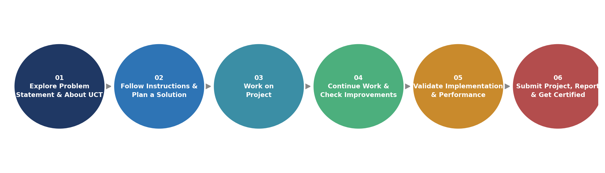
Figure: 6-Week Internship Roadmap
Over these six weeks, I learned the practical, end-to-end workflow of a machine learning project — data cleaning, encoding, model training and evaluation, and deployment through a Streamlit interface — along with how to structure and document a project for real-world use. The overall experience significantly strengthened my confidence in applying ML concepts to solve business problems.
I would like to thank the entire team at UniConverge Technologies Pvt Ltd and upSkill Campus / The IoT Academy for their guidance, structured curriculum, and the opportunity to work on this problem statement during this internship.
To my juniors and peers who take up this internship in the future: start early, be consistent with your six-week plan, and don't hesitate to explore beyond the minimum requirement of the problem statement — the additional experimentation is where most of the learning happens.

2. Introduction

2.1 About UniConverge Technologies Pvt Ltd
UniConverge Technologies Pvt Ltd (UCT) is a company established in 2013, working in the Digital Transformation domain and providing industrial solutions with a prime focus on sustainability and RoI.
For developing its products and solutions, UCT leverages various cutting-edge technologies, e.g. Internet of Things (IoT), Cyber Security, Cloud Computing (AWS, Azure), Machine Learning, Communication Technologies (4G/5G/LoRaWAN), Java Full Stack, Python, and Front-end technologies.
- UCT IoT Platform (UCT Insight) — an IoT platform for quick deployment of IoT applications with dashboards, analytics, alerts, and third-party integrations (Power BI, SAP, ERP).
- Smart Factory Platform (Factory Watch) — a scalable, modular SaaS platform for production and asset monitoring, OEE and predictive maintenance.
- LoRaWAN-based Solutions — for Agritech, Smart Cities, Industrial Monitoring, and Smart Utility Metering.
- Predictive Maintenance — industrial machine health monitoring using Embedded Systems, IIoT, and Machine Learning to estimate Remaining Useful Life (RUL) of production machinery.

2.2 About upSkill Campus (USC)
upSkill Campus, along with The IoT Academy and in association with UniConverge Technologies, has facilitated the smooth execution of the complete internship process.
USC is a career development platform that delivers personalized executive coaching in a more affordable, scalable, and measurable way, supporting learners through career growth/upskilling, professional networking, a collaboration platform, and a job/internship platform.

2.3 About The IoT Academy
The IoT Academy is the EdTech division of UCT that runs long-term executive certification programs in collaboration with EICT Academy, IITK, IITR, and IITG across multiple domains.

2.4 Objectives of the Internship Program
The objective of this internship program was to:
- Get practical experience of working in the industry.
- Solve a real-world problem using a complete, end-to-end approach.
- Have improved job prospects through a hands-on, deployable project.
- Gain an improved understanding of machine learning and its industrial applications.
- Achieve personal growth in areas such as communication, documentation, and problem solving.

2.5 Reference
[1] UCI Machine Learning Repository / Telco Customer Churn dataset (churn.csv)
[2] Scikit-learn Documentation — https://scikit-learn.org/
[3] Streamlit Documentation — https://docs.streamlit.io/

2.6 Glossary
Terms | Full Form
ML | Machine Learning
RF | Random Forest (Classifier)
UCT | UniConverge Technologies Pvt Ltd
USC | upSkill Campus
UI | User Interface
F1 | F1 Score (harmonic mean of precision and recall)

3. Problem Statement
Customer churn — when a customer stops using a company's product or service — directly impacts revenue and growth. Acquiring a new customer is significantly more expensive than retaining an existing one, so businesses need a way to identify customers who are at risk of leaving before they actually do.
The assigned problem statement was to design and build a Machine Learning based system that:
- Analyzes historical customer data (tenure, charges, contract type, services subscribed, support interactions, etc.) to identify patterns associated with churn.
- Predicts, for a given customer, the likelihood that they will churn.
- Presents this prediction through a simple, usable interface so that non-technical business/retention teams can act on it.
The scope of the project covered the complete pipeline — data cleaning and preprocessing, model training and evaluation, and deployment of the trained model as an interactive web application — rather than only a notebook-based experiment.

4. Existing and Proposed Solution

Existing Solutions and Their Limitations
- Reactive win-back campaigns: many companies only act after a customer has already cancelled, which is too late to retain them.
- Manual review / rule-based flags (e.g., “flag if tenure < 3 months”): simple thresholds miss non-obvious combinations of factors that actually drive churn.
- Generic BI dashboards: report churn rate after the fact but do not predict which individual customers are at risk, and give no actionable probability score.

Proposed Solution
A supervised Machine Learning pipeline that trains a Random Forest Classifier on historical customer data (demographics, account information, and service usage) to predict whether a customer will churn, along with the probability of churn. The trained model is deployed behind a Streamlit web application so that a user can enter a customer's details and instantly get a prediction, without needing to touch the underlying code.

Value Addition
- Churn probability score (not just a yes/no label) enabling risk-based prioritization of customers for retention outreach.
- Feature importance analysis to surface the top factors driving churn for a given customer base, useful for business strategy.
- A lightweight, self-contained Streamlit application that can be run locally or deployed, making the model usable by non-technical stakeholders.
- Modular project structure (train.py / app.py / saved model artifacts) that separates training from inference, so the model can be retrained on new data without changing the application.

4.1 Code Submission (GitHub link)
https://github.com/sonakshiM12/upSkillCampus

4.2 Report Submission (GitHub link)
https://github.com/sonakshiM12/upSkillCampus

5. Proposed Design / Model
The solution follows a standard end-to-end Machine Learning workflow, from raw data to a deployed prediction interface, as shown below.

5.1 High Level Diagram
Figure 1: High Level Diagram of the System

5.2 Low Level Diagram
At the component level, the project is organized as follows:
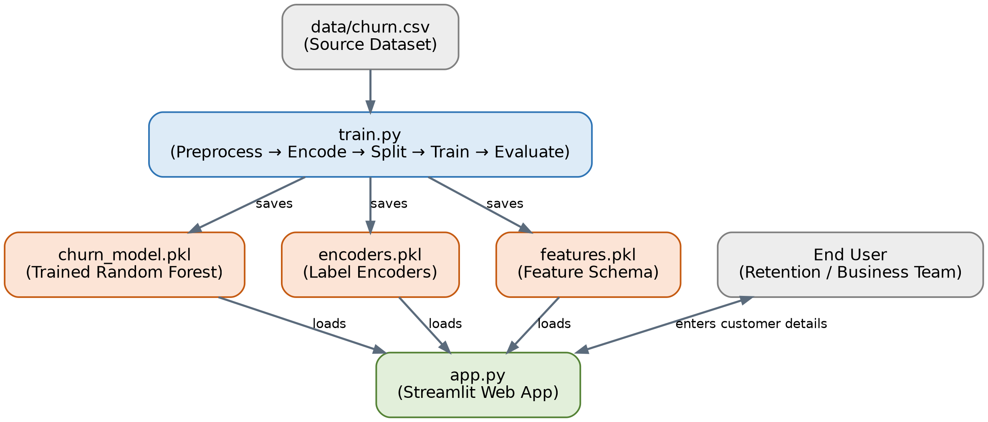
Figure 2: Low Level Component Diagram
train.py | Loads churn.csv, cleans and label-encodes the data, splits it into train/test sets, trains the Random Forest model, evaluates it, and saves churn_model.pkl, encoders.pkl and features.pkl using joblib.
model/ artifacts | churn_model.pkl (trained classifier), encoders.pkl (fitted label encoders for categorical fields), features.pkl (expected feature order/schema).
app.py | Streamlit application that loads the saved model and encoders, renders an input form, encodes the user's input using the same encoders used in training, and returns the churn prediction and probability.
data/churn.csv | Source customer dataset used for training and evaluation.

5.3 Interfaces
The primary interface is the Streamlit web application. A user enters a customer's details (e.g., tenure, monthly charges, contract type, internet service, and other account attributes) into the form.
Figure 3: Inference Flow through the Interface
- Input: raw form values from the Streamlit UI.
- Encoding: categorical fields are transformed using the same encoders.pkl used during training, ensuring consistency between training and inference.
- Model inference: the encoded feature vector (ordered per features.pkl) is passed to the loaded Random Forest model (churn_model.pkl) via joblib.
- Output: a churn / no-churn prediction along with the associated probability, displayed back to the user in the Streamlit UI.

6. Performance Test
Since this project is intended to support real retention decisions rather than remain a purely academic exercise, it was important to validate the model's predictive performance on unseen data before treating it as usable.

6.1 Test Plan / Test Cases
- Split the cleaned, encoded dataset into training (80%) and testing (20%) sets.
- Train the Random Forest Classifier only on the training set.
- Evaluate the trained model on the held-out test set, which the model has not seen during training.
- Verify that the Streamlit application's predictions for sample customers are consistent with the model's direct output.

6.2 Test Procedure
- Run python train.py to execute the full pipeline: load data, preprocess, encode, split, train, and evaluate.
- Record Accuracy, Precision, Recall, F1 Score and the Confusion Matrix produced on the test split.
- Run streamlit run app.py and manually test the form with a range of representative customer profiles to confirm the predicted outcome and probability are reasonable.

6.3 Performance Outcome
Algorithm Used | Random Forest Classifier
Accuracy | 79.56%
Metrics Evaluated | Accuracy, Precision, Recall, F1 Score, Confusion Matrix

The model achieved an overall accuracy of 79.56% on the held-out test set. This level of accuracy is reasonable for a customer churn dataset, where class imbalance (fewer churners than non-churners) typically makes the task harder than a simple accuracy figure suggests — this is discussed further under Future Work Scope.

7. My Learnings
This internship gave me hands-on exposure to the complete lifecycle of a Machine Learning project, well beyond what is typically covered in a classroom setting. Key takeaways include:
- Practical data preprocessing — handling raw customer data, cleaning it, and preparing it for modeling.
- Label encoding categorical variables correctly and consistently between training and inference.
- Training and tuning a Random Forest Classifier, and understanding how ensemble tree-based models work in practice.
- Evaluating a classification model using multiple metrics (accuracy, precision, recall, F1 score, confusion matrix) rather than relying on accuracy alone.
- Persisting trained models and preprocessing artifacts using joblib, and loading them correctly in a separate application.
- Building an interactive front-end for a Machine Learning model using Streamlit.
- Structuring a project (data / model / app / training script) so it is maintainable and reusable.
- Using Git and GitHub to version and submit project work professionally.
Beyond the technical skills, this internship also improved my ability to independently scope a real-world (rather than purely academic) problem, plan my six weeks of work, and document the outcome in a structured, professional report — skills that will directly support my career growth.

8. Future Work Scope
Due to the 6-week time limitation, the following ideas could not be implemented but are identified as future scope for this project:
- Experiment with additional algorithms (e.g., Gradient Boosting, XGBoost, Logistic Regression) and compare their performance against the current Random Forest model.
- Perform systematic hyperparameter tuning (e.g., GridSearchCV / RandomizedSearchCV) to improve model performance.
- Address class imbalance in the churn dataset using techniques such as SMOTE or class-weighting, since churners are typically a minority class.
- Incorporate additional features (e.g., customer support interaction history, usage trends over time) to improve prediction quality.
- Deploy the Streamlit application to a cloud platform (e.g., Streamlit Community Cloud, AWS) for wider accessibility.
- Integrate the prediction service with a CRM system to generate real-time churn-risk alerts for the retention team.

