Add two integers

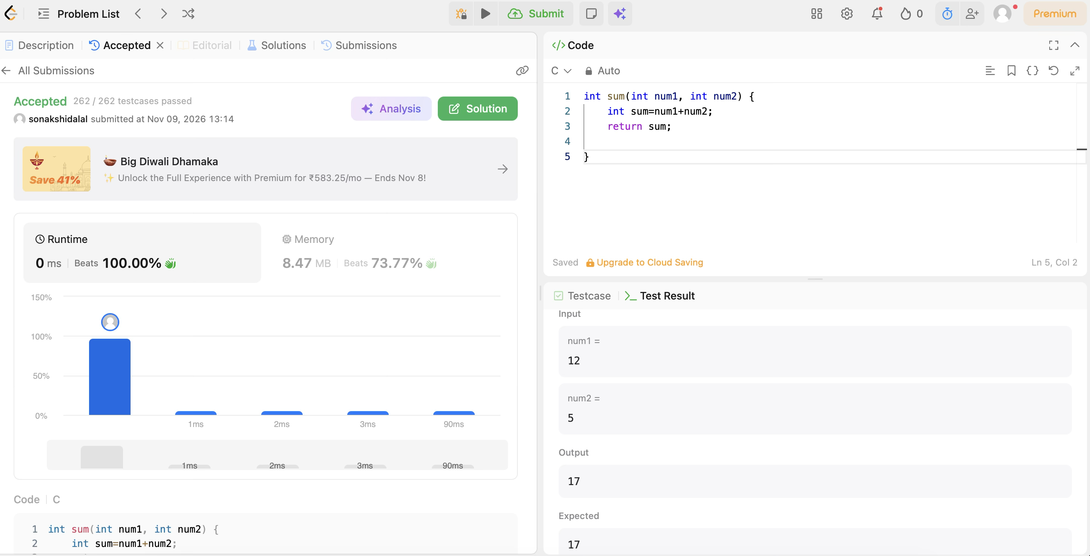
CODE:

int sum(int num1, int num2) {
int sum=num1+num2;
return sum;
}

