Calculate Delayed Arrival Time
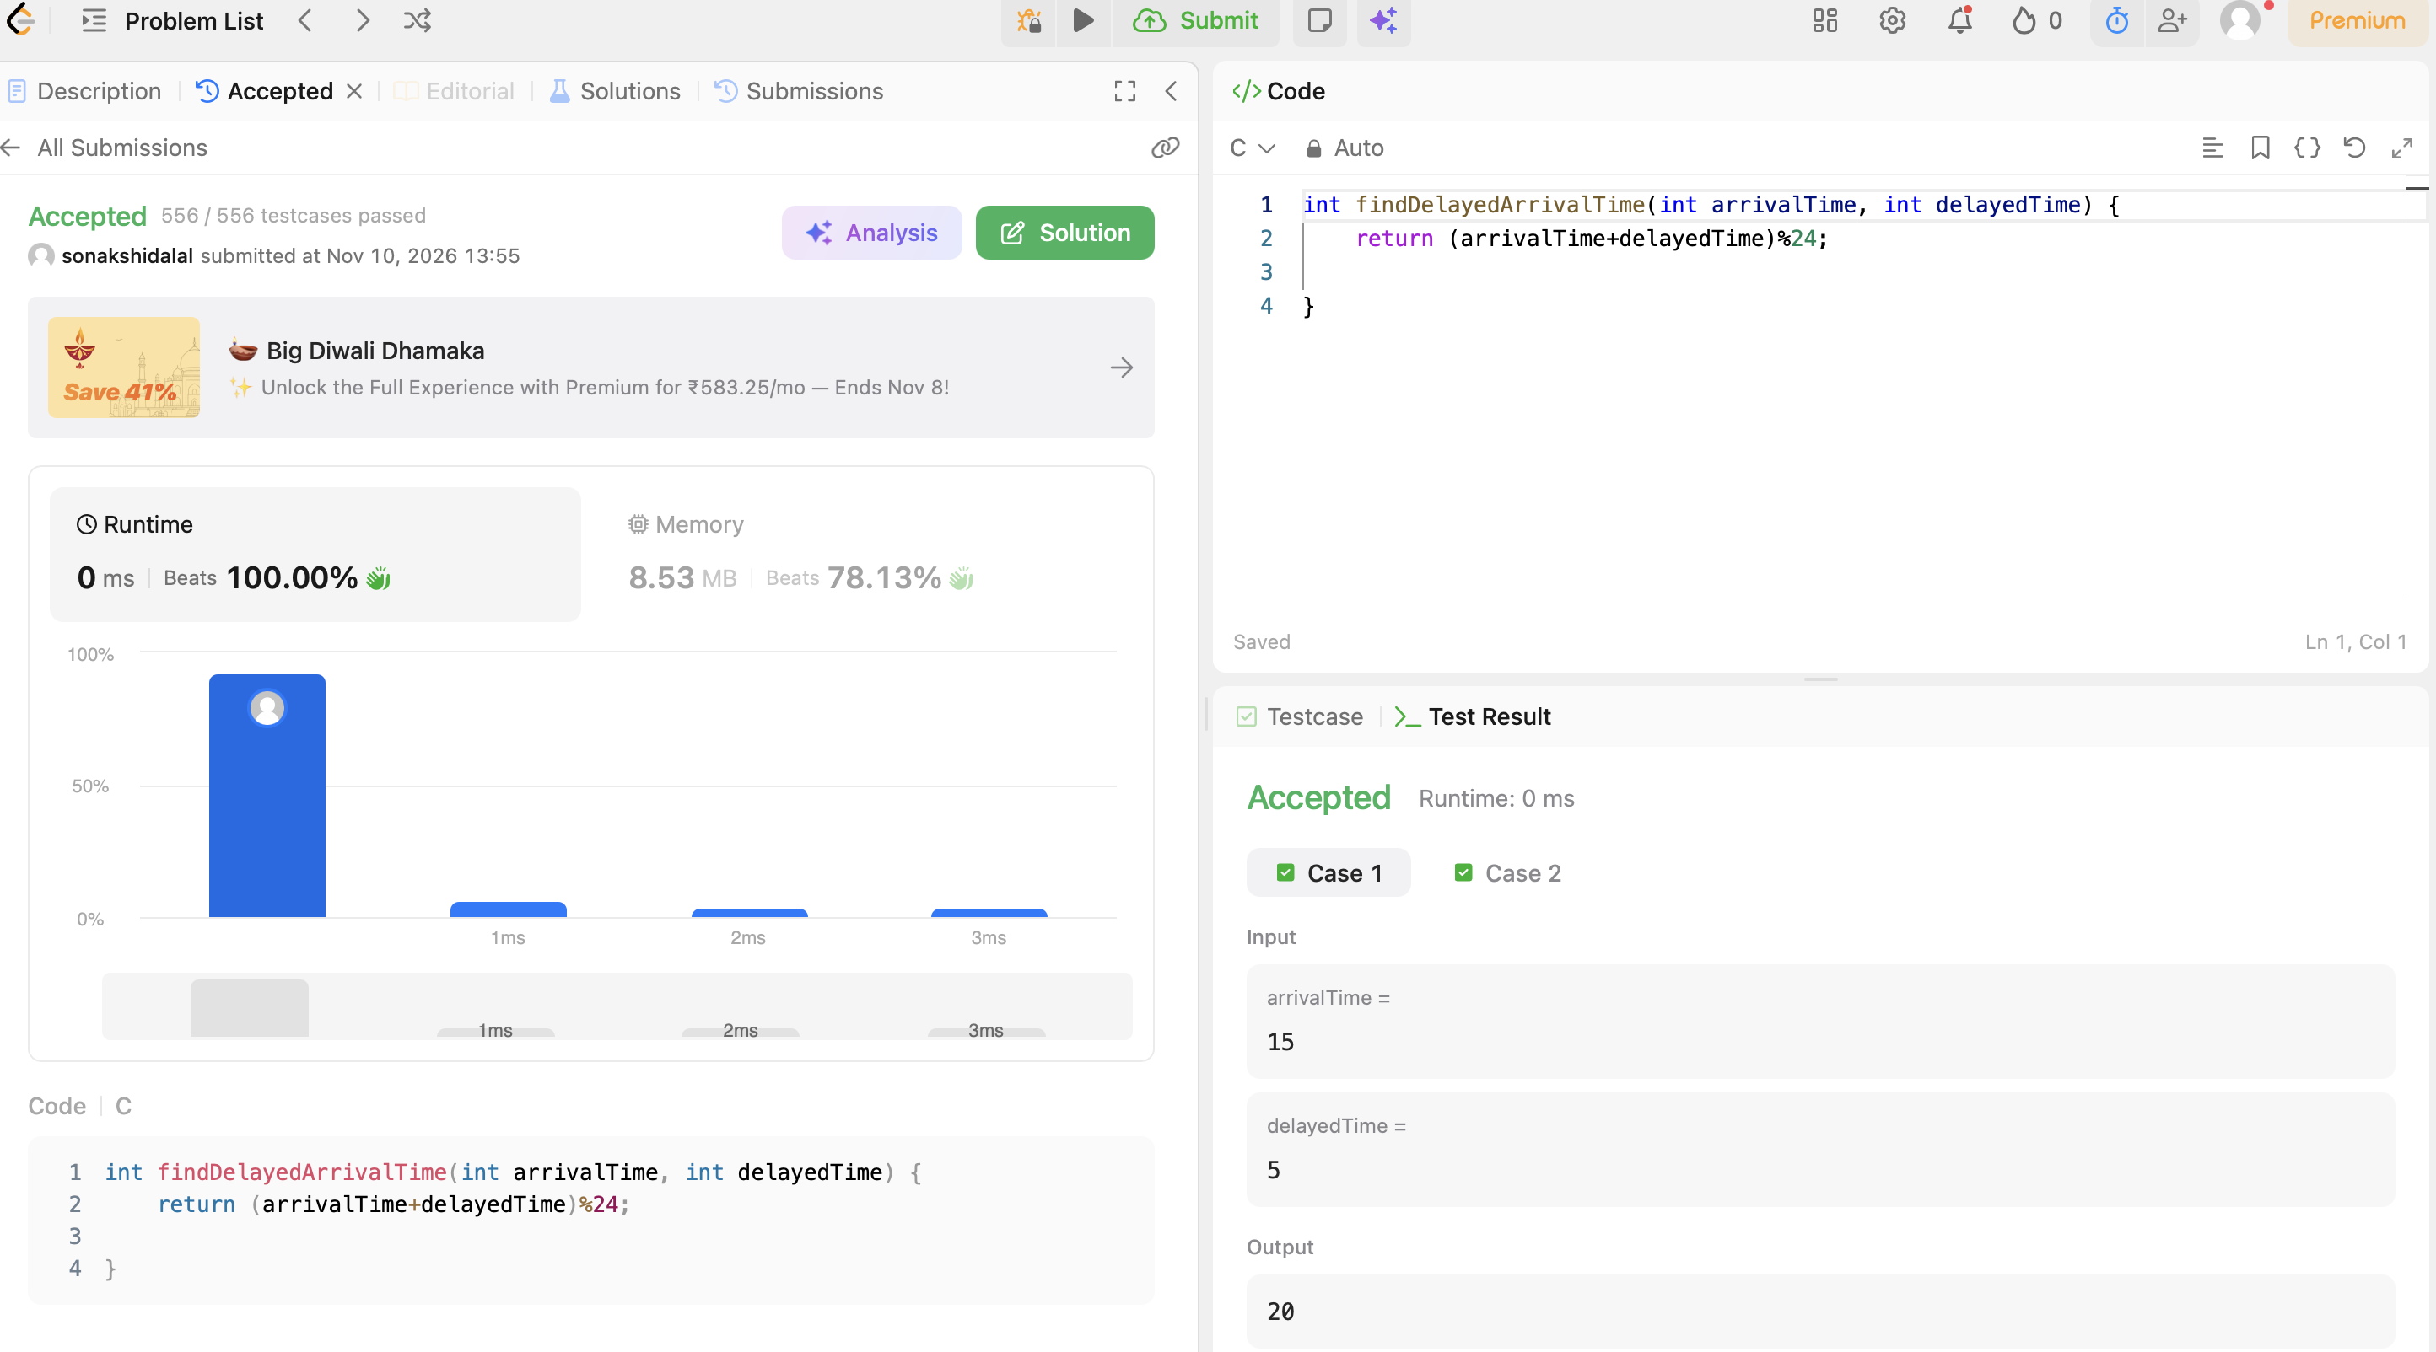
CODE:
int findDelayedArrivalTime(int arrivalTime, int delayedTime) {
return (arrivalTime+delayedTime)%24;
}

