Pime Numbers
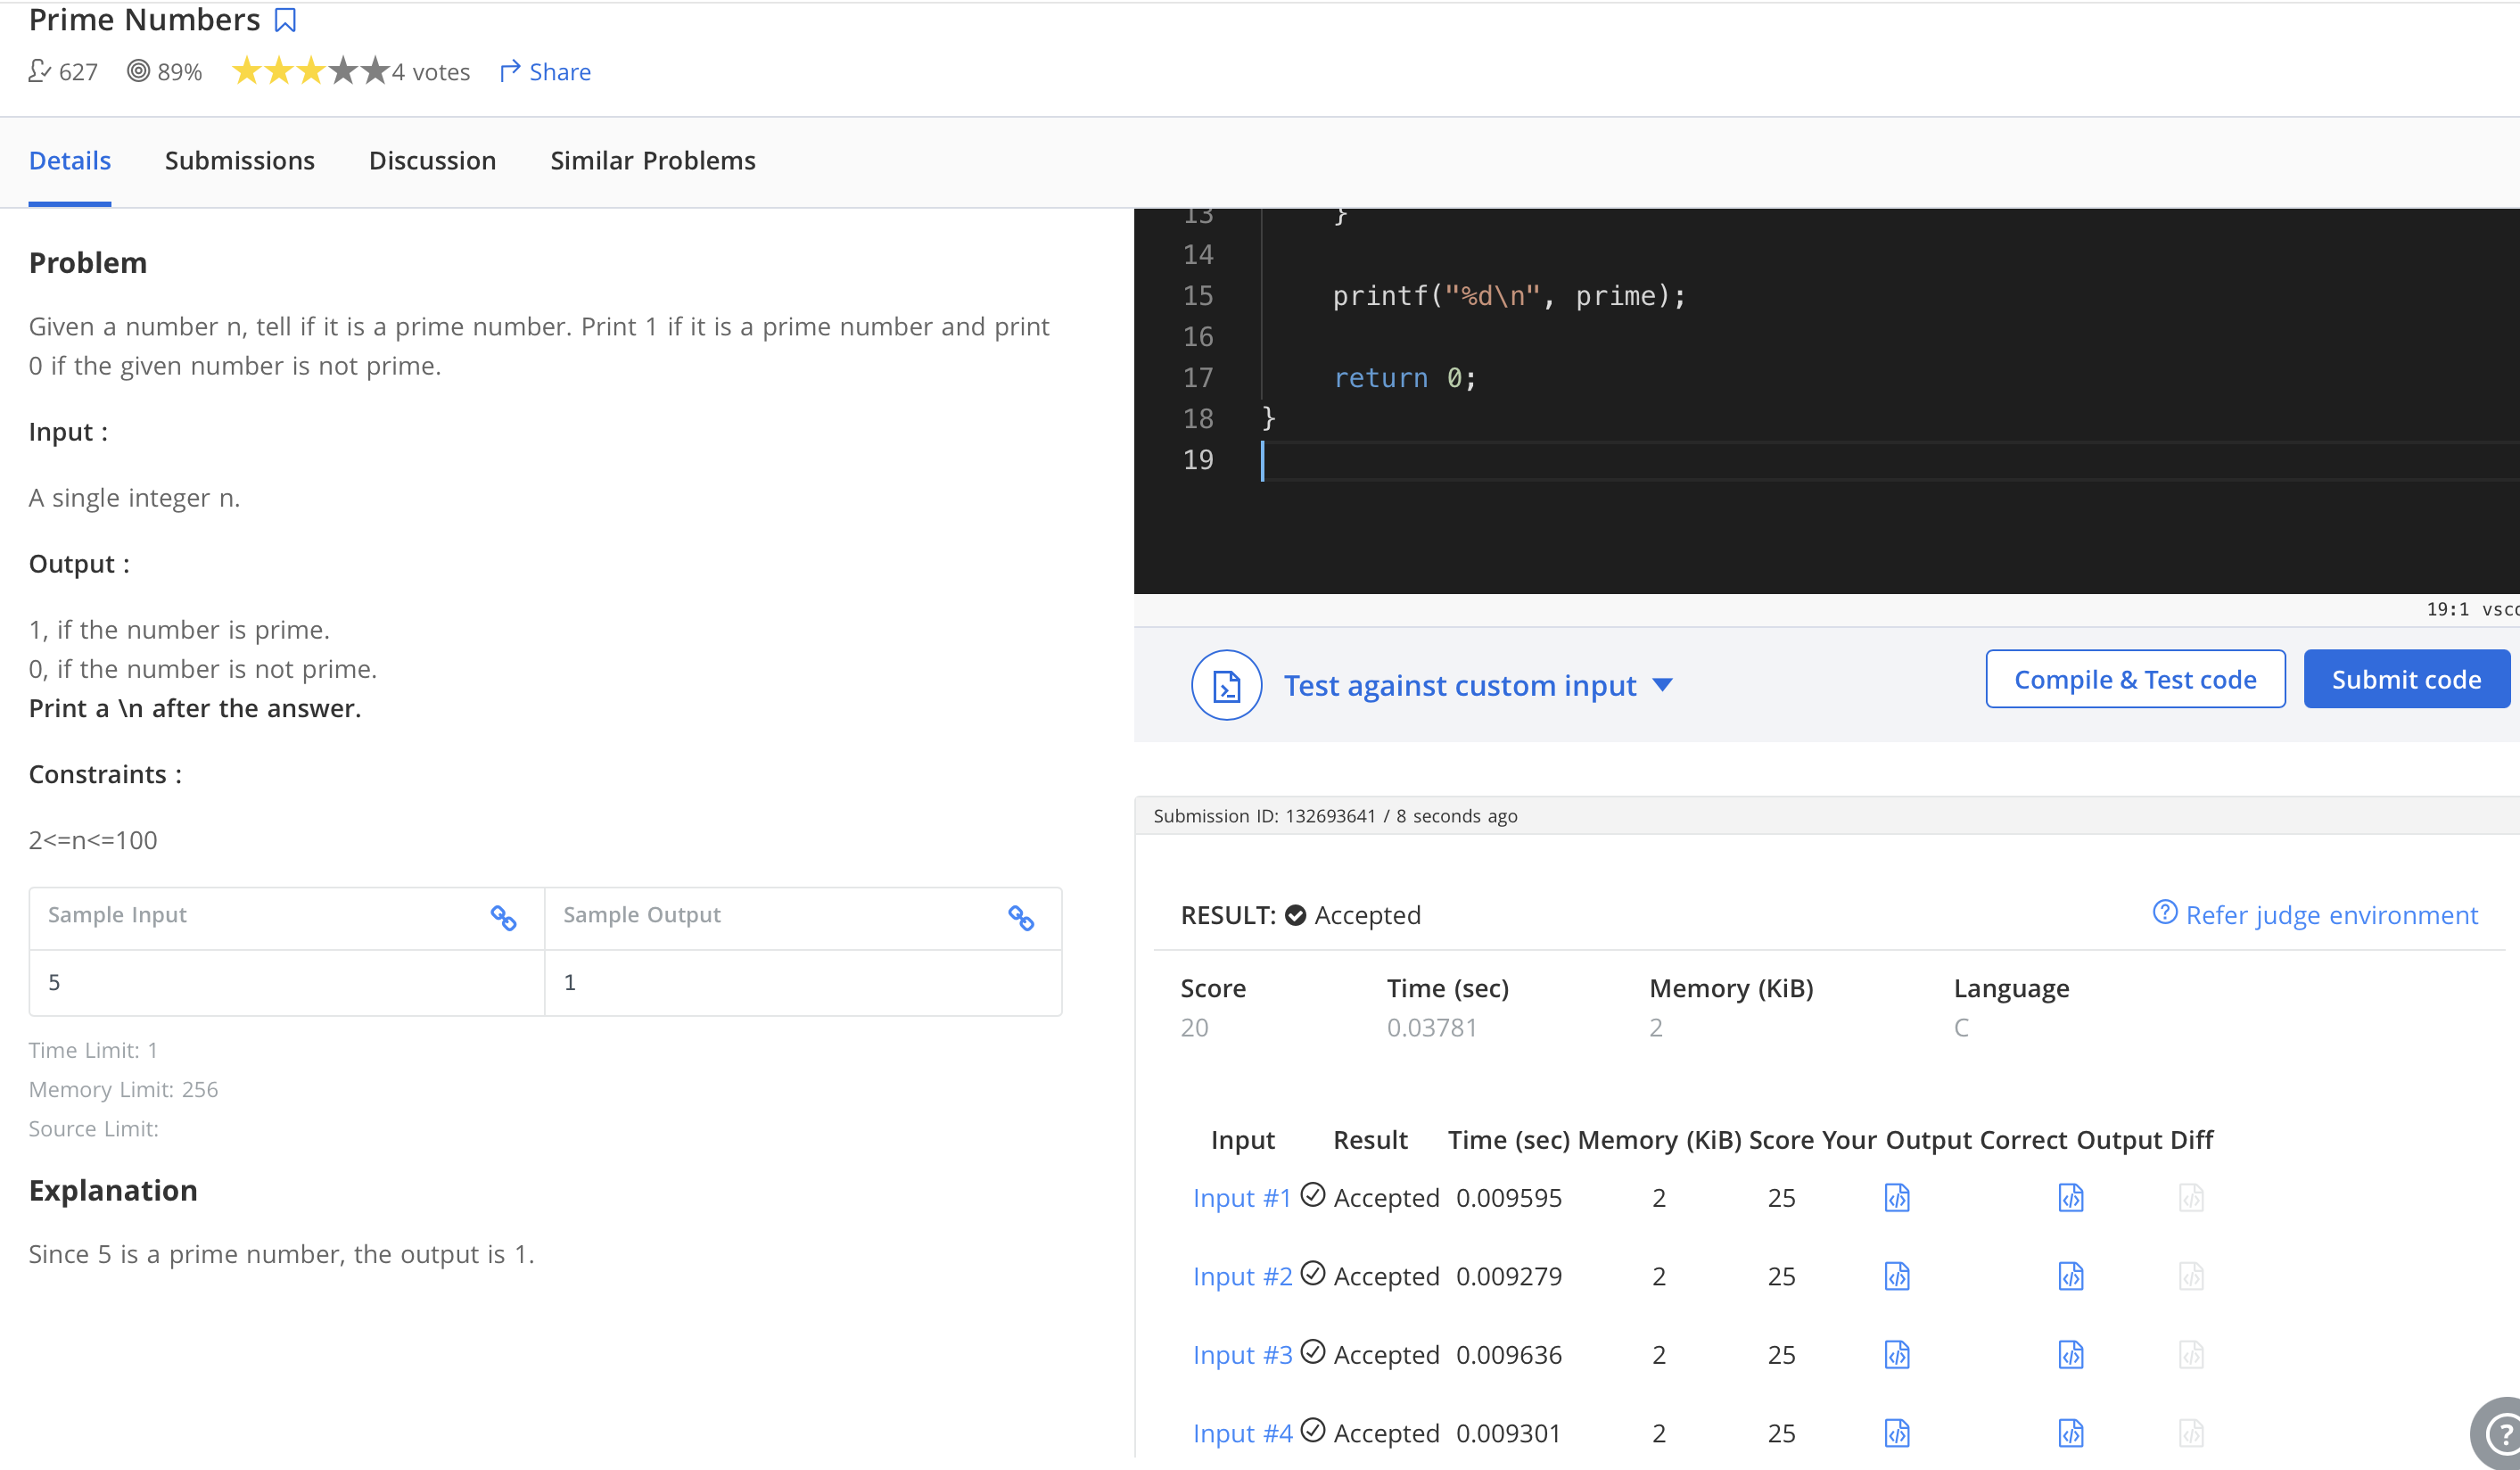
CODE:
#inclUde <stdio.h>

int main() {
int n, i, prime = 1;

scanf("%d", &n);

for (i = 2; i < n; i++) {
if (n % i == 0) {
prime = 0;
break;
}
}

printf("%d\n", prime);

return 0;
}

