Count Divisors
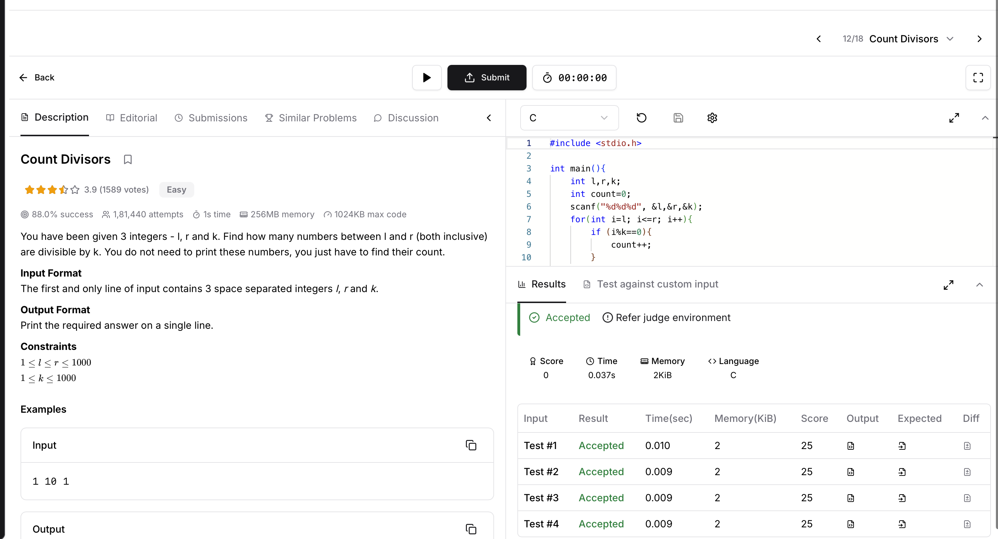
CODE:
#include <stdio.h>

int main(){
int l,r,k;
int count=0;
scanf("%d%d%d", &l,&r,&k);
for(int i=l; i<=r; i++){
if (i%k==0){
count++;
}
}
printf("%d\n", count);
return 0;
}

