Factorial!
Link: https://www.hackerearth.com/practice/basic-programming/input-output/basics-of-input-output/practice-problems/algorithm/find-factorial/
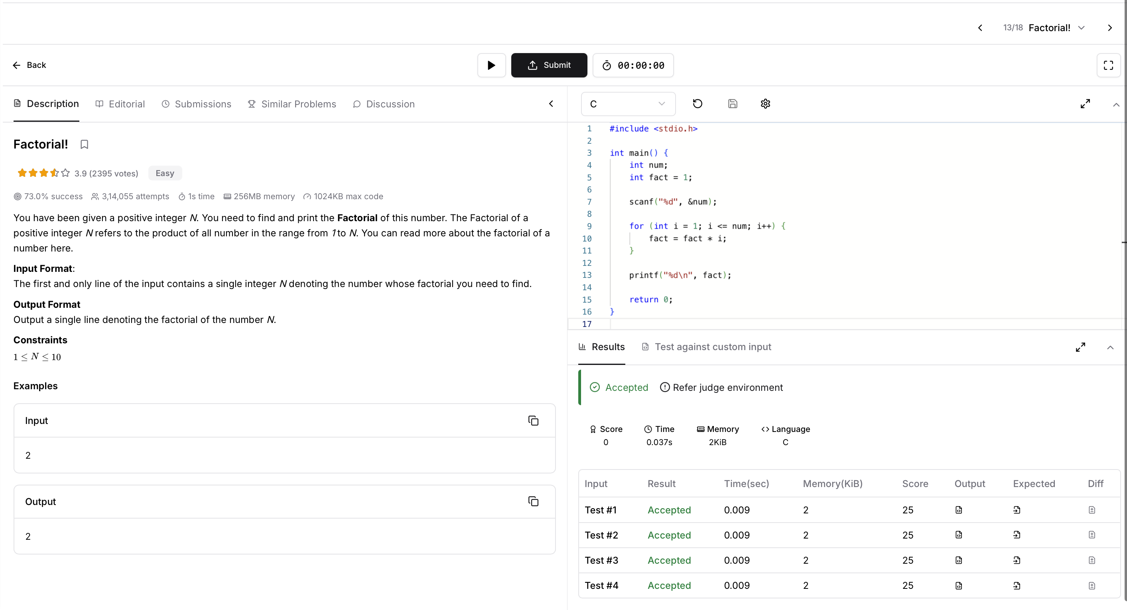
CODE:
#include <stdio.h>

int main() {
int num;
int fact = 1;

scanf("%d", &num);

for (int i = 1; i <= num; i++) {
fact = fact * i;
}

printf("%d\n", fact);

return 0;
}

