Total Distance Travelled
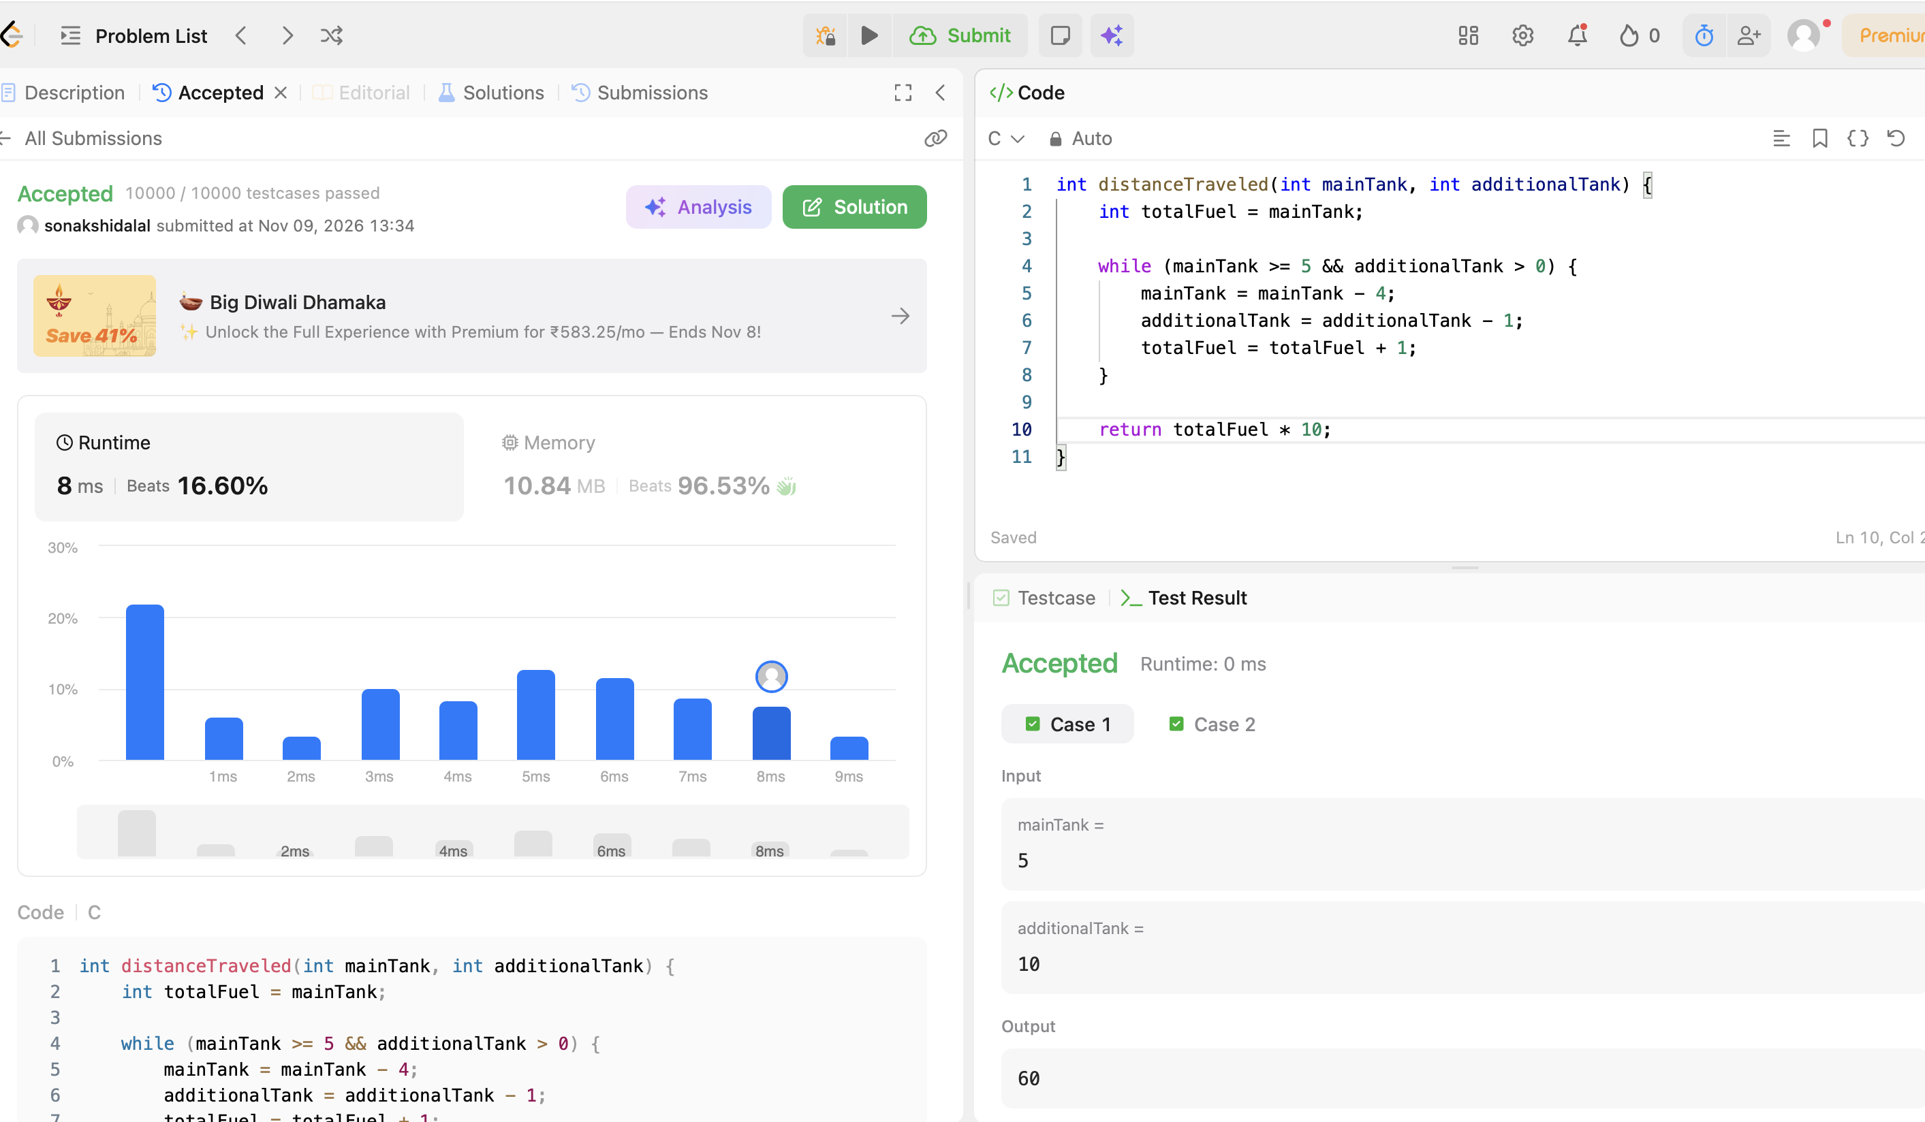
CODE:
int distanceTraveled(int mainTank, int additionalTank) {
int totalFuel = mainTank;

while (mainTank >= 5 && additionalTank > 0) {
mainTank = mainTank - 4;
additionalTank = additionalTank - 1;
totalFuel = totalFuel + 1;
}

return totalFuel * 10;
}

