Smallest Even Multiple
Link: https://leetcode.com/problems/smallest-even-multiple/
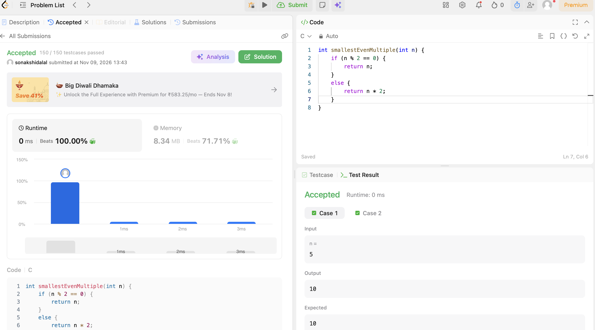
CODE:
int smallestEvenMultiple(int n) {
if (n % 2 == 0) {
return n;
}
else {
return n * 2;
}
}

