FizzBuzz
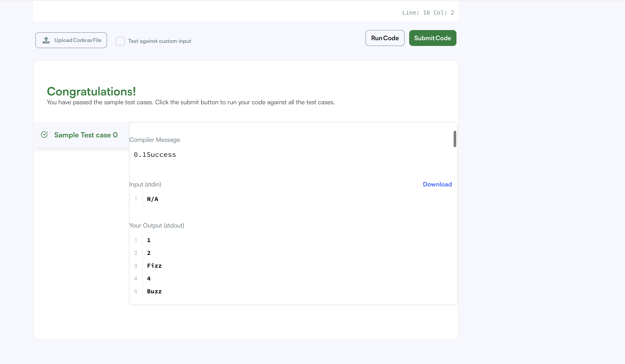
CODE:
#include <iostream>
using namespace std;
int main()
{
for(int i=1;i<=100;i++){
if((i%3 == 0) && (i%5==0))
cout<<"FizzBuzz\n";
else if(i%3 == 0)
cout<<"Fizz\n";
else if(i%5 == 0)
cout<<"Buzz\n";
else
cout<<i<<"\n";
}
return 0;
}

