Data Structures and Algorithms: Programming Assignment
Course: MBA. Tech CE (Div-A)– Semester III
Subject Code: 702CO1C001
Instructor: Dr. Nitin Choubey
Submission Deadline: 01st November 2025
Mode of Submission: Submit GitHub repo link or PDF with screenshots and code as submission for this.

Objective
To strengthen your understanding of core data structures and algorithms by solving real-world problems on competitive programming platforms. This assignment will help you develop problem-solving skills, optimize code, and prepare for technical interviews.

Platforms
You may use any of the following platforms:
- LeetCode
- CodeChef
- HackerRank
- GeeksforGeeks Practice
Assignment Task: Data Structures Practice
Solve any two problems from the mentioned categories,
- Array
- Linked List
- Stack
- Queue
(Note: if you are chosen first problem from the Array, then the second problem should be from the other three categories)
Submission Guidelines
- Create a GitHub repository named DSA_Assignment_YourName
- For each problem, include:
  - Problem link
  - Your code (with comments)
  - Screenshot of successful submission
  - Brief explanation of your approach (2–3 lines)
- Alternatively, compile all of the above into a single PDF and upload it to MS Teams.
Evaluation Criteria
- Completion of required problems
- Code correctness and efficiency
- Clarity of explanations
- Proper submission format

Array:
Problem Statement:
Link: https://leetcode.com/problems/move-zeroes/description/
283.Move Zeroes
Code
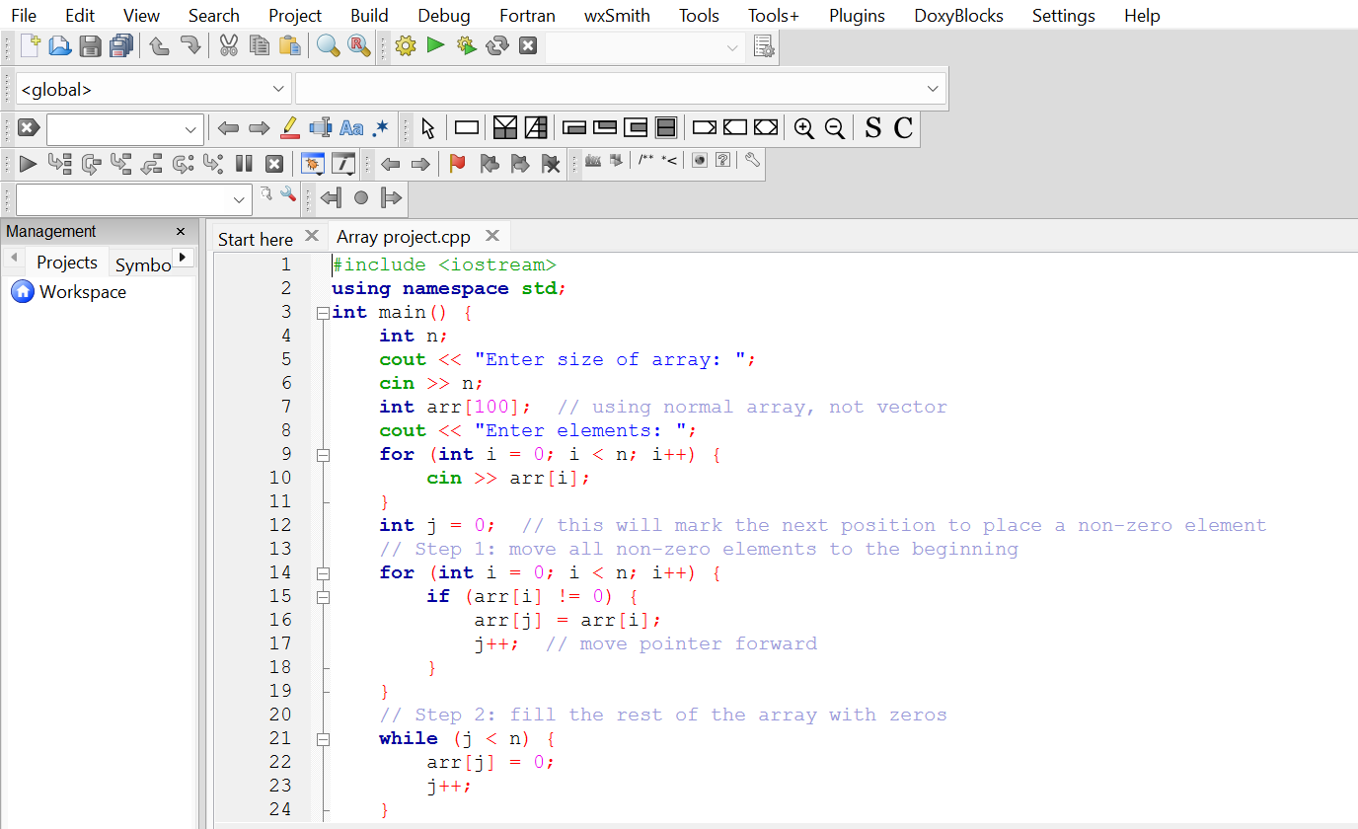
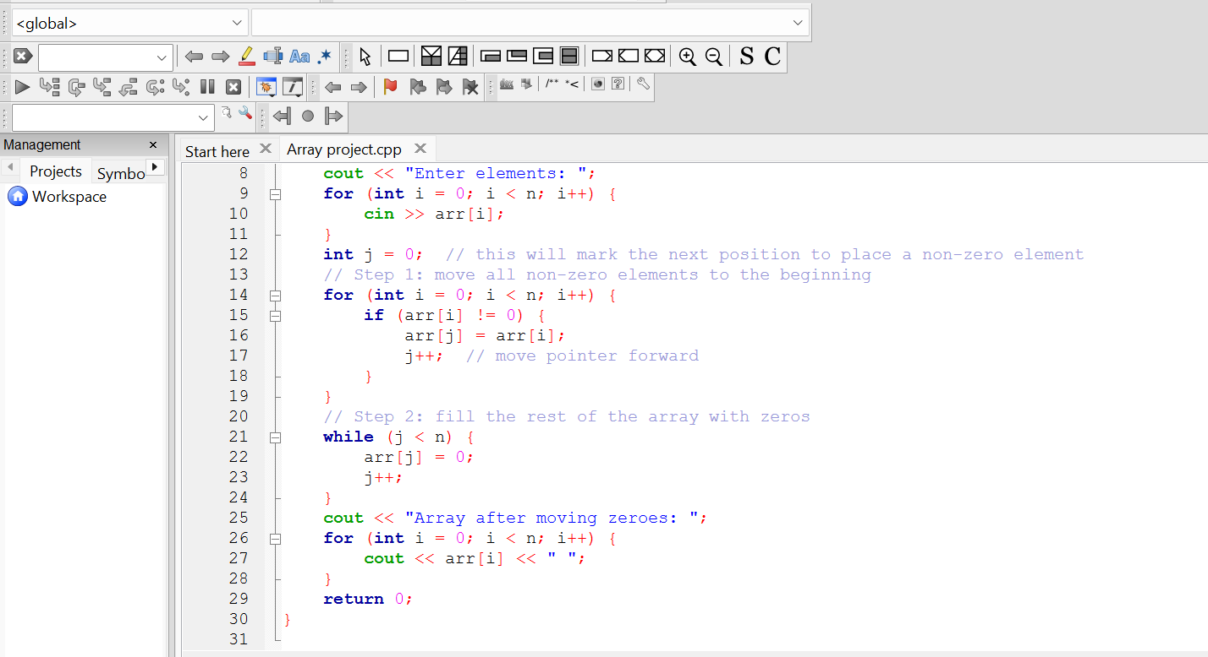
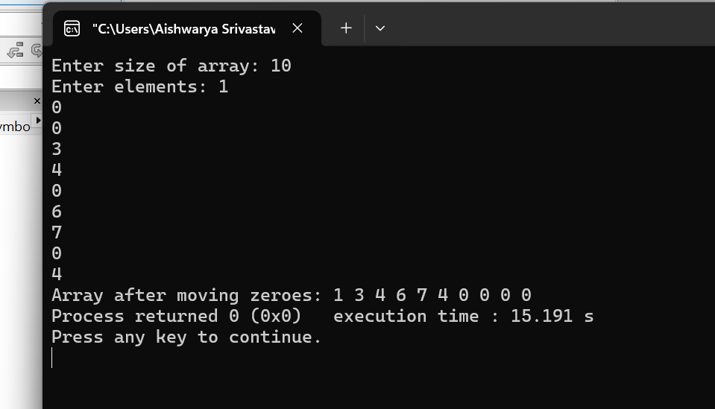

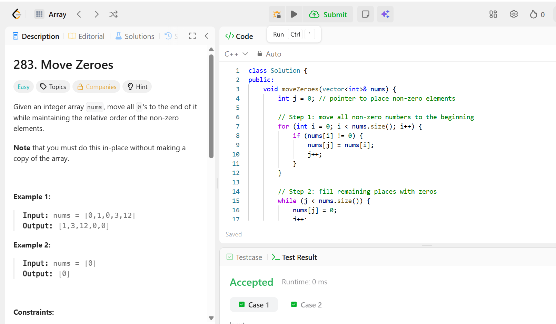
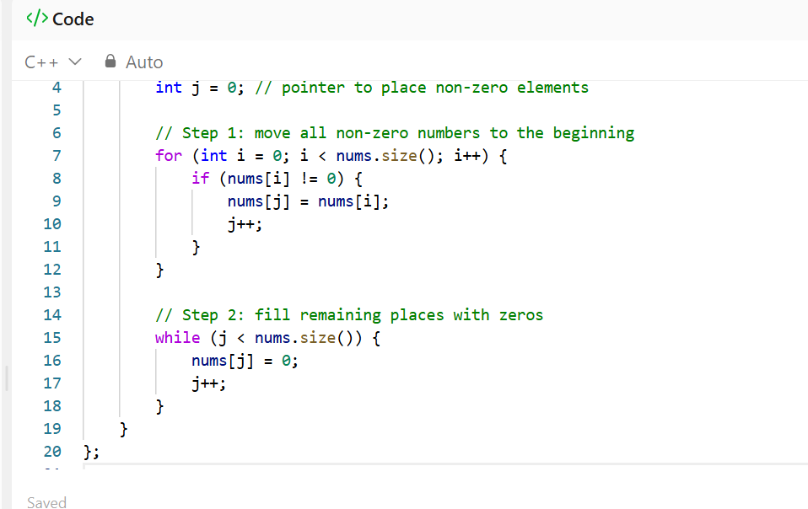
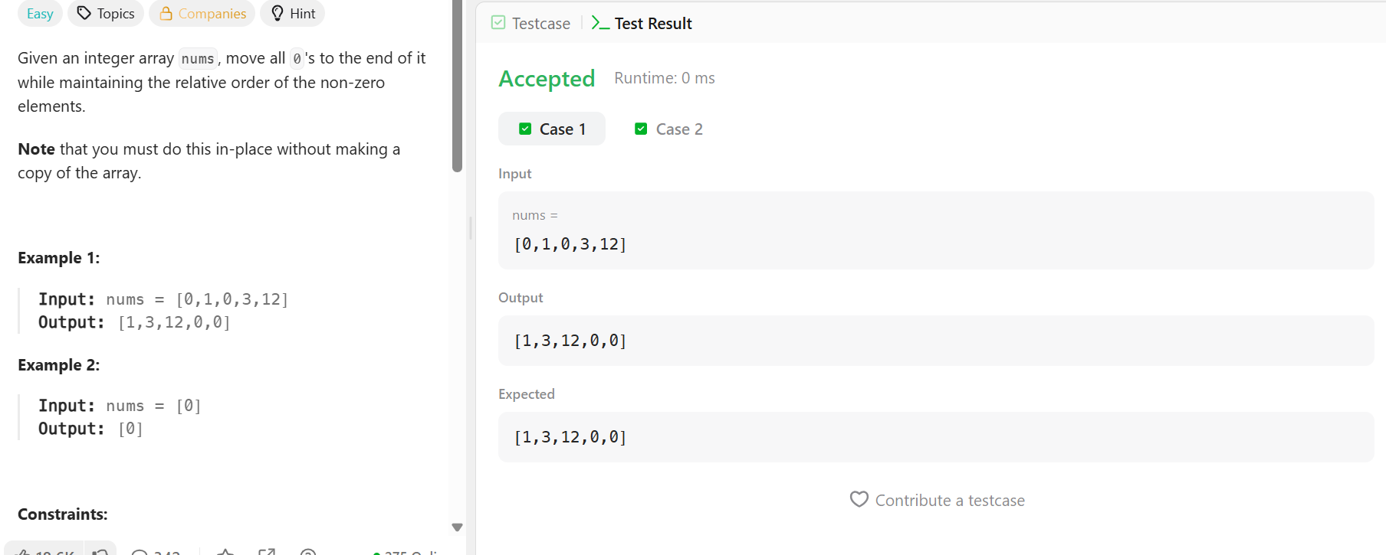
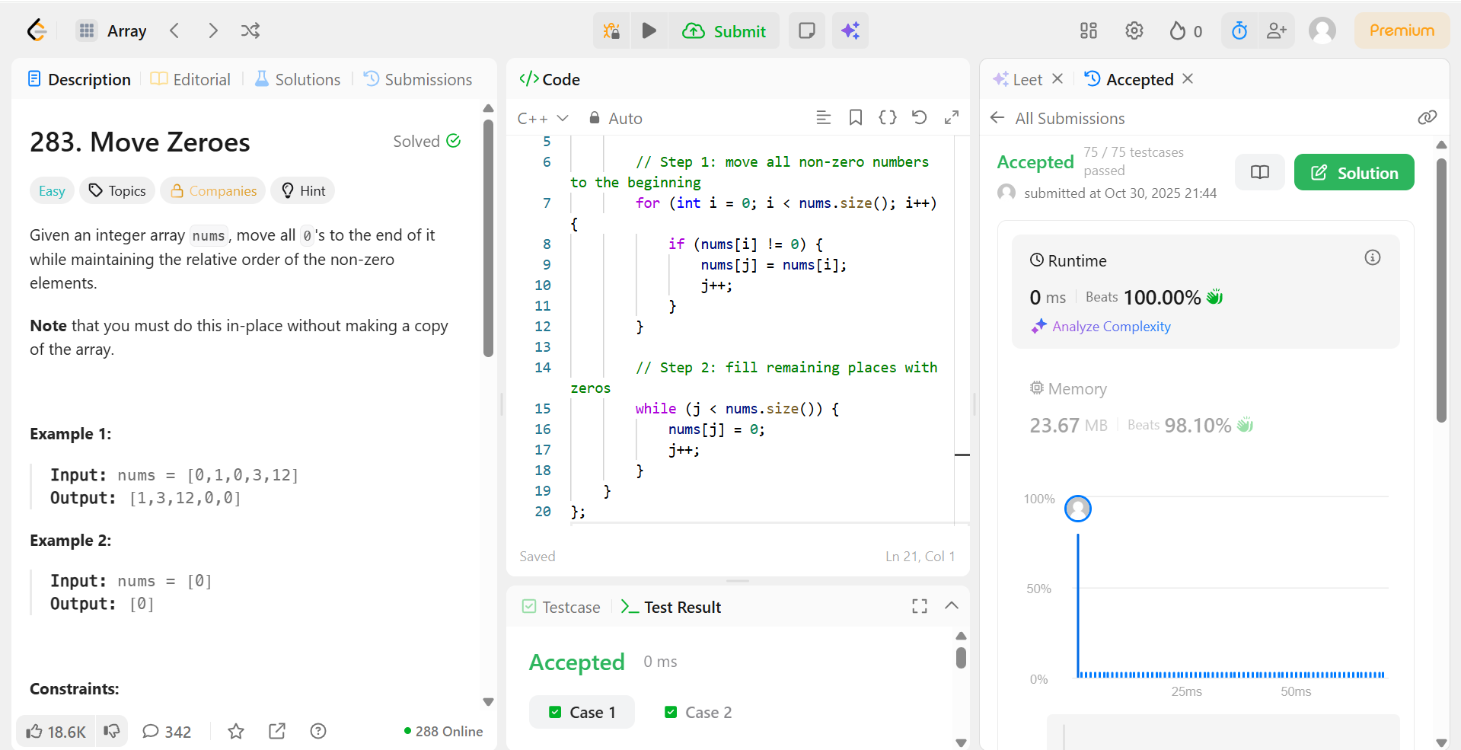
Explanation of approach:
We just go through the array once, and whenever we find a non-zero number, we put it at the front.
After all non-zero numbers are moved, we fill the rest with zeros.
Stack:
Problem statement:
Link :https://leetcode.com/problems/valid-parentheses/description/
20.valid Parenthesis
Code:
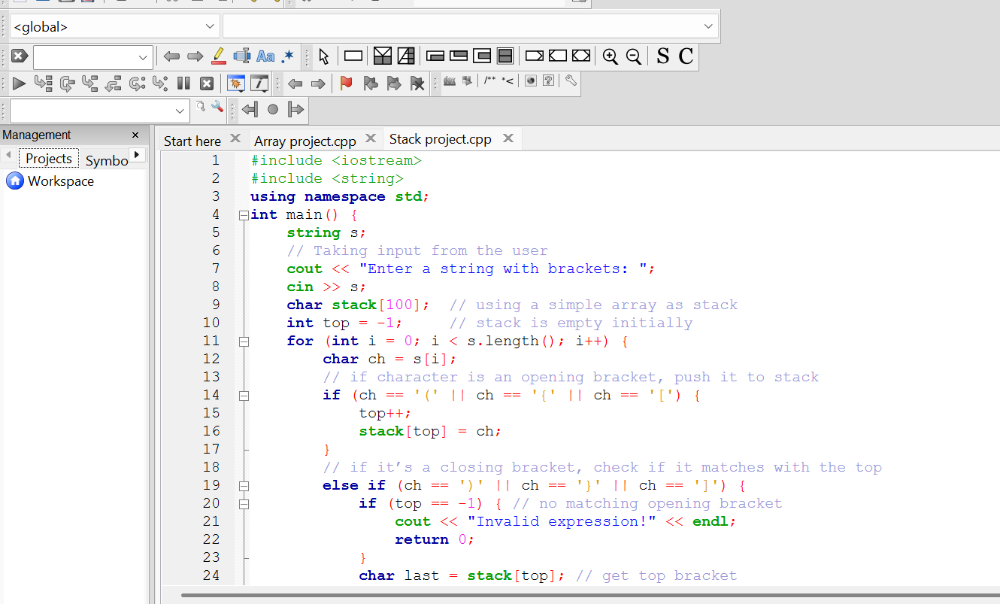
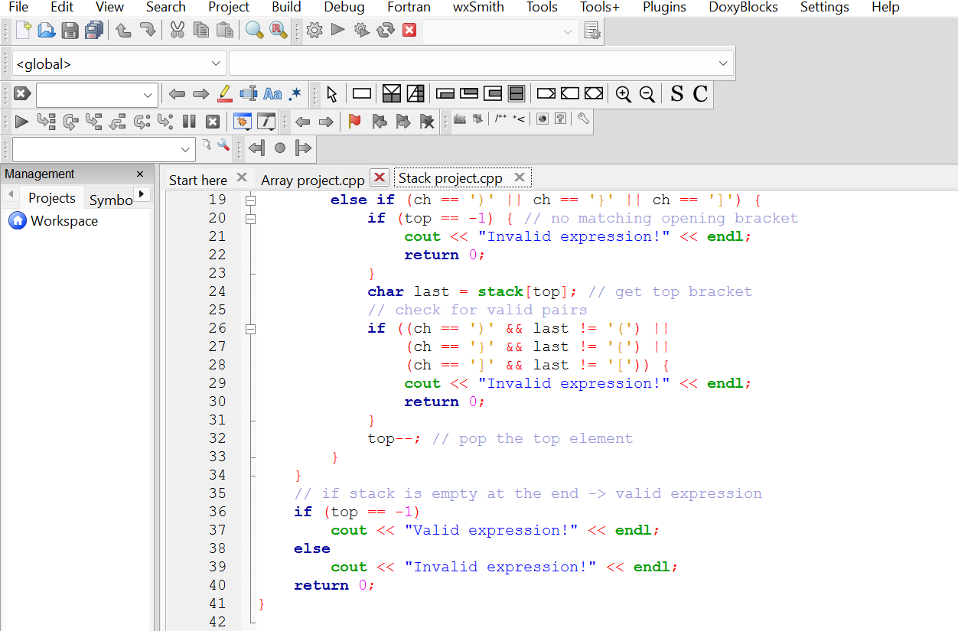
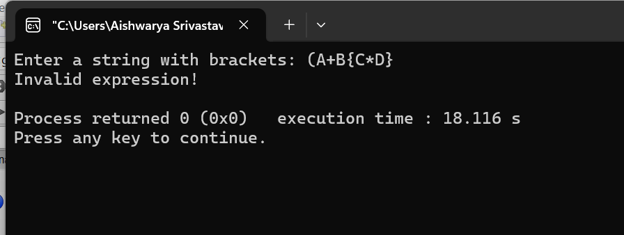
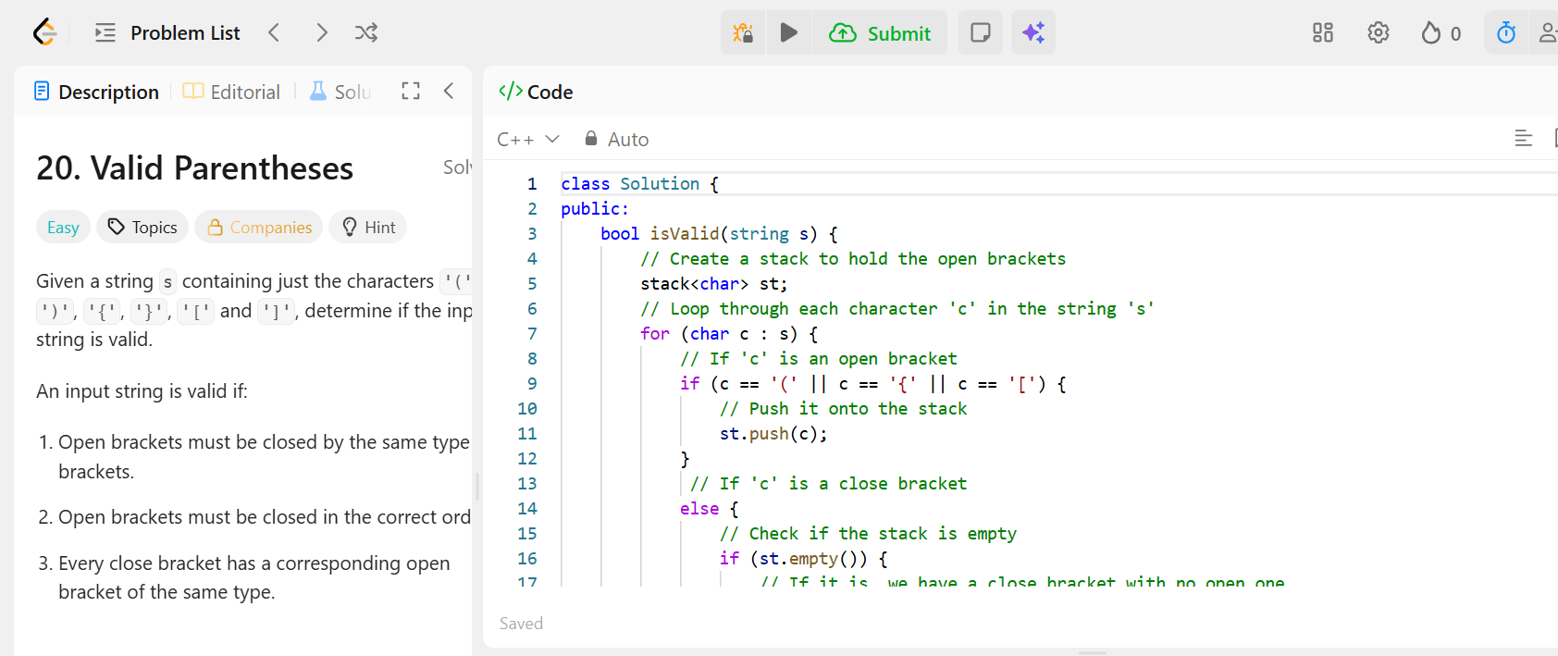
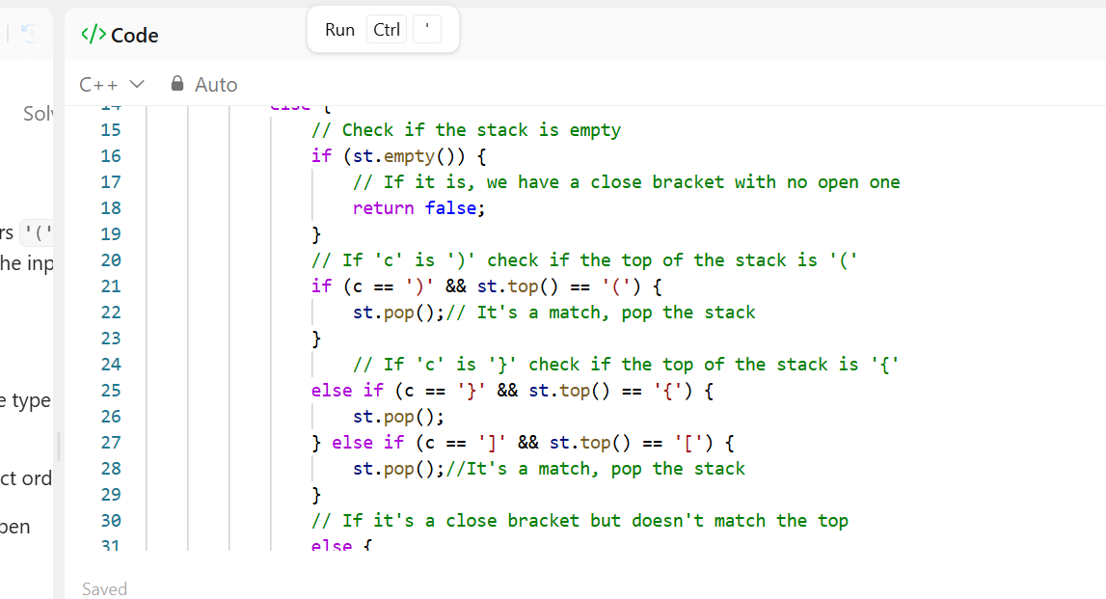
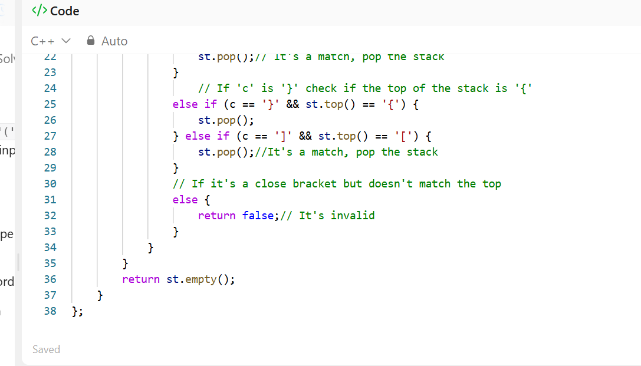

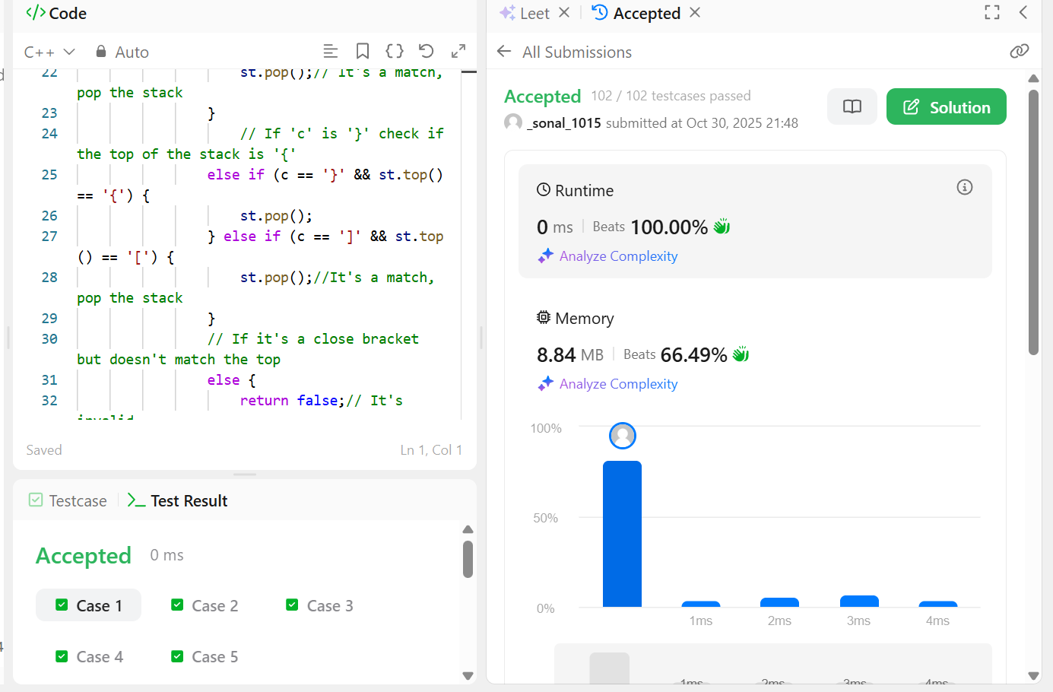
Explanation of approach:
We push every opening bracket into a stack. When a closing bracket comes, we check if it matches the last one we pushed. If everything matches and nothing is left in the stack, it’s a valid expression. If not — it’s invalid.

