**Assignment Week1a**

**Part 3**

What is GitHub? When was it created? Why? By who? What similar platforms exist? Why would you use such a platform? (Answer between 5 and 10 lines)

GitHub is a web-based repository service.

It was created in 2005.

To host your projects, to track issues, to host a web site (static pages only), to get analytics on your project, to contribute to open source projects.

Created by Linus Torvald.

CVS (1986), Subversion (2000), Mercurial, BitKeeper

We need such platform for below reasons: -

1. To manage your source code.
2. To keep history of your project.
3. To facilitate collaboration on project.

**Part 5**

Define the following terms in the context of Git (2 lines maximum):

* Repository-

The purpose of Git is to manage a project, or a set of files, as they change over time. Git stores this information in a data structure called a repository.

Example-.git/

* Commit

**The commit command is used to save your changes to the local repository.**

**Example-**git commit

* Push

To push commits made on your local branch to a remote repository.

Example-git push origin master

* Branch

The git branch command lets you create, list, rename and delete branches.

Example-git branch

* Fork

A fork is a copy of a repository. Forking a repository allows you to freely experiment with changes without affecting the original project.

* Merge

The git merge command lets you take the independent lines of development created by git branch and integrate them into a single branch.

Example-git merge clean_up

* Clone

The git clone command copies an existing git repository into a new directory.

Example- git clone https://user@bitbucket.org/user/repo.git

* Pull

The git pull command is used to fetch and download content from a remote repository and immediately update the local repository to match that content.

Example – git pull

* Pull request

Pull requests let you tell others about changes you've pushed to a repository on GitHub

**Part 7**

List the commands and strategy you use to do this part of the exercise in the *LastnameFirstnameGitTutorial-mm-dd-yyyy.docx* file and push it to: <https://github.com/yourpseudo/CS6392018>.

This part of exercise is done by following the below steps on github:-

1. Click the README.md file.

2. Click the pencil icon in the upper right corner of the file view to edit.

3. In the editor, update the details as asked.

4. Write a commit message that describes your changes.

5. Click **Propose file changes** button.

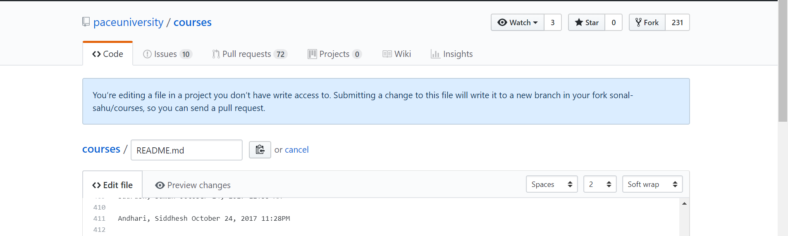



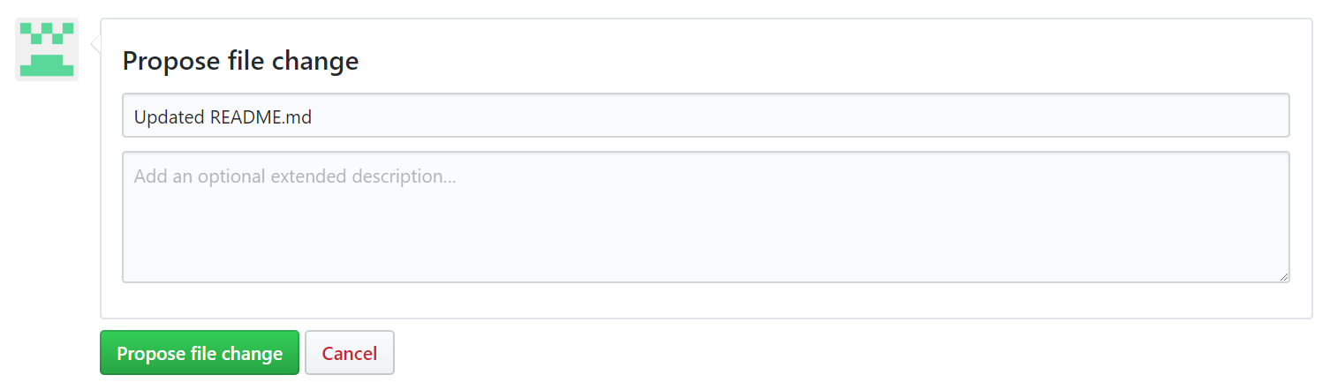

6. Click the **Pull Request** tab, then from the Pull Request page, click the green **New pull request** button.

7. Look over your changes in the diffs on the Compare page, make sure they’re what you want to submit.

8.When you are satisfied that these are the changes you want to submit, click the big green **Create Pull Request** button.

9. Give your pull request a title and write a brief description of your changes.

10. When you’re done with your message, click **Create pull request**!

11.Once the merge pull request gets confirmed, you will see a successful merge message.

12. Go ahead and delete the branch, since its changes have been incorporated, with the **Delete branch** button in the purple box.

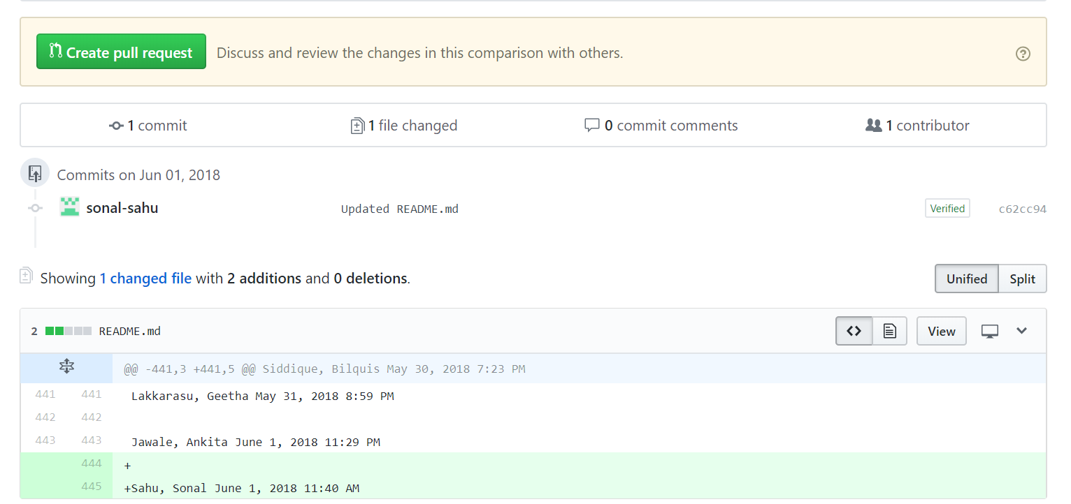

13.Detail will get updated on the README.md page.

