Baadal

Baadal is an academic cloud developed by IIT-Delhi responsible for providing virtual machines to the user on demand. It is built on Web2py Web Framework, an open source full-stack framework for rapid development of fast, scalable, secure and portable database-driven web-based applications, written and programmable in Python.

System Design
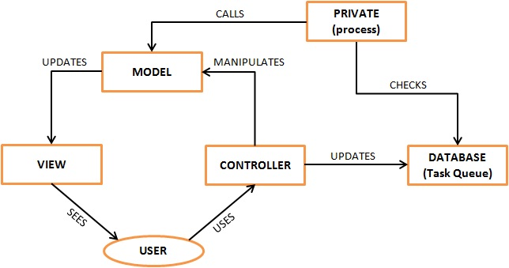
As shown in the above figure, this framework deploys Model–View–Controller(MVC), a type of computer user interface that separates the representation of information from the user's interacting with it. The Model consists of application data and computation rules, the Controller mediates input, converting it to commands for the model or view and the View can be any output representation of data, such as text or a chart or a diagram. This architecture focuses on code re-usability and separation of concerns. The typical workflow of a request in web2py is described in the following diagram
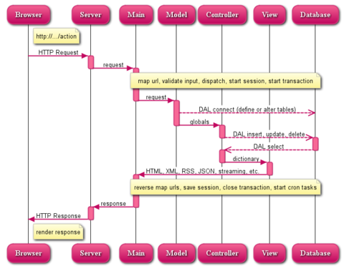

Views
This block is responsible for all the that is rendered on the GUI. it mediates with the help of Controller and updates the computation done by Model. In other words, View coordinates with Model to perform authentication checks and fetch data, with the help of Controller. Initially Web2py directs the first incoming request to index.html, residing in the default directory and then operates accordingly.
View provides for a default user panel, and an admin panel.

Controllers
This block is dedicated towards the interfacing of View(or user) with Model(or data computation). To mediate the interface this block updates the task queues, virtual machine tables, request tables, etc. The format of these tables is mentioned in Model(db.py). It also fetches the data present in the database(the same data is updated by the Model after computation) and sends it to Model for computation of results, which are conveyed to the user in-order to cater to his request. HTTp request and Response is handled at the controller level.
Controller folder consists of following packages:
user.py is responsible for handling all type of requests from a user. Some of the functionalities handled by this class is:
- Request VM
- Add Collaborator
- Start/Shutdown/Destroy/Resume/Pause/Delete Machine
- Snapshot VM / Revert to snapshot
- List user's VM
- List user's task
- Check VM Performance graph
- Request for cloning VM
- Request for attaching extra disk to VM

faculty.py is responsible for handling all type of requests from a faculty. Some of the functionalities handled by this class is:
- Aproove request
- Reject request

orgadmin.py is responsible for handling all type of requests from a orgadmin. Some of the functionalities handled by this class is:
- List all VM for the organisation
- Approve/Reject VM requested by users in its organisation
- Send reminder mail to faculty

admin.py is responsible for handling all type of requests from an administrator. Some of the functionalities handled by this class is:
- list all VMs
- view task list for all users
- migrate VM
- lock VM
- Retry task
- Reject request
- Manage VM User
- Manage Host
- Check details of running hosts
- Manage Datastore
- Manage Template
- Manage Security Domain
- Sanity Check

Default.py is responsible for user authentication and rendering default pages.

Models
This folder is dedicated towards the computing and updating of data, providing functionalities to cater the requests made by the user. The functions are also called by the background asynchronous process to serve the request pending in the Task Queue.
Model folder consists of following package:
0_contants.py: is the constants file. It is invoked before loading all other model classes.
db.py consists of the format of tables and also specifies the password of the database. The table’s format is self-sufficient in defining a database(i.e, compulsory initial values have been specified).
user_model.py: handles all the requests from user.py. The DB interaction and computation needed for handling the user tasks are taken care by this model class.
faculty_model.py: handles all the requests from faculty.py. The DB interaction and computation needed for handling the faculty tasks are taken care by this model class.
orgadmin_model.py: handles all the requests from orgadmin.py. The DB interaction and computation needed for handling the orgadmin tasks are taken care by this model class.
admin_model.py: handles all the requests from admin.py. The DB interaction and computation needed for handling the admin tasks are taken care by this model class.
common_models.py: This file contains functions that provide functionalities common to different user types. Below are few functionalities that are accomplished through this file:

- Performance Graph generation
- Fetch VM information
- Generic Decorator for Exception Handling
- Decorators to check User Types
- Push tasks to scheduler queues
- Populate VM operations
- Fetch VM Snapshot List
- Get Faculty Information

logger.py is responsible for handling application logs.
mail_handler.py is responsible for handling mailing related tasks.
menu.py is responsible for creating the application menu on the basis for logged-in users roles .
task_scheduler.py is responsible for handling scheduled tasks. The tasks that are scheduled are install, start, suspend, resume, destroy, delete, migrate, snapshot, revert, delete_snapshot, edit_vm_config, clone, attach_extra_disk.
This class calls the appropriate method for a task, and the accordingly updates the task queue with updated status information, and the error message if present.
sanity_model.py is responsible for checking the sanity of configured hosts. Hosts are checked for the Vms and, then the ground reality is compared with DB entries. Any discrepancy is corrected if possible. For Orphan Vms, user gets the option of deleting the VM from DB or else add it to the DB. In case of missing Vms, user can delete the entry from Db and accordingly other disk usage related info is updated in DB.

Modules
This folder is for independent classes, which are not tightly coupled to a controller or model.
Note: The tables are interfaced asynchronously through apache servers and any changes made manually to the tuples in the database will create inconsistency.
Modules folder consists of following package:
auth_user.py is responsible for handling authentication related task. Major functionalities handled by this class are:
- fetching LDAP User
- Updating DB after LDAP user logs in for first time
- Create user without user logging-in.
- Add/Update user membership(user role)
helper.py has standard helper methods that are used across the packages. Some of the functions are:
- Get current date and time
- check user role
- get user details
- get constant values
vm_helper.py is responsible for handling VM related functionalities. VM operations are performed using libvirt APIs. For installing a new vm, we use virsh ( command line utility) to create a vm with different parameters like host, datastore, template, mac, ip address, vncport. The user has the provision to take atmost 3 snapshots of his vm. He can revert or delete the snapshot(s) at any time. Moreover, he can create atmost 100 clones of his vm for simulation or any other requirements.
- install
- start
- suspend
- resume
- destroy
- delete
- migrate
- snapshot
- revert
- delete_snapshot
- edit vm configuration
- clone VM
- attach extra disk

Private
This folder handles the asynchronous background process. It is currently used for generating performance graphs.
Private folder consists of following package:
rrd_gen_cron.py:
1. This script is responsible for updating the rrd file for every VM defined in the system.
2. These rrd files are stored in vm_rrds/ directory stored on the file present at /vol/baadalcse.
3. These files can be accessed from /mnt/datastore/vm_rrds/ folders from local machine as /vol/baadalcse/ is mounted on /mnt/datastore on the local machine.
4. This script is run every 5 minutes through a cron set in crontab on the local machine.
5. Its work in to ping active hosts, fetch the details(cpu usage, ram usage etc.) of all the running VM's on that host and update the rrd file for that particular VM.
6. An rrd file is created when a VM is initiallly created. If by any chance the rrd file for a running VM does not exist then it is being created.
python -u /home/www-data/web2py/web2py.py -S baadal -M -R /home/www data/web2py/applications/baadal/private/rrd_gen_cron.py

