README File

Files in the zip folder:

README.docx – This is the readme file

SonalSarinSourceCode.pdf – This is the pdf document of the source code

SonalSarinTextInImage.py – This is the actual program. By clicking on this, it will open the terminal so that you can run the program

SonalSarinTextInImage.pyproj – This is the documented source code in visual studio 2015. Need Visual Studio 2015 installed with Python extension to view this.

testImage.jpg – This is the image that we will use to embed the text

testImage.png – This is the image that the text will get embedded into.

Name: Sonal Sarin

Brief Description of your application architecture:

The program has been developed in python 3 and uses python pillow in Visual Studio 2015. I submitted the documented source code in a pdf version and the documented source code with the .pyproj extension file. To view the documented source code with the .pyproj extension, you need to have visual studio installed. If you don’t have visual studio 2015 installed, I have submitted the program itself (SonalSarinTextInImage.py) to be ran when clicked. Then, you can refer to the pdf source code to view the code.

Instructions on how to execute the application:

Make sure the files you are embedding and extracting are inside the project folder. This makes it easy to type in the file name when asked.

To run in the terminal: type SonalSarinTextInImage.py

The program will ask you to enter 'e' to encrypt or 'd' to decrypt. Type in e or d.

If 'e' to encrypt:

1. You will be asked to enter the name of the image to use. Make sure to enter the

image path correctly.

2. You will be given a choice to encrypt a file (f) or a string (s). Because the requirements said to encrypt the source code, type in 'f' to encrypt a file.

If 'f':

1. You will be prompted to type in the name of the file. Type in the name of the file: SonalSarinTextInImage.py

else if 's':

1. You will be prompted to type in a string. Type in the string: Security is fun

[This is when the embedding will happen. Nothing to do but wait! Once the embedding is finished, the embedded text will be saved in a testImage.png file. The program will finish and to decrypt you must run the program again.]

If 'd' to decrypt:

1. Type in 'd' when asked to enter 'e' to encrypt or 'd' to decrypt.

2. You will be prompted to enter the name of the file to decrypt. Type in testImage.png.

[This is when the extraction will happen.]

Below are images for encrypting and decryting:

1. Embedding a file (such as, embedding the source file):

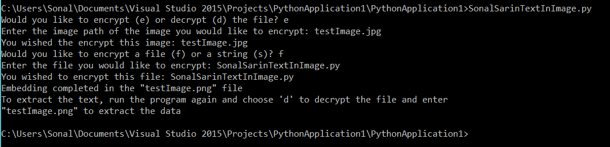

1. Embedding a string (such as, embedding "security is fun"):

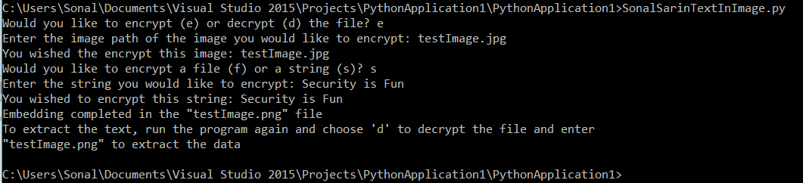

3. Decrypting a file (such as, decrypting the source file):

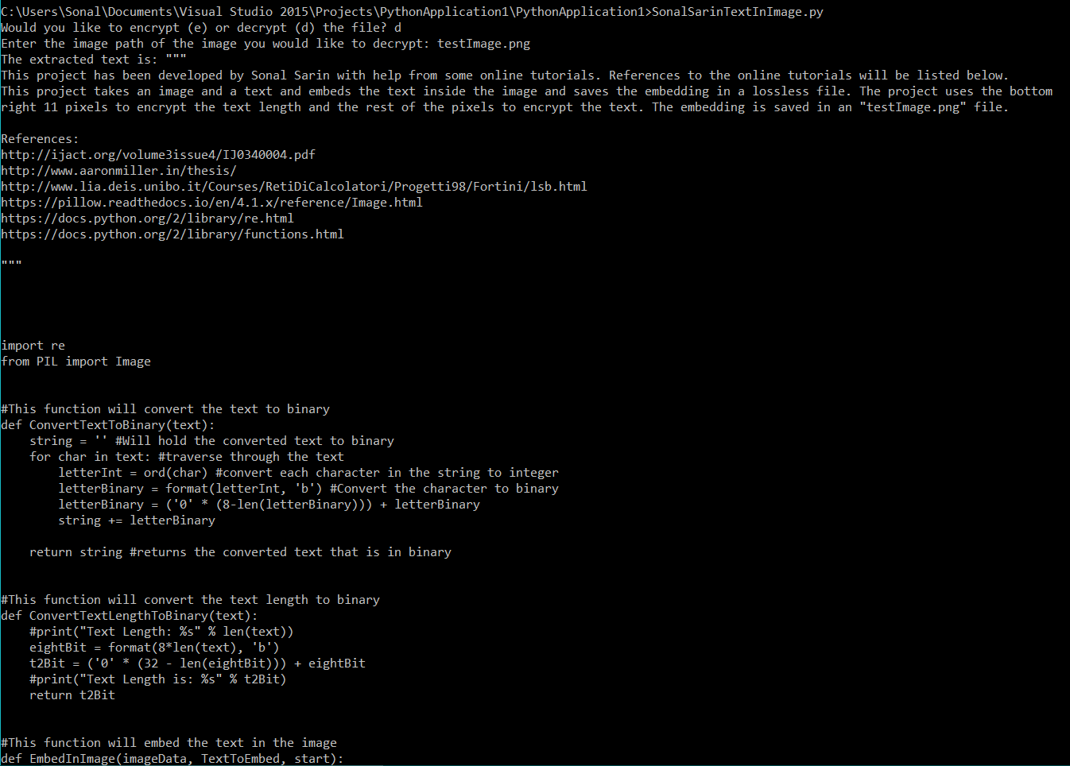

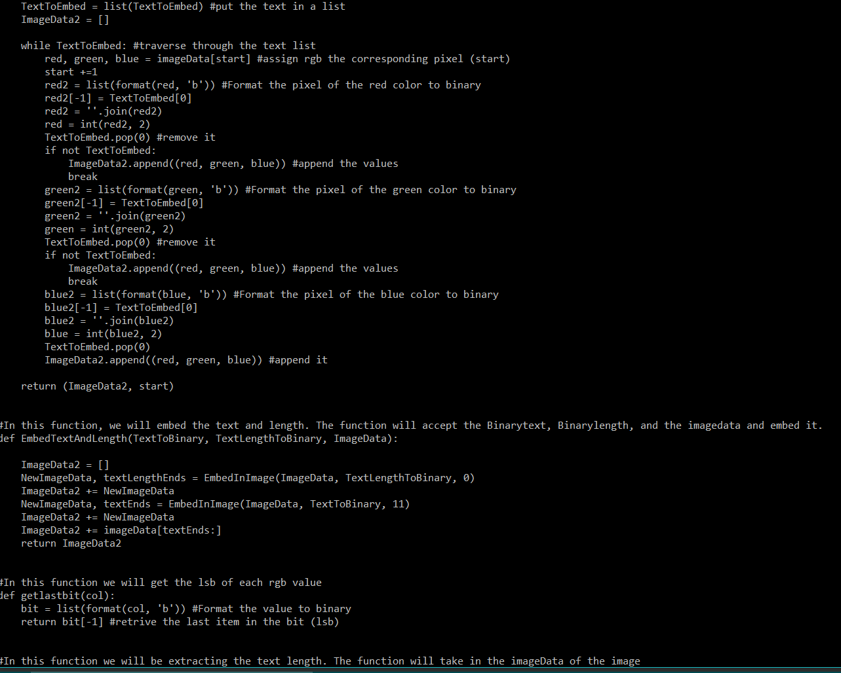

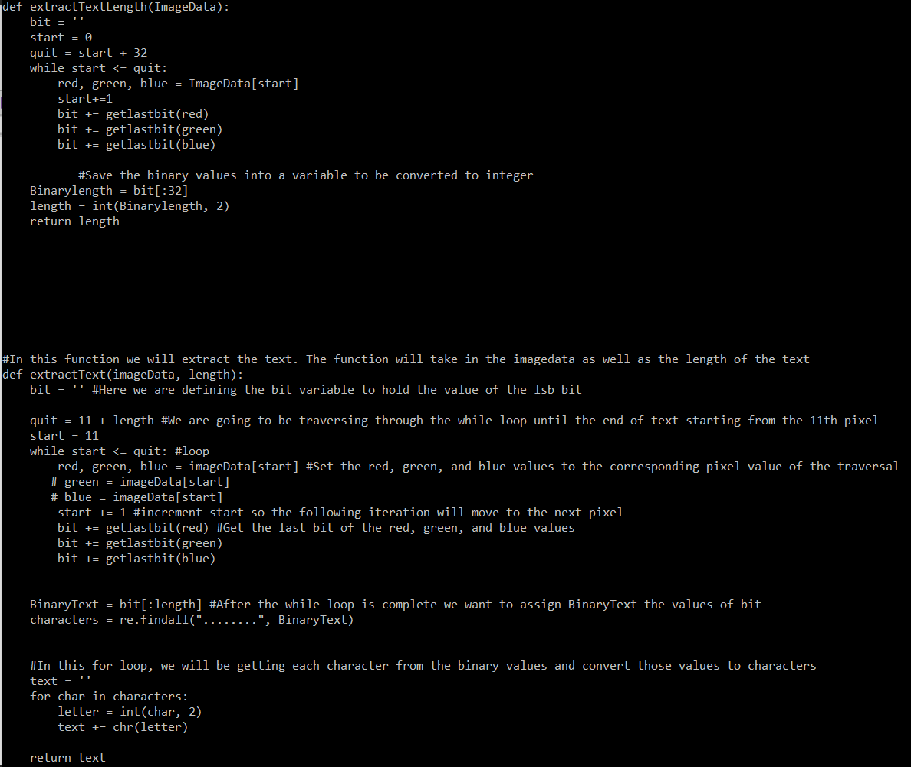

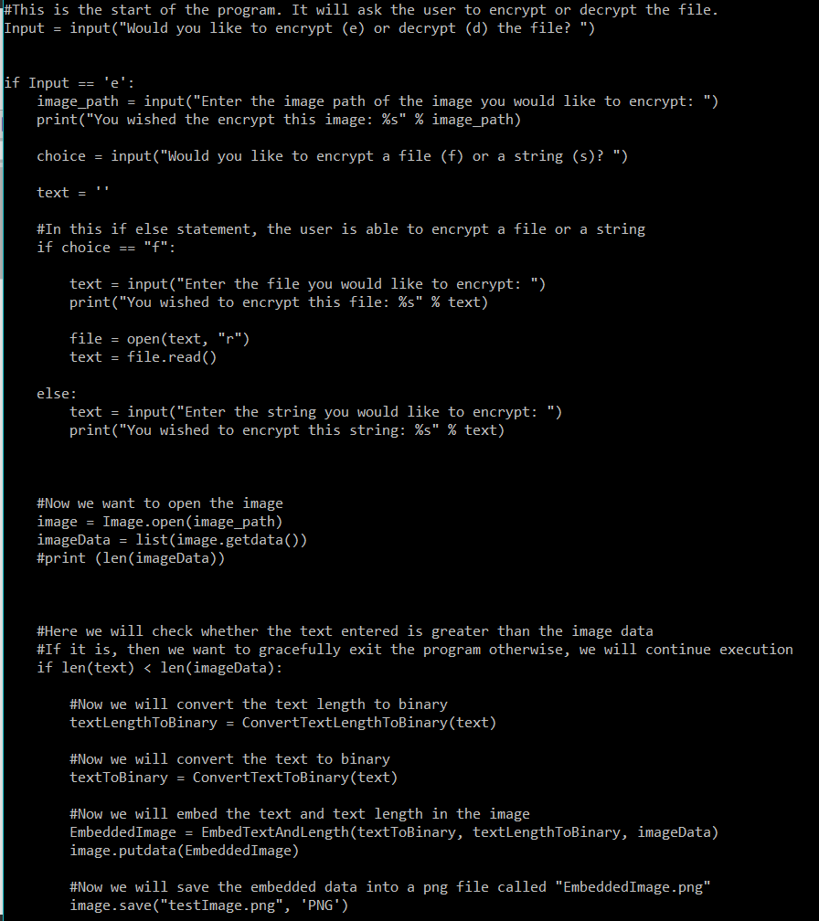

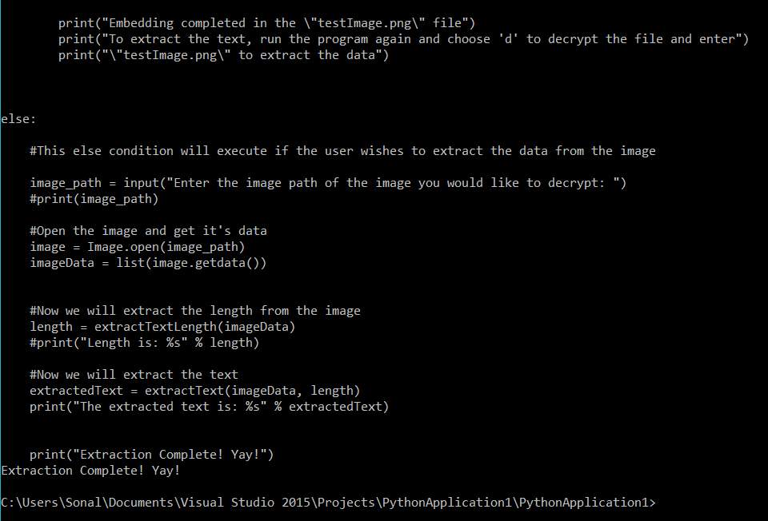

4. Decrypting a string (such as, decrypting "security is fun"):

