Report
Of
Artificial Intelligence and Machine Learning Internship
Submitted
To
School of Computer Science and Engineering
IILM University, Greater Noida, U.P.
In partial fulfilment of the requirement of degree of
B.Tech CSE

By
Name of Student: SONAL
Roll Number of Student: 25SCS1003003066
Section: 2CSE13
Semester: 3rd Semester
Batch: 2025–2029

CANDIDATE'S DECLARATION
I, Sonal, hereby declare that the internship report titled “Artificial Intelligence and Machine Learning Internship” is an original record of the work completed by me in fulfilment of the requirement for the award of the degree of Bachelor of Technology in Computer Science and Engineering. All sources of information used in this report have been duly acknowledged, and no material has been reproduced from any other source without appropriate reference. I further affirm that this report has not been submitted, in part or in full, to any other institute for any degree or diploma, and that I shall be personally responsible for any copyright violation found in this regard.
Signature: ___________________
Student Name: Sonal
Roll No.: 25SCS1003003066

ACKNOWLEDGEMENT
Completing this one-month Artificial Intelligence internship at Codec Technologies Pvt. Ltd. would not have been possible without the support and guidance of several people, whom I would like to sincerely thank.
I am especially grateful to Dr. Anurag Shrivastava, Program Manager at Codec Technologies Pvt. Ltd., for overseeing the internship program and providing the guidance needed to complete it successfully.
I also wish to thank the School of Computer Science and Engineering, IILM University, Greater Noida, for including this internship as part of the academic curriculum and giving me the opportunity to gain this practical experience.
Finally, I am thankful to my family for their continued encouragement and support throughout this internship.
Signature: ___________________
Student Name: Sonal
Roll No.: 25SCS1003003066

INTERNSHIP COMPLETION CERTIFICATE
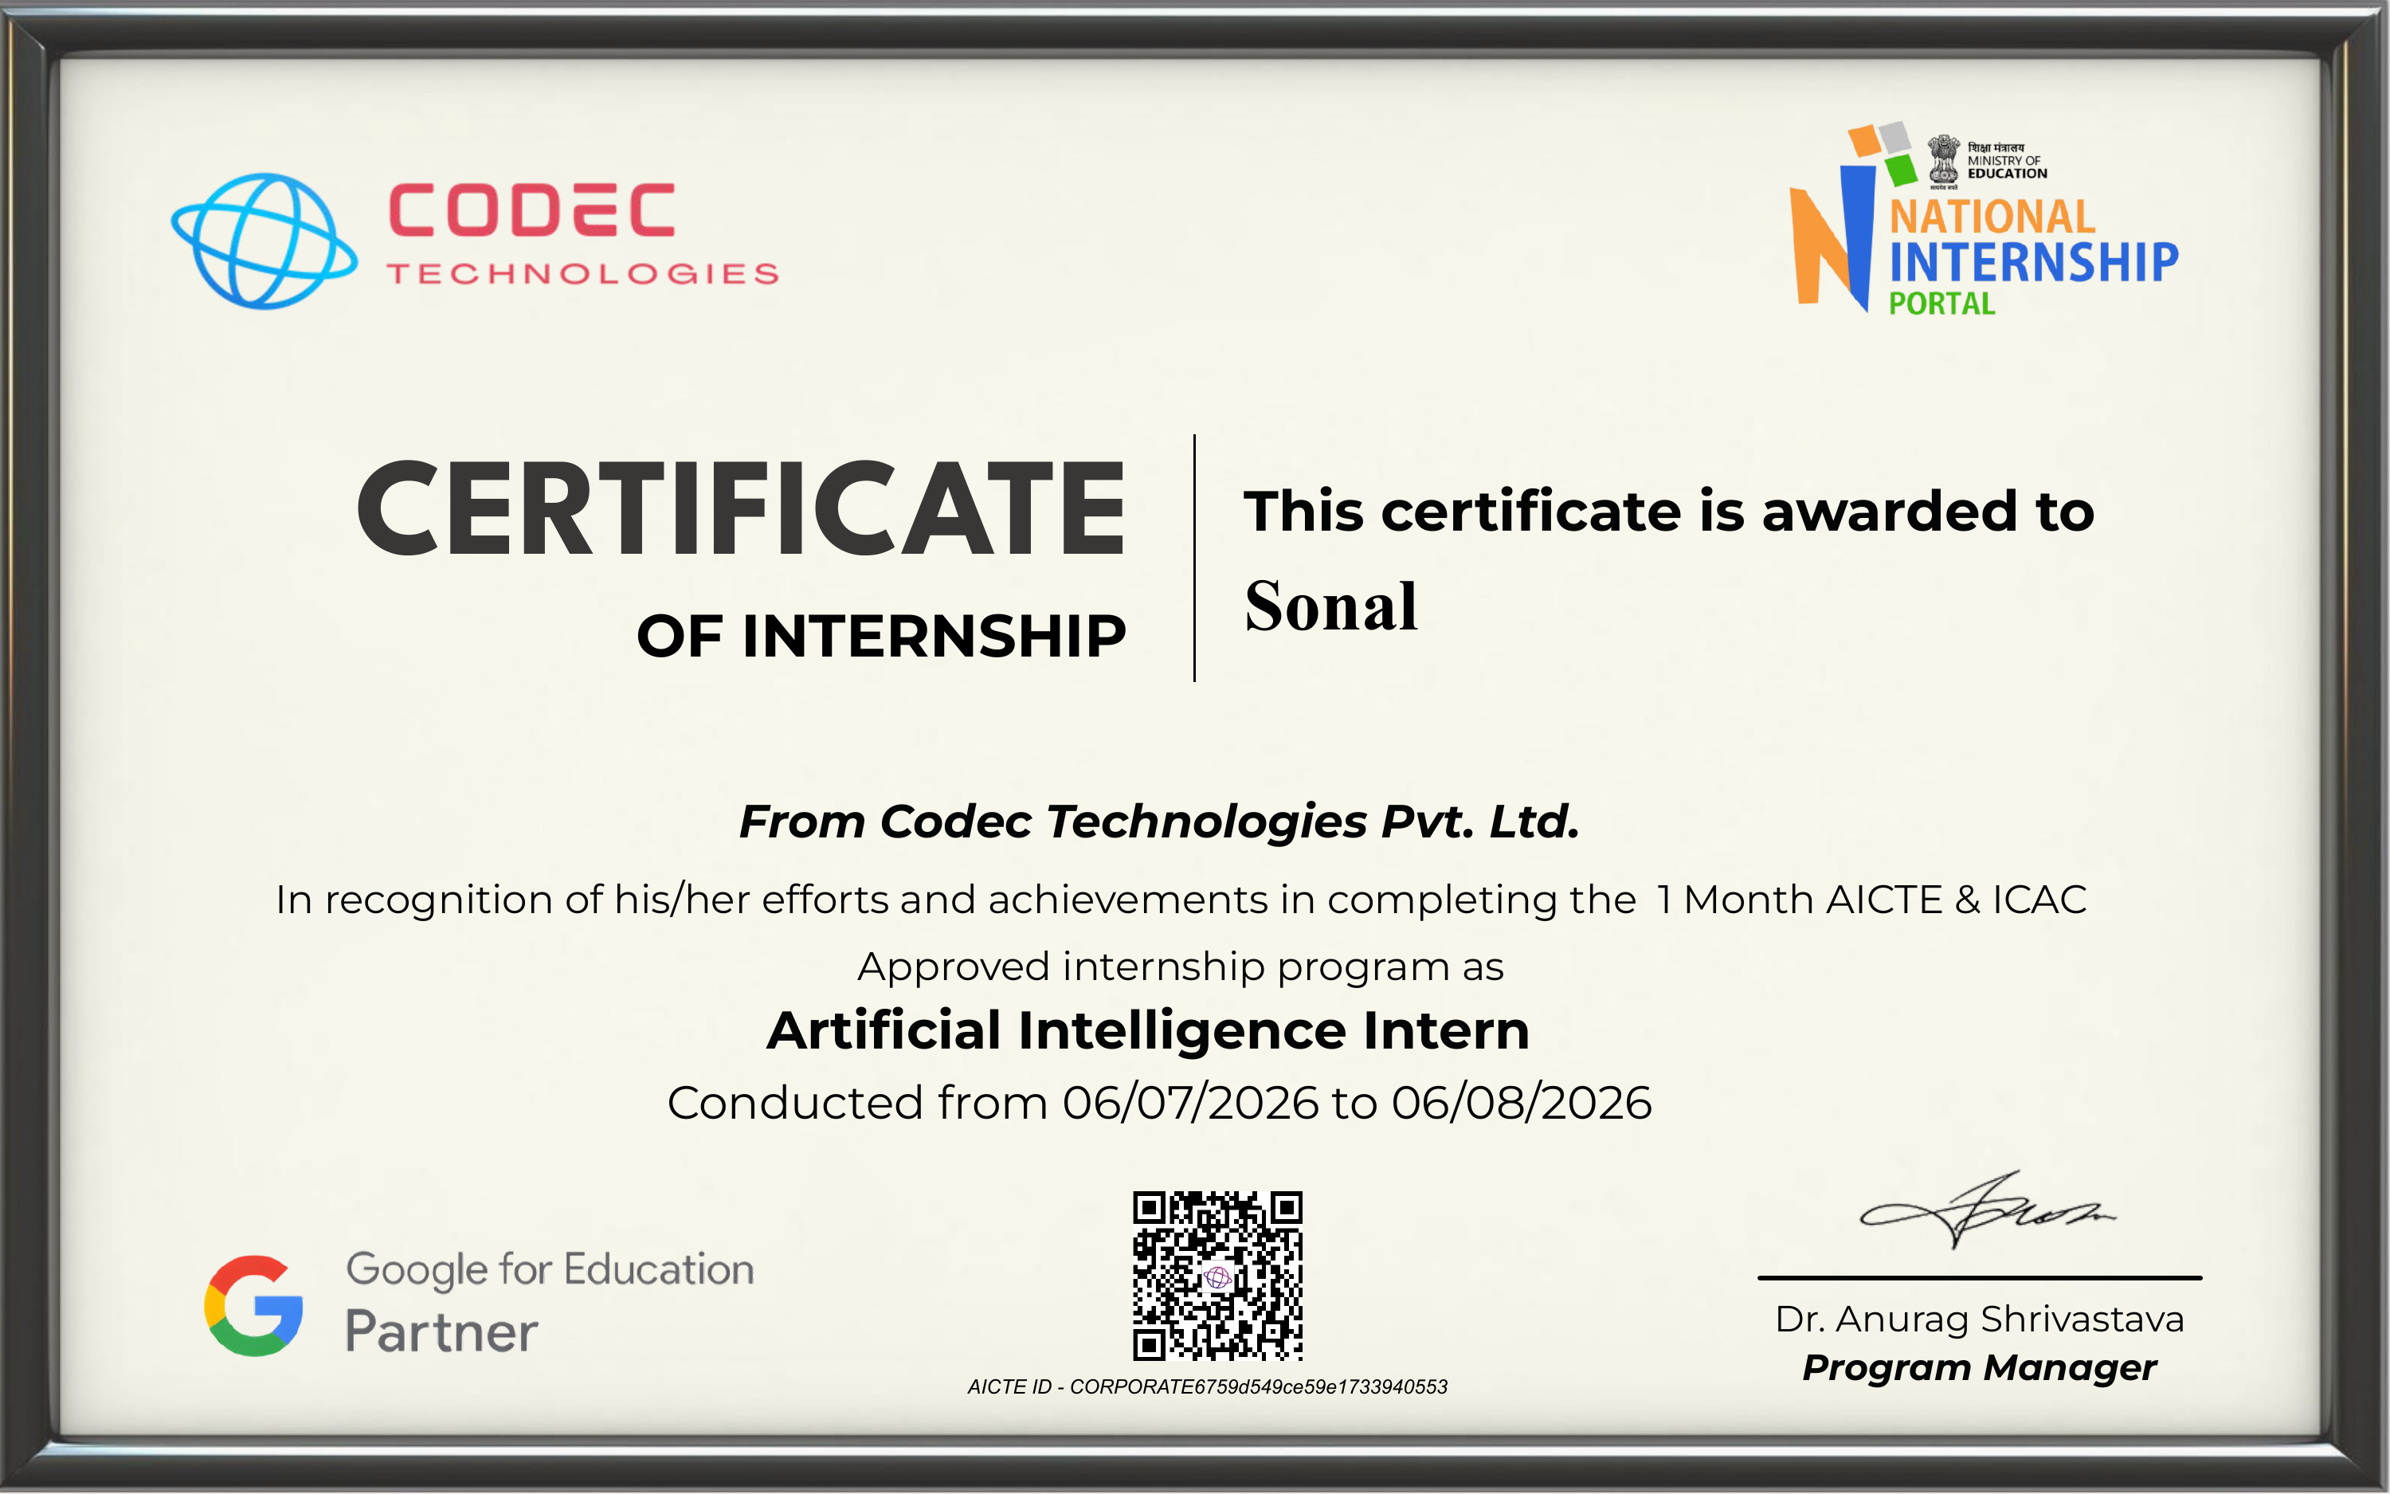
Certificate issued by Codec Technologies Pvt. Ltd.

LIST OF TABLES
Table 4.1: Technologies and Tools Used — Page No. 3
Table 4.2: Weekly Task Breakdown — Page No. 3

LIST OF FIGURES
Figure 4.1: Weather Data Analysis and Prediction Pipeline Followed During the Internship — Page No. 3
4. PROJECT DESCRIPTION
4.1 Introduction
This report describes the work completed during a one-month industrial internship undertaken as part of the B.Tech Computer Science and Engineering program at IILM University, Greater Noida. The internship was carried out at Codec Technologies Pvt. Ltd., under the role of Artificial Intelligence Intern, over the period 6 July 2026 to 6 August 2026. It was designed to apply core Artificial Intelligence (AI) and Machine Learning (ML) concepts to a practical problem — analysing historical weather records and predicting short-term temperature trends — through hands-on tasks built around Python and commonly used data-science libraries.
Rather than focusing on theory alone, the internship centred on a single applied project — Weather Data Analysis and Prediction Using Historical Data — which walked through each stage of a typical machine-learning pipeline in practice: preparing several years of historical daily weather data, exploring its seasonal patterns, building a model to predict next-day temperature, and checking how well that model performs, so that the concepts learned in the classroom could be connected to real, working code.
4.2 Organization Profile
Codec Technologies Pvt. Ltd. is the organization that hosted this internship. It runs AICTE and ICAC approved internship programs aimed at engineering students, with tracks covering Artificial Intelligence, Machine Learning and other emerging technology areas. The program undertaken here was supervised by the organization's Program Manager, Dr. Anurag Shrivastava. Codec Technologies Pvt. Ltd. hosted the internship and provided practical exposure to Artificial Intelligence and Machine Learning through a structured internship program supervised by Dr. Anurag Shrivastava.
4.3 Problem Statement
Most people check a single daily forecast number without any visibility into how weather conditions have actually trended over recent seasons, and without a data-backed estimate of what tomorrow is likely to bring. Historical weather records are widely available but are rarely turned into something useful — a clear seasonal picture and a working short-term prediction. This internship addressed that gap by requiring the intern to work through a complete, small-scale AI/ML pipeline using Python — cleaning historical weather data, exploring its seasonal patterns, and training a model to predict next-day temperature — rather than studying the steps in isolation.
4.4 Project Objectives
- To build a working understanding of core Artificial Intelligence and Machine Learning concepts by applying them to real historical weather data.
- To gain hands-on experience handling a multi-year historical weather dataset using Python.
- To practice cleaning, preprocessing and exploring weather data — handling missing readings and seasonal outliers — before modelling.
- To implement and compare regression algorithms suited to predicting a continuous value such as temperature.
- To train, test and evaluate a temperature-prediction model on historical weather data using standard error metrics.
- To become familiar with the standard Python AI/ML toolchain used in industry, and to present weather trends clearly through visualisation.
4.5 Scope of the Project
The internship was scoped as a learning exercise rather than a production deployment. It covered the essential stages of a basic ML pipeline — preprocessing, exploratory analysis, model implementation, training, testing, and evaluation — applied to a historical daily weather dataset (temperature, humidity, wind speed and precipitation) for a single city. Advanced topics such as deep-learning time-series models, live weather-API integration, or deployment to production systems were outside the scope of this one-month program.
4.6 Technologies and Tools Used
The following technologies and tools were used during the internship:
Technology / Tool | Purpose
Python | Core programming language used for all implementation work
Jupyter Notebook | Interactive environment used to write and run code, and view results
NumPy | Numerical computation and array handling
Pandas | Loading, cleaning and manipulating tabular data
Matplotlib | Data visualization and plotting results
Scikit-learn | Implementing and evaluating basic machine-learning algorithms
Table 4.1: Technologies and Tools Used — Page No. 3
4.7 System Architecture
The pipeline followed during the internship began with historical weather data, which was cleaned and enriched with time-aware features (such as lagged and rolling-average temperature) before being explored to understand its seasonal structure and patterns. This exploration guided the choice of a regression model, which was then trained on past data and finally tested on the most recent days to check how well it predicted next-day temperature. The stages of this pipeline are shown below.
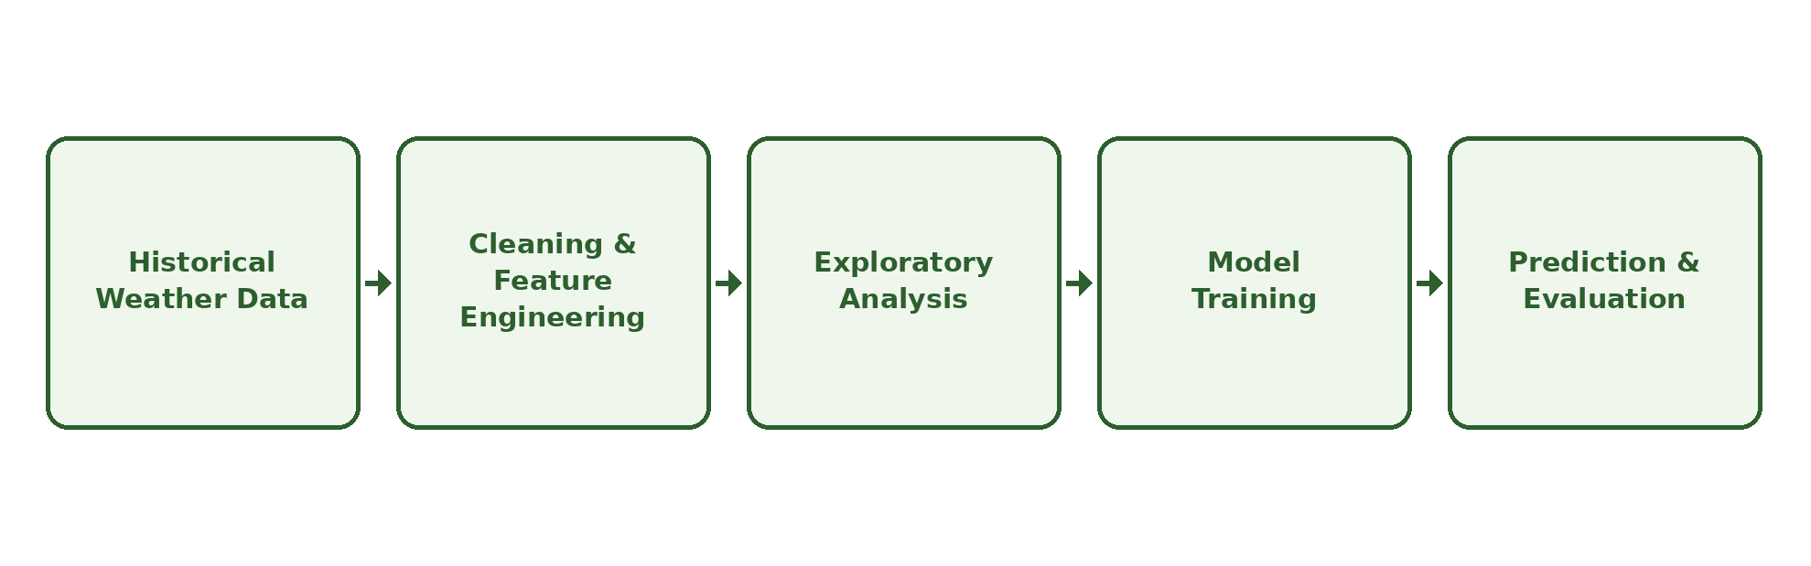
Figure 4.1: Weather Data Analysis and Prediction Pipeline Followed During the Internship
4.8 Methodology
The internship program was structured across four weeks, as summarized below:
Week | Activities Performed
Week 1 | Orientation to the internship program; introduction to AI/ML concepts, setup of Python and required libraries, and collection of a historical daily weather dataset
Week 2 | Working with the historical weather dataset: cleaning missing/inconsistent readings, engineering lag and rolling-average features, and visualising seasonal trends
Week 3 | Training and comparing regression models (Linear Regression and Random Forest) to predict next-day temperature, followed by initial testing
Week 4 | Evaluating prediction accuracy (MAE, RMSE, R²), consolidating learnings, and preparing documentation
Table 4.2: Weekly Task Breakdown — Page No. 3
Each week built on the previous one, so that concepts introduced early (such as Python basics) were reinforced through their direct use in later, more applied tasks such as model training and evaluation.
4.9 Expected Outcomes / Actual Outcomes
By the end of the internship, a working, practical AI/ML pipeline for weather data analysis and prediction had been developed — covering everything from cleaning historical weather records to training and evaluating a next-day temperature prediction model. The trained Random Forest model outperformed a simple linear baseline on held-out data, and clear seasonal trend charts and a correlation heatmap were produced alongside it. Hands-on comfort was gained with commonly used Python libraries, namely NumPy, Pandas, Matplotlib and Scikit-learn, along with a clearer picture of how machine-learning techniques are applied to real, time-series datasets in practice. Alongside the technical learning, the internship also helped build habits such as documenting work consistently and managing tasks over a fixed timeline.
4.10 Certificates of Completion and Other Communication Mail Proof
The Internship Completion Certificate issued by Codec Technologies Pvt. Ltd. is attached in the preceding section of this report. No additional communication or mail proof is included in this report.
5. BIBLIOGRAPHY / REFERENCES
[1] Codec Technologies Pvt. Ltd. — Internship Completion Certificate, 2026.
[2] Python Software Foundation. Python Language Reference. Available at: https://www.python.org
[3] Pandas Development Team. Pandas Documentation. Available at: https://pandas.pydata.org
[4] NumPy Developers. NumPy Documentation. Available at: https://numpy.org
[5] Scikit-learn Developers. Scikit-learn: Machine Learning in Python. Available at: https://scikit-learn.org
[6] Matplotlib Development Team. Matplotlib Documentation. Available at: https://matplotlib.org
[7] Project Jupyter. Jupyter Notebook Documentation. Available at: https://jupyter.org
[8] Publicly available historical daily weather records for the selected city, used as the source dataset for the Weather Data Analysis and Prediction project.

