Sales Dashboard Analysis Report

1. Introduction
The purpose of this report is to present a comprehensive analysis of the ShopNest Store's sales performance using the Power BI dashboard. The dashboard consolidates data into meaningful insights covering customer orders, product ratings, revenue trends, payment methods, delivery performance, and geographical distribution of customers. This report includes visualization screenshots, detailed explanations, and business insights for each analysis task.

2. Dashboard Overview
The dashboard provides an interactive view of key performance indicators (KPIs) such as total orders, percentage of delayed orders, year-over-year sales growth, and order delays. It also includes slicers for state-wise and date-wise analysis, as well as customer demographics.

1. Total Orders & Delays Analysis
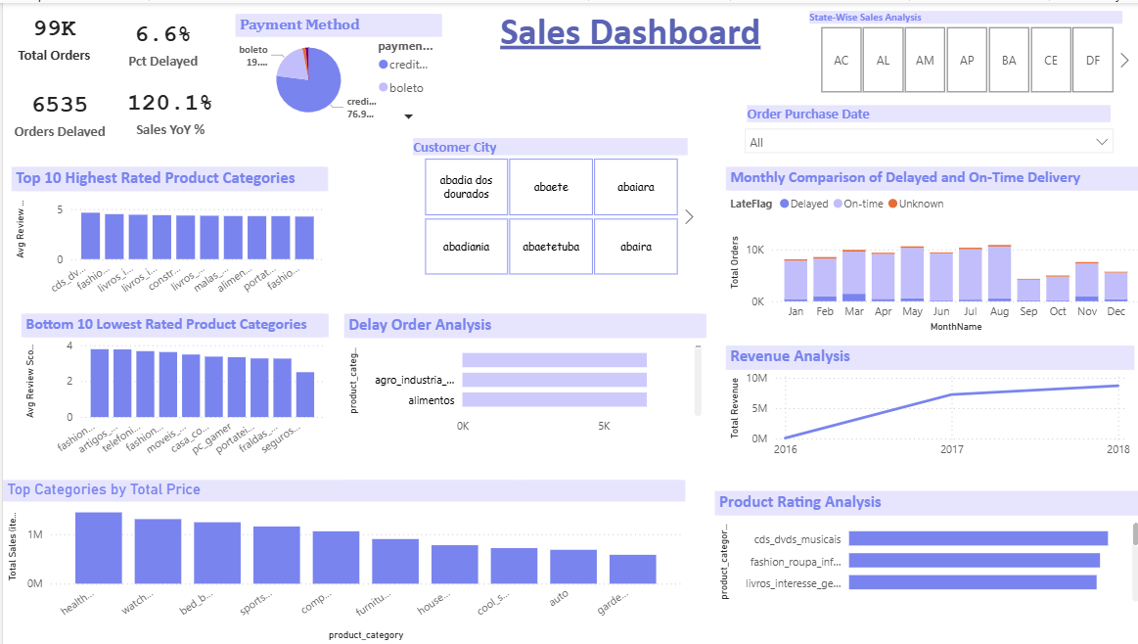
The dashboard shows a total of 99K orders with 6.6% delayed. Sales grew by 120.1% YoY. This highlights strong overall growth despite delays.

2. Payment Method Analysis
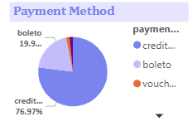
Credit cards dominate payment methods (77%), followed by boleto (19.9%). This indicates customer preference towards digital payments.

3. Customer City Analysis
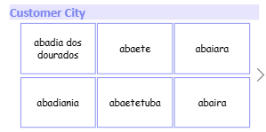
The top cities with the highest number of orders include Abadia dos Dourados, Abaete, and Abaira. Geographical insights allow focusing marketing campaigns.

4. State-wise Sales Analysis
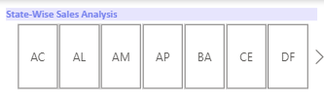
State-wise analysis shows varying demand across Brazilian states. This helps in identifying high-potential regions for expansion.

5. Product Rating Analysis
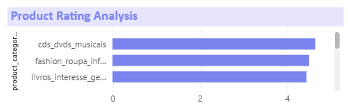
Top 10 highest-rated categories have average ratings above 4.5, while lowest-rated categories fall near 2.5–3. These insights help improve weak categories.

6. Top Categories by Total Price
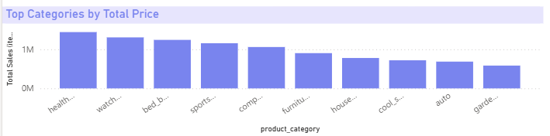
Top-selling categories by revenue include Health, Watches, Beds, Sports, and Computers. These categories drive majority of revenue contribution.

7. Monthly Comparison of On-Time vs Delayed Delivery
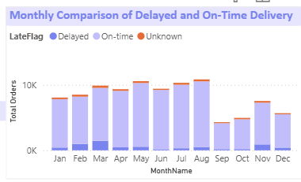
On-time delivery performance fluctuates, with delays higher in peak months like April–August. This highlights supply chain challenges in festive seasons.

8. Revenue Analysis
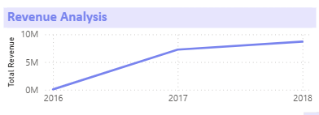
Revenue has shown consistent growth from 2016 to 2018, reaching nearly 10M. This indicates strong upward momentum in sales trends.

9. Delayed Order Analysis
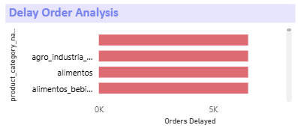
The chart shows the number of delayed orders across product categories.
We can clearly see that categories such as agro_industria_e_comercio, alimentos, and alimentos_bebidas face a higher volume of delivery delays compared to others. This indicates possible inefficiencies in the supply chain or logistics for these categories. Reducing delays in these key segments can directly improve customer satisfaction and operational performance.

10. Conclusion
The ShopNest Store sales dashboard provides valuable insights into customer behavior, product performance, and operational efficiency. Key highlights include strong sales growth, dominance of credit card payments, regional demand variations, and areas requiring improvement such as delivery delays and low-rated product categories. These findings can guide data-driven strategies for enhancing customer satisfaction, optimizing operations, and maximizing revenue growth.

