EXERCISE :MAVEN

4.Explain different tags (plugins, dependency, parent, profile, properties, modules and project related(i.e. modelVersion, groupId, artifactId, packaging, version, description)) of POM file created using archetype.
The different tags in pom file are:
a) Plugins:There are two types of maven plugins are-
1.Build Plugins :These plugins are executed at the time of build. These plugins should be declared inside the <build> element.
2.Reporting Plugins : These plugins are executed at the time of site generation. These plugins should be declared inside the <reporting> element.
A list of maven core plugins are given below: clean,compiler,install etc
b)dependency: This block defines a dependency. It is used inside dependencies section.
c)Parent: maven reads the parent POM tag from your local repository and creates an 'effective POM' by merging the information from parent and module POM.The child now able to inherit the properties ,dependencies,constants etc from the parent POM.
d)Profile:A profile in Maven is an alternative set of configuration values which set or override default values. Using a profile, you can customize a build for different environments. Profiles are configured in the pom.
e)Properties:The Properties Maven Plugin is here to make life a little easier as It provides goals to read properties from files and URLs and write properties to files, and also to set system properties. It's main use-case
is loading properties from files or URLs instead of declaring them in pom.
f)Modules:A Maven module is a sub-project. To create a Maven module you will need to already have a Maven
project available. The parent project must have its Packaging option pre-configured to pom, for a module to be
created and associated with it. Every module have their own POM file already when we create a sub project.

Project related tags used in POM file:
1)Model Version:It is the sub element of project. It specifies the modelVersion. It should be set to 4.0.0.
2) groupId:It is the sub element of project. It specifies the id for the project group.
3)artifactId: It is the sub element of project. It specifies the id for the artifact (project). An artifact is something that is either produced or used by a project.It can be in form of jar,war file etc.
4)Packaging: It defines packaging type such as jar, war etc.
5)Version: It is the sub element of project. It specifies the version of the artifact under given group.

5.Demonstrate the inheritance and aggregation of POM.

Inheritance :
It refers to inherit the properties of one pom into another pom

Following are some common configuration which gets merged in inheritance.
1.) Dependencies
2.) Developers and Contributors
3.) Plugin lists (including reports)
4.) Plugin executions with matching ids

The inheritance is used in child POM:
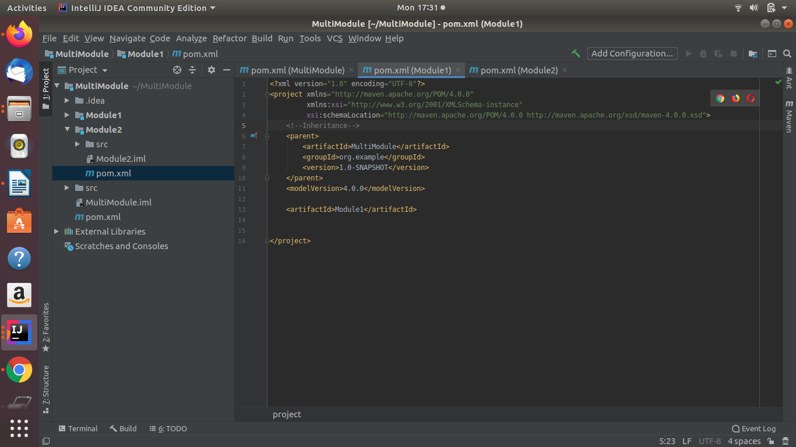

Project Aggregation:

It is very similar to project inheritance the only difference is instead of specifying parent we specify child of a pom. By doing this a pom knows the modules attached to it and whenever we do any action on a pom and that action also applied on its modules mentioned in config.
For proper project aggregation these two must be applied:-

1.) Change the parent POMs packaging to the value "pom".
2.) Specify in the parent POM the directories of its modules (children POMs).
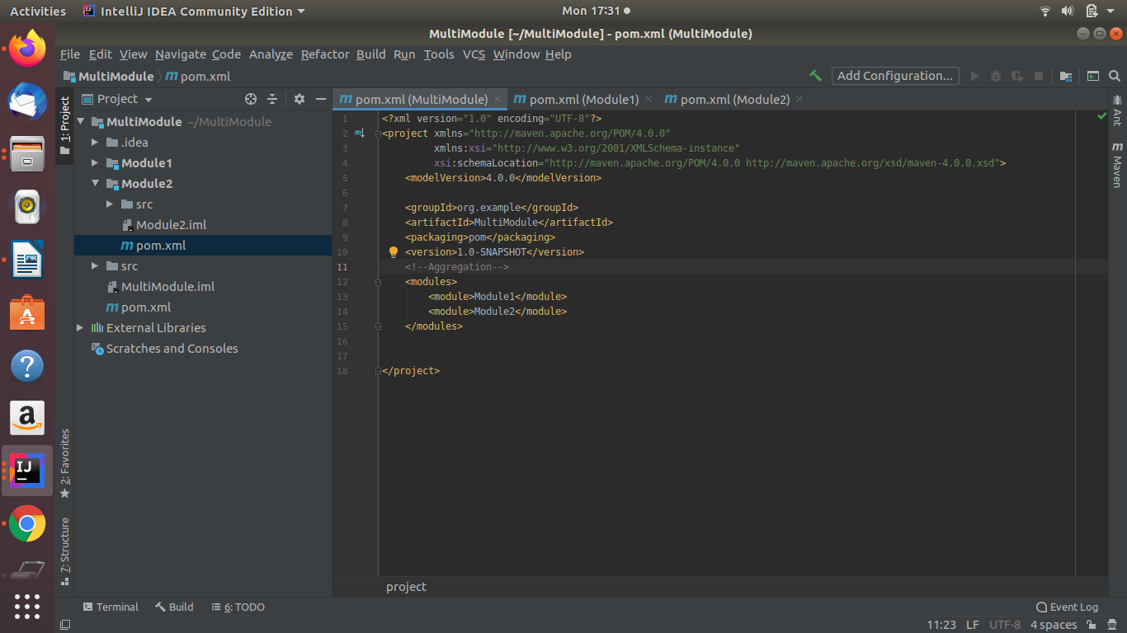

6.Point out the differences between Gradle and Maven.

Gradle and Maven are both build automation tools for Java but still there some of the differences between them are listed below:

Gradle

1) Gradle is a build automation system that uses a domain-specific language based on the programming language Groovy.
2) Gradle does not use an XML file to describe a project that is being built, instead, it uses the domain-specific language Groovy DSLwhich is Java-based DSL that supports Groovy language features.
3 ) It uses incrementality(It build only the parts of codes /files that have changed ) and work avoidance.
4) It allow for faster build times.
5) Gradle allows for a wide range of customizations and is very flexible. It can be used for native development with C/C++.
6) The build.gradle file contained in gradle is short ,clean and easy to understand as compated to maven.

Snapshot of build.gradle file:
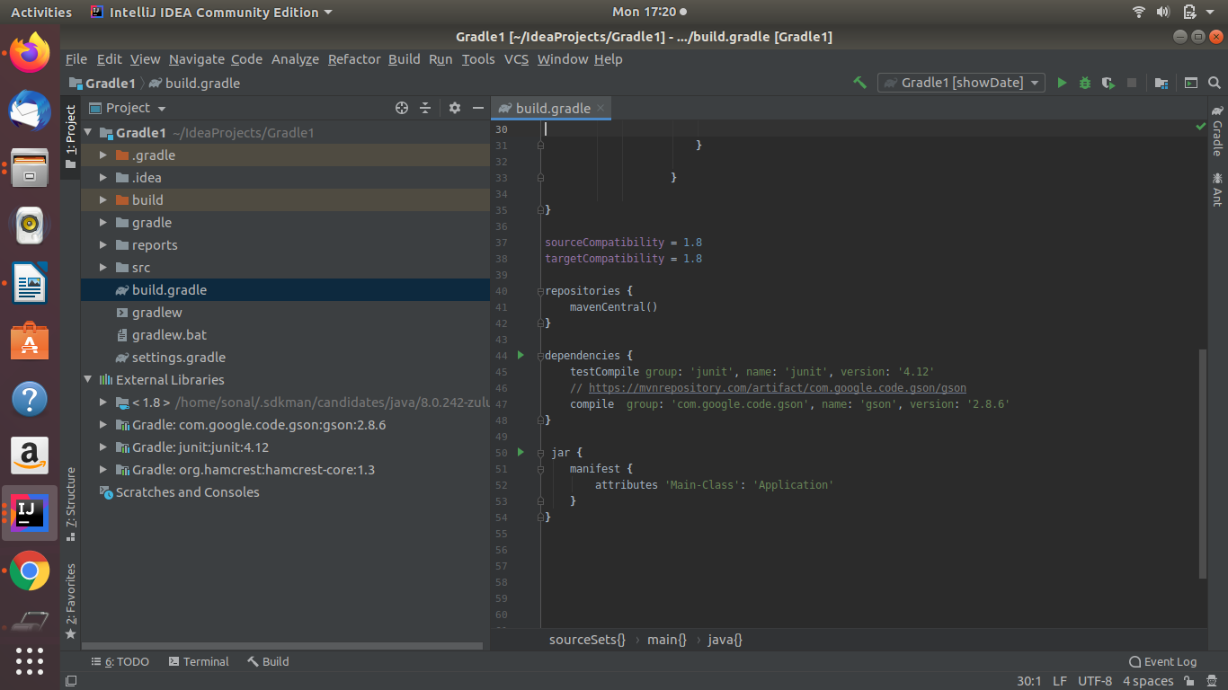

Maven

1) Maven is a software project management and comprehension tool. It is mostly used with Java-based projects.
2) It uses an XML file to describe the project, its dependencies, the build order, and its required plug-ins.
3) It does not use incrementality thus its builds times are slower than gradle.
4) Customization is complicated in Maven due to its limited parameters and requirements. However, this also makes Maven easier to understand and configure.
5) Maven build scripts, written in XML, are difficult to understand as Gradle scripts are.

Snapshot of POM.XML file:
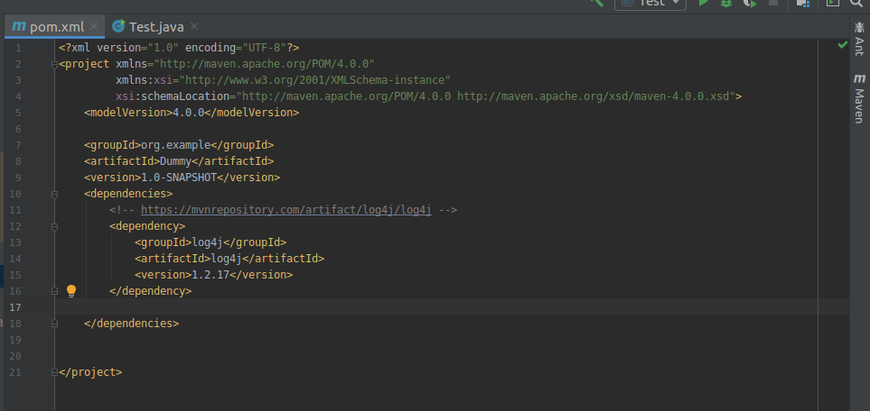

7. What is the purpose of mvn clean install and its usage in the project.

When you build with Maven, the goal is to create some artifact(s) for deployment, this can be a jar for a library, a war for a web application or something else altogether. When you do a Mvn install, it will roughly:
- Generate whatever it needs,
- Compile the sources,
- Copy other resources,
- Create the artifact for your project,
- Run unit tests,
- Copy the artifact to the local Mvn repository (this is usually $HOME/.m2/repository).
So a Mvn clean install will first clean the target and then run the steps above.

Note: For the question no. 1,2,3 I have attached the project.
Project- Dummy (Q1)
project- Dummy-normaljava(Q2)
project-MultiModule(Q3)

