Exercise:Introduction to Html and CSS

1..How are inline and block elements different from each other?

The inline elements are those elements which do not start with a newline and only take up the width as required.These elements can exits inside the block elements.List of inline elements are: span,strong, b etc.

The Block elements are those which takes up all the space in their parent container(means in which they are defined).It always starts with a newline.
List of block elements: paragraph(p),div tag etc.

Example:Inside the <p> tag we can use the span tag.

<!DOCTYPE html>
<html>
<head>
</head>
<body>
<p>My name is Sonal Gupta</p>
<p>I am from kanpur</p>
<span>To</span><span>The</span><span>New</span>
</body>
</html>
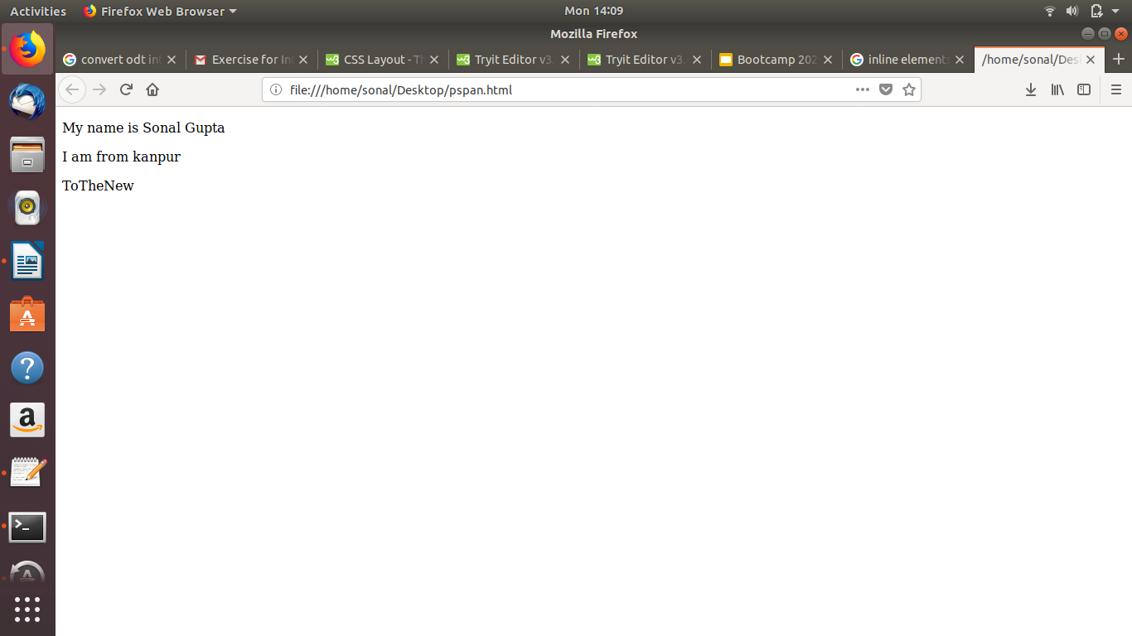

2.Explain the difference between visibility:hidden and display:none
Visibility:hidden
In this the tag will not be visible but the space will be allocated for it on the page.
Example:
<head>
<style>
.first
{
display:none;
}
</style>
</head>
<body>
<p>My name is Sonal Gupta</p>

<h6 class="first">I love to play badminton</h6>
<p>I am from kanpur</p>
</body>
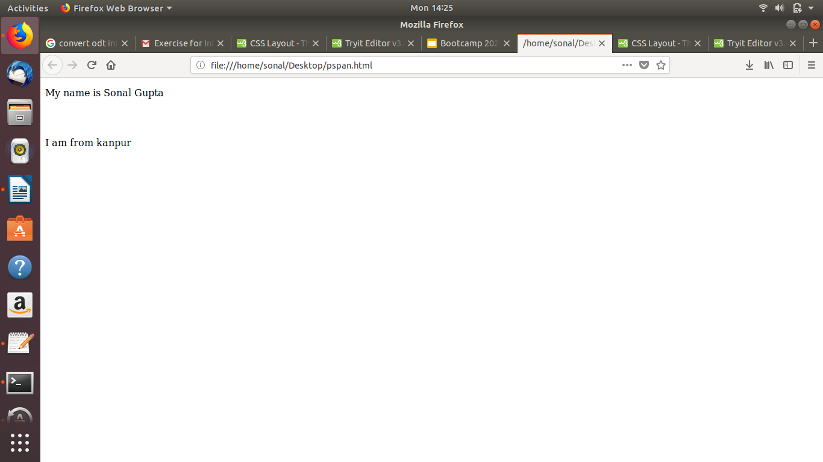

Display:none
It will completely removes the element from the document and the allocated space for it will also be removed and the page will be rendered as there was no text on the page.

Example:
<head>
<style>
.first
{
display:none;
}
</style>
</head>
<body>
<p>My name is Sonal Gupta</p>
<h6 class="first">I love to play badminton</h6>
<p>I am from kanpur</p>
</body>
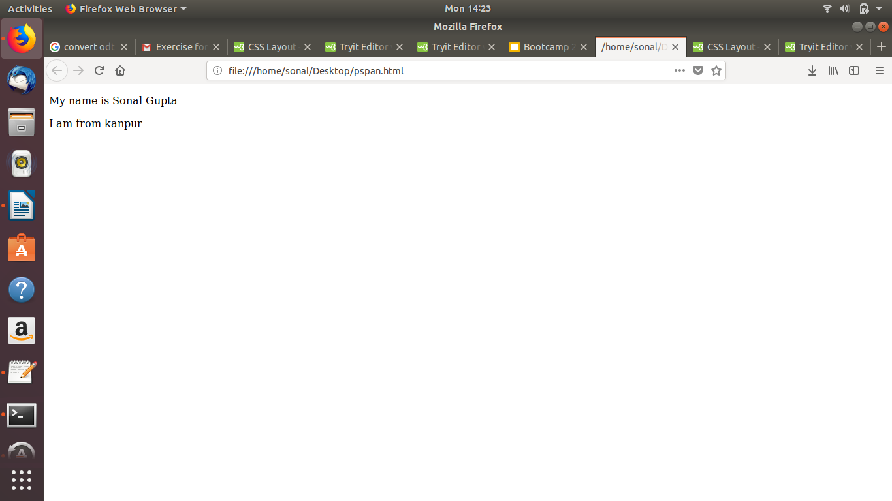

3.Explain the clear and float properties.
Clear Property: It specifies what elements can float beside the cleared element and on which side.
It is having flowing values:
- left - No floating elements allowed on the left side
- right- No floating elements allowed on the right side
- both - No floating elements allowed on either the left or the right side
Example:I have used clear:right on the div id “e”.So the purple div is not floated on the right side.
<style>
#a
{
width:300px;
height: 300px;
background-color:black;
float:left;
}
#b
{
width:300px;
height: 300px;
background-color:blue;
float:left;

}
#c
{
width:300px;
height: 300px;
background-color:green;
float:left;
}
#d
{
width:300px;
height: 300px;
background-color:red;
float:left;
}
#e
{
width:300px;
height: 300px;
background-color:purple;
clear:right;
}
</style>
</head>
<body>
<div id="a"></div>
<div id="b"></div>
<div id="c"></div>
<div id="d"></div>
<div id="e"></div>
</body>

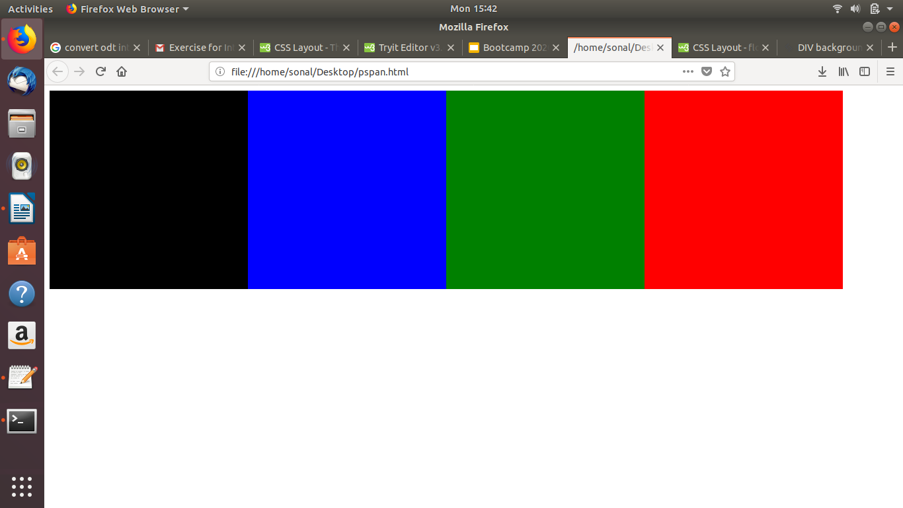

Float Property:It specifies how an element should float and on which side either left,right or none.
The float property can have one of the following values:
- left - The element floats to the left of its container
- right - The element floats to the right of its container
- none - The element does not float (will be displayed just where it occurs in the text). This is default
Example:
I have used float:right to shift the image to the right side.
<style>
img
{
float:right;
}
</style>
</head>
<body>
<h1><strong>Technologies</strong></h1>
<img src="techno.jpg" alt="Italian Trulli" style="width:170px;height:170px;margin-left:15px;">
<p>We solve complex problems using cutting edge technologies.We take a deep dive into various digital advances and leverage these technologies to build winning products. We work on breakthrough technologies and deliver mission critical mobile and web applications. Some of the technologies that we have mastered include Grails, Angular.js, Node.js, and React to name a few.</p>
</body>
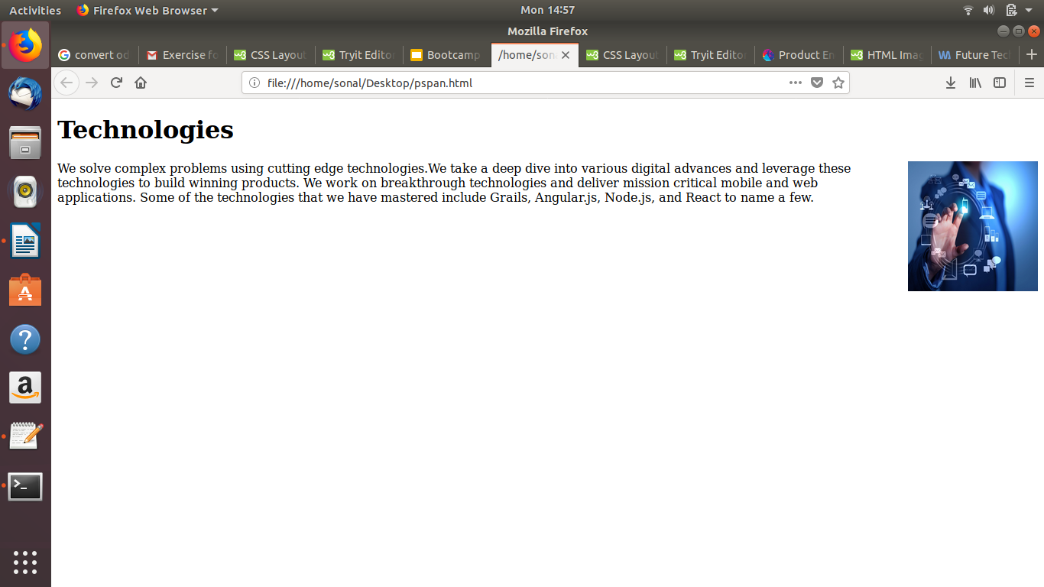

4.Explain difference between absolute, relative,fixed and static.
Absolute:
An element with position:absolute will be position itself relative to its nearest parent.If the parent does not have position:relative then it uses the document body .

Relative:An element with position:relative is positioned relative to its normal position.There change will occur only when we set top,bottom properties of this element.

Fixed: An element with position:fixed will always remains in the same state even if the page is scrolled.

Static:An element with position:static are positioned static by default.They are not affected by the top, bottom, left, and right properties.

Example:

<style>
div.relative {
position: relative;
width: 300px;
height: 200px;
border: 3px solid red;
}
div.absolute {
position: absolute;
top: 80px;
right: 0;

width: 200px;
height: 100px;
border: 3px solid black;
}
div.fixed {
position: fixed;
top: 80px;
right: 0;
width: 200px;
height: 100px;
border: 1px solid black;
}
div.static{
position: static;
border: 1px solid black;
}
</style>
</head>
<body>
<h2>To The New</h2>
<div class="relative">I AM FROM KANPUR
<div class="absolute">I AM RECENTLY IN NOIDA</div>
</div>
<div class="fixed">this is fixed on the page</div>
<div class="static">this is static by default</div>
</body>

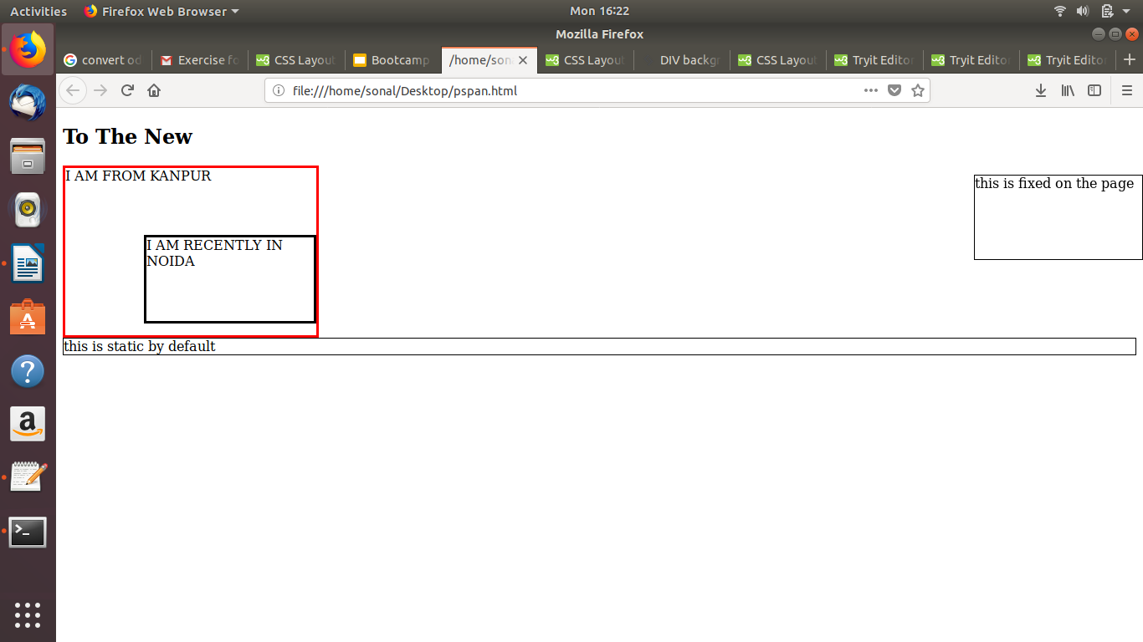

5.Write the HTML code to create a table in which there are 4 columns( ID , Employee Name, Designation, Department) and at least 6 rows. Also do some styling to it.

<head>
<style>
table {
font-family: arial, sans-serif;
border: 3px solid black;
width: 100%;
}
td, th {
border: 1px solid #0080ff;
text-align: left;
padding: 8px;
}
tr:nth-child(even) {
background-color: #ffbf00;
}
</style>
</head>
<body>
<h2>Employee Table</h2>
<table>
<tr>
<th>ID</th>
<th>Employee Name</th>
<th>Designation</th>
<th>Department</th>
</tr>
<tr>
<td>1</td>
<td>Ritwik Gupta</td>
<td>Manager</td>
<td>Development</td>
</tr>
<tr>
<td>2</td>
<td>Rahul Omer</td>
<td>HR</td>
<td>Admin</td>
</tr>
<tr>
<td>3</td>
<td>Jatin Gupta</td>
<td>Technical Lead</td>
<td>Development</td>
</tr>
<tr>
<td>4</td>
<td>Aakansha Narwale</td>
<td>Marketing</td>
<td>Sales</td>
</tr>
<tr>
<td>5</td>
<td>Parbat Chauhan</td>
<td>Trainer</td>
<td>IT</td>
</tr>
<tr>
<td>6</td>
<td>Nivesh Chauhan</td>
<td>COO</td>
<td>Development</td>
</tr>
</table>
</body>

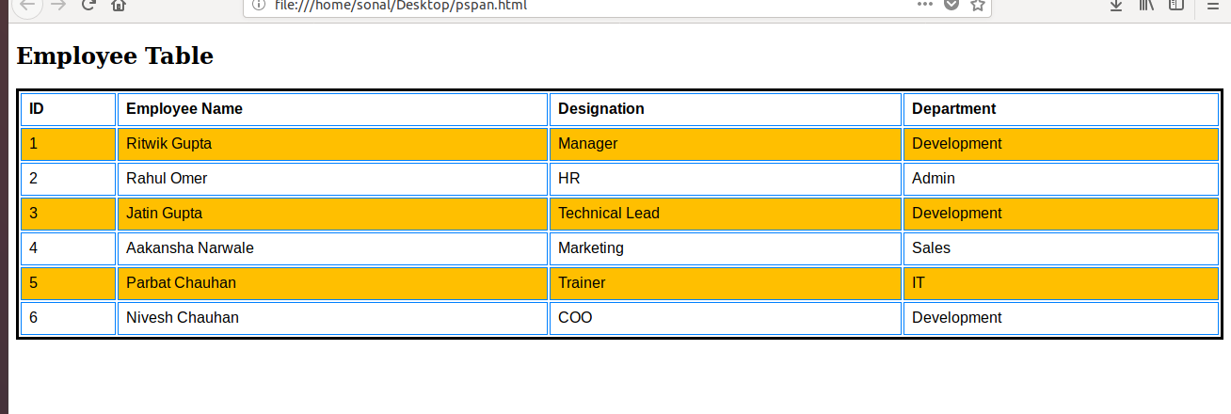
6.Why do we use meta tags?

The <meta> tag provides metadata about the HTML document. It will not be displayed on the page.They are typically used to specify page description, keywords, author of the document and other metadata. It helps to improve the SEO of a web page by using certain keywords.
Examples:
<!DOCTYPE html>
<html>
<head>
<meta name="description" content="Free Web tutorials">
<meta name="keywords" content="HTML,CSS,XML,JavaScript">
<meta name="viewport" content="width=device-width, initial-scale=1.0">

</head>
<body>
<p>All the information related to metadata are displayed inside the head tag...</p>
</body>
</html>
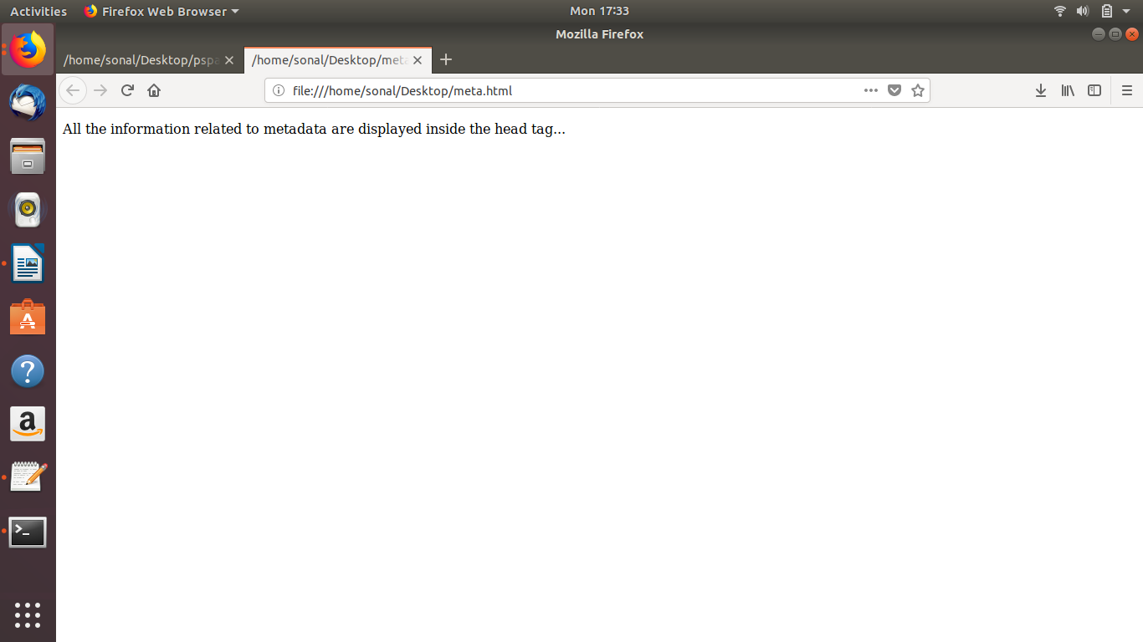
7.Explain box model.
The box model is essentially a box that wraps around every HTML element. It consists of: margins, borders, padding, and the actual content.
The following parts are displayed below:

- Content - The content of the box, where text /images appear
- Padding - Clears an area around the content.It is transparent
- Border - A border that goes around the padding and content
- Margin - Clears an area outside the border. It is transparent
Example:
<head>
<style>
div {
background-color: #ff6666;
width: 500px;
border: 10px solid #ff0040;
padding: 50px;
margin: 20px;
}
</style>
</head>
<body>
<h2>The Box Model</h2>
<div>We provide padding 50px to the content inside the div and margin 20px to the area outside the border to adjust them with top,left,bottom or right accordingly.</div>
</body>
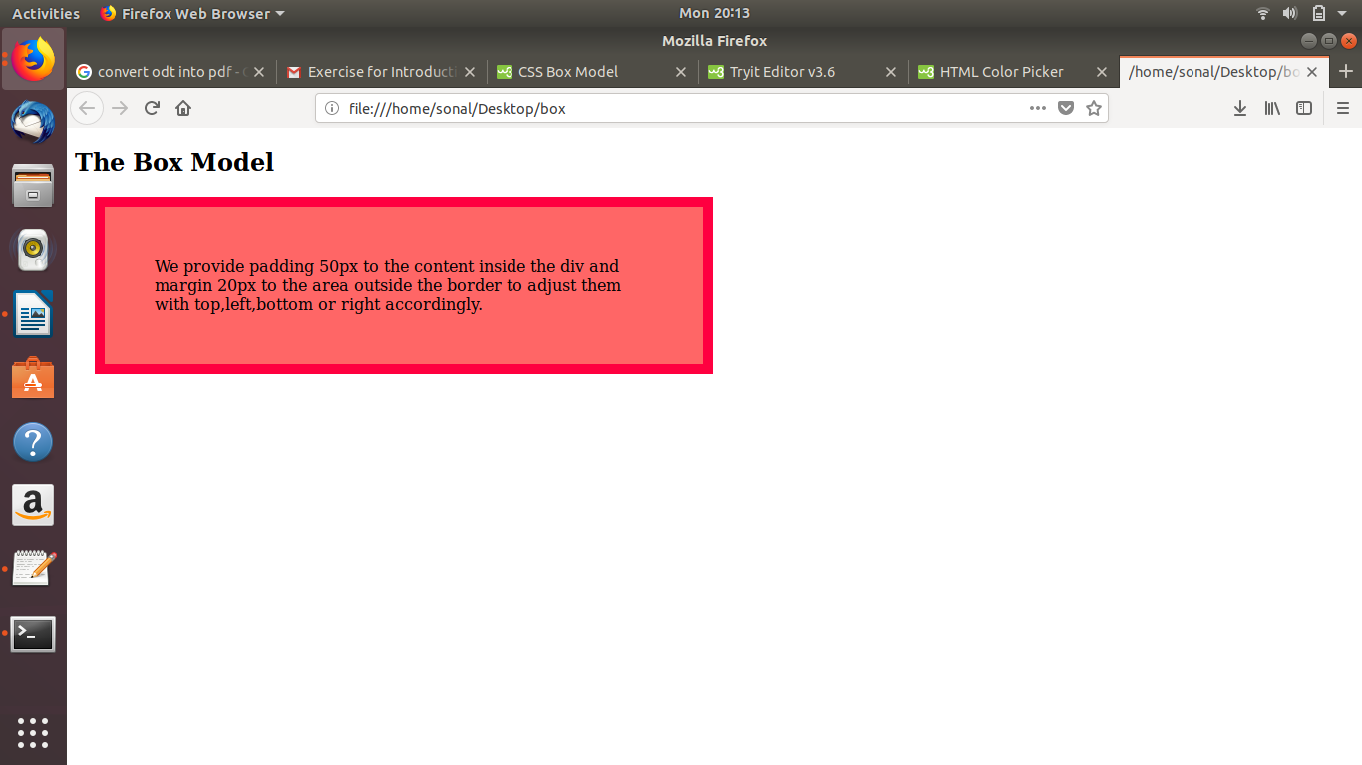

8.What are the different types of CSS Selectors?
Selectors are the pattern used to select the elements you want to provide style.
There are many selectors:
a) .class:Select all class elements

b) #id: Select all elements with particular id defined

c) * :Select all elements

Format:
Selector{
property:value;
}

Example:
1) body{
background-color:#ff6666;
font-family:Sans Serif;
}

2) h1 {
text-align: center;
color: red;
}

9.Define Doctype.
The Doctype is the first thing in your html document before the html tag.It is an instruction to the web browser about what version of HTML the page is written in.It is important to add the <!DOCTYPE> declaration to your HTML documents, so that the browser knows what type of document to expect.
HTML4 requires this type of declaration but the HTML5 does not requires the reference to DTD.

<!DOCTYPE html>
<html>
<head>
</head>
<body>
</body>
</html>

10.Explain 5 HTML5 semantic tags.
The 5 HTML5 semantic tag are as follows:

1)<article>:An <article> element is used to replace <div> tag which is used in html4.

2)<header>:The <header> element is generally found at the top of a document, a section, or an article and usually contains the main heading and some navigation and search tools.

3)<footer>:If there is a <header> there must be a <footer>. A <footer> is generally found at the bottom of a document, a section, or an article.It contains the author details, legal information, and/or links to related information.

4)<section>:A section is a thematic grouping of content.It is also used to replace <div> tag.

5)<nav>:we can separate our menu items with a <nav>, for navigation between your pages. You can have any number of <nav> elements on a page.

Example:

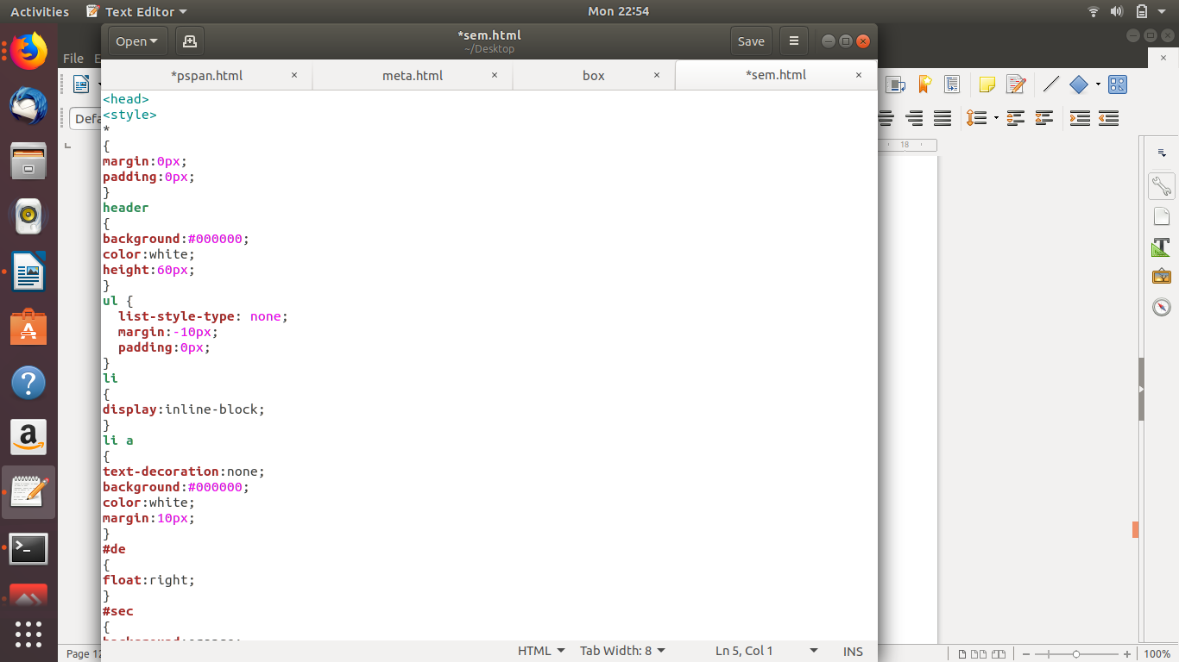

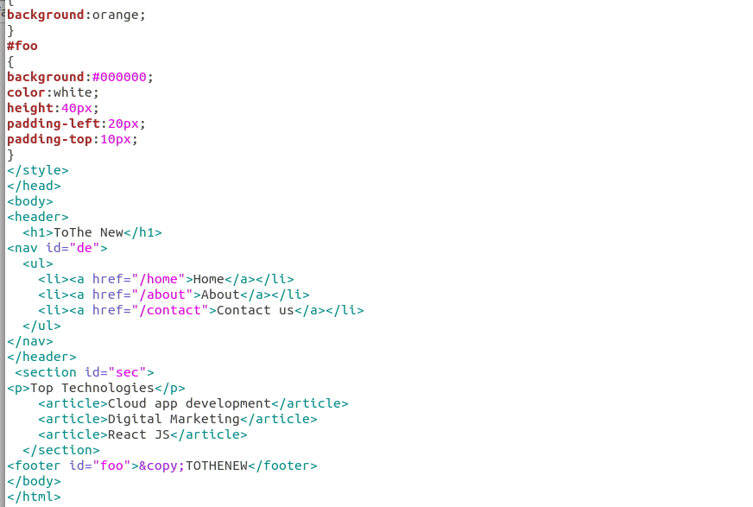

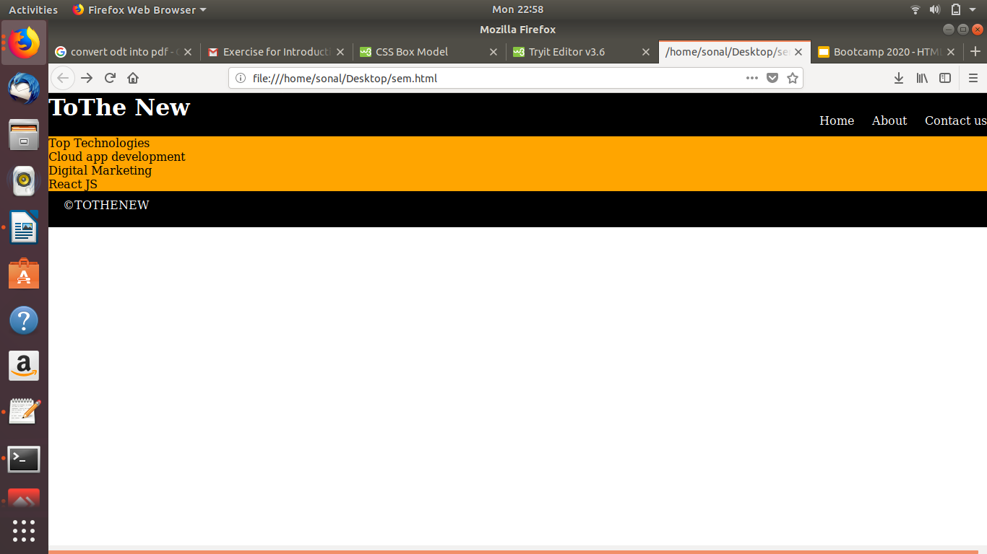

11.Create HTML for web-page.jpg (check resources, highest weightage for answers)

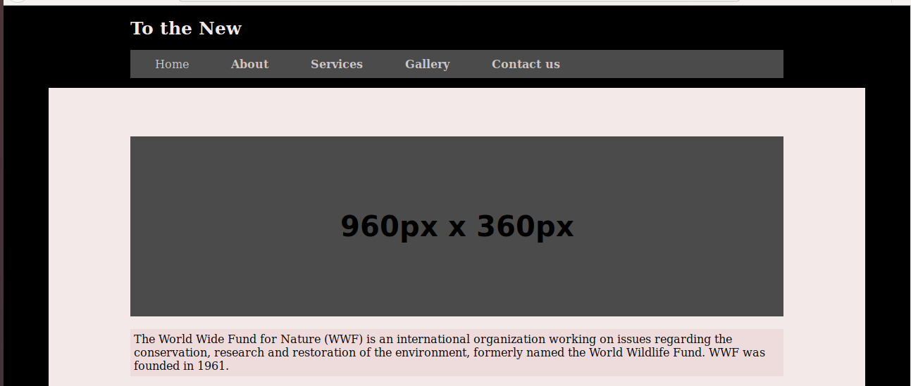
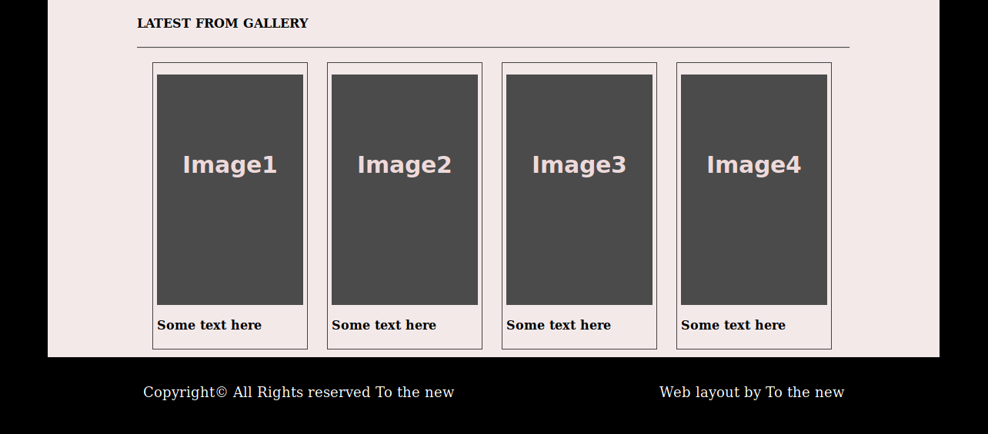

12.Create HTML for form-page.png (check resources, highest weightage for answers)

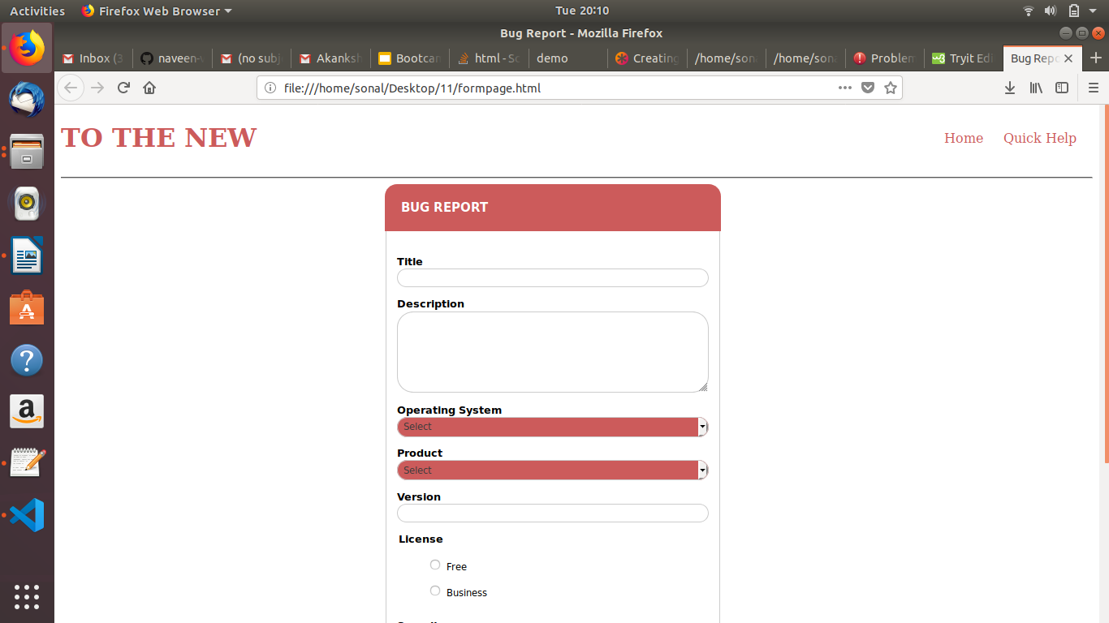
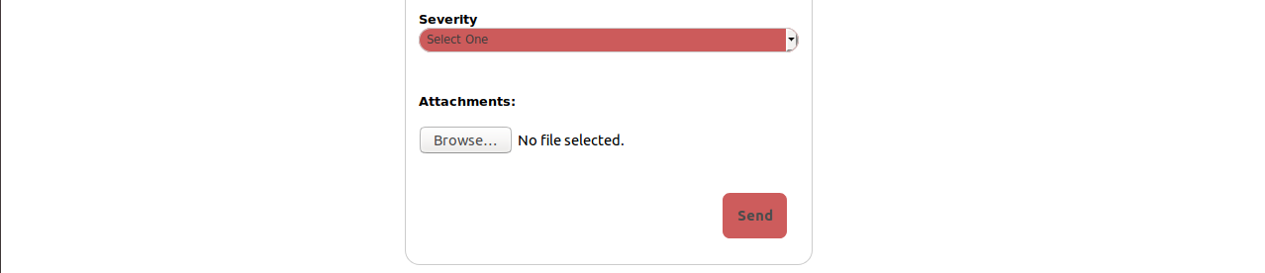

NOTE:For the 11th and 12th question source code is submitted in github.

