Exercise :Introduction to AEM_Runmodes

1. Define the priority when run mode are applied using options
sling.properties file
system properties (-D)

Setting custom runmode to author + qa in sling.properties file :
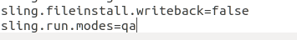

Setting custom runmode to author+dev through system property:
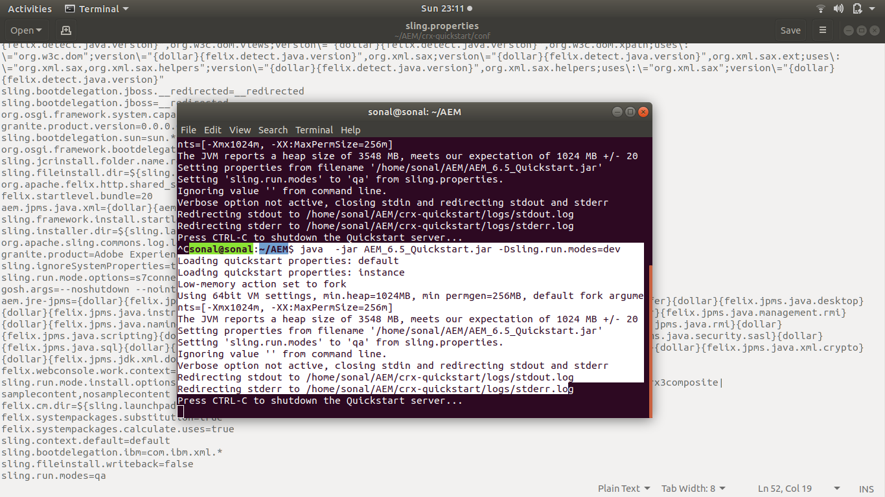

output:
runmode is in development environment
system properties has higher priority than sling properties file

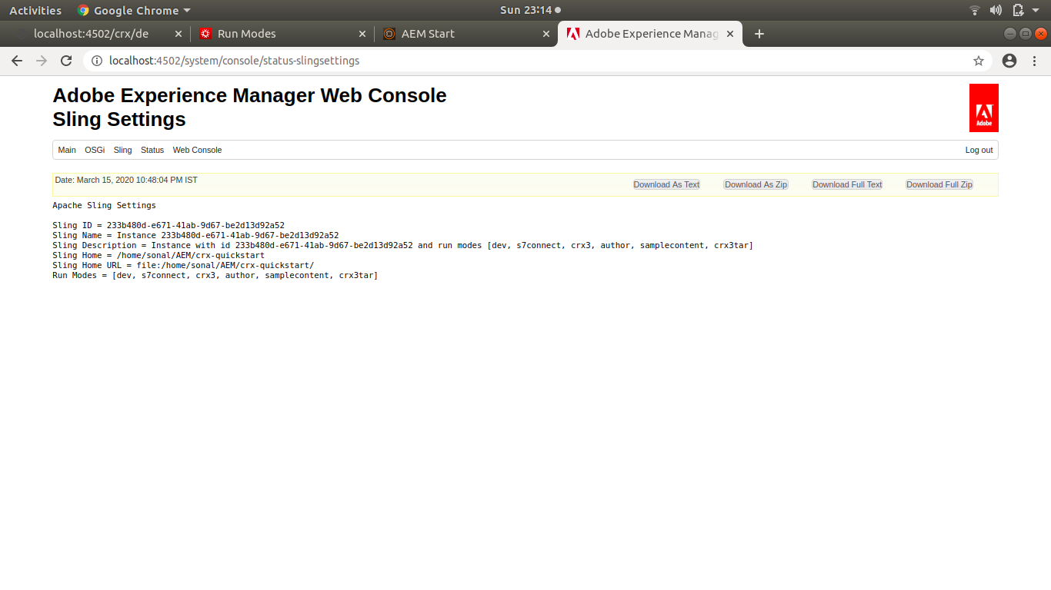

2. Creating a OSGi service which have two properties to configure. Define these configuration for run modes :
a. dev

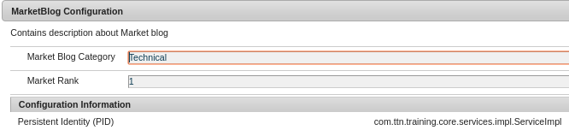
b. dev,pub
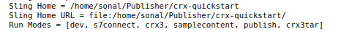
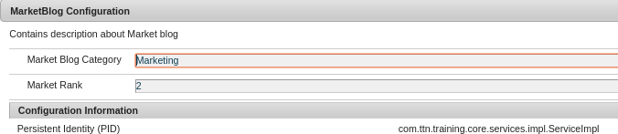

Note: I am attching the project with it in which config folder contains MarketBlogConfig and Services contains the interface and Impl contains the service.

