REST Architecture and Java Servlet

Exercise

1. Create a registration from which includes 3 fields email, username and password.
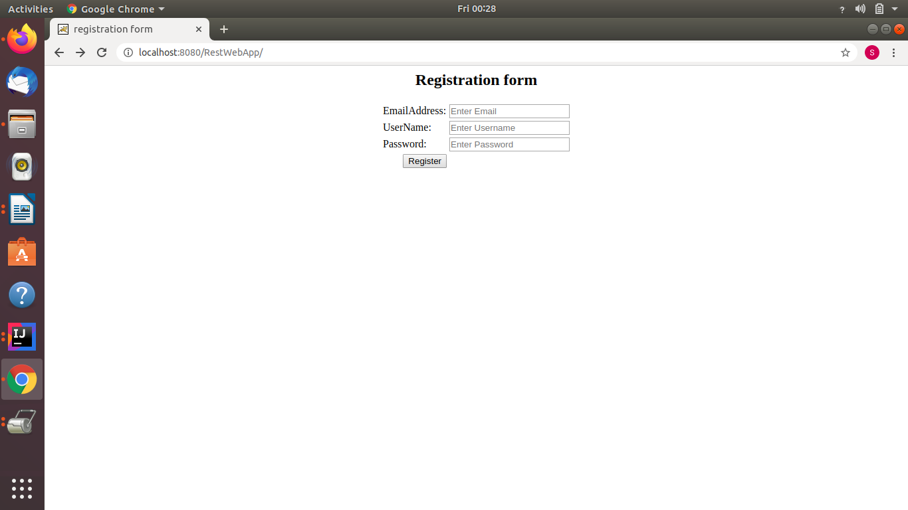

2. Post that registration form and show the filled data in tabular format.
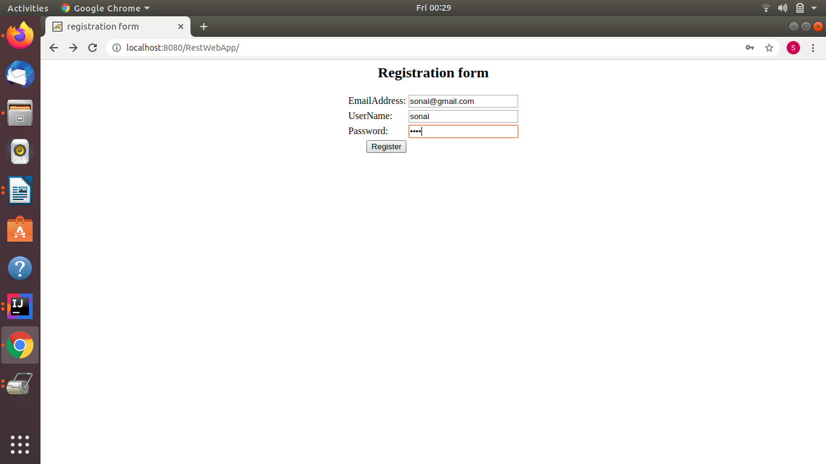
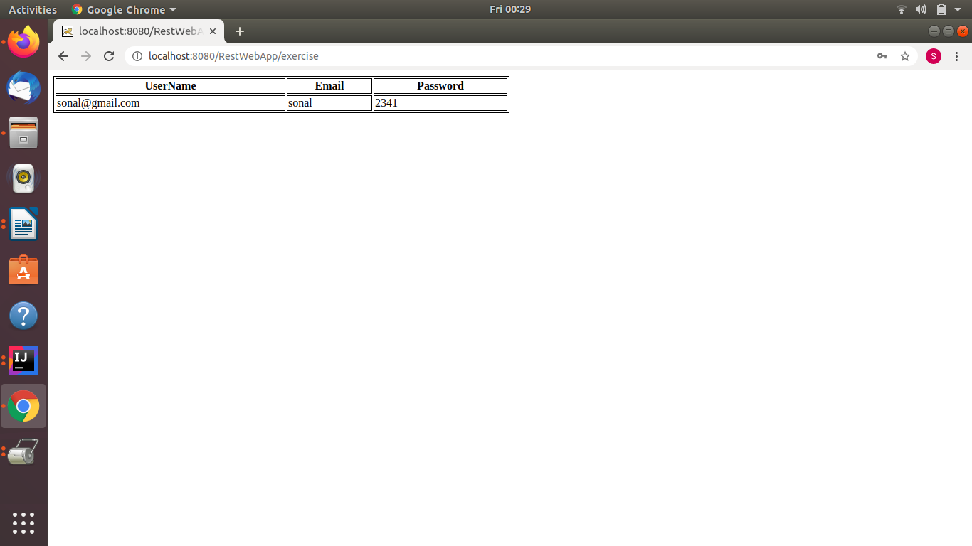

3. Explore all the lifecycle methods and their invocation sequence. Print SOPs.
Ans. There are basically three servlet lifecycle methods:
- Init() : This method is invoked when the servlet starts. This method is only invoked once in a servlet life cycle.
- service() : This method is invoked whenever the web server receives a request for the servlet. The request can be get or post request. Based on the request type doGet() or doPost() will be called. This method can be invoked multiple times.
- destroy() : This method is called when the servlet container shuts down. This is also invoked once in the lifecycle.

Note: Code is in the folder

