Exercise:User and Groups

1.Create two groups(editor and author) and create users of each group.

The two group:
author-group and editor-group

The two users of each group:
user-author and user-editor

Below are the screenshots for the same.

a) author-group
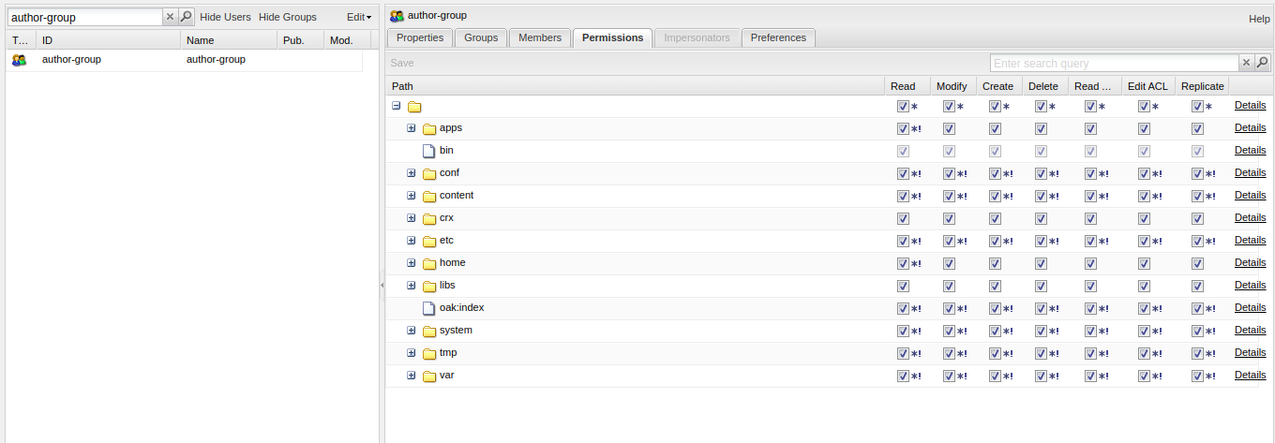

user-author:It is the user of author-group
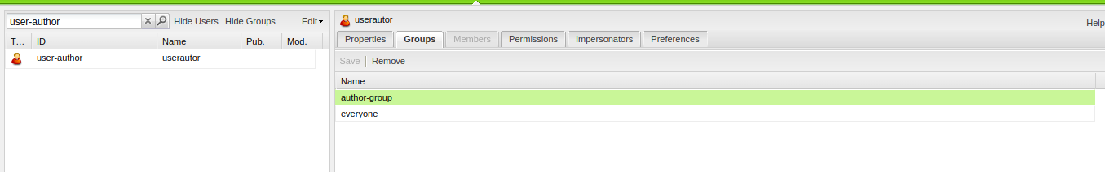

b)editor-group:
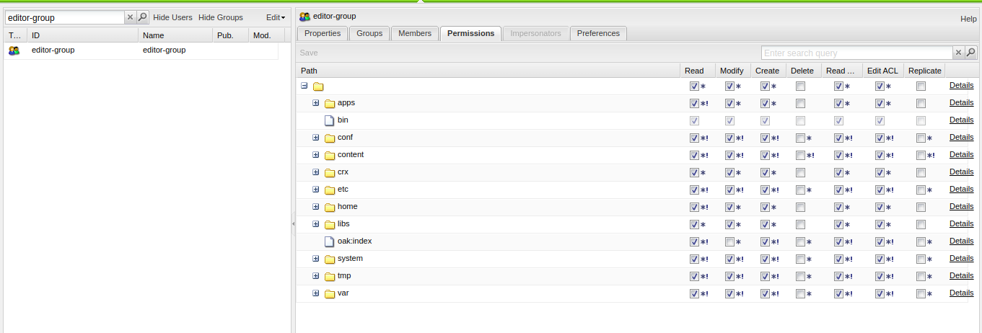

user-editor: The user of editor-group

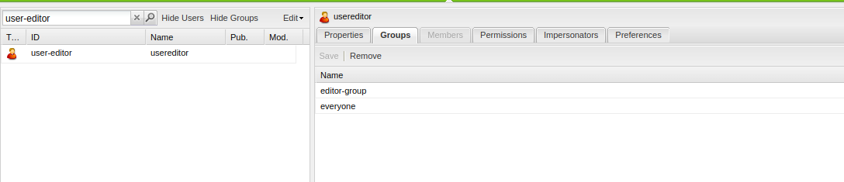

2.Impersonate a user of editor gp to author gp and test if you can replicate or delete the pages.

As the user-editor does not have permission to replicate and delete pages but the user-author had all these permissions.

So, after impersonating user-editor as the user-author ,user-editor can delete pages.

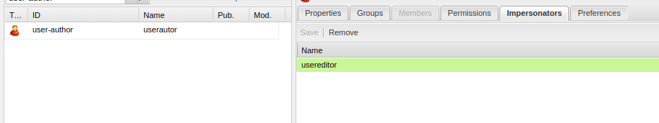
Login as user-editor



Impersonate to user-author
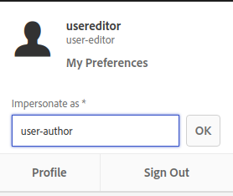
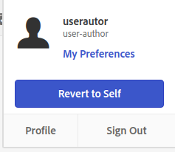

The user-editor can delete the pages after impersonating:

